DESIGN BRIEF
National Parks Association of NSW logo

Organisation’s full name/logo wording:
National Parks Association of NSW

Age of organisation:
58 (started in 1957)

Tagline:
Protecting nature through community action

Who we are:
The National Parks Association of NSW (NPA) is a not-for-profit organisation that seeks to protect, connect and restore the integrity and diversity of natural systems in NSW and beyond, through national parks, marine sanctuaries and other means. We have been established for over 57 years and have played a role in the establishment of many of New South Wales national parks and nature reserves. NPA also runs one of Australia’s largest bushwalking groups, offering over 1,000 volunteer led outdoor activities to members every year. For more information visit www.npansw.org.au.

Situation Analysis:
NPA is well known within some industry sectors especially amongst environmental community groups, state and federal government, and environmentally conscious citizens, however support and awareness amongst the wider general public, particularly the younger generations, can be improved.

Organisation’s target markets:
Primary target markets
- Employed middle to high income residents aged 25 - 39 living in NSW
- Employed or recently retired middle to high-income residents aged 45 - 65 living in NSW

Secondary target markets
- NSW high school and university students aged 15 - 25, particularly those who display an awareness and concern for the natural environment and have a passion for outdoor activities.
- School children aged 7 – 15
- The media
- State Government
- Large corporates

Similar organisations in Australia:
Nature Conservation Council of NSW (www.nature.org.au)
Wilderness Society (www.wilderness.org.au)
Foundation for National Parks and Wildlife (www.fnpw.org.au)
Other NPA’s around the country

How we differ from similar organisations:
NPA has generally been around a lot longer than many other organisations in the conservation sector and has an established reputation. NPA advocates for the NSW environment through campaigns and alliances but also has a strong focus on public education and awareness. By connecting people with nature through our bushwalking program, citizen science initiatives and events we provide people with an opportunity to develop a greater understanding and sense of stewardship towards their local environment.

Current logo:

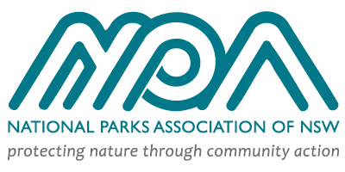

Why we need a new logo:
The current NPA logo gives the organisation an outdated appearance and makes brand identify difficult, especially when printed at a small size. Development of a new logo with a stylised and easily recognisable icon will assist in increasing brand recognition and will serve to lift the brand by making it more modern and broadly appealing.

Logo design
NPA’s new logo should be unique, modern and professional with clean and simple lines. The symbol should reflect conservation and/or communities working together.

Logos that work well:
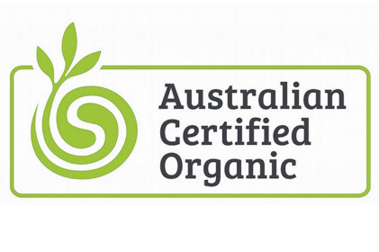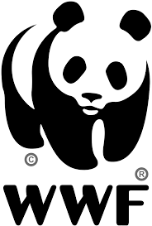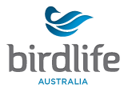

Logos that aren’t as effective:

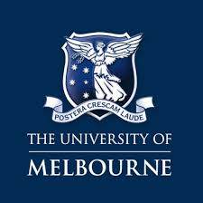
(Old fashioned Serif font. Logo is difficult to read at a small size)



(Too cluttered. Looks old fashioned)

What the logo should convey:
The new logo should denote integrity, dedication, connection and community voice. People should be left feeling inspired, empowered and compelled to act.

What the logo needs to include:
Full name of organisation. The tagline, ‘Protecting nature through community action’ is currently included but this is not a requirement of the new design. A symbol should be incorporated into the design that serves to make the logo more eye-catching, representative of nature and make it easily identifiable from other conservation organisations.

Colours:
- Two to three colour (CMYK)
- Mono and reverse versions also required

How/where will the logo be used:
- On a range of print media including NPA’s journal ‘Nature NSW’, brochures, flyers and signage
- The logo should also be easily translatable into digital format for use on websites and social media platforms
- Promotional material

Formats required:
EPS, PNG, JPEG, GIF

Project completion date:
Two weeks from receipt of brief.

