The name of the company is one word, BellyRub, with a capitol B and R and then Pet Services. So, “BellyRub Pet Services”.
I’ve taken a look at hundreds of animal logos and following are some that have multiple animals that I liked. The reason for the animal within the animal (different animals) is to represent more than just the dog. While a vast majority of clients will be dog owners, I want to hit more than the dog lover at first glance.
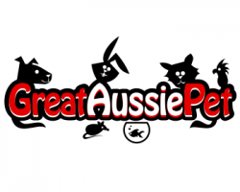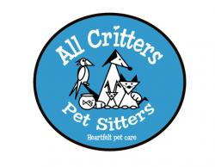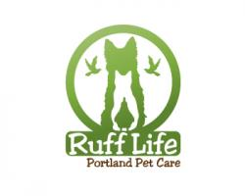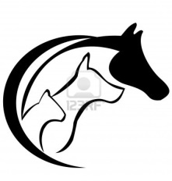

Thought the collar, tongue and teeth were a cute add to this silhouette.
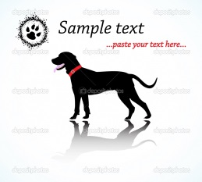

I’ve also envisioned (and not sure proper creative lingo) an artistic representation of the animals with the following look...more a profile or outlined impression.
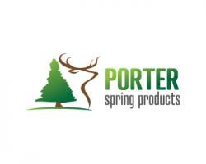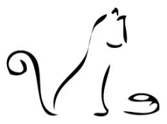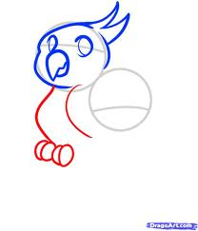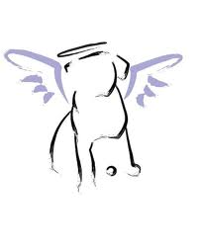

Along the lines of this….I traced the lines of one of my dogsfrom a picture that gives a good representation of what I am talking about. In keeping with multiple pets it would be interesting to see this type of drawing with more than the dog, but not sure if that would look good or resonate well with audience, though I do like the idea of having this somehow into the logo….even if it is just a dog.
