PICTURE 1  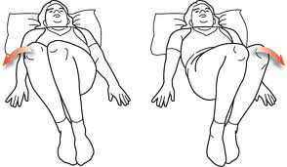  picture to show a person lying on the floor with knees bent at approximately 90 degress and then swing/move their knees to either side towards the floor | PICTURE 2  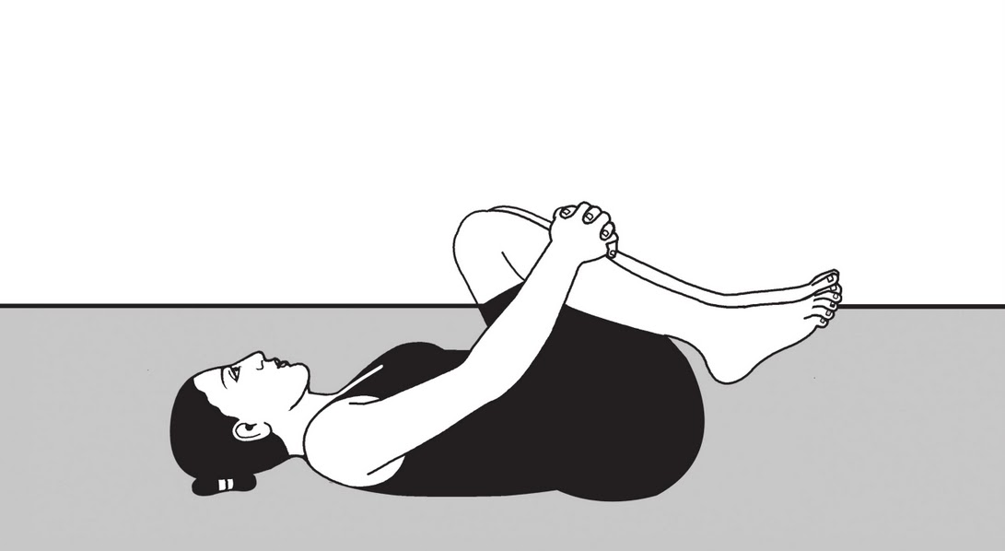  picture to show a person bringing their knees to their chest and then swing their knees side to side (probably use arrows to show this?)  - this is similar to picture 1 except the knees are brought towards the chest first  - the picture can show their hands/arms just by their side is fine like picture 1
- PICTURE 3  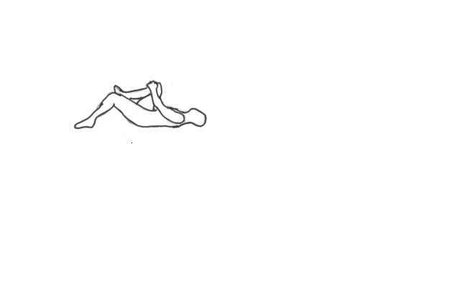picture to show person lying on the back with one knee bent and bringing the other knee to the chest (just like the picture basically)  - this person pictured will have a massage tool underneath their back (this does not have to be in the picture – but it would be great if you can put it in – the tool is basically just a small oval block – see spinal drawing 1) | - PICTURE 4  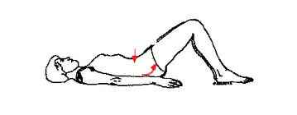  picture to show person lying on the floor with knees bent and lifting up their bottom/pelvis at the same time as pushing down their back into the floor (over a massage tool) – red arrows in this picture shows this perfectly  - this person pictured will have a massage tool underneath their back (this does not have to be in the picture – but it would be great if you can put it in – the hands are in the way here and probably need to have them placed across their chest/stomach to see the tool)

The pictures are to be the same format, here its all different because I was just searching the web for any images matching my exercise positioning
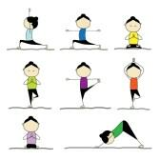
I really like these exercise drawings, just to give you an idea that it does not have to look like a real human being, but cartoonish drawing is perfectly fine with me– as long as the exercise pose are clearly seen – I also like that there is a bit of colour in these drawings

SPINAL DRAWING 1

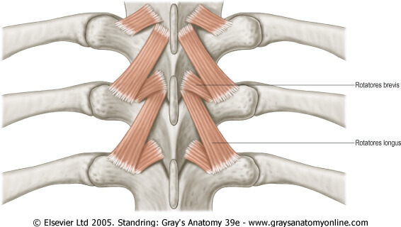

this picture is the same as spinal diagram 2 (see below) except that it has the “massage tool” picture superimposed over it, this shows people where the tool is placed.
After spinal diagram 2 is drawn, please do spinal diagram 1 with the tool like the above in the same/similar proportions as I have done

SPINAL DRAWING 2:
picture to show everything this picture does. Its exactly what I need. Please do the same like this showing the ribs and muscles and joints as is. Including muscle names Rotatores brevis and Rotatores longus

SPINAL DRAWING 3
This picture shows multifidus a different muscle to the one above. However you can use the same basis as the picture above just place this muscle in – basically I need just a segment from this picture, so it does not need to show the skull or that much spine just the 3 segments (3 vertebrae and 3 ribs on either side) as in the above picture is fine.
- include the muscle name Multifidus

