Seeing is believing

before & after example
Precision Content™ structures information making it easier to use. Compare this before and after excerpt from a manual that went through the Precision Content™ process.
Before
After
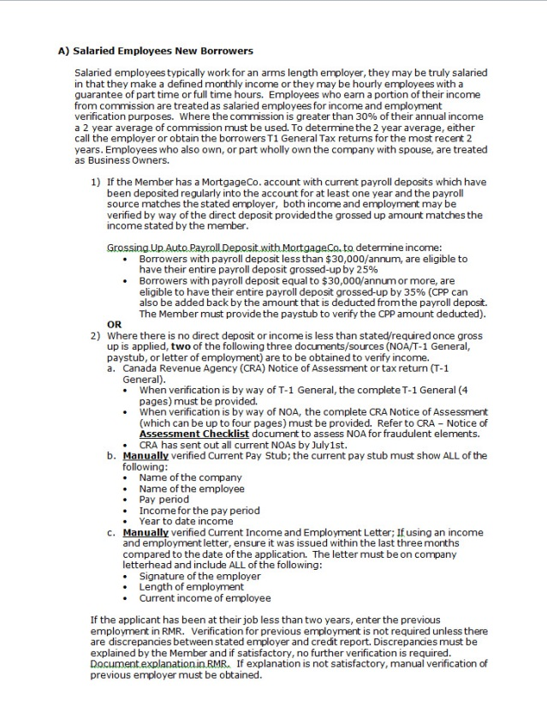
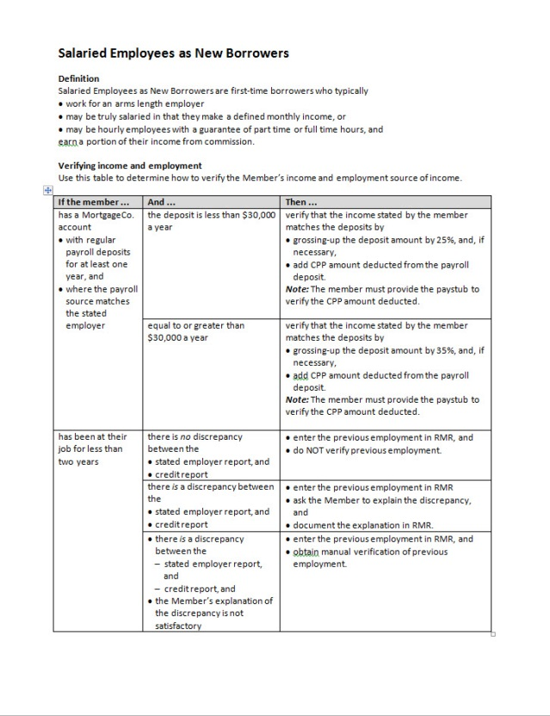
Comparing the documents
Factor | Before | After | % improvement
Total number of words | 531 | 310 | 41%
Words per sentence | 20.2 | 10.3 | 49%
Flesch-Kinkaid Grade level | 12.1 | 9.0 | 25%
This table shows the improvement in readability provided by applying the Precision Content™ method.

