
Conjunction
Agent
Event

Table of contents

 | Page  2 – 8 | Sydney:  Projects to Sell | - North Village - Kellyville  - The Endeavour - Arncliffe  - Crowle Estate - Ryde  - The Charles - Canterbury  - One Victoria – Ashfield
 | 9 – 13 | Brisbane:  Projects to Sell | - Vivir - Nundah  - Illuminia - Toowong
 | 13 | Upcoming Projects  To buy as a VIP | - Hurstville  - Kirrawee
 |  |  |  |  |  | Sydney
Projects to Sell

The North Village |  |  | 
 | Kellyville | Sydney
Stage II - Launch Next Week
Address: 133-149 Samantha Riley Drive,
Kellyville NSW 2155
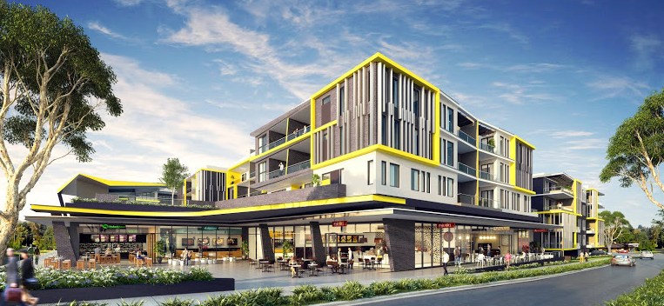 | 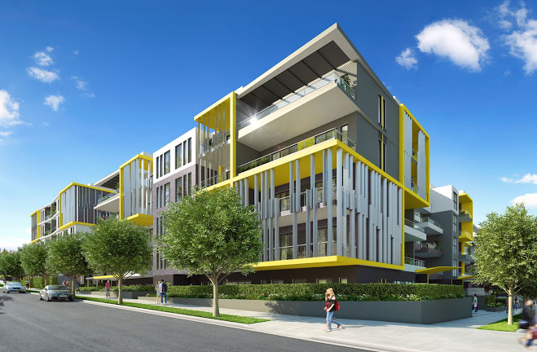

Developer | Feature Include
DeiCorp | - Mix of spacious 1, 2 & 3 bedroom apartments  - Just 42 km Northwest of Sydney CBD  - Close to Castle Towers shopping centre  - Kellyville or Sherwood Ridge Public School, Oathill & Kellyville High School or William Clark College, all just minutes away.  - Close to Norwest Business Park  - The Hills Private Hospital is close by  - Easily accessible by the Lane Cove Tunnel & M2 Motorway.  - Minutes to Kellyville new train station  - Close to Bernie Mullane sporting complex
Architect
Nordon Jago
Builder
DeiCorp Construction
Estimated Completion
Mid 2017
Building Attributes | Deposit Requirement
- 208 Apartments over 6 levels  - 14 Ground Floor retail and restaurant | - 10% deposit (Cash Deposit, Bank Guarantee)

Apt Type | No.  Available | Internal Size  (sqm) |  | Price Range |  | Rental estimate  Per week |  | Annual Strata Levies
1 Bed | 13 | Approx 70 |  | From high 400K |  | $440 - $490 |  | $550 - $740 per qtr
2 Bed | 162 | Approx 90 |  | High 500K |  | $520 - $570 |  | $750 - $1000
3 Bed | 34 | Approx 110 |  | Low 700K |  | $650 - $710 |  | $900 - $1200
 | The Endeavour
 |  |  | Arncliffe |  | Sydney

Address: 104-128 Princes Highway,
Arncliffe NSW 2205
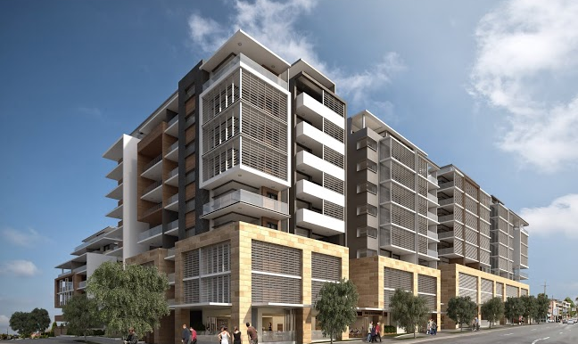 | 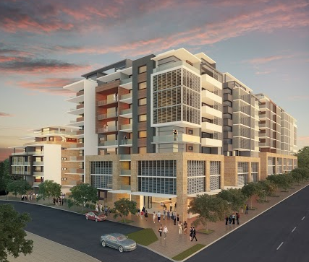

 | Developer |  |  |  |  |  |  | Feature Include
 | DeiCorp |  |  |  |  |  |  | - Mix of spacious 1 & 2bedroom apartments  - Just 10km South of Sydney CBD  - Only 3 min to Arncliffe train station  - 6 min drive to Sydney airport  - 5 min walk to the local public school  - Close to Arncliffe village and major shopping centre  - Stroll along the promenade beside the water in Brighton-Le-Sands  - Close to the proposed Sydney next Business Technology Park – Cooks Cove,  - Easy access to M5
 | Architect
 | Nordon Jago
 | Builder
 | DeiCorp Construction
 | Estimated Completion
 | End of 2017
 | Building Attributes |  |  |  |  |  |  | Deposit Requirement
 | - Apartments over 6 levels  - Ground Floor retail and restaurant |  |  |  |  |  |  | - 10% deposit (Cash Deposit, Bank Guarantee)
Apt Type |  |  | No.  Available | Internal Size  (sqm) |  | Price Range |  |  | Rental estimate  Per week * |  | Annual Strata  Levies
Studio |  |  | 1 | 50-55 |  | - |  |  | $440 |  | $500 - $600
1 Bed |  |  | 35 | 72-105 |  | $564K - $567K |  |  | $480 - $550 |  | $600 - $800
2 Bed |  |  | 148 | 45 |  | $687K - $768K |  |  | $580 - $700 |  | $700 - $900
3 Bed |  |  | 3 | 110 |  | $687K |  |  | $750- $800 |  | $1000+
 |  | Crowle Estate
 |  |  |  |  | Ryde |  | Sydney
Stage III - Released
Address: 74-78 Belmore Street,
Ryde NSW 2114

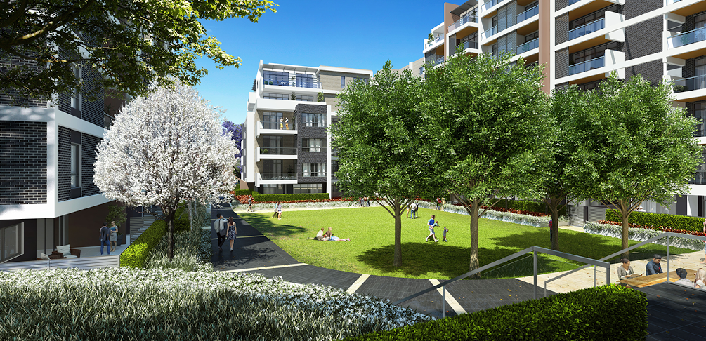 |  | 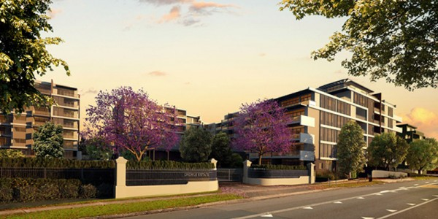
Developer | Feature Include
DeiCorp | - Mix of spacious 1& 2 bedroom apartments  - A village plaza - 26 speciality stores including ALDI  - Only 20min to Sydney CBD  - Train : only 9 stops to Wynward Station (38 min)  - Ferry :13 stops from Meadowbank to Darling Harbour (50 min)  - Buses: Sydney buses run two routes via Meadowbank station.  - School – Meadowbank TAFE, Meadowbank public school, Ryde public school, West Ryde public school  - Situated just 5km from Sydney Olympic park and Macquarie University
Architect
Nordon Jago
Builder
DeiCorp Construction
Estimated
- Estimated completion Early 2017
- Council rates per annum $960
- Water rates $700
Building Attributes | Deposit Requirement
- 416 Apartments over 6 levels  - Ground Floor retail and restaurant | - 10% deposit (Cash Deposit, Bank Guarantee)

Apt Type | No.  Available | Internal Size  (sqm) | Price Range | Rental estimate  Per week * | Annual Strata  Levies
1 Bed | 25 | 52-66 | $555K - $653K | $500 - $520 | $550 - $570 per qtr
1 Bed + Study | 4 | 54-68 | $610K - $669K | $550 - $600 | $560 - $750
2 Bed | 7 | 82-83 | $763K- $825K | $620 - $680 | $750 - $1100
3 Bed | 3 | 103 | $935K - $955k | $700- $750 | $900 - $1200

The Charles
 | Canterbury | Sydney
Address: 2A Charles Street,
Canterbury NSW 2193

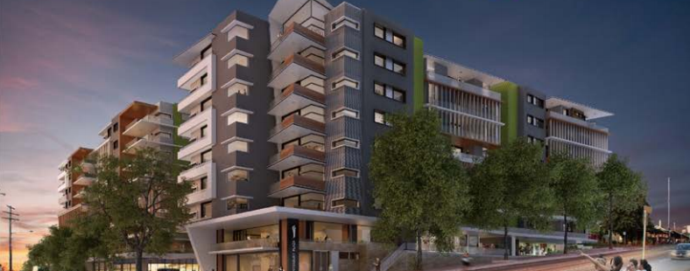 | 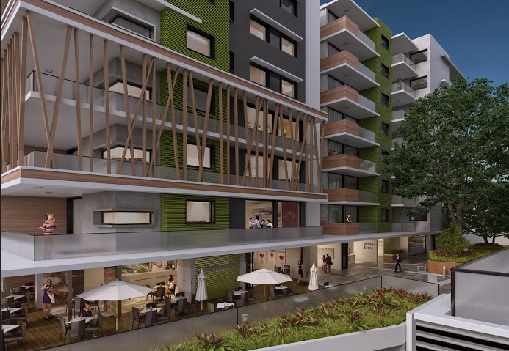

Developer |  |  |  |  | Feature Include
DeiCorp |  |  |  |  | - Mix of spacious 1 & 2bedroom apartments  - Drive to Sydney CBD in 16 min  - Train to Sydney CBD in 20 min (Bankstown Line)  - Supermarket & liquor shop on the ground floor  - ALDI – 5 min walk  - Campsie Centre – 5 min drive  - 5 min walk to Canterbury Public School and is close to Canterbury Boys & Canterbury Girls High School  - Canterbury Hospital is only 5 min drive & The Sydney Private Hospital is 8 min drive
Architect
Nordon Jago
Builder
DeiCorp Construction
Estimated
- Estimated Completion date Mid 2016
- Council Rates - $200 per quarter
- Water Rates - $170 per quarter
Building Attributes |  |  |  |  | Deposit Requirement
- 202 Apartments, 3 level basement car parking  - Ground Floor retail and restaurant |  |  |  |  | - 10% deposit (Cash Deposit, Bank Guarantee)
 | Apt Type | No.  Available | Internal Size  (sqm) | Price Range |  | Rental estimate  Per week | Annual Strata  Levies
 | 1 Bed | 31 | 60 - 82 | $547K - $597K |  | $500 | $550 - $650
 | 2 Bed | 141 | 80 - 86 | $692K - $716K |  | $600 | $700 - $800
 | 2 Bed + Study | 15 | 80 - 83 | $672K - $697K |  | $620-$650 | $820 - $850
 | 3BEd | 15 | 104 - 106 | $772K - $807K |  | $700 - $800 | $900 - $1000

One Victoria
 | Ashfield | Sydney

Address: 1 Victoria St,
Ashfield NSW 2131
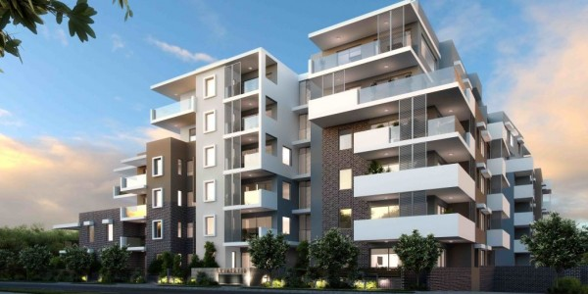

Developer | Feature Include
Surewin Pty Ltd | - Mix of spacious 1, 2 & 3 bedroom apartments  - Sunny north-east facing  - Only 15 min Sydney CBD  - Walk to Ashfield & Summer Hill train stations  - Close to transport, parks, shopping amenities and highly reputable schools  - High quality finishes with modern fittings  - Design by award winning architects Nettleon tribe
Architect
Nettleton tribe
Builder
DeiCorp Construction
Estimated Completion
Mid 2016
Building Attributes | Deposit Requirement
- 62 Apartments over 6 levels | - 10% deposit (Cash Deposit, Bank Guarantee)  - Council Rates: $238 Per quarter  - Water Rates: $175 per quarter

Apt Type |  | No.  Available | Internal Size  (sqm) | Price From | Rental estimate  Per week |  |  |  |  | Annual Strata  Levies
Studio |  | 3 | 44 | $545, 000 | $450 - |  |  |  |  | -
1 Bed |  | 14 | 52 – 58 | $595,000 | $550 - $650 |  |  |  |  | $600 per quarter
2 Bed |  | 33 | 81 – 95 | $755,000 | $700 - $800 |  |  |  |  | $800
3 Bed |  | 12 | 115 – 129 | $995,000 | $900 - $1000 |  |  |  |  | $1100
 |  |  |  |  |  |  | Brisbane
 | Projects to Sell

Vivir
 | Nundah | Brisbane

Address: 24-28 Station St,
Nundah QLD 4012
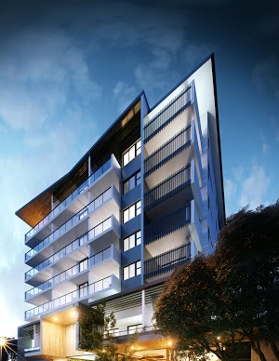 | 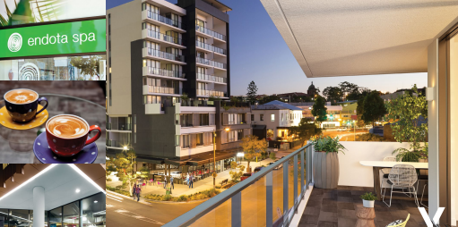

Developer | Feature Include
Property Solutions | - Mix of spacious 1, 2 & 3bedroom apartments  - Just 6 min to Brisbane CBD via AirportlinkM7  - 7 min drive to international airports  - Quality schools – Mary Mackillop College and Nundah State Primary School  Train – 7 stops to CBD  2 major shopping centres, child care facilities, parks, the Eagle farm and Doomben Racecourses  - Precinct facilities - Extensive new retail plazas including bars, cafes and indoor and outdoor dining at Circa; 2,000m2 “Go Health” super club at Circa; Private resident only lounge and media room
Architect
Arkhefield
Builder
McNab
Estimated Completion
March 2016

Building Attributes | Deposit Requirement
- 54 Apartments | - 10% deposit (Cash Deposit, Bank Guarantee)

 | Apt Type | No.  Available | Internal Size  (sqm) |  | Price Range |  | Rental estimate  Per week |  | Annual Strata Levies
 | 1 Bed | 41 | 51 - 63m2 |  | $361,500 - $437,500 |  | $390 - $440 |  | $55 - $70 p/w
 | 2 Bed | 12 | 77m2 |  | $533,250 - $569,800 |  | $495 - $625 |  | $75 - $90
 | 3 Bed | 1 | 104m2 |  | $730,000 |  | $650+ |  | $95 - $105
Illumina

 |  |  |  | Toowong |  | Brisbane

Address: 52 Jephson St,
Toowong QLD
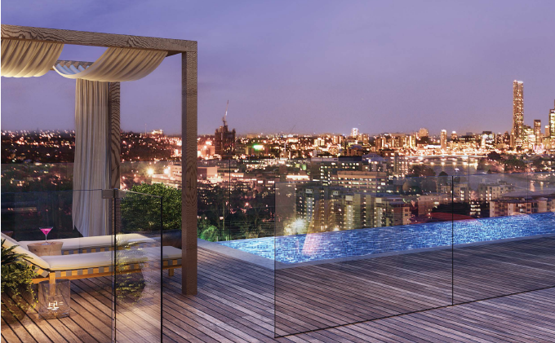 |  | 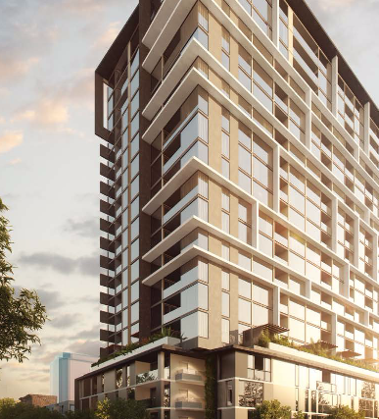
Developer | Feature Include
Property Solution Group & Chiway Land | - Major regional Activity Centre in SE OLD Regional Plan  - Only 5 km away from the heart of Brisbane City.  - Under 5 min walk to Toowong Station  - Bus stop on the doorstep – 10mins to CBD  - 10 min walk to CityCat Terminal  - Walk & cycle paths along river to CBD and UQ  - New tunnel fast track from Toowong to Inner City Bypass and Airport  - Brisbane Airport- 15 min drive  - 2 Major Shopping Centre - Indooroopilly & Toowong Village ($50M refurbishment to include stores like David Jones, Coles, Library, 80 speciality stores) – 100m  - Toowong Village Commercial Precinct – 100m  - University of QLD – 3.2km or 5 min drive (St Lucia Campus)  - Coronation Drive Office Park – 2.9km  - 15 min drive to airport  - Hospital – 5 min to Wesley Hospital & Toowong Private  - 11 Schools in the area - only 5 min walk to Toowong State school, Brisbane Boy’s College
Builder
TBA
Estimated Completion
Anticipated for late 2017
Building Attributes | Deposit Requirement
- 221 Apartments with integrated outdoor living from the Sky deck on level 21 featuring an infinity edge swimming pool, rooftop cinema and outdoor entertainment zones  - Ground Floor retail and restaurant | - 10% deposit (Cash Deposit, Bank Guarantee)  - Council and water rates: Approximately $1,500 to $2,000 per annum  - Initial $2000 to secure your residence

Apt Type | Internal Size  (sqm) | Price Range | Rental estimate  Per week | Annual Strata Levies (per week)
1 Bed | 50- 90 | $347K - $465K | $415 - $495 | $55 -$60
1Bed +Study | 58 | $481K - $506K | $480 - 4520 | $60
2 Bed | 75-120 | $550K - $671K | $475 - $750 | $60 -$70
3 Bed | 120 -163 | $916K - $1.38M | $850 - $900 | $75 - $85

Sydney
Upcoming Projects
To Buy as a VIP

We will keep you posted
- Hurstville
- Kirrawee

Disclaimer
This document has been prepared HOME789 for the purpose of providing information to potential purchasers. It is provided on a confidential basis and is not to be distributed or reproduced in whole or in part without the prior written consent of HOME789.

This document does not purport to contain all the information that a potential purchaser or any other interested party may require. It does not take into account the individual circumstances, financial situation, investment objectives or requirements of a potential purchaser or any other person. It is intended to be used as a guide only and does not constitute advice, including without limitation, investment or any other type of advice. The information contained in this document does not constitute any offer or contract, including for sale or otherwise.

Any potential purchaser or any other interested party should obtain independent financial, taxation, accounting, legal and other advice to assist them in making their own decisions and assessment appropriate to their circumstances. HOME789 and its clients assume that any person who reads or uses this document is capable of evaluating the merits and risks of any investment or other decision with respect to a property transaction, its suitability and its financial, taxation, accounting and legal implications without any reliance on this document.

This document may contain information prepared by third parties. Figures, calculations and other information contained in this document that has been provided to HOME789 by third parties have not been independently verified by HOME789. Any projections or analyses represent best estimates only and may be based on assumptions, which, while reasonable, may not be correct.

Past performance of any property described in this document is not a reliable indication of future performance of such property. At all times, HOME789 acts as a provider of real estate services only. Except where otherwise provided, all references to rent, income or price are GST exclusive.

Users should not rely on any information contained in this document as a statement or representation of fact and must make their own enquiries to verify and satisfy themselves of all aspects of such information, including without limitation, any income, rentals, dimensions, areas, zoning and permits. While the information in this document has been prepared in good faith and with due care, no representations or warranties are made (express or implied) as to the accuracy, currency, completeness, suitability or otherwise of such information. Great Fortune Investment, its clients, officers, employees, subcontractors and agents shall not be liable (except to the extent that liability under statute or by operation of law cannot be excluded) to any person for any loss, liability, damage or expense arising directly or indirectly from or connected in any way with any use of or reliance on such information.

