This goal of this project is to enhance the design of our “internal shopping” application. We call it “eRequest”. eRequest allows an employee to requisition material or services. The user fills a shopping cart and “checks out” in a manner similar to Amazon or any other commercial site.
The task is to redesign the form below and “pull out” panels. We are looking for a clean, contemporary design consistent with our branding. Our goal is to make the shopping experience as close as possible to what a user experiences on consumer sites (e.g. Amazon, Staples, Home Depot). A new user should be able to shop and check out without any training. Therefore, it is important that the shopping experience be familiar to the user.
Designer Instructions
Please submit designs for the Main form and the three “panel overlays” shown below.
It is important to note, that the form is framed by a black “app status bar” and a set of green menu tabs which must remain. These tabs allow the user to access other areas of our application. Please DO NOT REDESIGN THIS AREA. This frame is consistently used in all of our applications and we cannot change it without a major redesign. It is very important that your page looks good within this menu frame.
Here is the form as it appears currently when the user first accessed the shopping application.
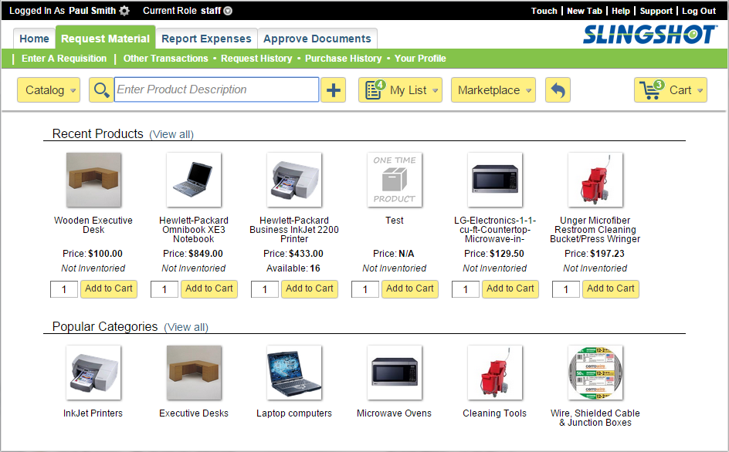
Design This Area
Menu Bar
Do Not Change

Design #1 Main Shopping Form
The various areas of the form are described below.
Click a Category and all products within the category will appear
All shopping options accessed from this bar
Recently ordered items can be reordered with one click
At the top of the form the user can select from the Catalog, Search for a Product, Select Items on Their Shopping List or “Punch out” to a Marketplace (Order on an external “consumer” site).
The items ordered appear in the shopping cart. The body of the form allows the user to re-order recently ordered items or, view the product in a popular category.
Items are ordered by clicking the “Add to Cart” button. The green counter on the shopping cart is incremented and the action label changes from “Add to Cart” to “Add More”.
Additional Info:
Hovering on a button displays a panel (described below). Clicking the button brings the user to another form with extended functionality. For example, clicking on “My List” takes the user to a form on which the user can maintain the list.
The “+” button to the right of the product search input box allows the user to create a new “one time” product.

The following pages define the “panels” which appear when the user mouse hovers over and of the aforementioned buttons.
Design #2 Catalog Overlay – Select category or product
Up to three levels of menus appear when hovering over the catalog (e.g. Office Supplies / Printing Paper Ink & Toner / Laser Jet Paper 8 ½ x 11)
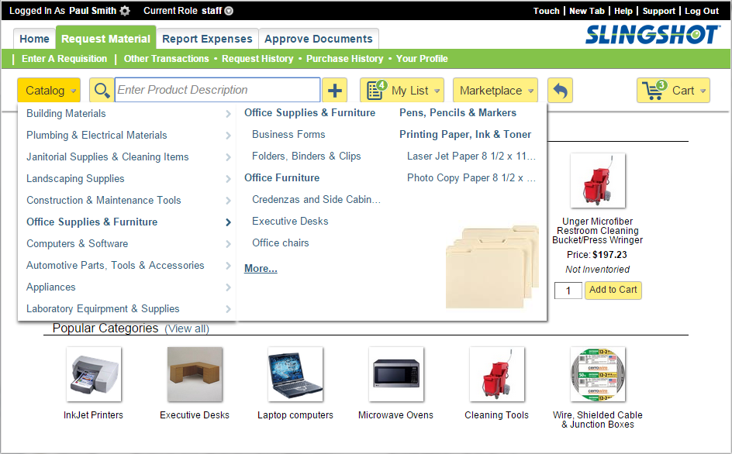

Design #3 Shopping List Overlay – Select from personal shopping list or access other lists
Hover over “My List” and Items on the user’s personal shopping list appear.
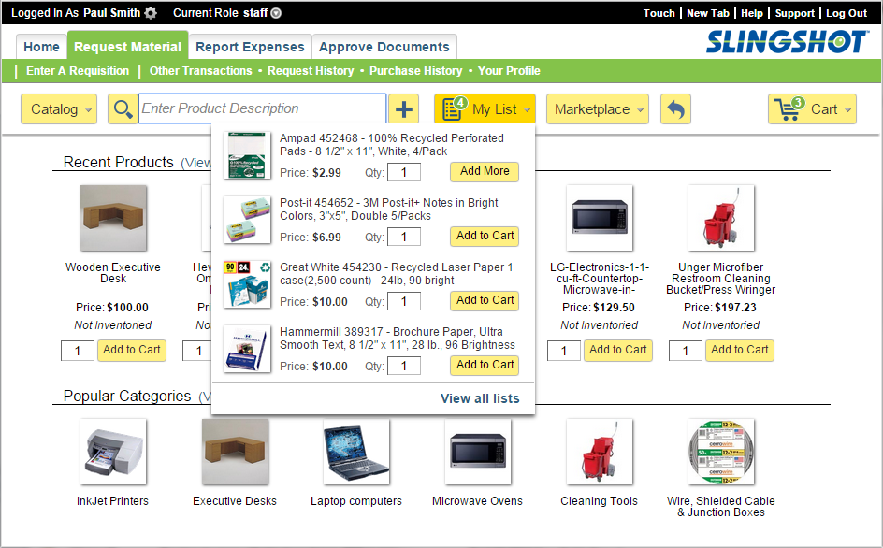

Design #4 Shopping Cart Overlay - Review and maintain Shopping Cart contents or, checkout
