Elements that I like

Hey designers, I just thought I’d update you on elements that I like, I want to see what you can do with this, I’m close to picking the winner soon. I’d like to close this off by Monday

- For the Nav bar, I like this simplicity, boldness and particularly, how the image fades into the Nav Bar. It gives a nice fat image without making it skinny, but keeps the nav bar predominantly white and simple
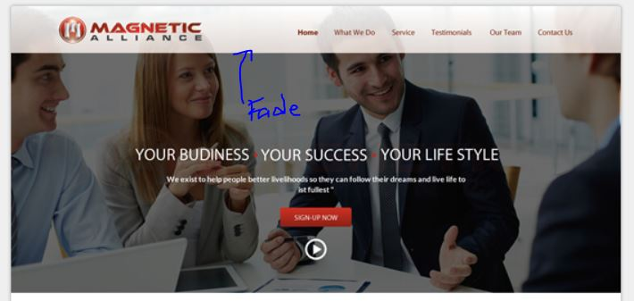

- These 3 points, I like how its:
  - Inside a shape
  - The shape has a transparency
  - Its not all in one line

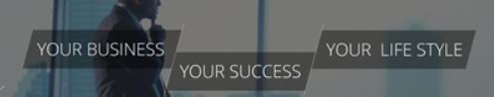

- I like this what we do, it’s very square and symmetrical (Ignore the font, I don’t like the font), but I like the image being the same size as the word section and how it flips around the opposite every line

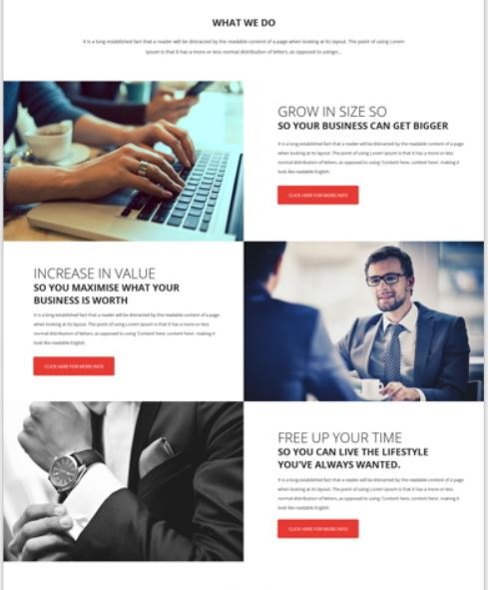

- I like this for “Our Services” because of
  - The colour – orange, very energetic
  - The simplicity and unclutteredness
  - The layout of the icon and text
  - The toggle arrows showing that we have more services
  - The transparency with the image behind it
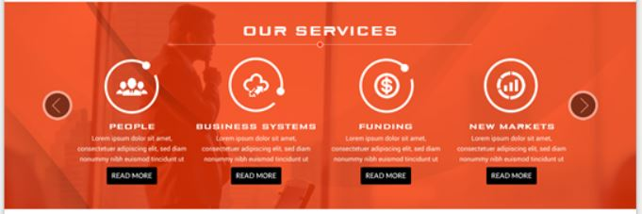

- I like how the circular image
  - Provides a change compared to the square feel of the site
  - Has the numbers 1 – 5 with the reasons to deal with us and the text to the side summarising why deal with us

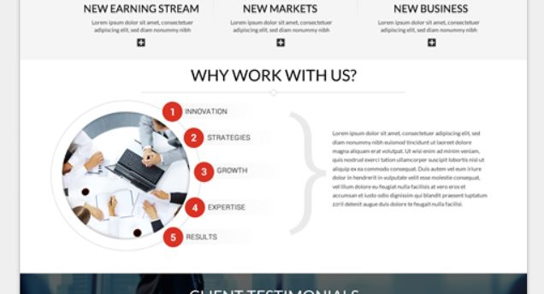

- The added “Call to action” bar – this is handy as a reminder, we would like to add it in a couple of places
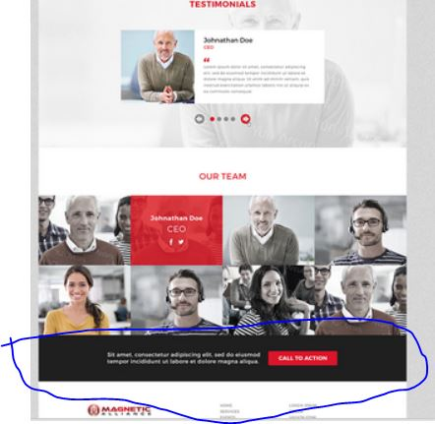

- Testimonials style because of:
  - Simplicity
  - There is a grayscale fade image behind the testimonial
  - There is a nice rectangular testimonial with image to left and worded testimonial to right
  - There is a toggle to see other testimonials

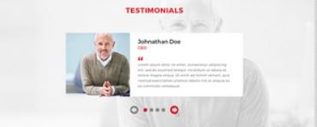

- Contact us – I like how there is an image of the google map behind the smoky transparency and a simple enquiry bar