Elements that I like

In addition to the elements I gave you here are some more

- I like this opt in box
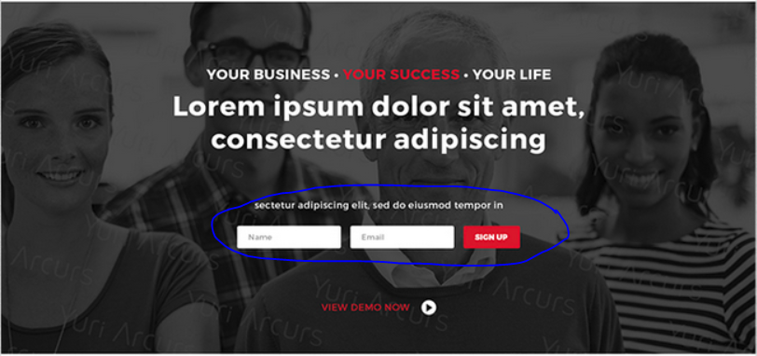

- I like this footer, it means we have a testimonial and easy contact info on every page
    - I’d like the initial “Testimonial” in the first “Elements I like” incorporated into the left hand side red part
    - I like a google map with black transparency incorporated into right side with simple enquiry box
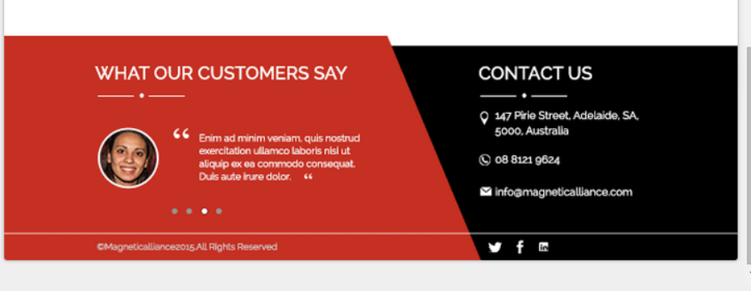
3 I like how pronounced the play button is on the below, perhaps we can make it classier, but the what we do also in the 1, 2 & 3 is very clear and easy. Would like you to try and put our Grow Your Business, Increase your value and Free up your time in the 1, 2 & 3 just to give me an idea of what it looks like

