My Keywords:
This section shows an overall account/keyword snapshot.
It Includes 3 sections…
Section 1: account overview (shows # of purchased keywords, active and passive keywords used, etc)
Section 2: Boost A keyword Phrase. This allows user to fill in info and start the ‘boosting’ process.
Section 2 will also be used on other area of the site so it should work as a stand along module as well. When user researches keywords, they will be able to ‘boost’ (fill out this form for the keyword phrase) or add to Que. If they add to the keyword to a que, they will later be able to view the que, click boost and submit this info for the desired keyword.
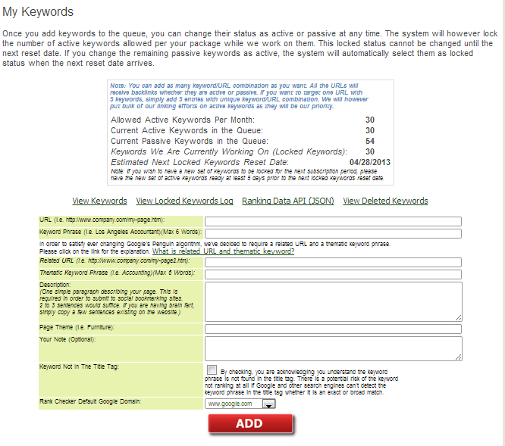

Keyword/Ranking Summary –
This section shows active and passive keywords that the user selected. I want this section to look much nicer and look like a web2.0 module. I want this section to be more user friendly and I am hoping to lay out the info in a better way. I also want to add a link to each keyword entered. Link will say: Check Current Ranking (since passive keywords will not show ranking snapshot)

