LOGO/BRANDING DESIGN BRIEF

The logo

- What words or letters do you want included in your logo? “Eight & Sand” and/or “8 & S”. This term was said to a train crew before departing to wish them a quick and safe journey. 8 comes from Notch-8 which is the highest power setting on modern locomotives and sand was shot on the tracks to prevent slippage.
- Do you have a tagline? Do you want it to be included in the logo? “Creating community through beer.” We’ll leave that up to you.
- Provide four adjectives to describe your logo. Simple, modern take on old style, clean, bold
- - - - - - - - - - - - - - - - - - - - - - - - - - - - - - - - - - - - - - - - - - - - - - - - - - - - - - - - - - - - - - - - - - - - - - - - - - - - - - - - -

Tell me about your company:

- Explain what your company / organization is and does. A small batch craft brewery and tasting room serving European style ales and lagers with newer American ingredients. Our brand will be focused around the South Jersey Railroad as our location is next to an old rail line and one of the founders has family ties to the railroad.

- How are you different than your competition? We offer small batch beers crafted with local ingredients and based on classic European styles. The majority are session (lower alcohol) so people can enjoy more. We are about educating the consumer about real craft beers and the stories behind them. We care about our surrounding community and plan to sponsor numerous charities.

- What are the benefits of your product/service? Fresh, personal, accessible, local beer available in our tasting room, on draught to go or at your local bar.

- What attributes of your business / organization would you like your logo to reflect? The mix of classic style with modern innovation; the small batch, artisanal nature of our products; the community centered feel of our tasting room and a nod to trains.

- How do you intend to market your company? Website, Facebook, Twitter, craft beer journalism and review sites, local events and publications, beer festivals, bar tap takeovers.

- - - - - - - - - - - - - - - - - - - - - - - - - - - - - - - - - - - - - - - - - - - - - - - - - - - - - - - - - - - - - - - - - - - - - - - - - - - - - - - - -

Goals and Objectives:

- What do you want to happen as a result of this project? To build our tasting room into a community fixture for craft beer drinkers and expand our production into large scale distribution throughout the tristate area.
- - - - - - - - - - - - - - - - - - - - - - - - - - - - - - - - - - - - - - - - - - - - - - - - - - - - - - - - - - - - - - - - - - - - - - - - - - - - - - - -

Describe what you want designed:

- Describe your aims and requirements in detail here — Looking for general branding including a logo. This logo will go on t-shirts, growlers, glasses, signage, the website, taphandles, etc. In year three of operation we’ll plan on canning our beer but the beer can design is not an immediate need. Directly or indirectly related to trains.

We’re hoping you could provide a few logos, one of which incorporates the below which is an old compass. The compass is important to us as it has an old classic style and symbolizes help whenever you’re lost, and I’m sure we’ll be lost somewhere along the way, but we’ll eventually get there. I’ve also included some old train tickets and pictures of Woodbury, NJ (our site’s location) for inspiration.

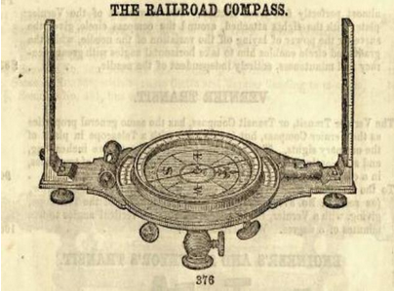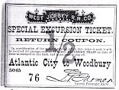
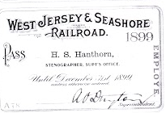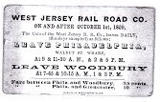
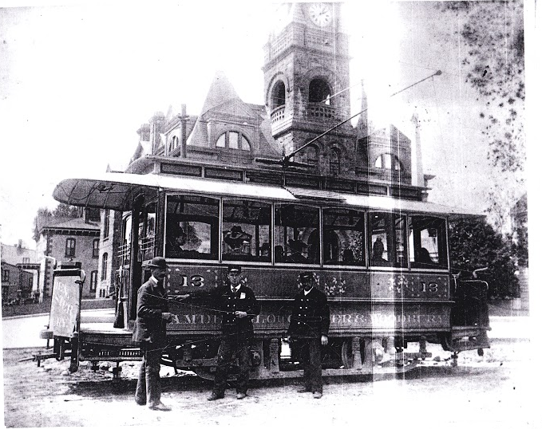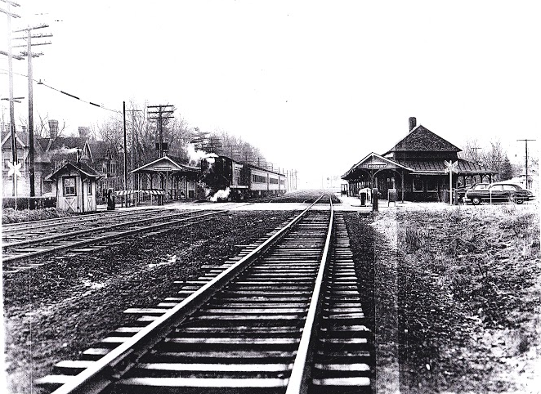

- What key pieces of information / copy need to be included? The logo should have the name spelled out as Eight & Sand Beer Co. so people can identify we sell beer.

Competitors Design
- Use Google to search for similar designs that you like, include at least (4), explain why you like them and what to include / exclude in your design:

These logos represent a combination of the classic sensibility of our brand combined with the modern, bold feel of design that we are looking for. Simple character elements or accents (i.e. the waves under Great Lakes). The earthy color schemes.

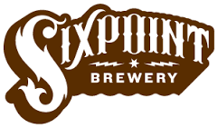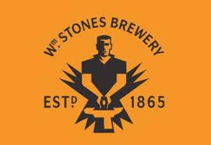

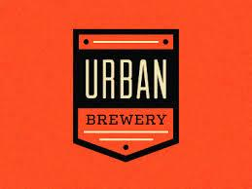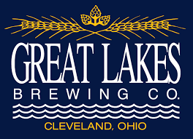

- Do the same exercise but look for (4) competitors designs that you DO NOT like and explain why.

As an example of what we do not like, these logos are cartoonish, heavily stylized, and very colorful (even though clown shoes is actually one of our favorite breweries).

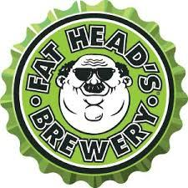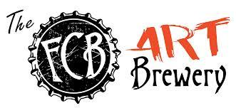

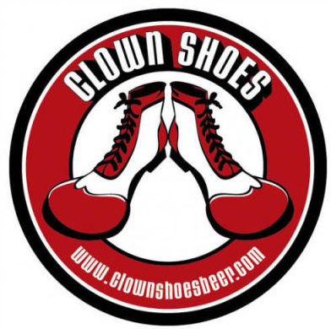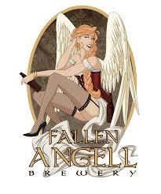

- - - - - - - - - - - - - - - - - - - - - - - - - - - - - - - - - - - - - - - - - - - - - - - - - - - - - - - - - - - - - - - - - - - - - - - - - - - - - - - -
Who is your target audience?

- Who are you trying to attract with your marketing message? Adults aged 21-50, craft beer enthusiasts, local food/produce consumers, ‘foodies’.

- What is the overall message you want to convey to your target audience? Classic/modern and local (South Jersey)

- - - - - - - - - - - - - - - - - - - - - - - - - - - - - - - - - - - - - - - - - - - - - - - - - - - - - - - - - - - - - - - - - - - - - - - - - - - - - - - -

Tone & Image:
Funny / Casual / Formal / etc. What tone and imagery will be most effective, specific visual goals? Formal
- - - - - - - - - - - - - - - - - - - - - - - - - - - - - - - - - - - - - - - - - - - - - - - - - - - - - - - - - - - - - - - - - - - - - - - - - - - - - - - - -

What colors would you like to see in your logo? (It is usually best to stick to one or two colors):

1 through 3 of any of the following: Black, Grey, Orange, Brown, Green. Earth tones.

- - - - - - - - - - - - - - - - - - - - - - - - - - - - - - - - - - - - - - - - - - - - - - - - - - - - - - - - - - - - - - - - - - - - - - - - - - - - - - - -

Below you see different ‘genres’ of logos. Please pick one that suits your design needs.

Character and Emblem, possibly a combination.
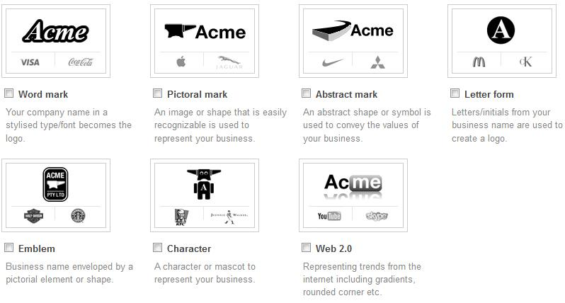

lastly:

- If your logo was a celebrity, who would it be? John Wayne – simple man who works his ass off and is not afraid to get dirty.

- How important is this project to you on a scale of 1-10? This is a company/brand we plan on passing to our children’s children. We will not be a national brand. We will stay to the tristate area.

