Our Sacred Calling
Exalting the Dignity of the Christian Ministry
And Encouraging Those Who Labor In It

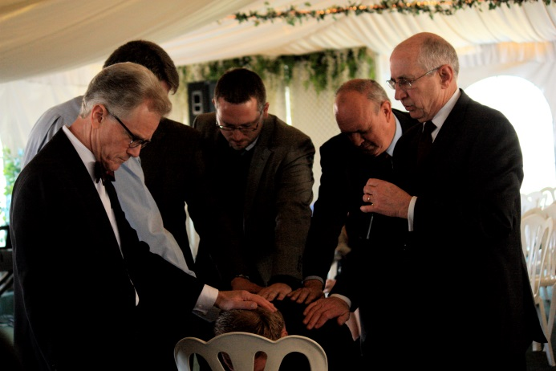



“Fight the good fight of faith. Take hold of the eternal life to which you
were called and about which you have made a good confession
in the presence of many witnesses.”
1 Timothy 6:12

