The Expense Capture application allows an employee to enter an expense report while traveling. Expenses can be entered in multiple currencies. Expenses can be charged to a company credit card or reimbursed to the employee. Expenses can be billed to a customer or absorbed as internal costs.
When an expense report is complete is is submitted to the server application (Slingshot Accounts Payable) and routed for approval.
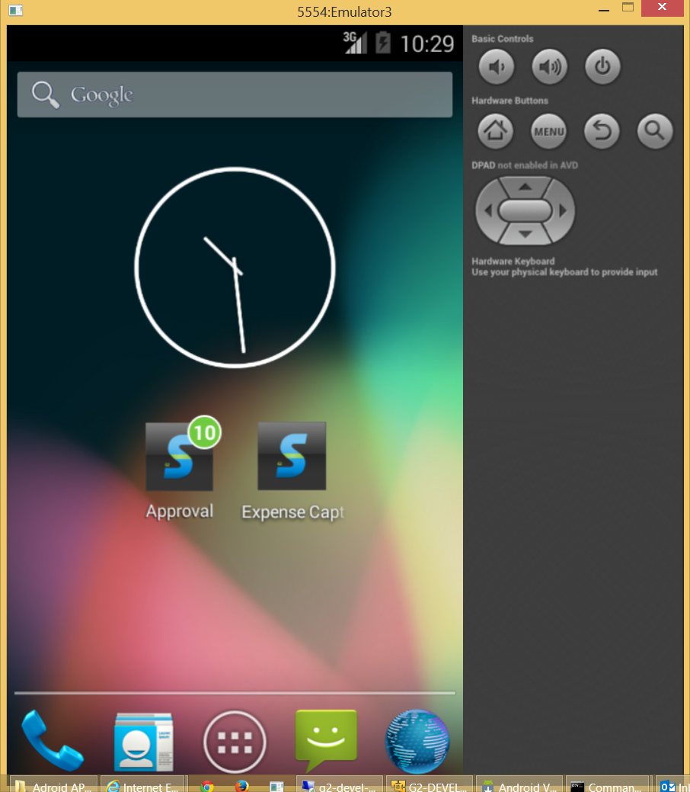

Click the desktop icon and a form appears for one second showing the current version of the application.
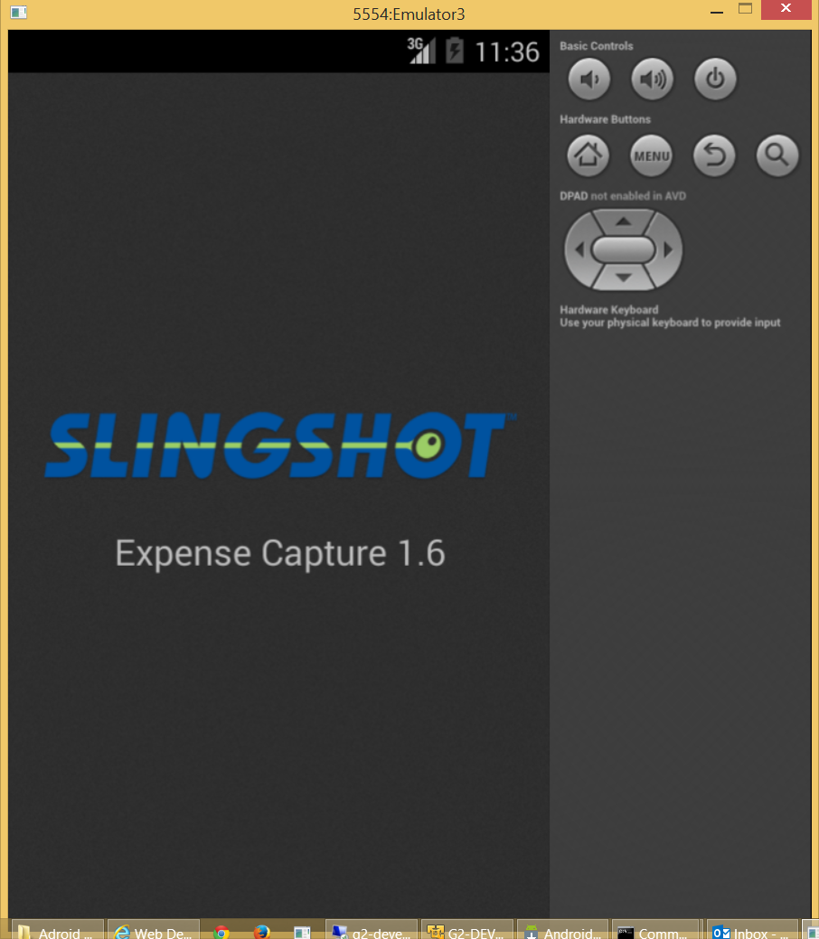

The previous form disappears and the following menu appears. Three buttons allow the user to “Enter Trip Info (each expense report is a single trip), File Expenses (each expense detail is a code, description, amount and currency) and “Submit Expenses” to the Slingshot Accounts Payable application for approval processing and payment.
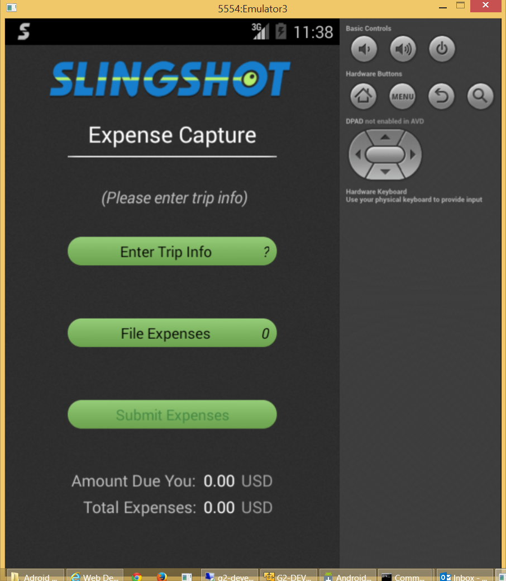

Click the “Enter Trip Info” button and the following form will appear. The keyboard is used to describe the reason for the trip.
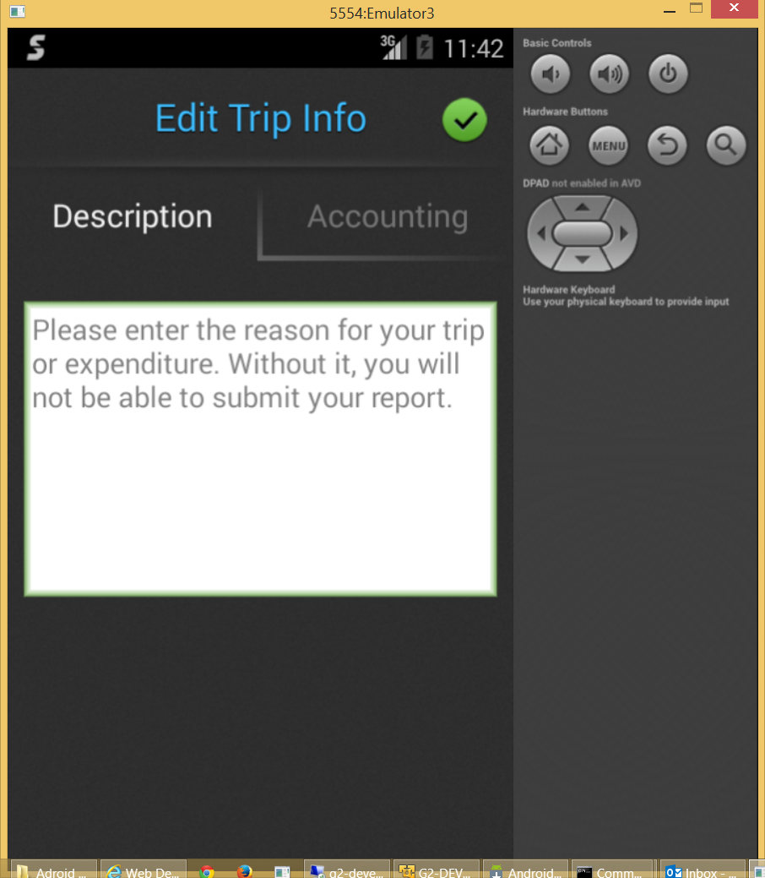

Click the “Accounting” tab and “expense report level” defaults can be overridden. These fields default from user preferences maintained on the server (not part of the mobile App). Therefore, this form is typically used for exception cases. The defaults are automatically copied to each expense report line where they can be changed.
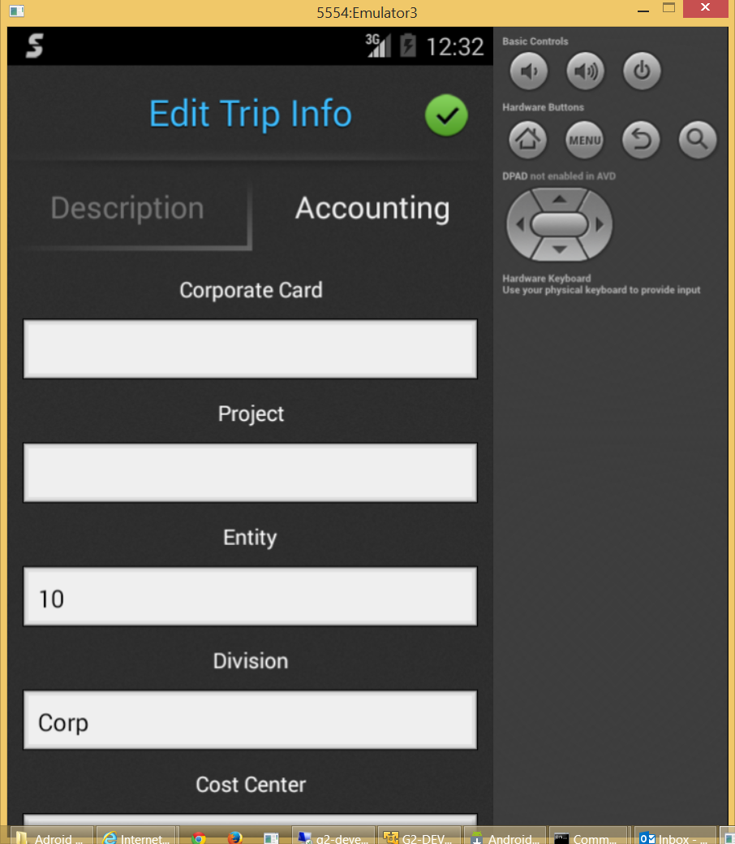

The user clicks the green check box above to save changes and the menu will re-appear. Notice the required trip information has now been specified (as indicated by the check box).
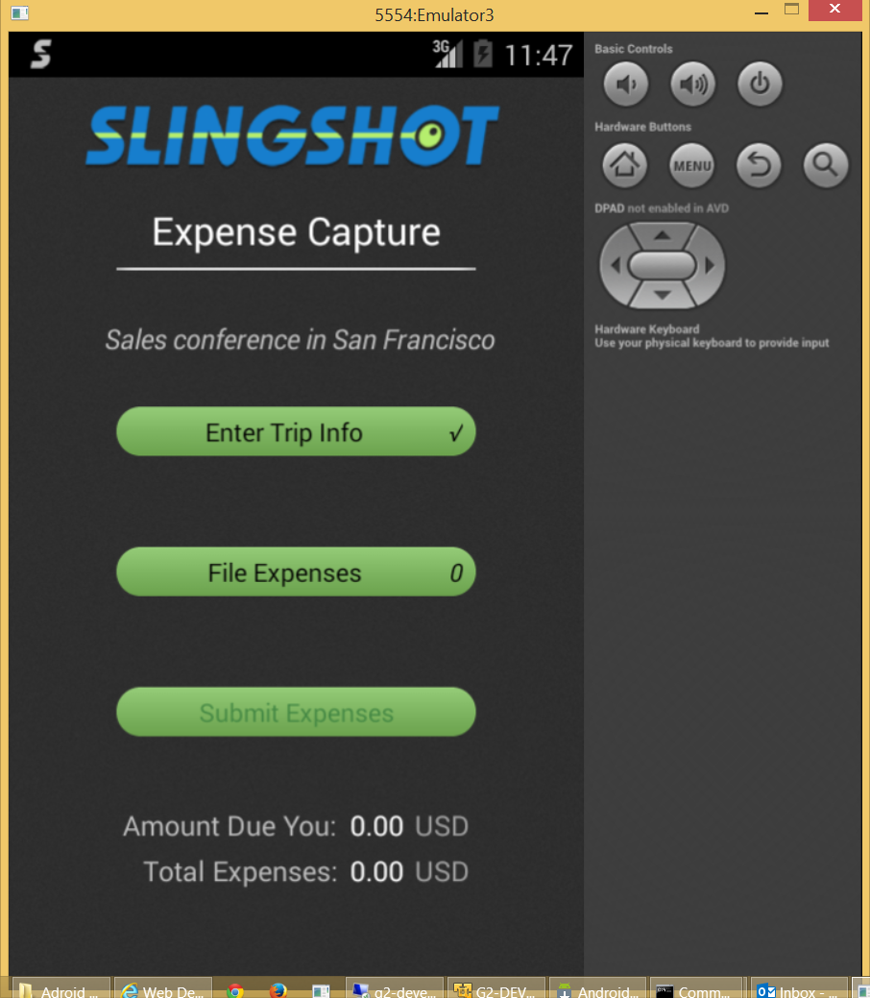

Click the File Expenses” button and the following form will appear.
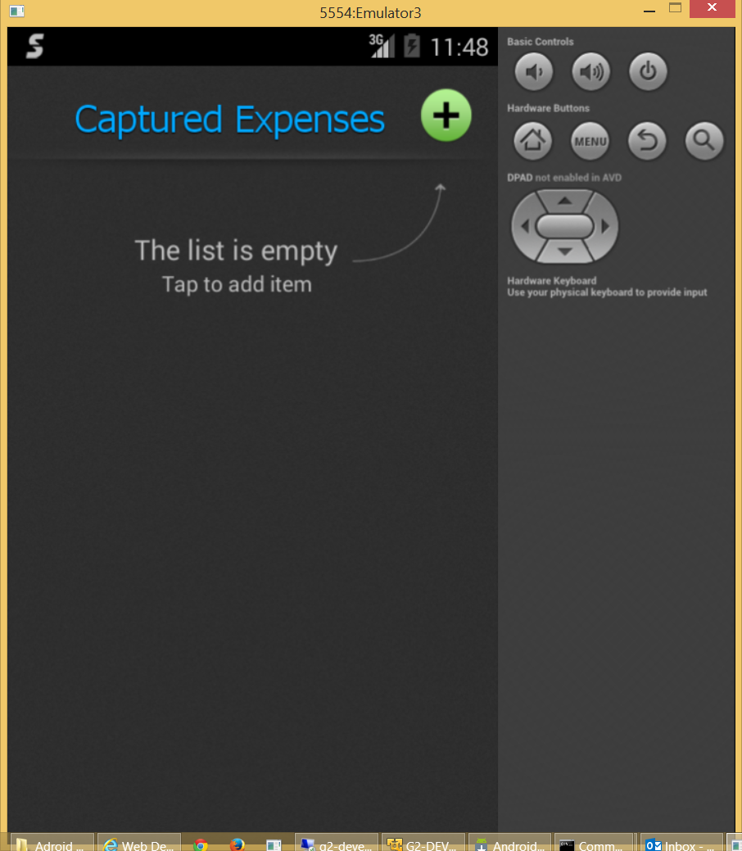

Click the plus sign to add an expense and the following panel will appear.
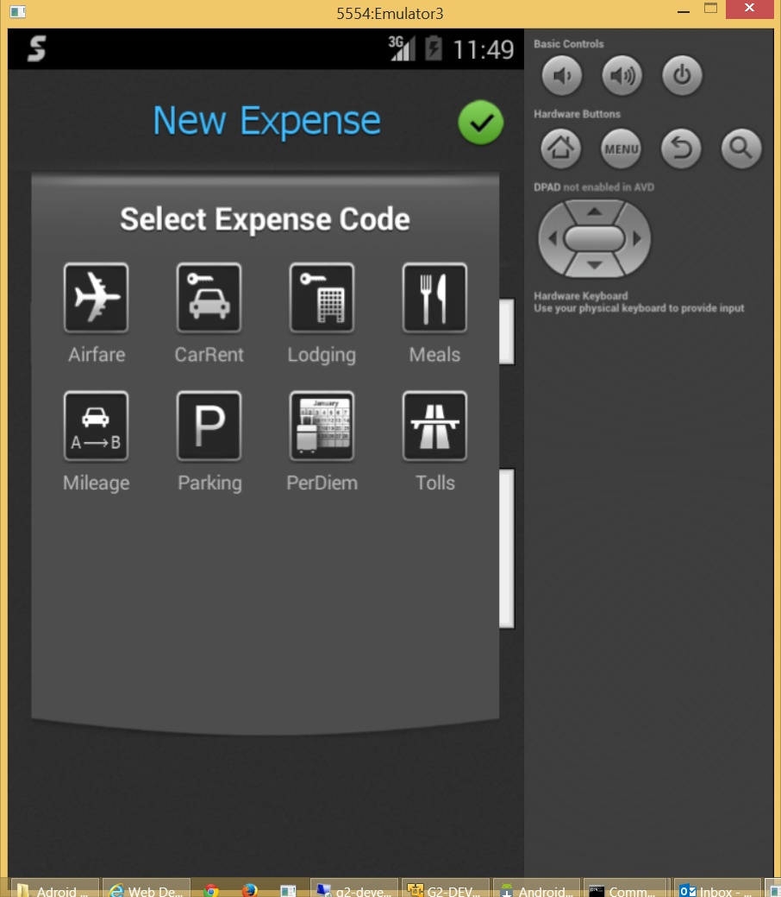
The user is required to select one of the predefined expense codes. We intend to add to the list show above (entertainment, gas, supplies, train, bus, taxi, other). Please include designs for these icons.

The user selects an icon and the panel disappears revealing the following form.
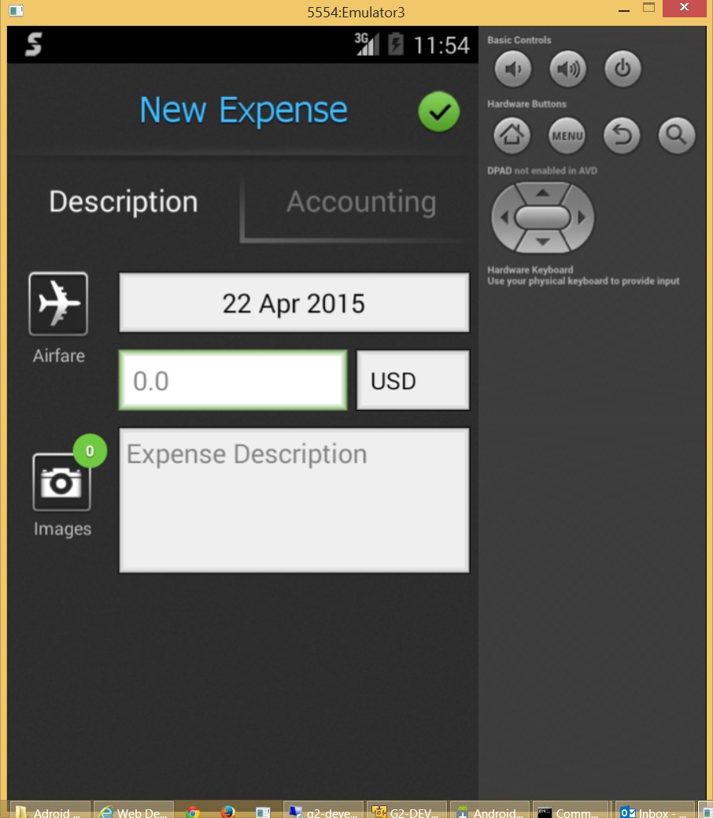
The user is required to enter an amount and a description. Images and account overrides are optional.

Clicking the “Accounting” tab allows the user to specify a credit card, a bill to customer or an accounting element (e.g. company, division or project).
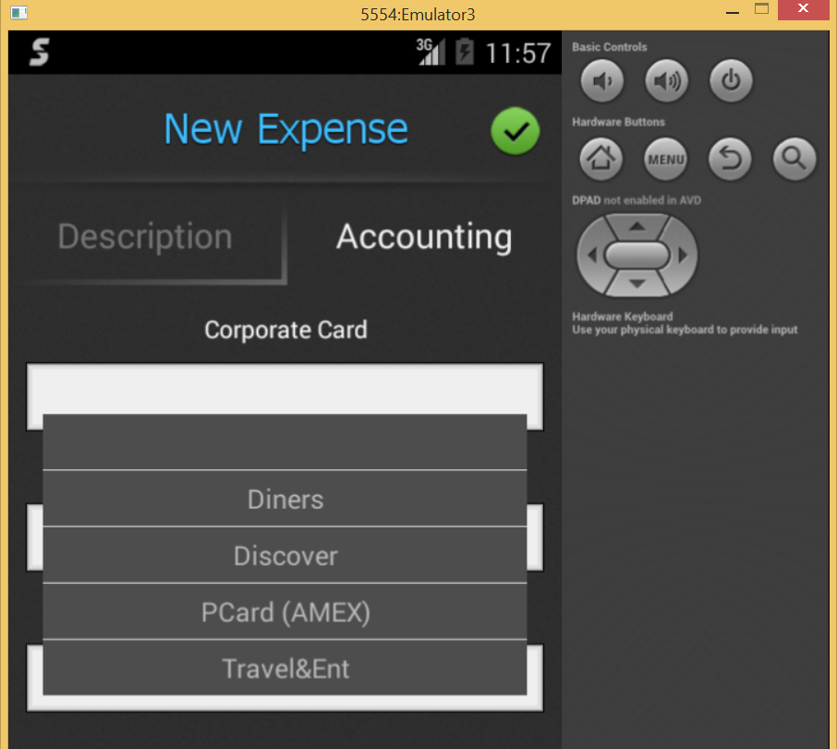
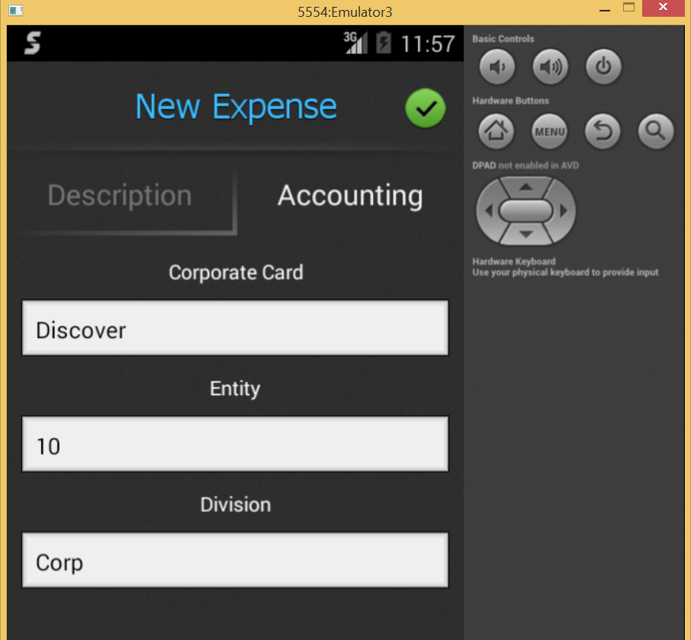
Click Description to return to the expense report line detail.
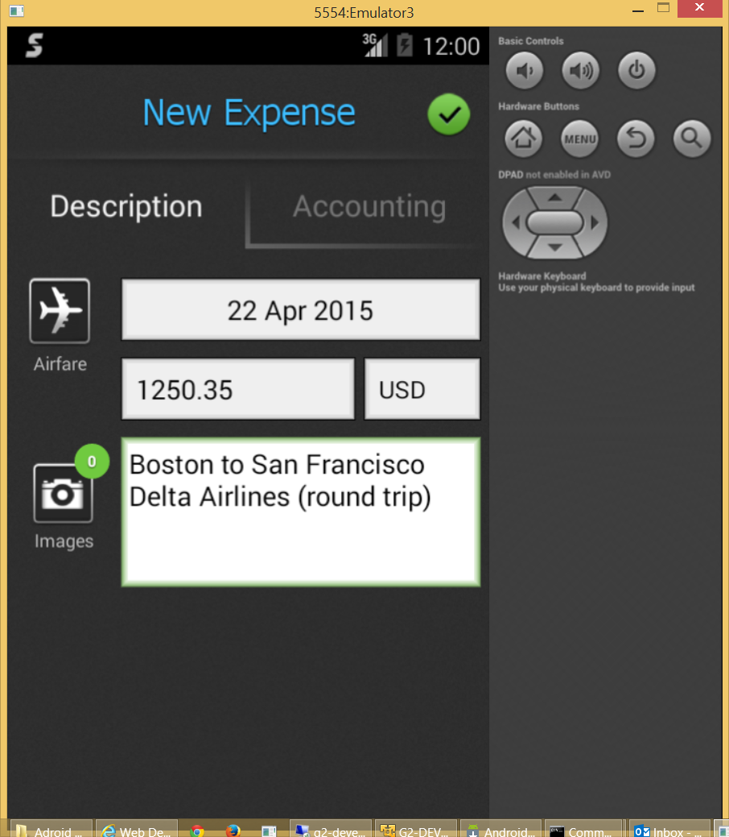

Click the camera button to attach one or more pictures of receipts. The camera will appear (simulated below). Click the shutter button followed by the check box to accept the image.
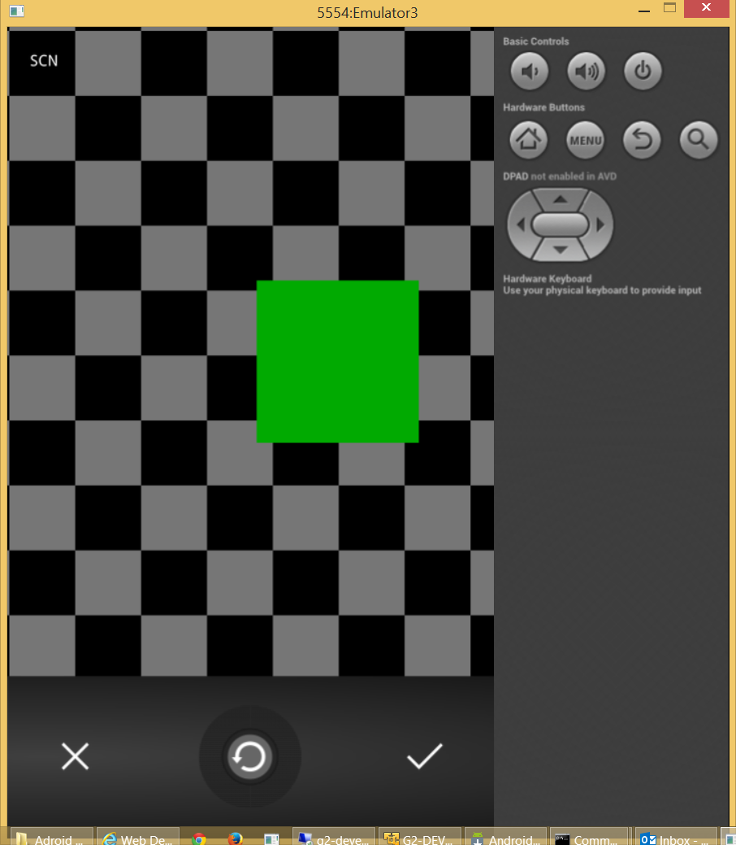

The gold message appears if the value of the document exceeds the user’s maximum. When this is the case another user is approving as well.

Buttons appear at the top of the form allowing you to discard the image (trash can) or add another (camera with plus sign).
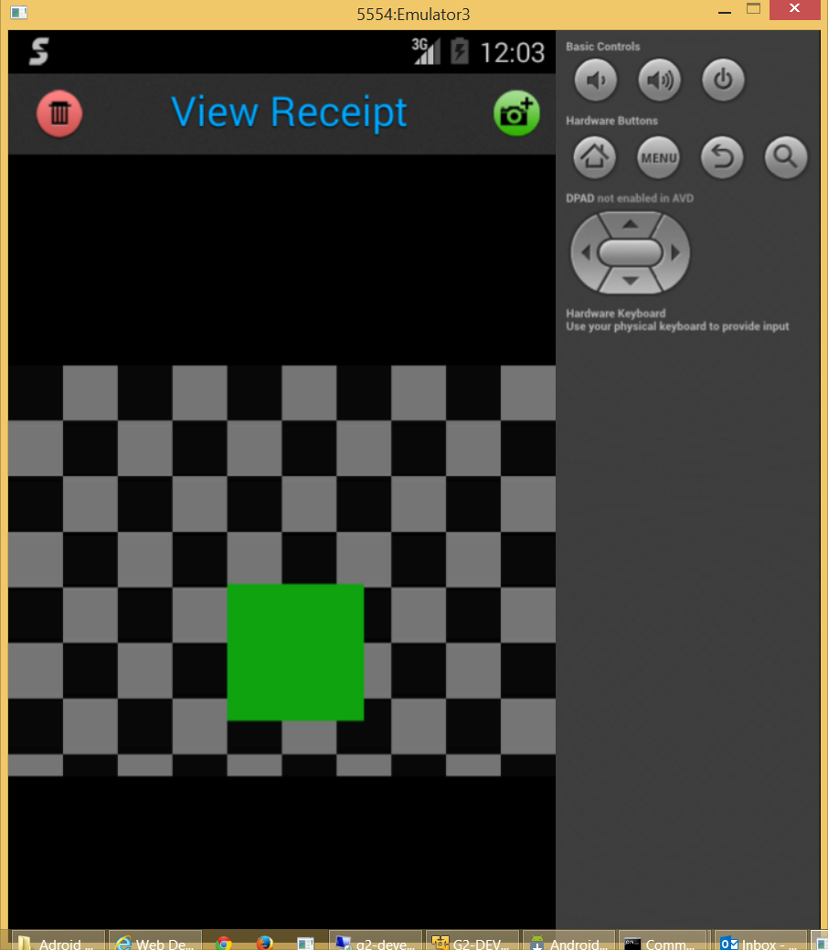

Hit the Android back button when you are finished adding images and the expense detail form will reappear.
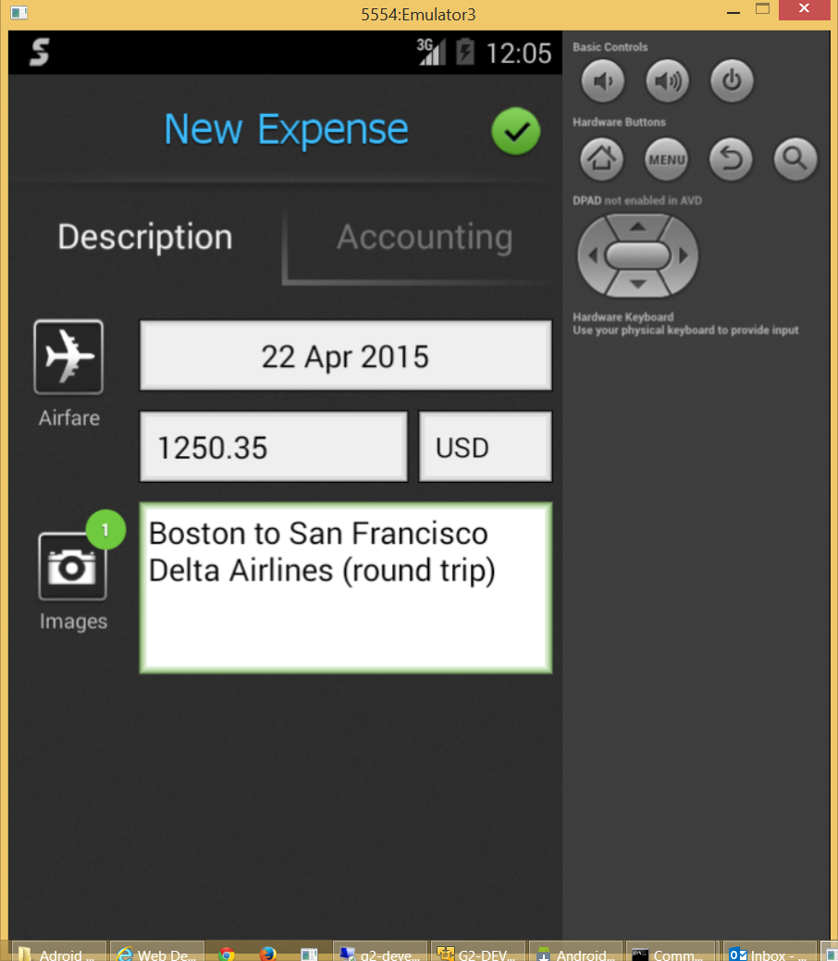

Click the green check box at the top of the form to accept this expense and add another. The Expense Code Selection panel will reappear.
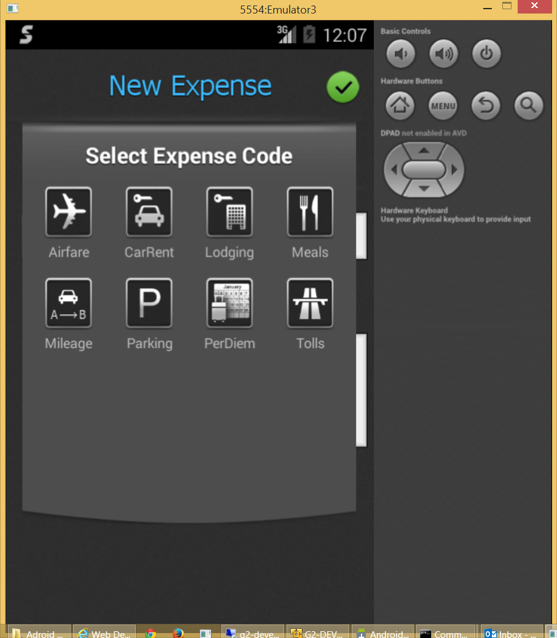

The process continues until all expenses are added at which time the user presses the Android back button on the above form to display the list.
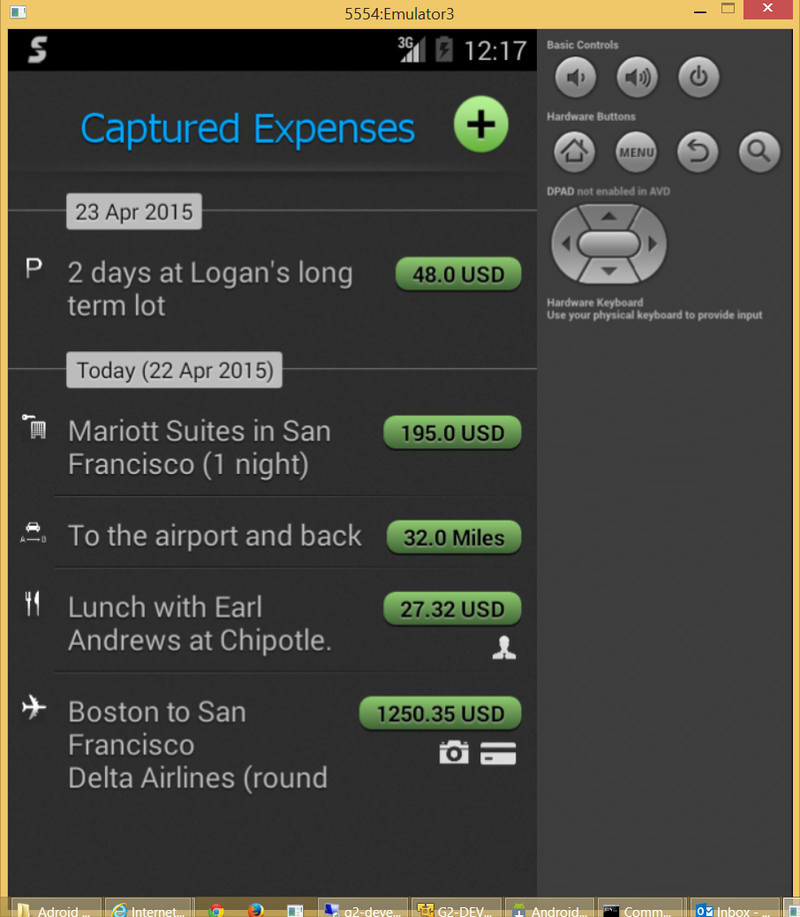
Notice that all expense are monetary amounts with the exception of mileage. The is a “rate based” charge. The user will receive a certain amount per mile (parameter stored on the server).
Also, notice the three small icons below each amount. The “head” indicates a charge billed to a specific project (bill to customer). The camera indicates one or more images are attached. The card indicates a credit card charge. The employee is reimbursed for all expenses which were not charged to a company credit card.

Click the Android Back button to return to the Apps main menu.
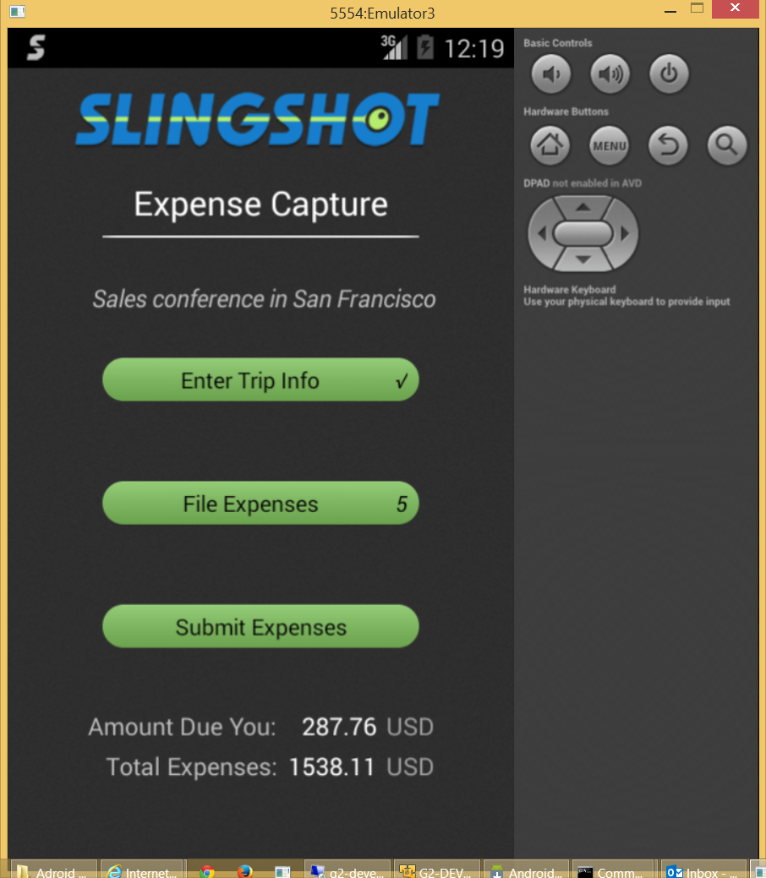
The user can click Enter Trip Info or File Expenses to update this information.

The user clicks “Submit Expenses” to send the expense report to the server for approval and payment processing. The following confirmation box will appear.
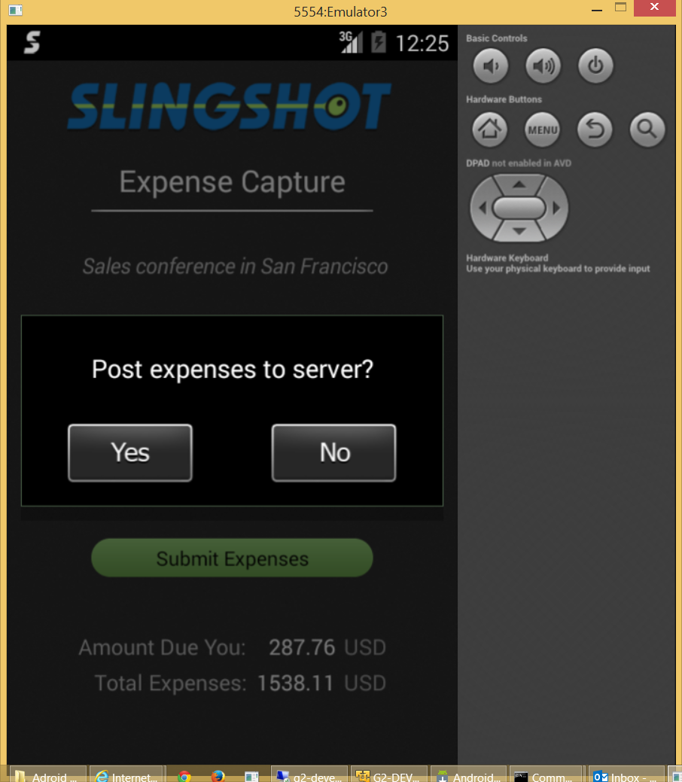

When the user presses “Yes” the report is uploaded and the progress bar (shown below) will appear.
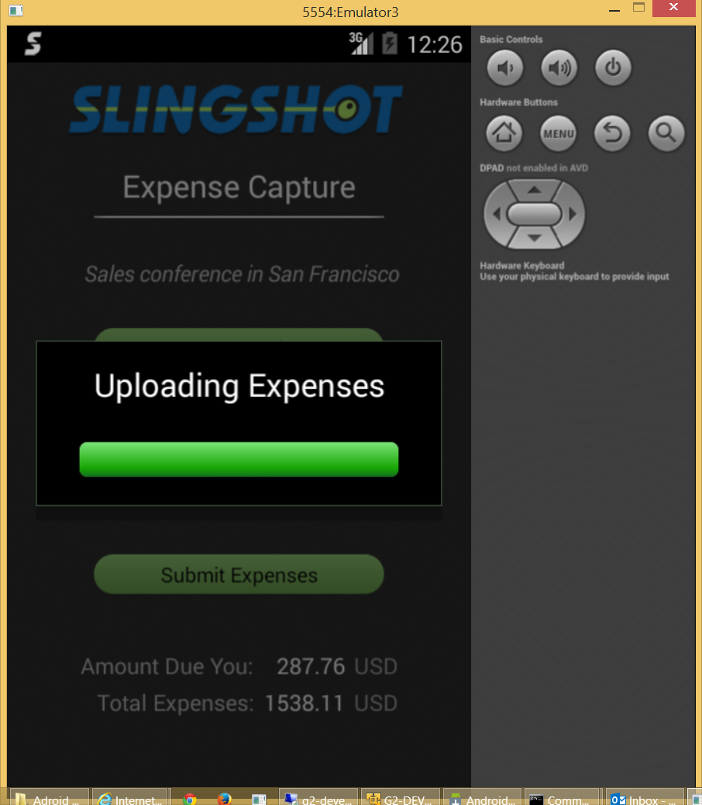

When the expense report has been transferred the menu form reappears.
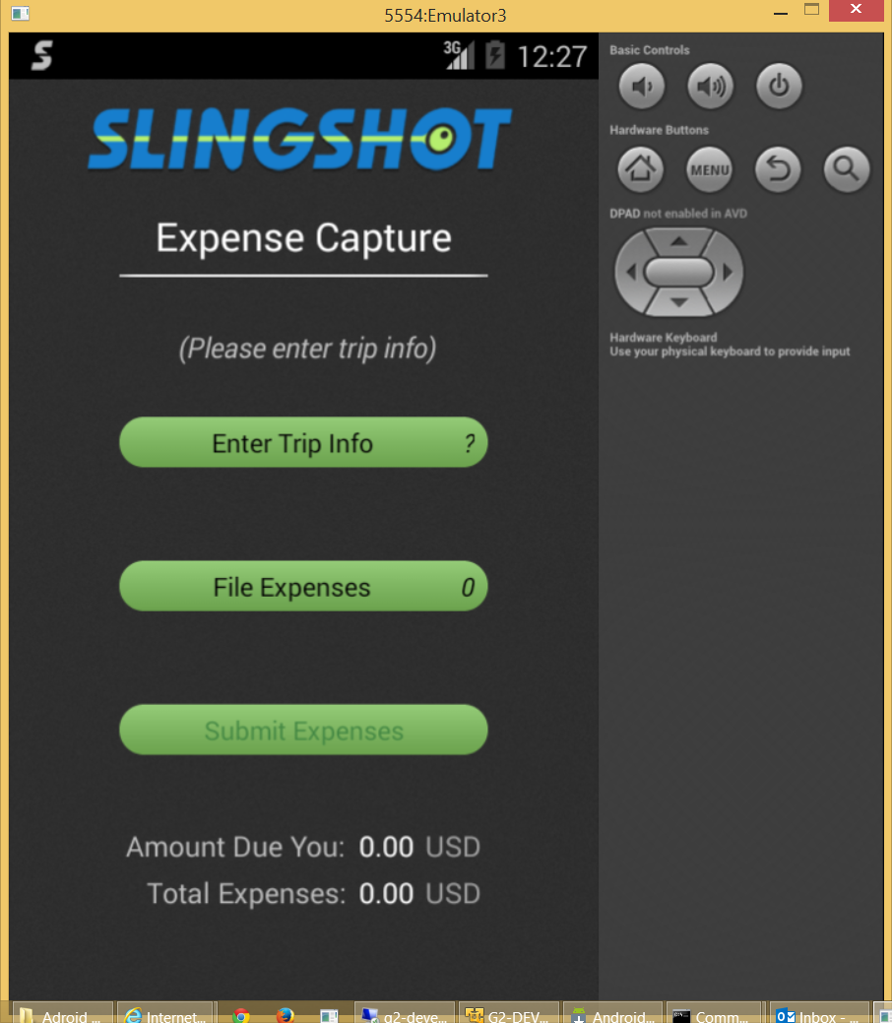

Click the Android menu button and a grey menu panel with “Settings”, “Errors” and “Web” will appear.
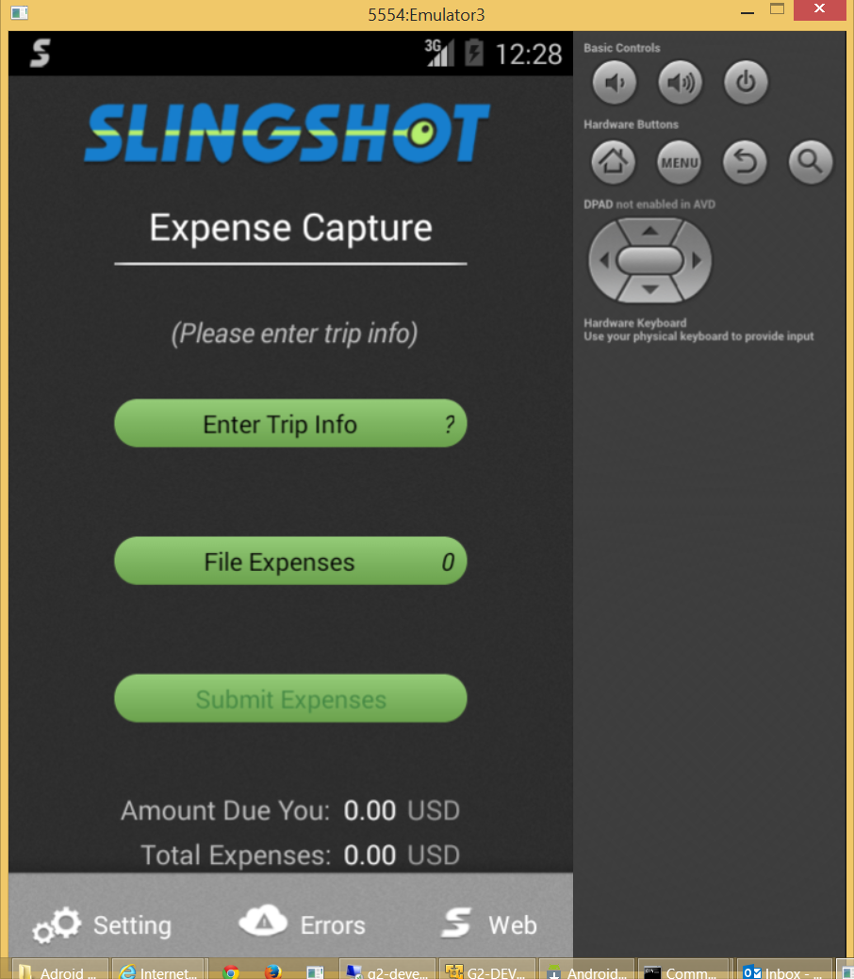

The “Settings” button allows the user to identify the server and his or her credentials. Generally this is only needed if a server is changed or a new version of the application has been installed.
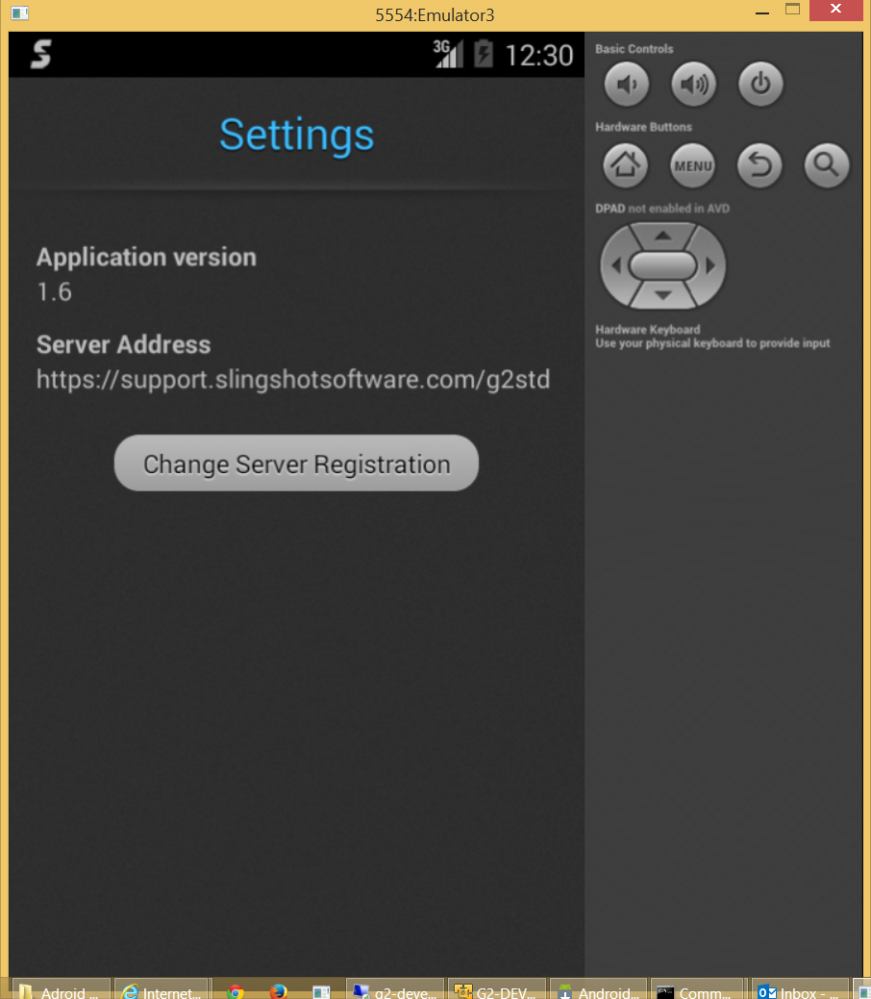

Click the “Change Server Registration” button above and the following form will appear.
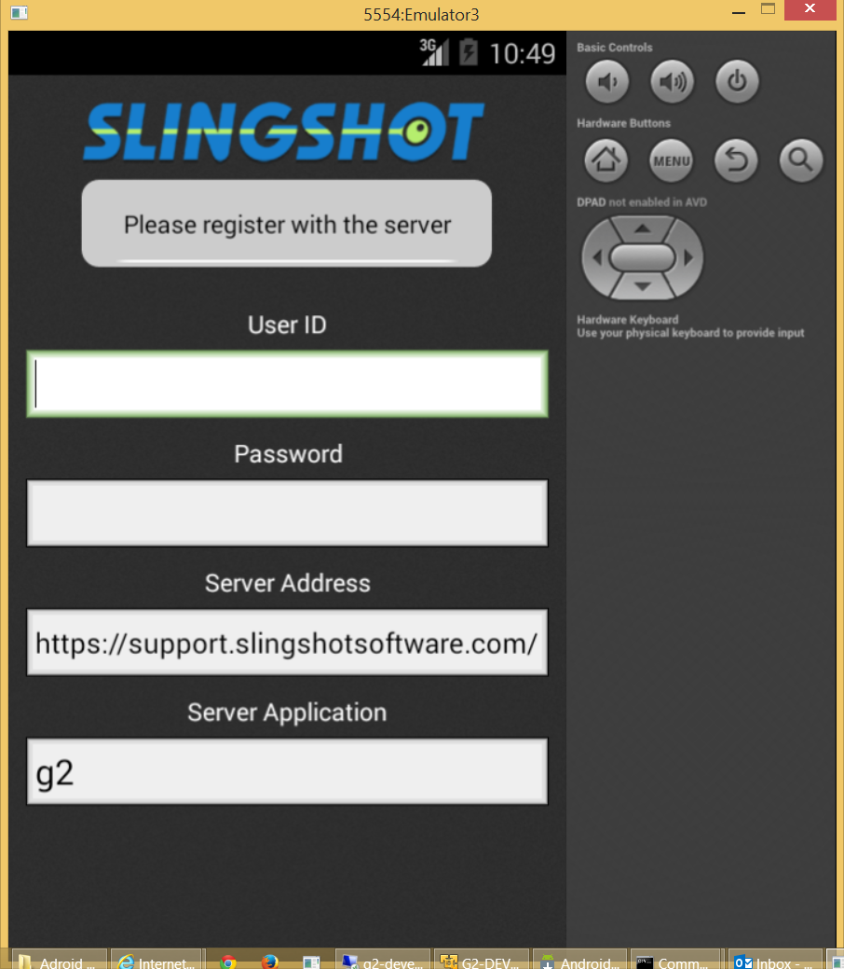

After entering credentials the form appears as shown below. The user taps the green button to sign in.
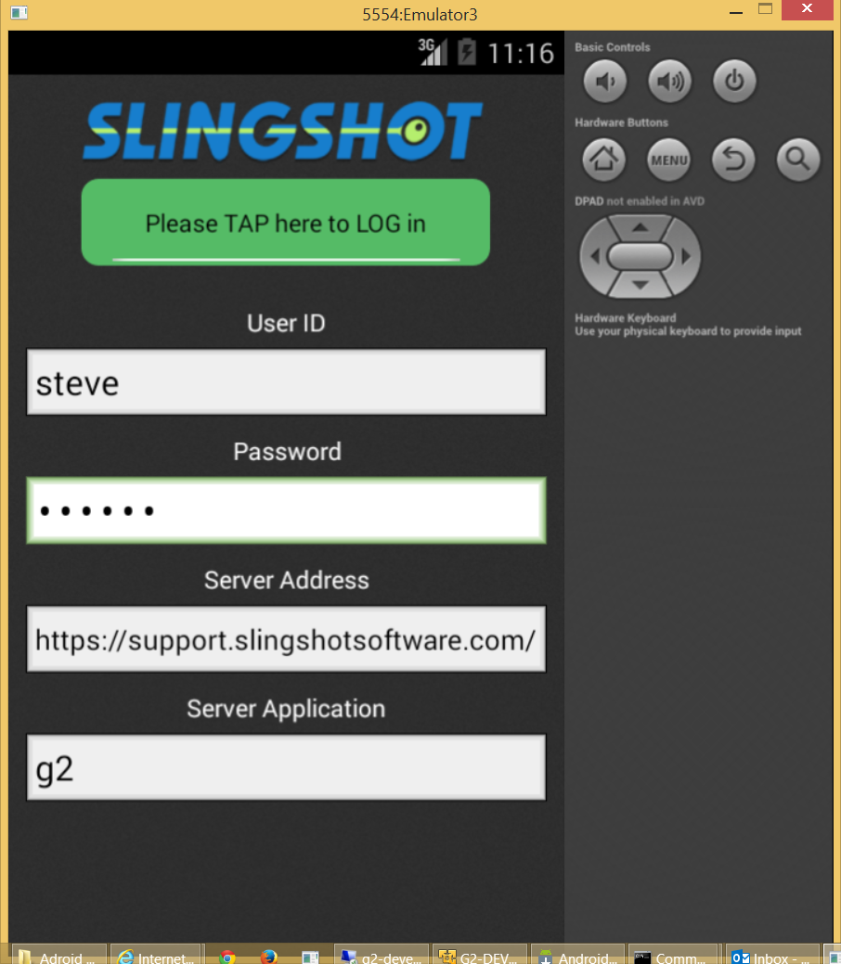

The “Errors” button shows a log of actions transmitted to the server and any errors encountered. None were encountered in this example. The green “OK” button is actually a status (clicking it has no affect).
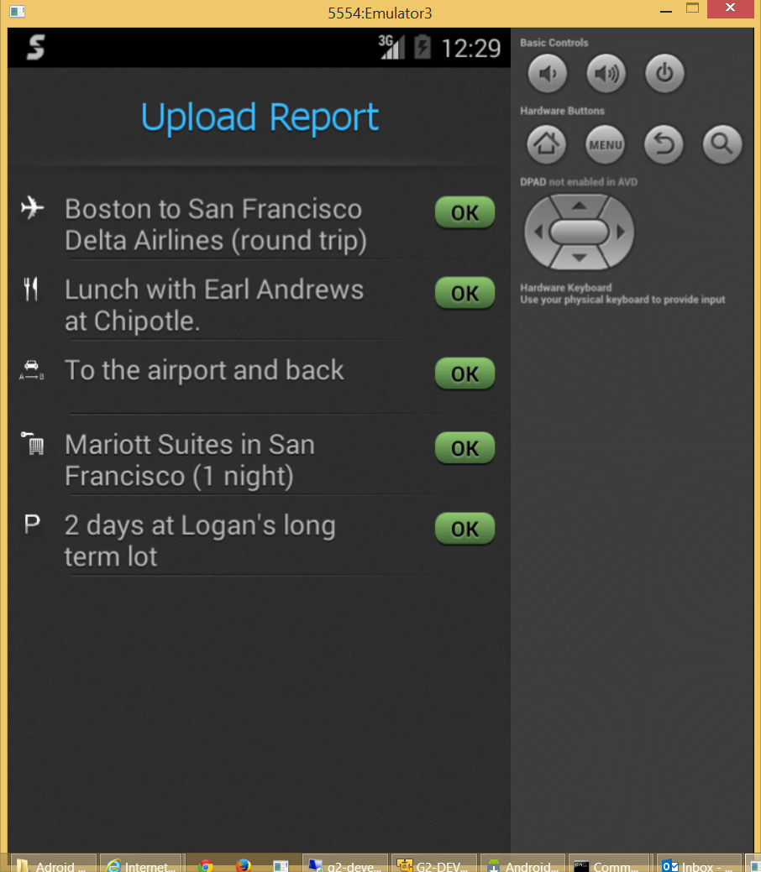

The last button on the menu labeled “Web” links the user to www.slingshotsoftware.com.

