The “Document Approval” mobile application receives documents requiring approval from Slingshot’s procurement applications (material requisitions, purchase orders, supplier invoices and expense reports). The App allows the approver to flip through the documents, review the line items (products and services) and approve or deny approval. These actions take place on the phone and are held there and can be changed until the user submits them to the server. The user receives a notification when a document requies approval. A “widget” (green circle below) atop the approval icon shows the number of documents requiring review.
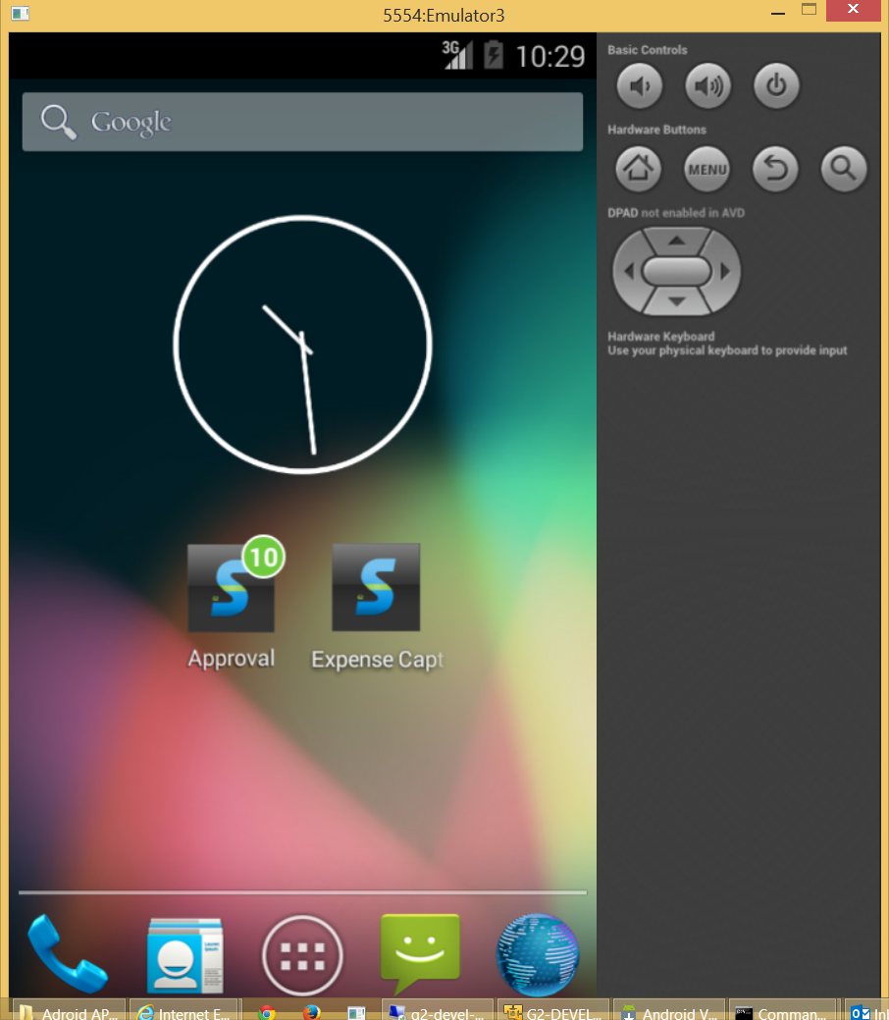

Click the desktop icon and a form appears for one second showing the current version of the application.
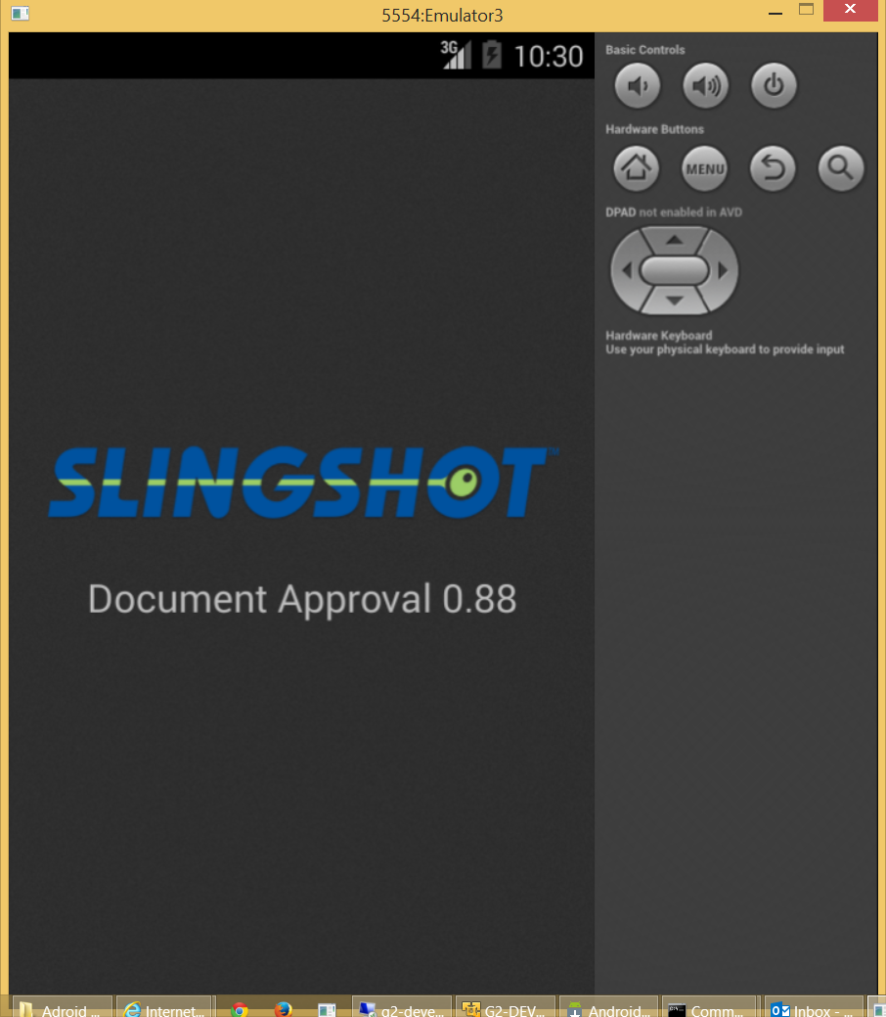

The previous form disappears and the following menu appears. Three buttons allow the user to access documents which have not yet been reviewed (Unprocessed Docs), review actions taken (approval or deny approval) and not yet submitted or, submit actions to the server procurement applications.
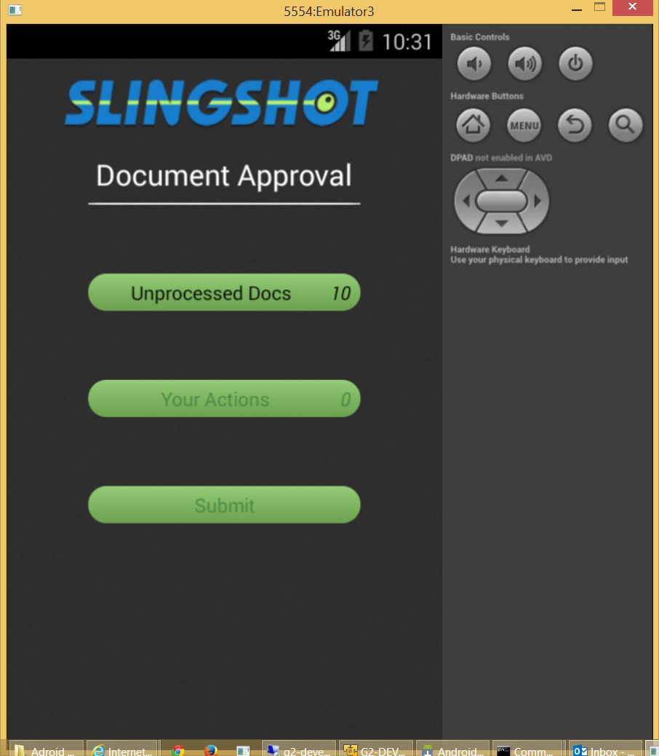

Click the Unprocessed Docs button and the following form will appear. The amount fields below appear to be buttons but are not (clicking has no affect).
There are two slightly different layouts depending on the type of document. The layout below is for purchase orders, supplier invoices and requisitions.
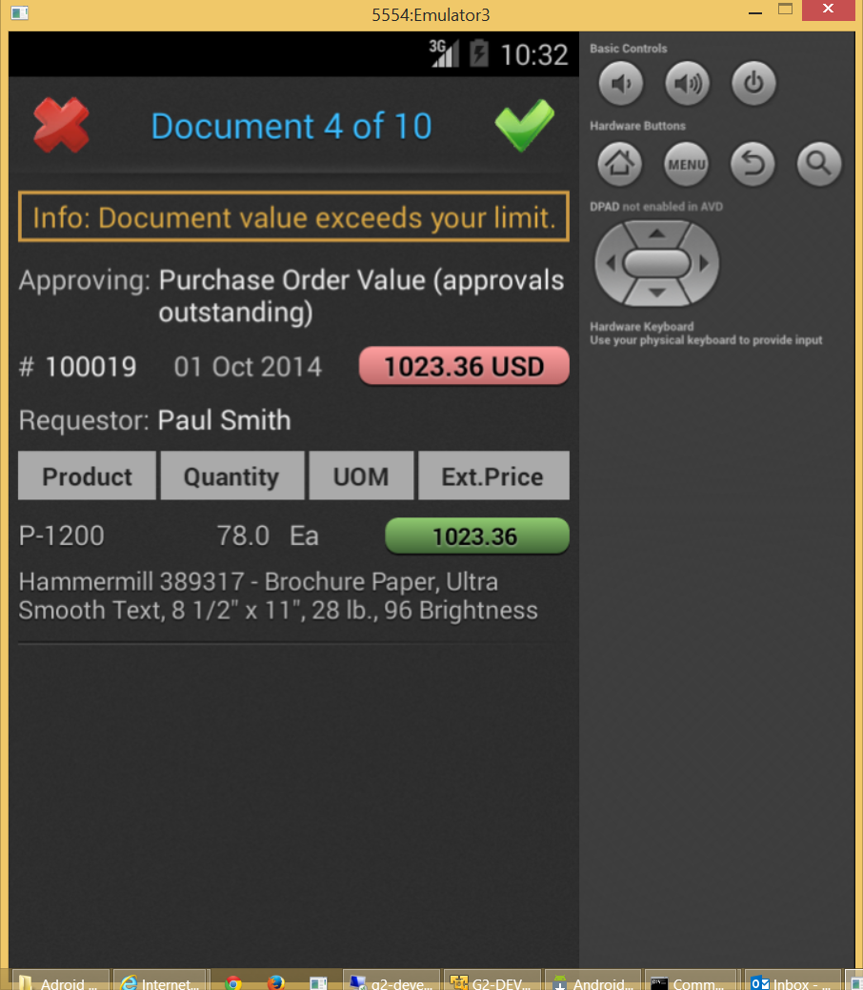
The gold message appears if the value of the document exceeds the user’s maximum. When this is the case another user is approving as well.

The user can swipe right or left to flip through documents.
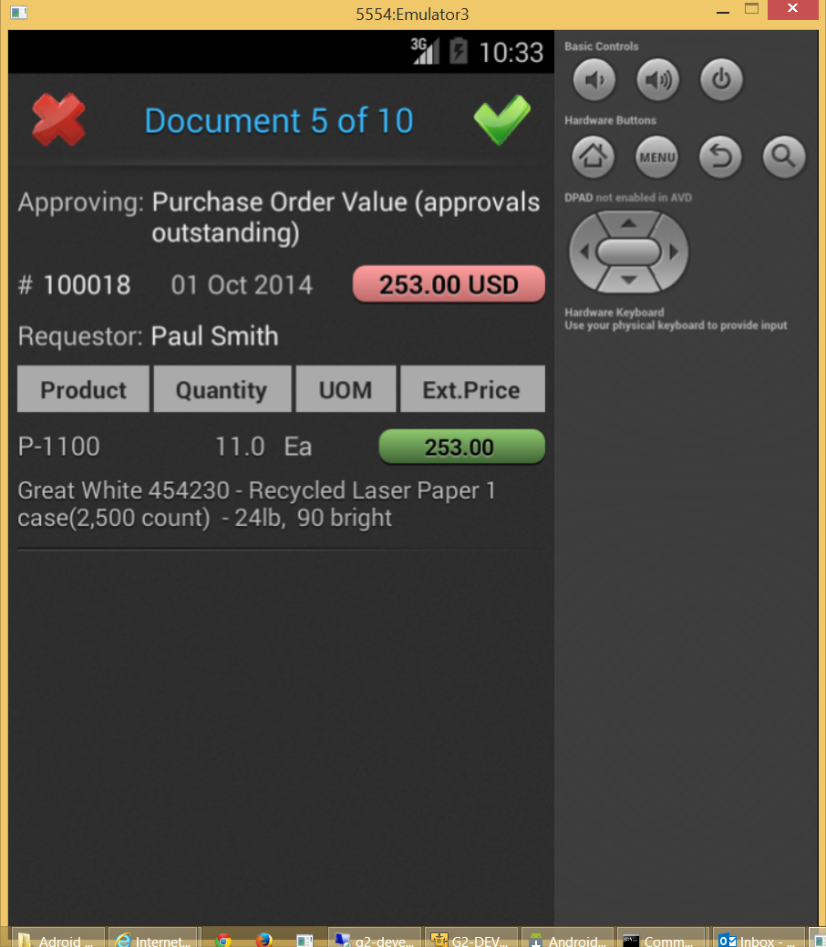

The format below is for Expense Report documents. Notice that the line items are slightly different.
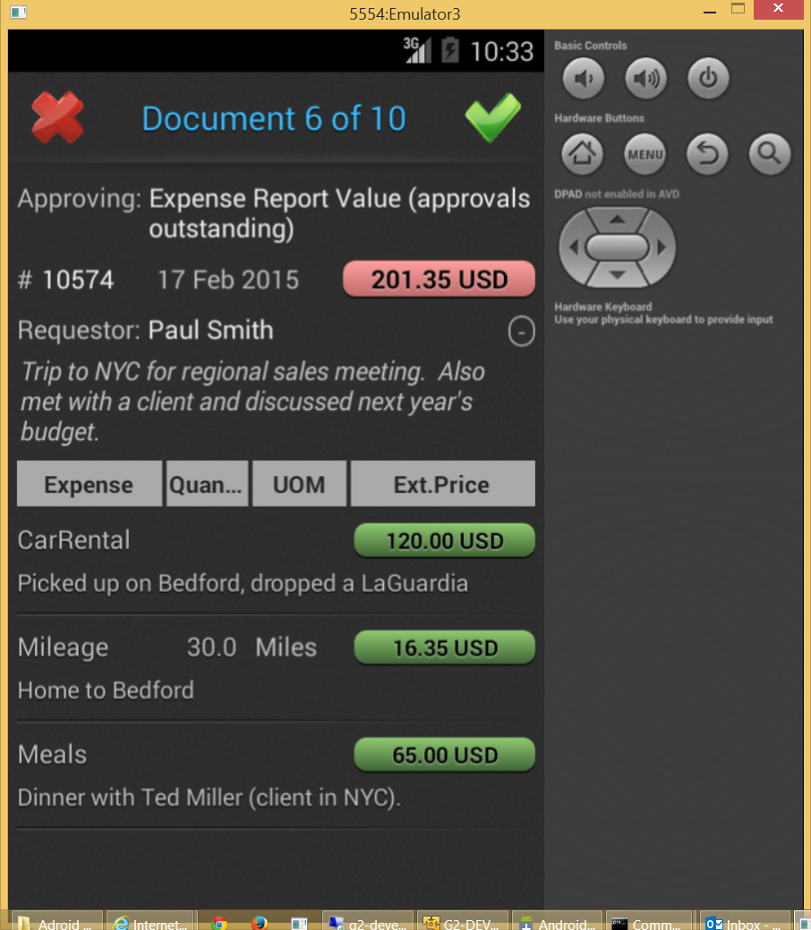

Click the green check mark to approve the document. The next document will appear and the count of remaining documents is decremented. A “toast” at the bottom of the form reports the last action taken (“Document 10575 is approved.”).
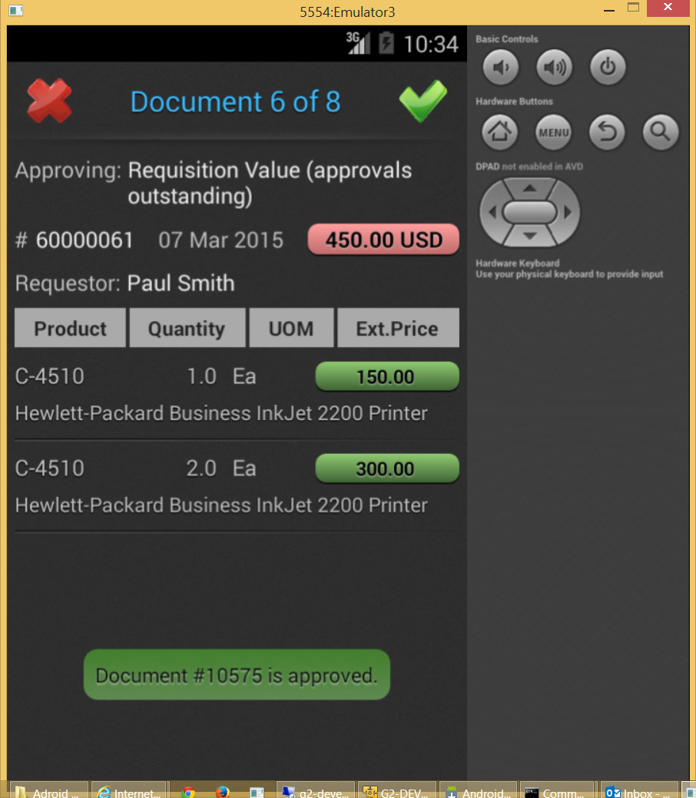

Click the red “X” to deny approval. A panel appears with predefined reasons. The user must select a reason or describe the reason for denying the document in the Text area.
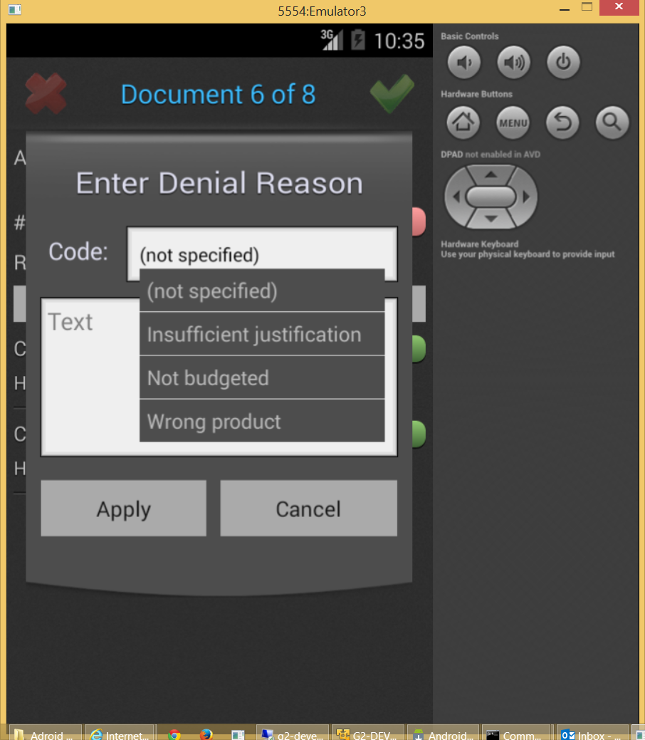

At any time the user can press the Android “back button” to return to the menu. The totals now show 3 actions taken and 7 documents which are unprocessed.
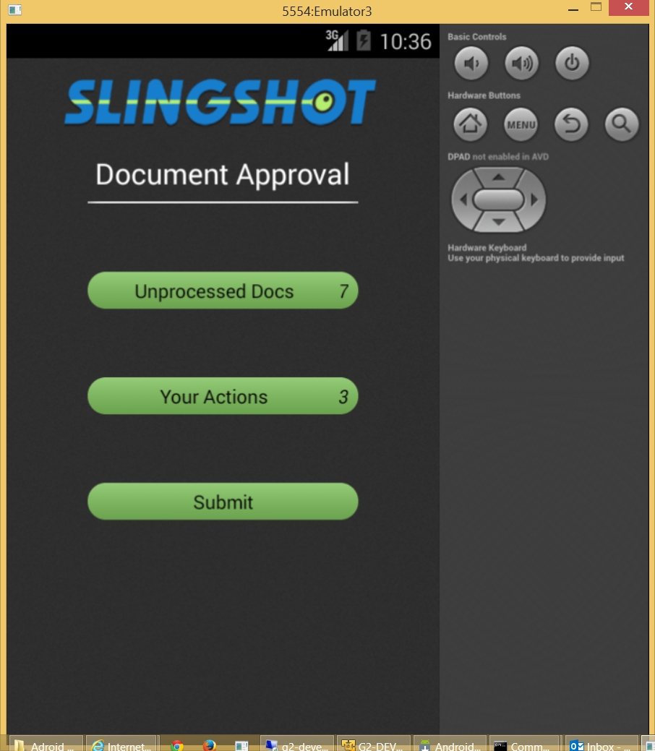

The user pressed “Action Taken” to return to review actions taken but not yet submitted. The “Discard” button removes the action and puts the document back into the “Unprocessed Docs” category.
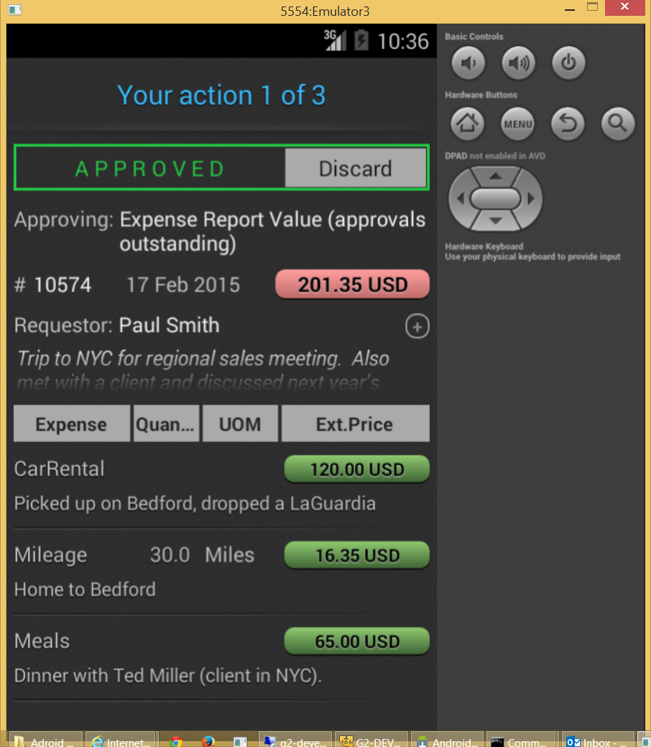

Denial actions can be edited or discarded. The amount fields below appear to be buttons but are not (clicking has no affect).
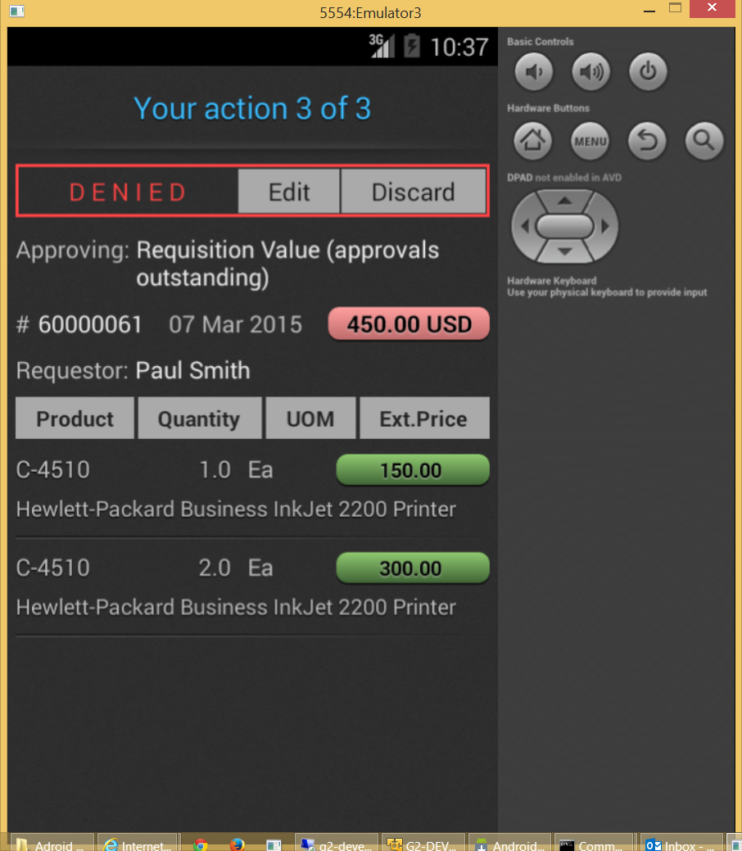

Click the “Edit” button and the denial reason panel appears.
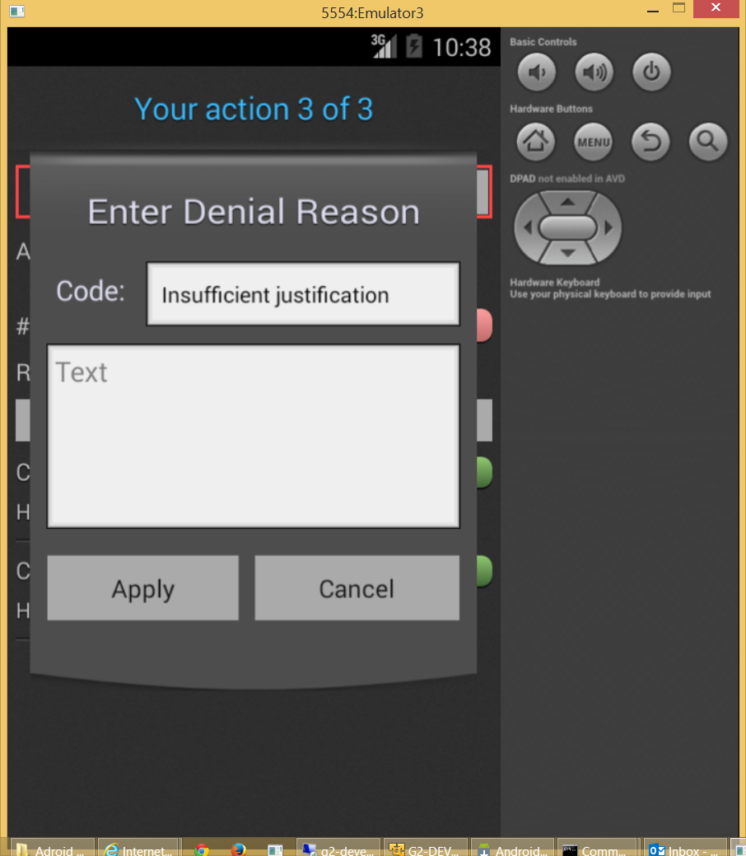

Press Submit on the menu to upload actions taken.
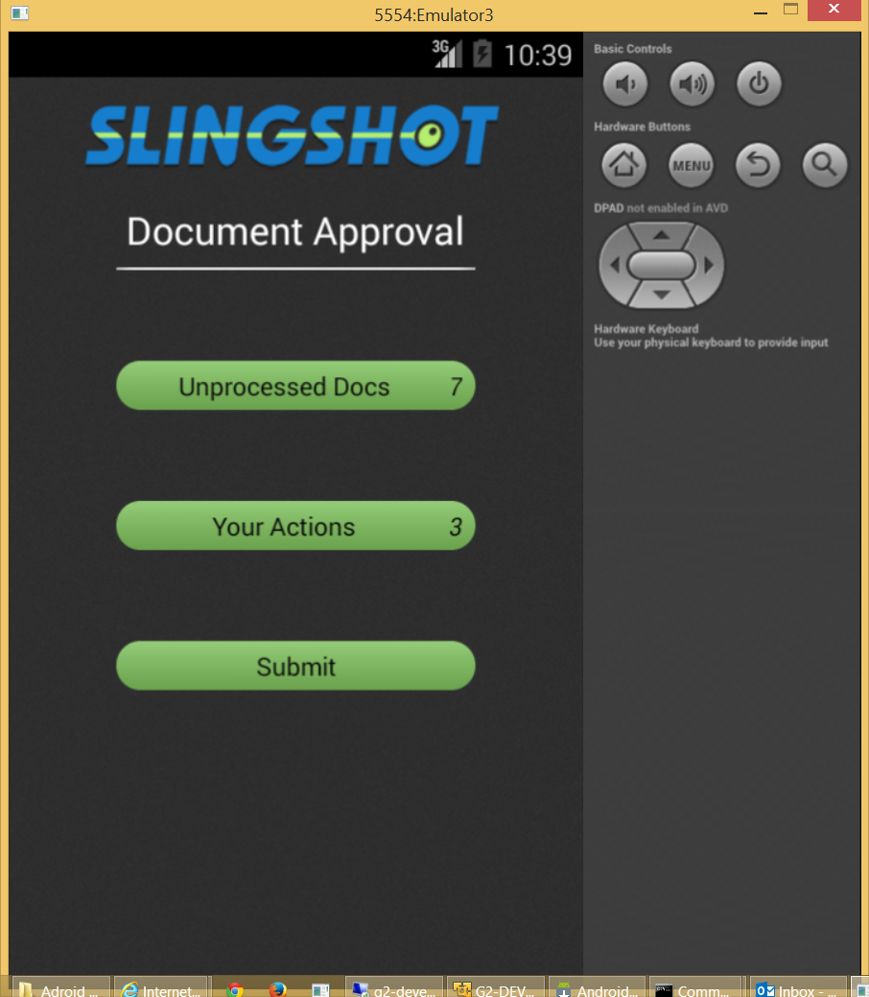

The following confirmation window will appear.
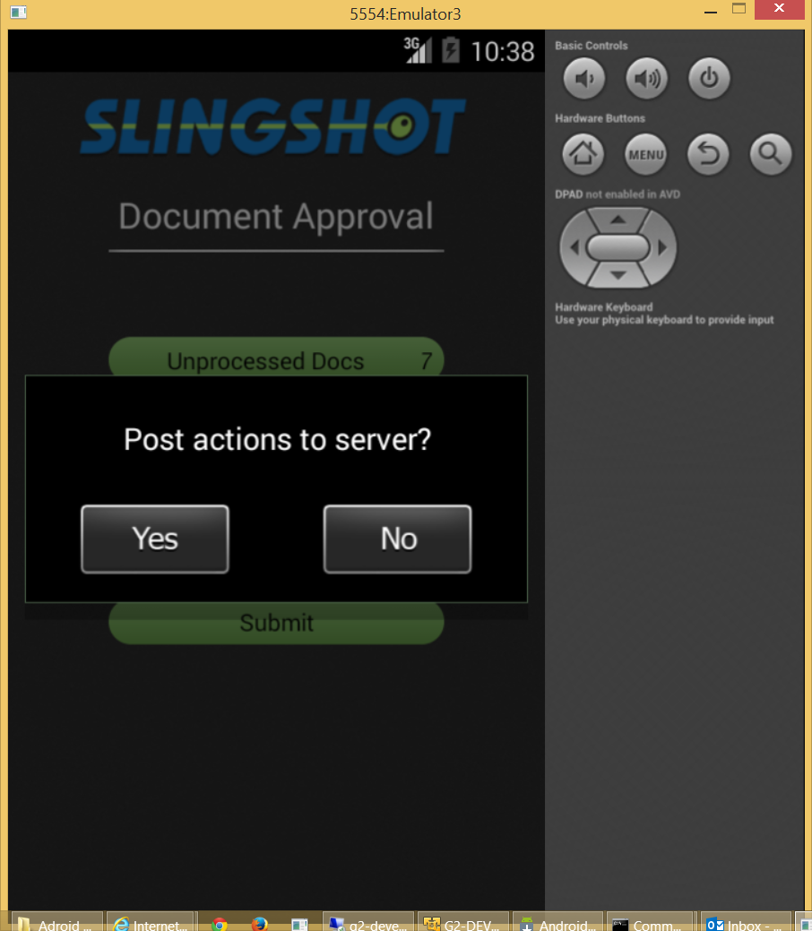

Press “Yes” and a progress control shows the actions being uploaded.
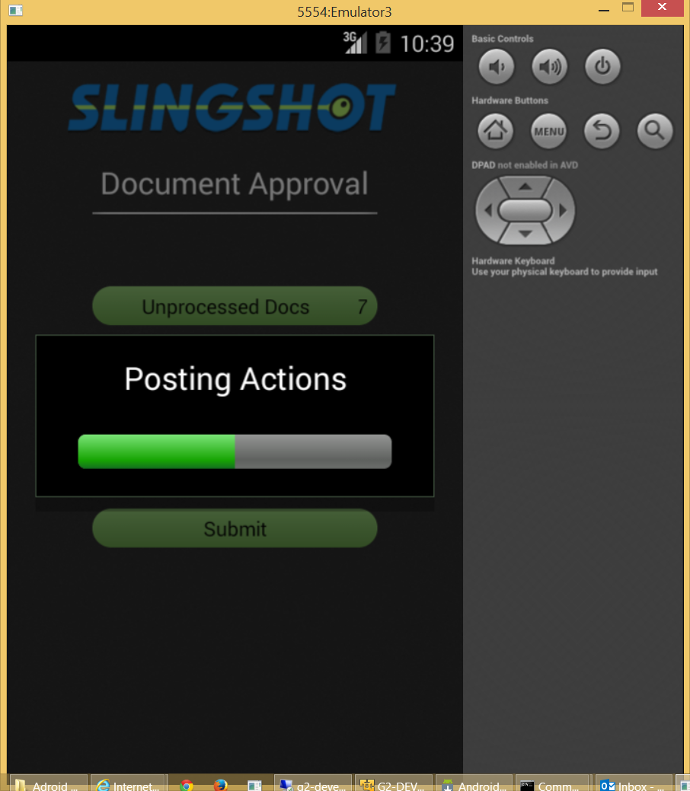

When the upload is complete the menu reappears. Click the Android menu button and a grey menu panel with “Settings”, “Errors” and “Web” will appear.
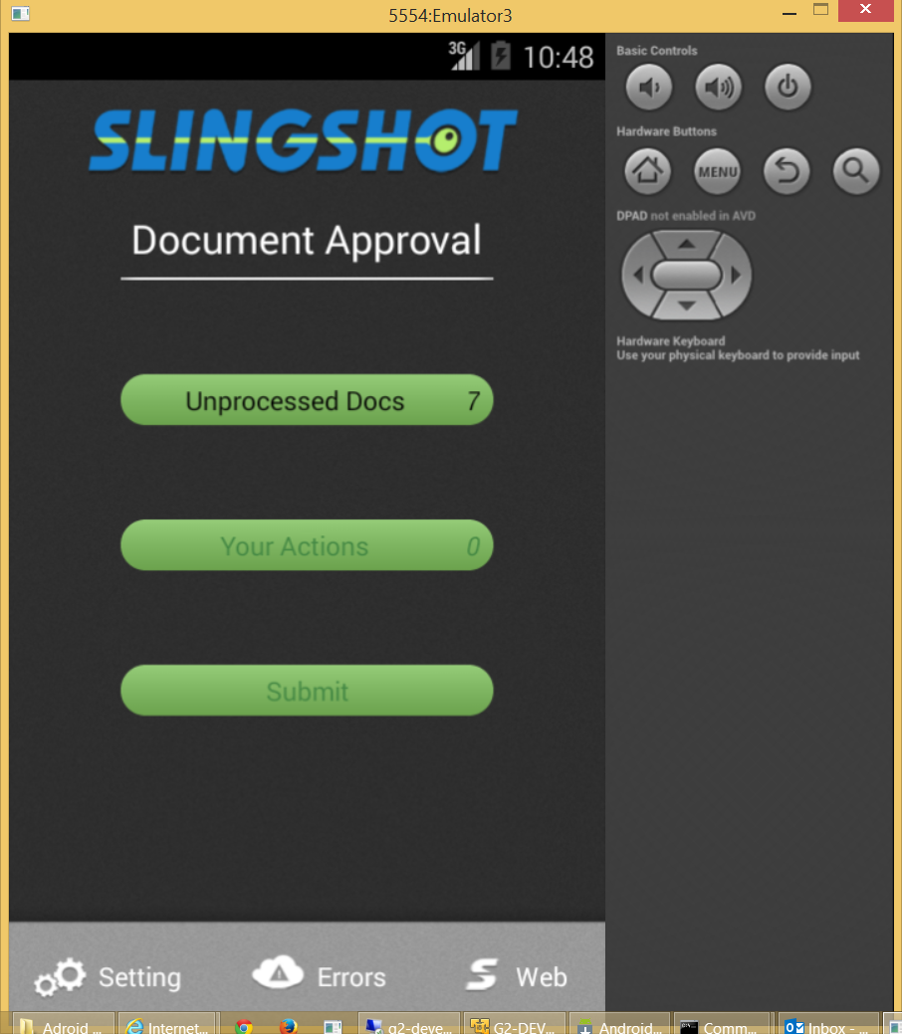

The “Settings” button allows the user to identify the server and his or her credentials. Generally this is only needed if a server is changed or a new version of the application has been installed.
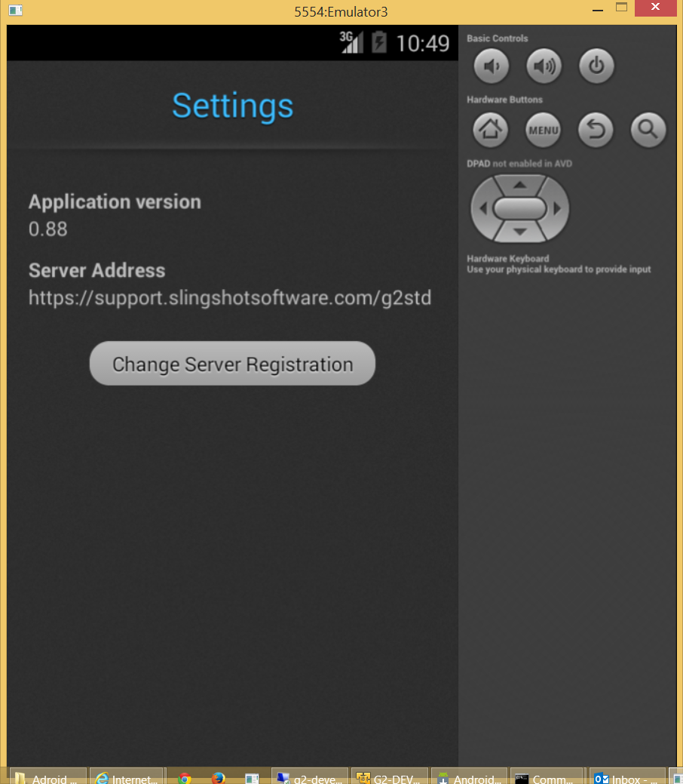

Click the “Change Server Registration” button above and the following form will appear.
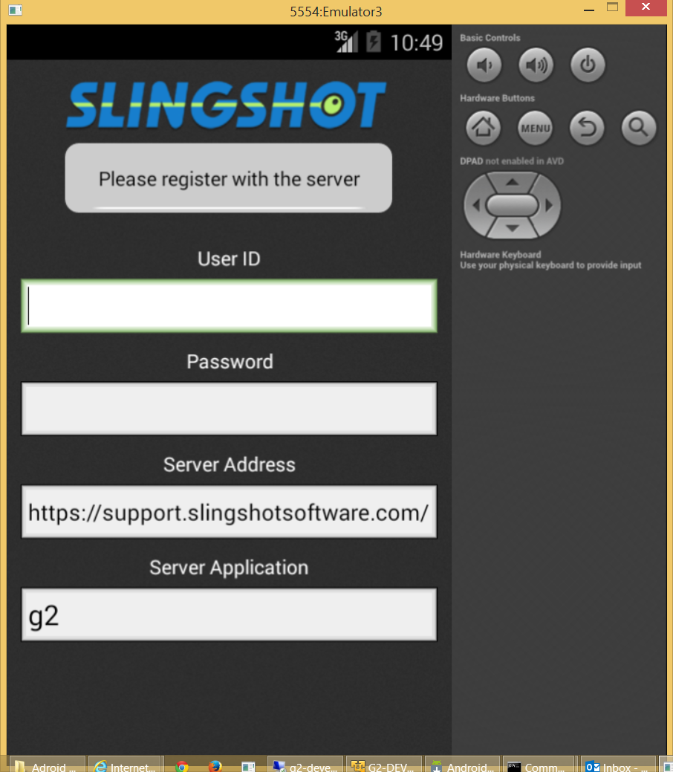

After entering credentials the form appears as shown below. The user taps the green button to sign in.
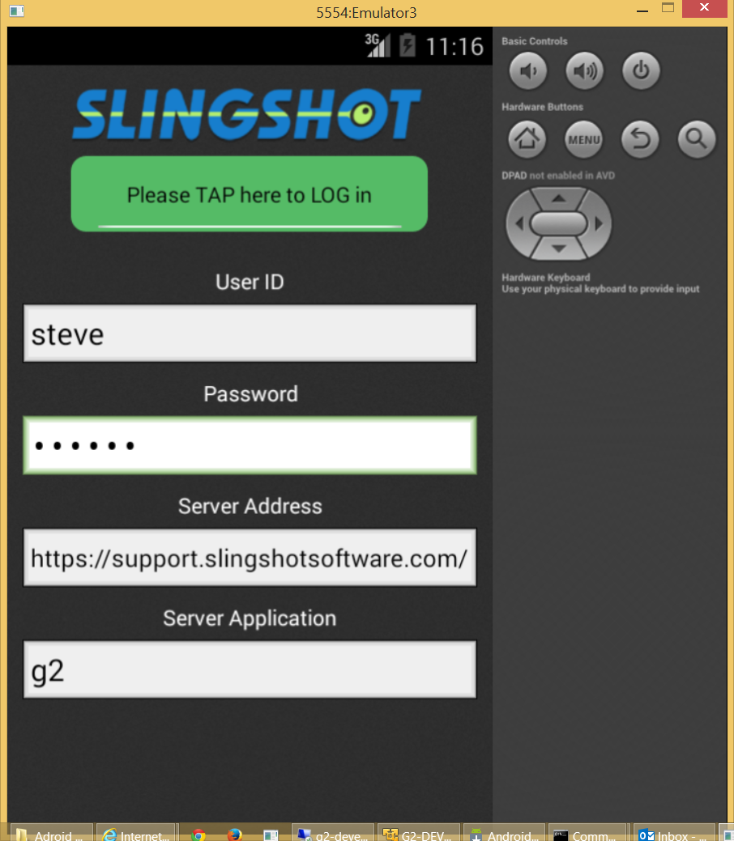

The “Errors” button shows a log of actions transmitted to the server and any errors encountered. None were encountered in this example. The green “OK” button is actually a status (clicking it has no affect).
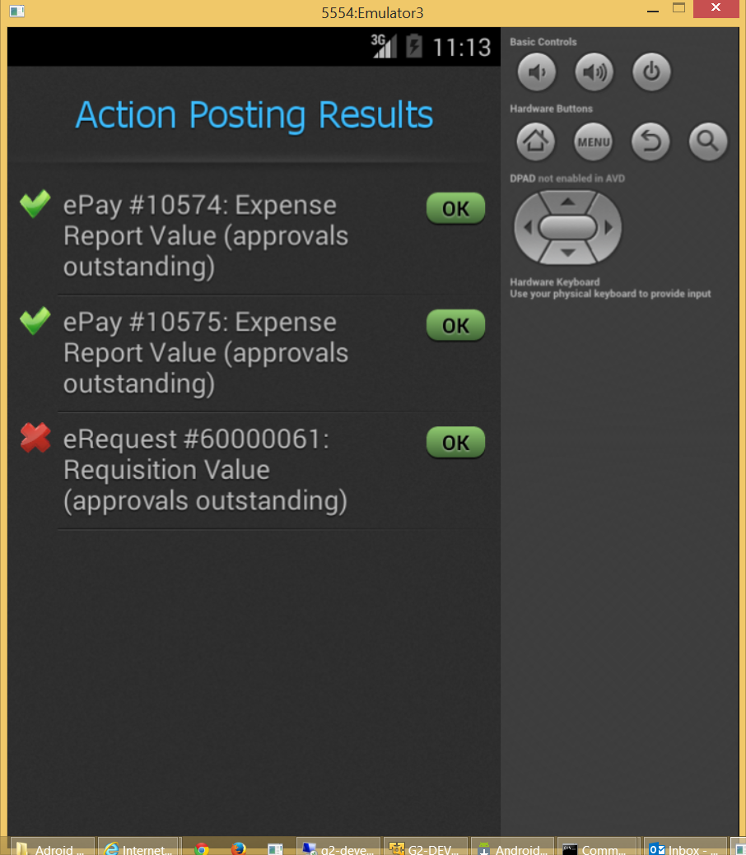

The last button on the menu labeled “Web” links the user to www.slingshotsoftware.com.

