New Zealand Herbal Brew Website Project

Home page
Welcome to New Zealand Herbal Brew, the site of herbal-craft tea blending. We offer a selection of herbal teas that have been blended for exquisite flavour, aroma and interest, and those that are helpful in assisting with common ailments and conditions. Our herbs are organically sourced both locally and internationally with excellence in quality being of utmost importance.

Herbal tea, in one form or another, has been part of many cultures historically. Typically, it was made from whatever was found in our local environment, with its purpose to provide nutritional and medicinal sustenance.

Almost anything can be solved over a cup of tea. When good news arrives we welcome the news with a cup of tea, like-wise when sadness presents itself, we put the kettle on and make a cup of tea; and when we hop in the car and take a trip away we pack a thermos of tea to have on the journey.
Brewing and drinking herbal tea allows us to connect with nature whilst taking time out of our busy lives to re-charge and centre ourselves before returning to reality.

Products page
Below is an example of a products page layout that I think will work well for my products.
Below this image is another image of the ‘detail’ content when you click into a product.

Our Products
Please select from our wonderful range of herbally-crafted, hand-blended teas and tea accessories.
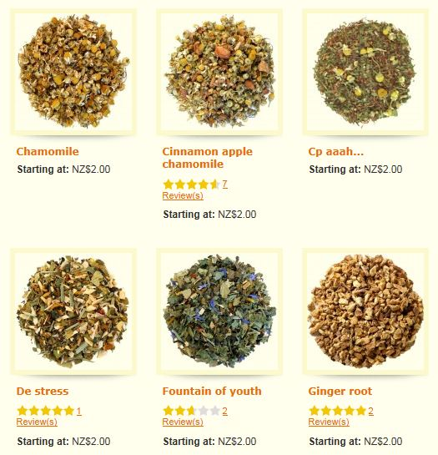

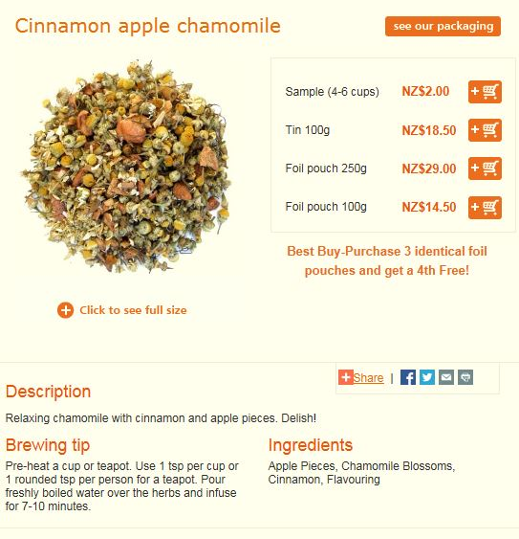

Information page
Page title: “The Craft of Brewing”
Please use the below content for my brewing page.

The Craft of Brewing

Hot Infusions
Infusions are the usual way we brew tea where herbs are left to steep in boiled water for 3-5 minutes. This allows for the flavour, aroma and constituents to be released. The tea can then be consumed either leaving the herbs still in the brew or straining and removing them.

We recommend our teas are brewed by way of hot infusion, although the other methods may be used if you wish. Each method will result in a different tea.

Decoctions
With decoctions, herbs are either placed in a pot with cold water and brought to the boil, or added to a pot with boiling water where they are left to boil for 15-20 minutes. The tea is then strained to remove the debris and consumed once cool enough. A different range of constituents are released through the boiling process, with less aroma, less of the delicate flavours and more bitterness.

Cold Infusions
Cold infusions are where the herbs are left covered, in cold water, overnight to allow the constituents to be released. This is more typically used for mucous-containing fresh herbs that are not suited to heat extractions. The tea is then strained and consumed at room temperature within a day of making.

Contact us page
This is an example layout for the contact us page.

Contact us

Should you wish to contact us, please do so by completing the below contact form. All enquiries are welcome.

Name*

Phone Number

Email Address*

Message*

reCAPTCHA

Type the text
Privacy & Terms

*Required fields

