Brief

I have current installed the Avada theme onto my IPage hosted website. It’s the launch of my company so doesn’t have an existing site. I would like to keep the existing theme unless there is a good reason not to.

I would like to be able to modify content easily and for the site to be not overly complex to manage on a day to day basis

The colour schemes should represent the brand found in the attached files (shown below)

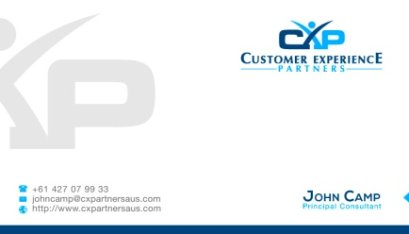

Company Introduction
Customer Experience Partners (CX Partners) is a consulting company focused on Customer Experience and Contact Centre Solutions. We are small (a few people) but we bring teams together for projects that have expertise in what is required
Why Organisation Use us
NO Bullshit Consulting, pragmatic advice, straight forward answers
We are technology experts, but not technology geeks. We don’t care that it’s cool technology, we care about the changes it can make to Customer Experience and to your bottom line. We not only know who does what in the market, we know how good they are, how good their last projects were and who their channel is and how good their channel is. We spend our time knowing this stuff so you don’t have to.
We are operationally focused, all of our consultants have spent time in delivery roles within the contact centre front line. We understand the business, not just the technology.
The team at CXP is experienced in all major industry sectors as well as government. This means that you aren’t getting a consulting engagement from people that have been entrenched in one single business for the last 12 months and are no longer market connected. We are passionate about Customer Experience and we deliver on our commitments.
Our key focus is on strategy, business improvement and transformation particularly in front and back-office, high volume complex operational environments. We understand that positive customer experience is beyond front-office moments of truth, it requires an end to end focus that safeguards ease of customer experiences.
Contact Centre Services
- Strategic Operational Review
- Contact Centre Benchmarking
- Current State v Future State Technology Analysis
- Cloud Readiness Assessment
- Caller Intent Analysis (understand why your customers are calling you)
- Self Service Strategy Review

Objectives of Website

Main objectives of the website is to inform potential customers about what we do and provide more detailed information (whitepapers etc) to them.

I will be blogging from the website & using twitter and facebook to drive customers to the website where they can download material.

The goal of the website will be to ask customers questions such as

“Do you feel like you are paying for a Ferrari of contact centre solutions but driving it like a Prius, but without the economy?”

“Are you confused about which contact centre solution might be the right one for you?”

“Are you letting your service provider or vendor drive your technology or contact centre decisions”

“Do you need pragmatic advice on how to accelerate your contact centre maturity?”

Behind each of these will be more detail about how we can help them answer these types of questions
The objective is for the website to promote the thought leadership we have in the contact centre and customer experience industy

3. Key Audiences
- Prospective customers or clients
- Contact Centre Managers
- Customer searching for contact centre solutions
- Customers searching for benchmarking capabilities
- Existing clients
- Members of the press
The other key objective is to get customers to sign up to our monthly newsletter

4. Provisional site structure

While I’m sure this will change during the process to begin with it needs to have the following

Home Page

Services

Partners

Blog

Get in Touch

The home page should have an easy graphical way to outline our solutions (for example, but not necessarily how it will look)

Front

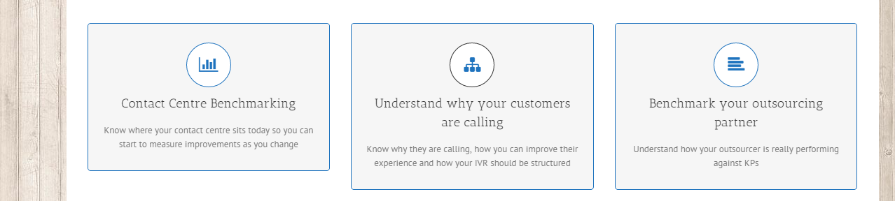

When hovered over

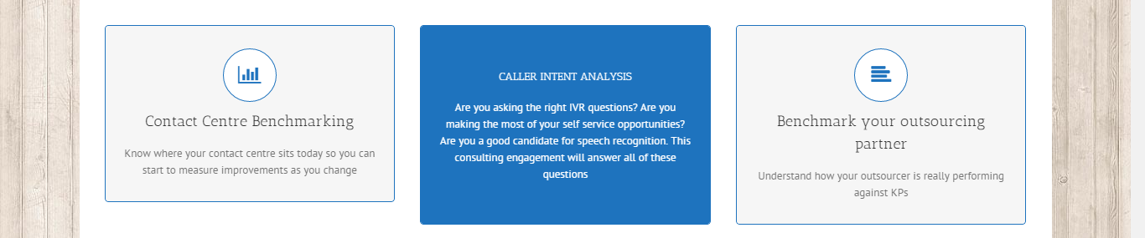

When clicked on it might drive you a more detailed description

7. Websites I Like

8. Who are you competitors?

https://limebridge.com.au/
https://ethangrou.com.au/
http://ccaction.com.au/
http://www.strategiccontact.com/
http://www.qualityconnex.com/consulting/

