Requested Changes
Some of the changes are corrections while others are needed modifications.
I am very pleased with the work done so far and I am looking forward to seeing the graphics samples that have not yet been provided.
Graphic #1 Finding the missing pieces of the prophet puzzle pg 93
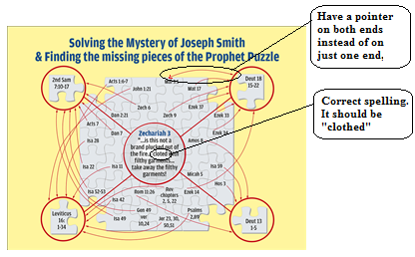
Graphic #2 Fifteen Year ministry of the prophet Joseph Smith (pg 148, 239)
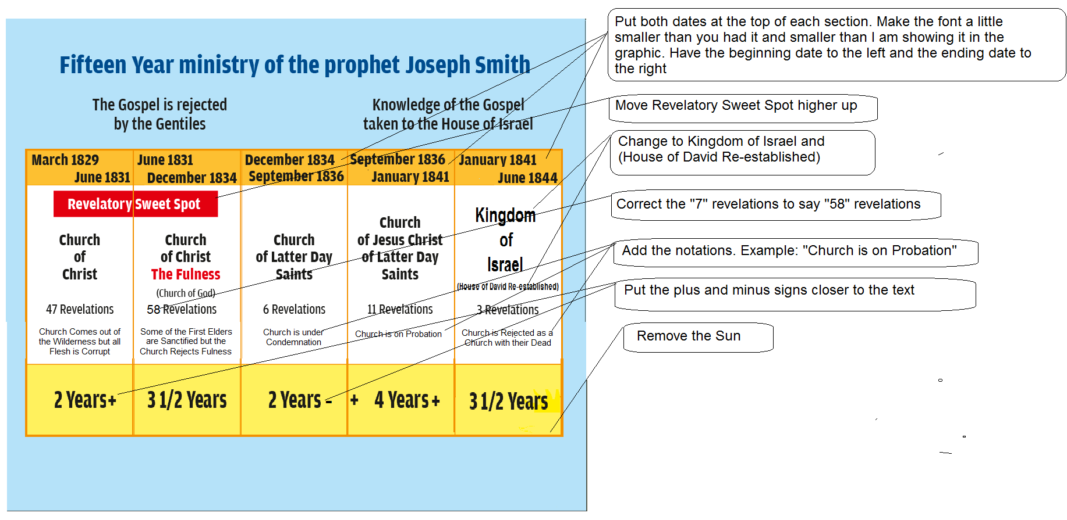
Here is your last graphic for comparison purposes
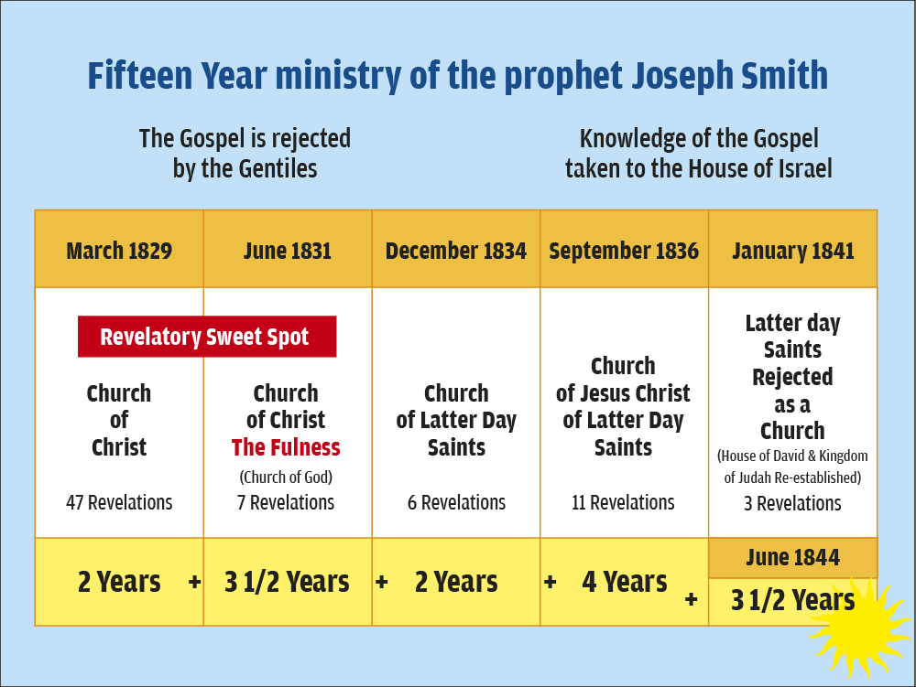
Graphic #3 true doctrines taken away pg 161
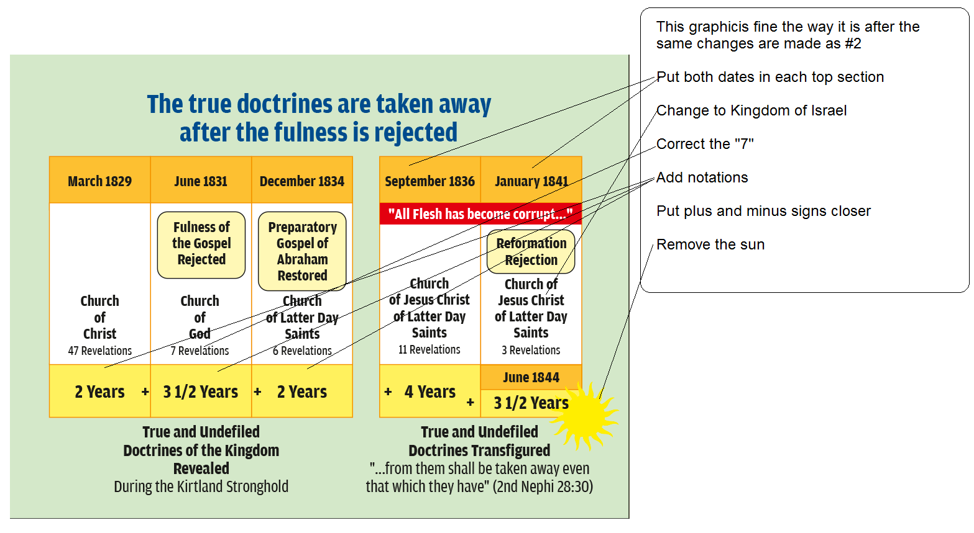
Graphic #4 three watches pg 124

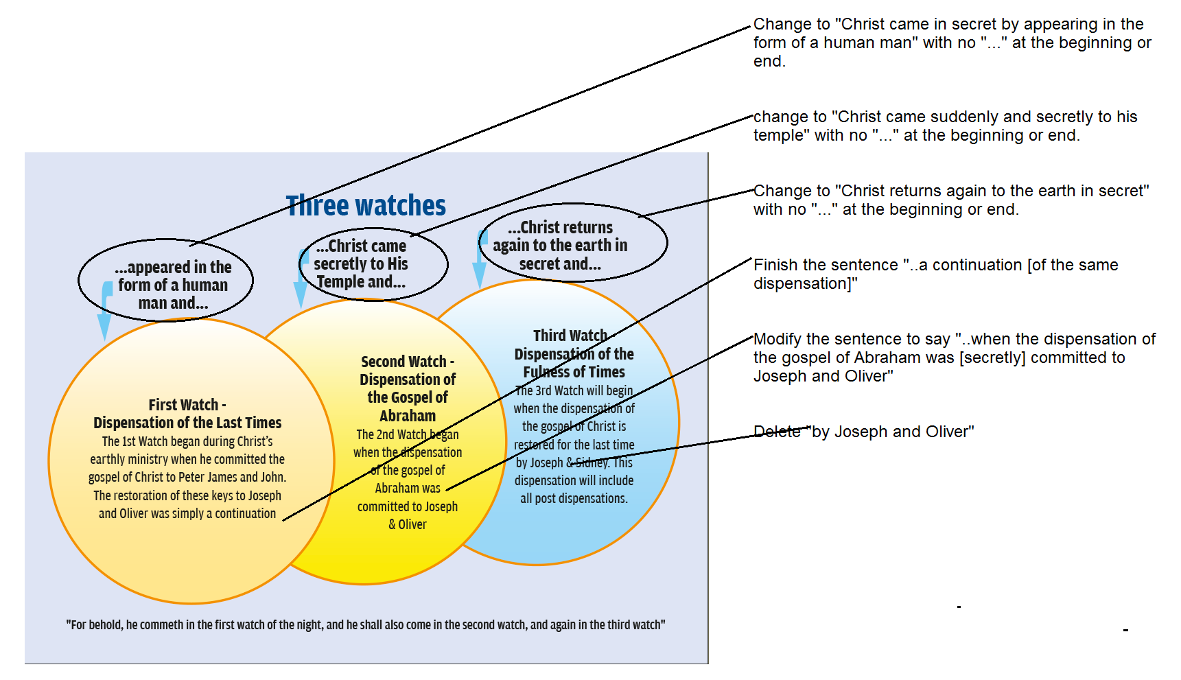

Graphic #5 Gospel taken from Gentiles to House of Israel Pg 238 287

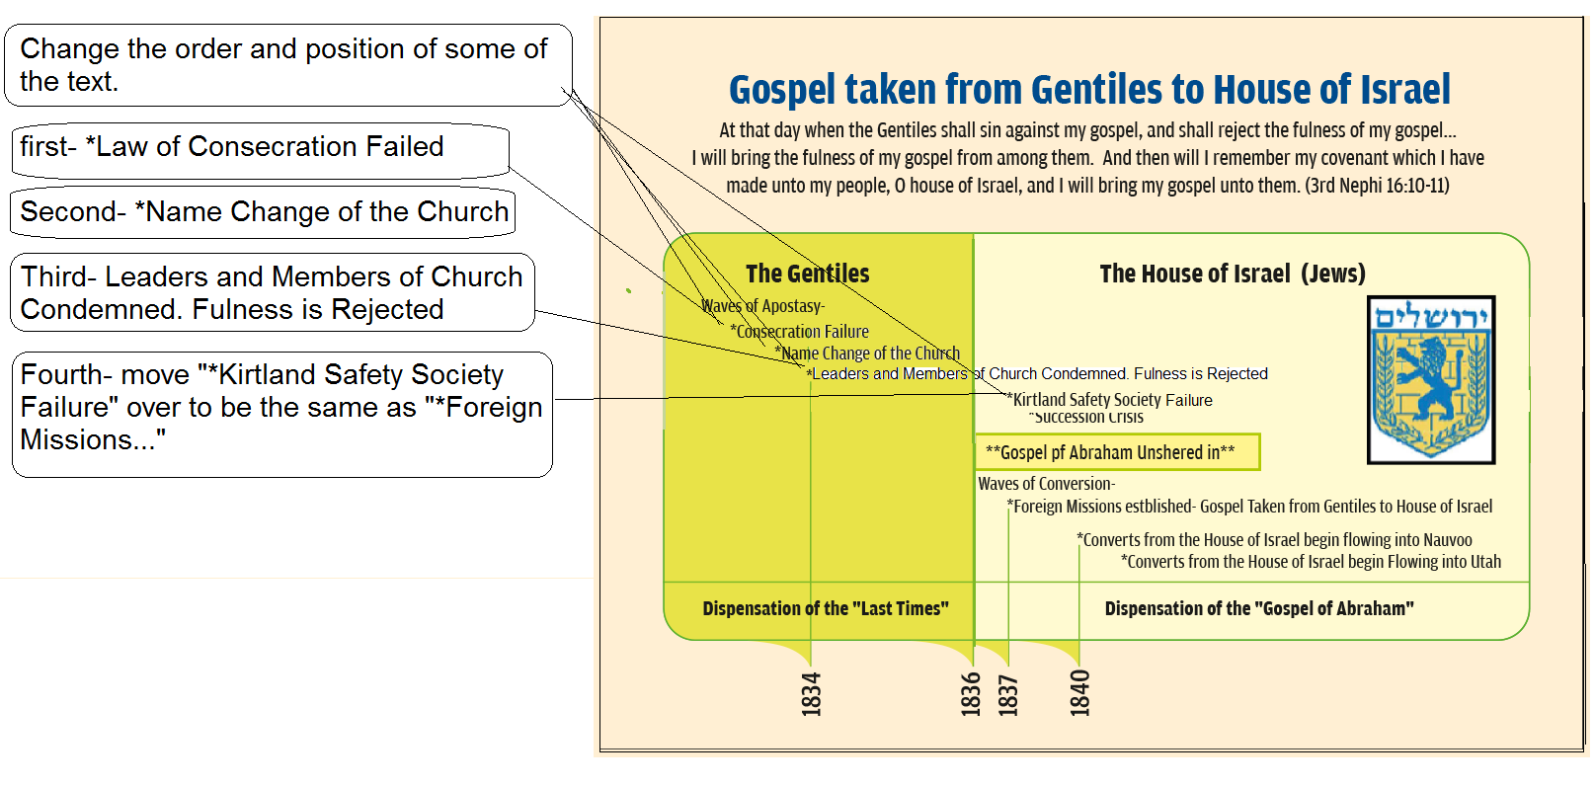
For comparison
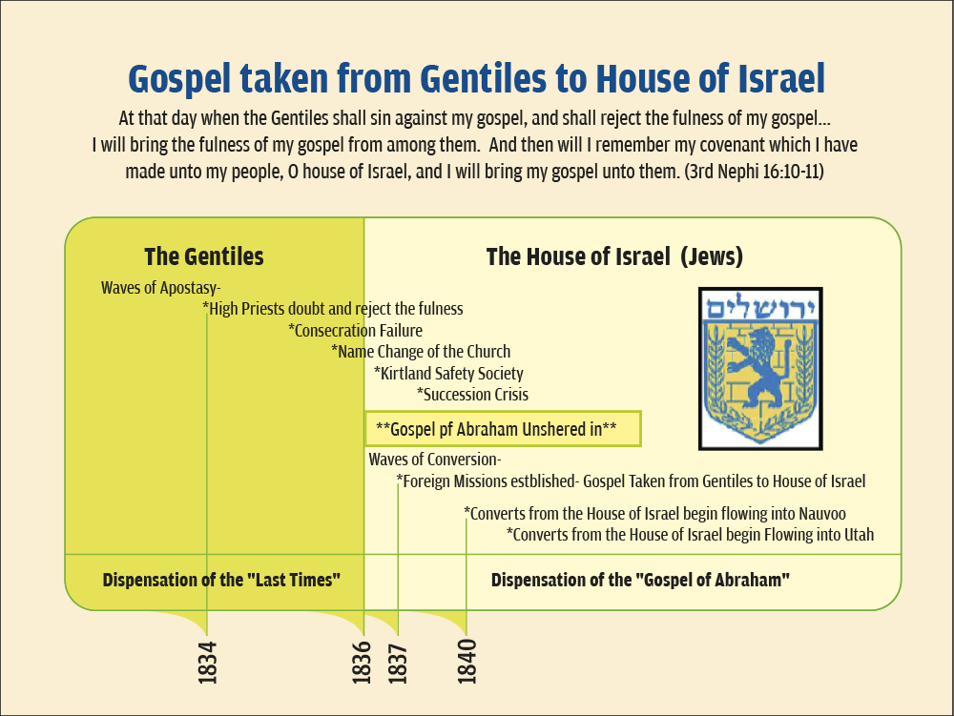

Graphic #6 Gospel of Abraham Restored pg 245 291 424

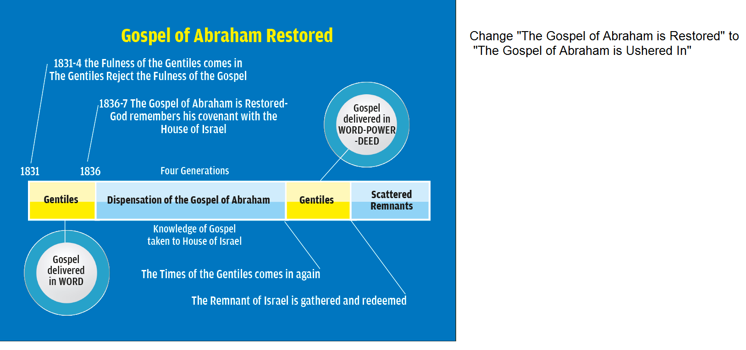

Graphic #7 John the Baptist is Elijah page 335
still waiting for sample
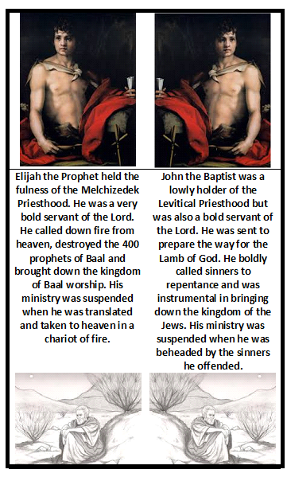

Graphic #8 Countless Sections of D&C testify of Section 110 page 347
Still waiting for sample
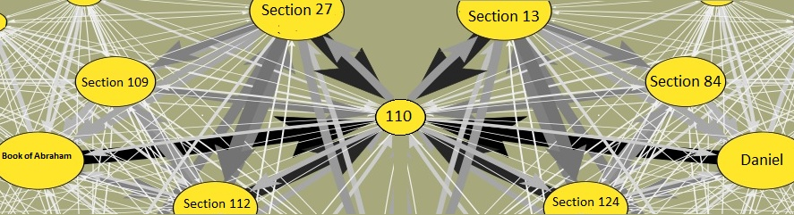
Graphic #9 Joseph Smith is the Marred Servant page 540
Still waiting for sample
