Graphics to be done

To be used in a power point and also a book
I am getting ready to publish a book composed of blog posts that I have written. In the blog posts I have used graphics that I have created from paint or modified from graphics taken from google images. For the book, I want all of the images to look more professional consistent looking. I also need to avoid copywrite issues.
I need the graphics to be provided in several formats including one the can be used in paint so that they can be cropped for various purposes. (the page numbers are for my reference in remembering where the graphic will go in the book)onl

No need to do sample of your work for all nine graphics below. I only need a few examples to make a decision

Graphic #1 Finding the missing pieces of the prophet puzzle pg 93

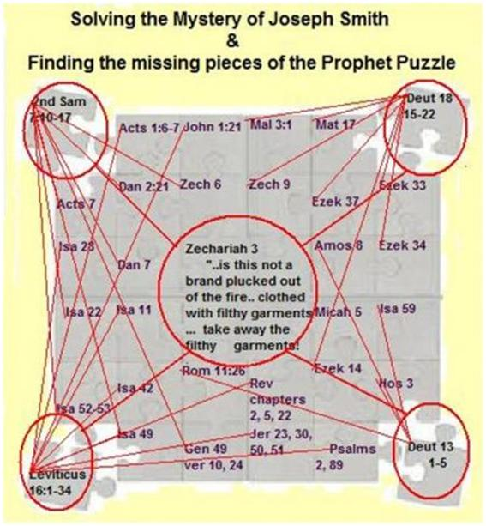

Graphic #2 Fifteen Year ministry of the prophet Joseph Smith (pg 148, 239)
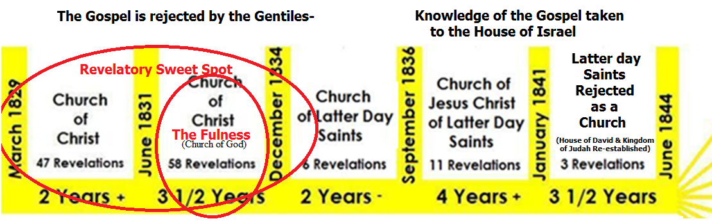
Graphic #3 true doctrines taken away pg 161

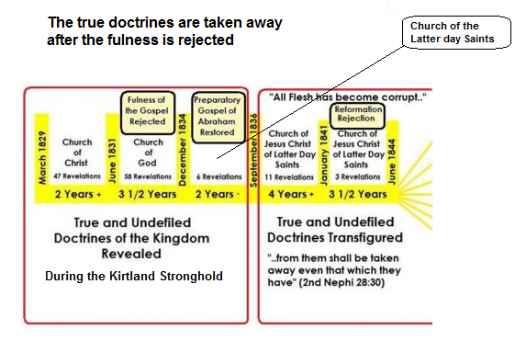

Graphic #4 three watches pg 162

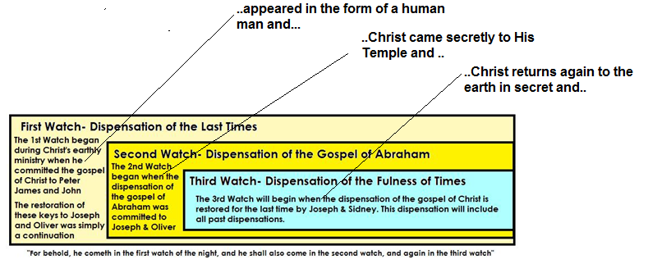

Graphic #5 Gospel taken from Gentiles to House of Israel Pg 238 287

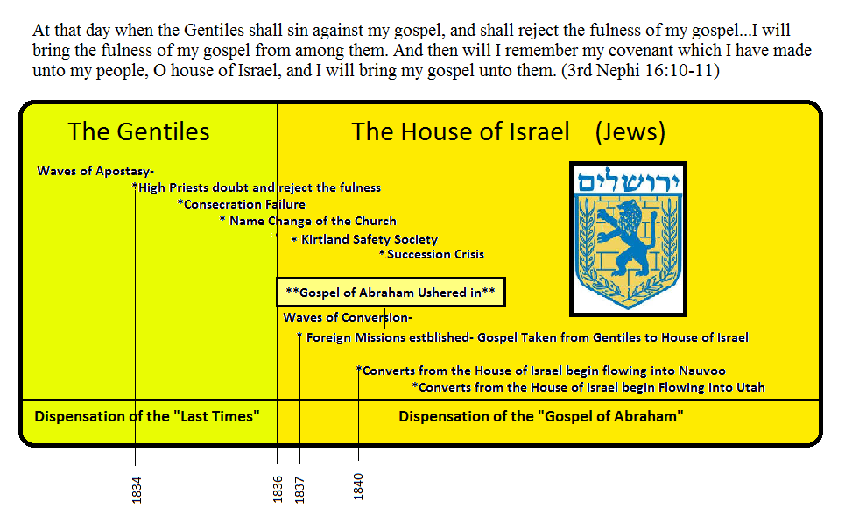

Graphic #6 Gospel of Abraham Restored pg 245 291 424

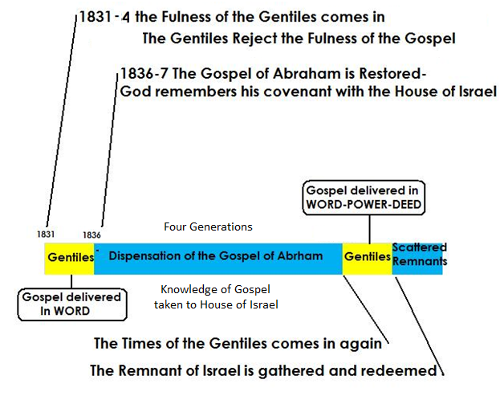

Graphic #7 John the Baptist is Elijah page 335
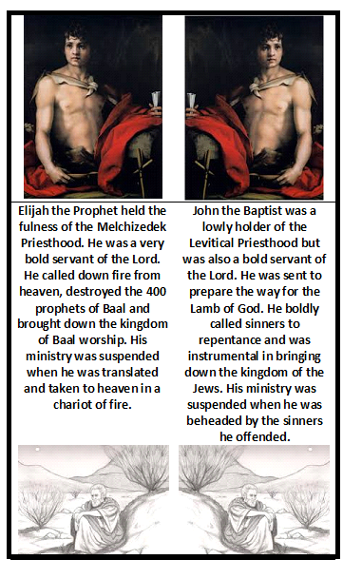

Graphic #8 Countless Sections of D&C testify of Section 110 page 347

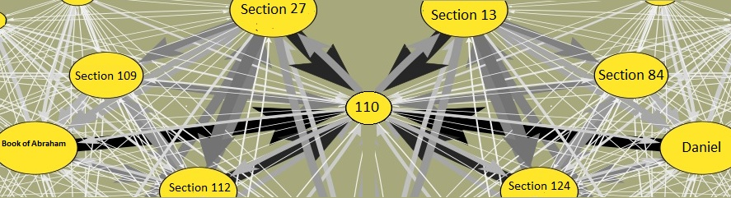

Graphic #9 Joseph Smith is the Marred Servant page 540
