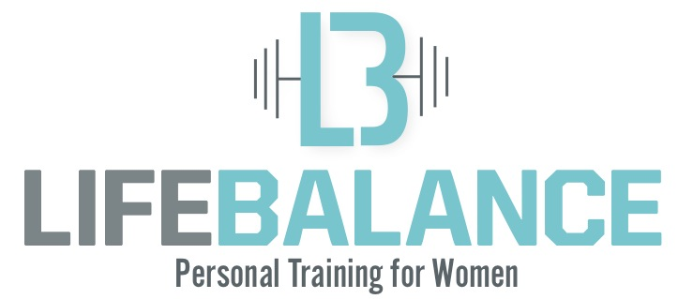
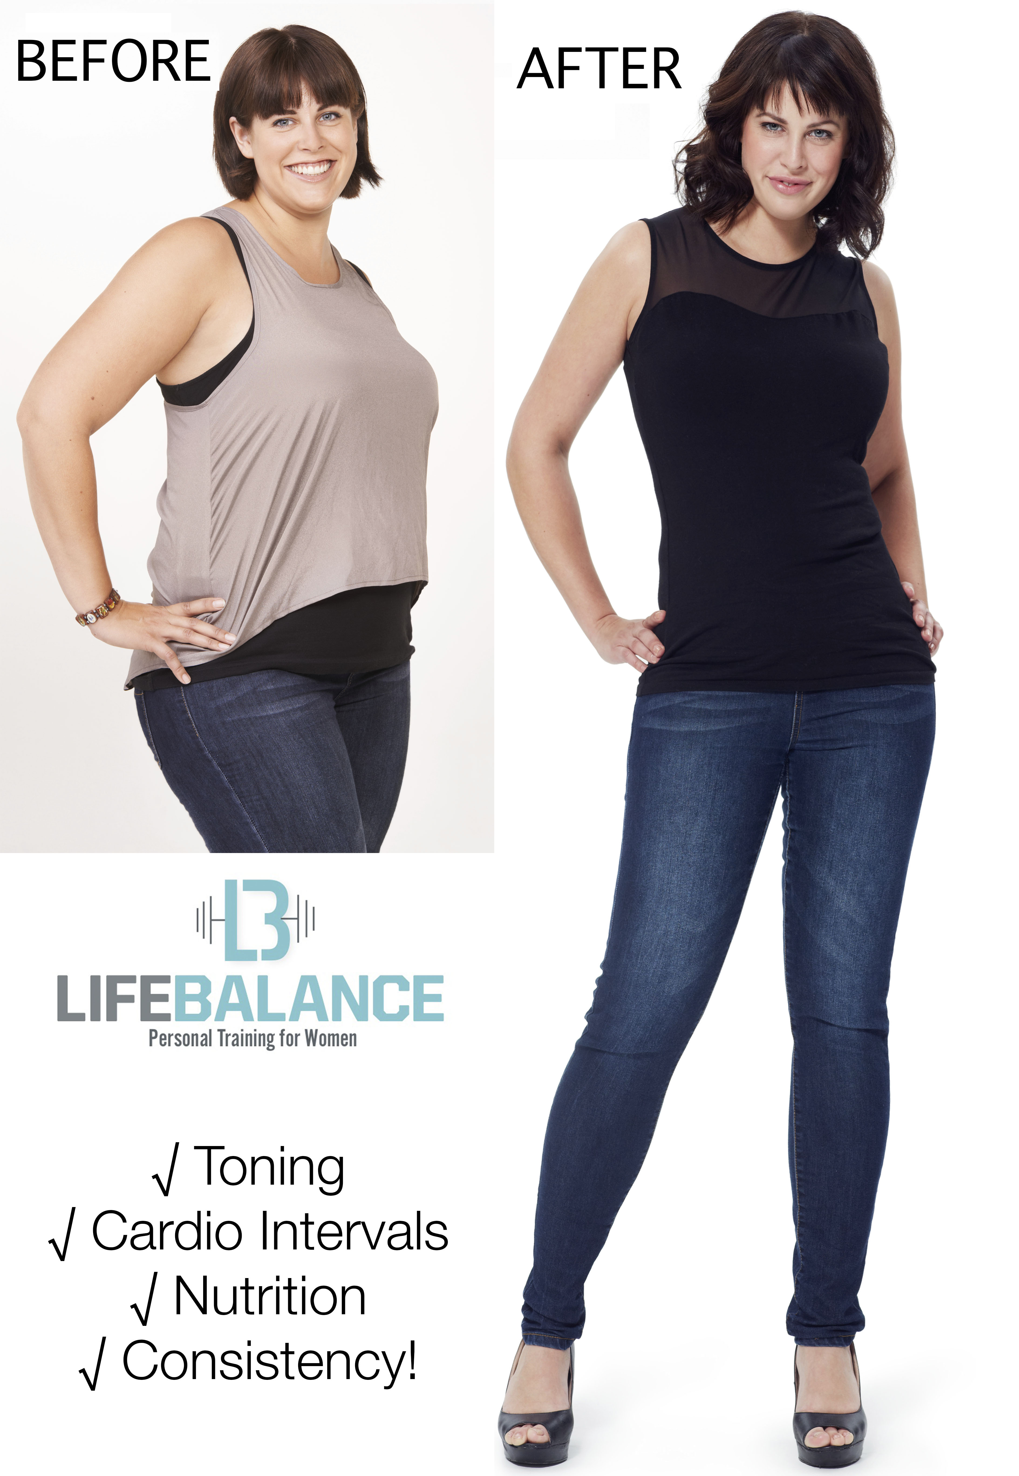

STRENGTH BALANCE & ENERGY
FOR THE BEST OF YOUR LIFE!
710 Deep Valley Drive
Rolling Hills Estates
Monday 6a-12p & 4p-8p
Tuesday 6a-12p & 4p-8p
Weds 6a-12p & 4p-8p
Thursday 6a-12p & 4p-8p
Friday 6a-12p
Saturday 6a-12p

www.lifebalancestudios.com
Lose that 10, 15, 20 lbs
OR MORE..
in just 3 quick months!!
Lose
the weight..

Gain
the strength..

Balance
your life!!
I lost 40lbs,
and nearly 12% body fat! –Kim W.
By incorporating the 4 Pillars of the LifeBalance Program into her life for just 12 weeks, Kim found that the weight came off easier than it went on! Not only did she find that her clothes fit her better, she had so much more energy to keep up with her kids, and fit in everything else she wanted to do with her time!

Praesent
congue sapien
sit amet justo.
For as Little as
$15 Per Session!

  - Integer egestas orci quis lorem feugiat adipiscing.

Lorem
Ipsum Dolor
Michelle was able to lose over 25lbs, and just completed her first 10K race! The 4 Pillars of the LifeBalance Program proved that even though she was never active or athletic before, her Top Tier Trainers showed her the way to live the fittest and healthiest life for herself and her family!
Consistency!
The above pillars of the LifeBalance Program are vital on their own, but the real difference comes when you string them together in a consistent schedule, week after week! Our Top Tier Trainers and Studio Consultants work with you through each of these pillars to hold you accountable to maintaining your consistency, so you see the results you are working for.

Our team is dedicated to you,
and your results.

Nutrition!
The most important pillar of your successful transformation is understanding nutrition's role in the program. Our Top Tier Trainers will guide you through understanding energy, and how to time the foods you love, so that they work for you, and not against you! We provide nutrition counseling, helpful meal prep tips, delicious family recipes that will become dinner table favorites, and snacks that will keep you from raiding the pantry late at night!
Cardio Intervals!
Cardio is important for so many reasons; Heart Health, Lung Health, Circulation.. But the tangible benefit is Fat Burning! We take Cardio a step further; our Top Tier Trainers work with you on Ellipticals, Treadmills and Bikes to perform specifically designed intervals of high and low cardio effort suited to your baseline! This essentially plays a trick on your body, revving your metabolism to a point where you reach that 'afterburn' (see: EPOC). This metabolic state burns the calories as if you were to continue running for an additional two hours, WOW!

Toning!
Working with one of our Top Tier Personal Trainers, you will perform a complete & thorough functional training workout to start each session, that will strengthen your muscles and joints, elevate your poise & posture, and activate all that beautiful Metabolically Active Tissue (Muscle Tone!). The advantage of your Toning Exercises is that your body requires more fuel to move that added muscle-tone! So the same tasks you perform today, will require more calories to perform tomorrow! WOW!

If I could do it, so can YOU! – Michelle H.
Live your life in
Balance!

