Logo Inspiration:

The logos below represent the feel I’m looking for within my logo.

The company name is ‘Pegasus.’ with the tagline of ‘Race the World. The tag line doesn’t have to be part of the logo.

Ideally an abstract shape or marking with a unique font type could be developed to represent my sports brand that specializes in endurance races around the world, be it swim, bike, run or multi-sports.

https://dribbble.com/shots/2003128-Yosakti-Brand

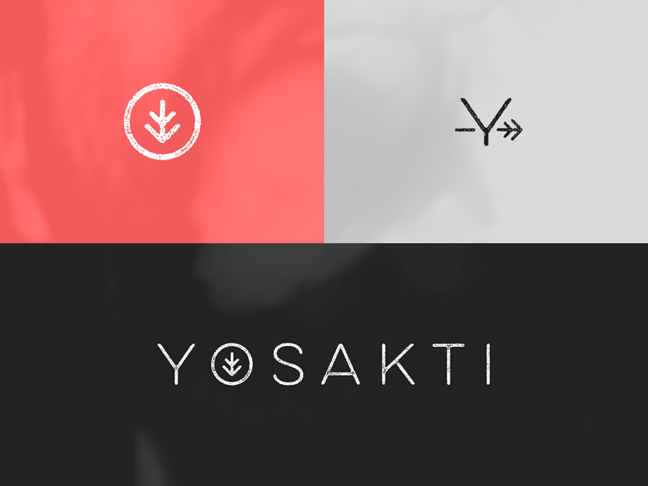

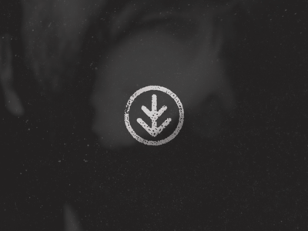

https://dribbble.com/shots/2014339-Re-Brand-to-Stanza

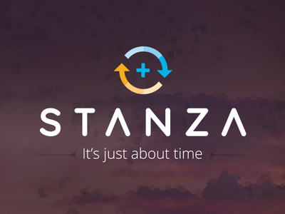

https://dribbble.com/shots/781518-Y-V-Visual-Identity



https://dribbble.com/shots/2017814-Visual-Labs-Logo-Exploration



https://dribbble.com/shots/2014213-Luxe-in-progress

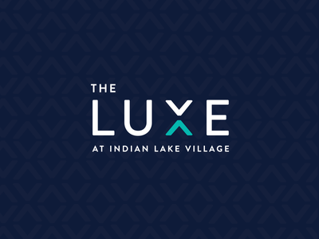

https://dribbble.com/shots/2017523-Moxy-App-Logo



https://dribbble.com/shots/2017252-Living-Hope-Church-Logo

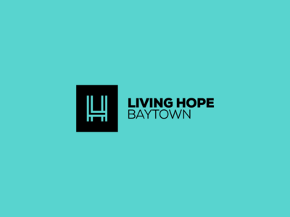

http://portfolio.iamfdm.com/originathletics.html




http://portfolio.iamfdm.com/freak.html
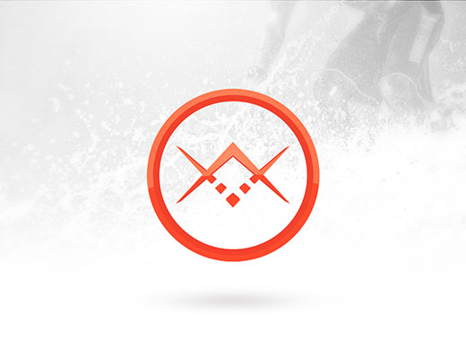
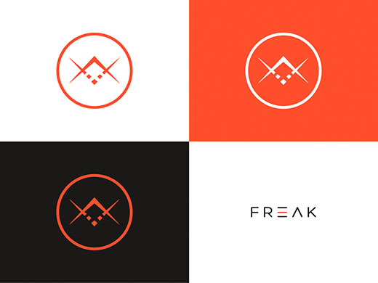

https://dribbble.com/shots/1413345-Well-v2

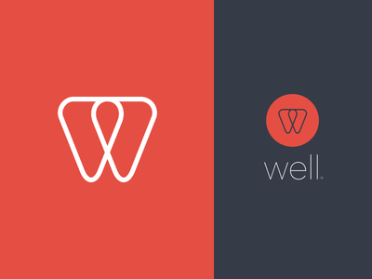

https://dribbble.com/shots/216038-Cloved

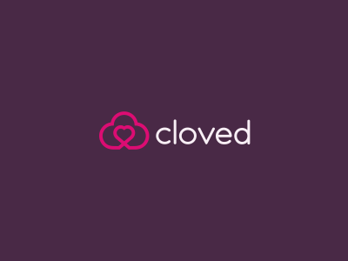

http://www.jonnydelap.com/Melody-Arguile-Stationery

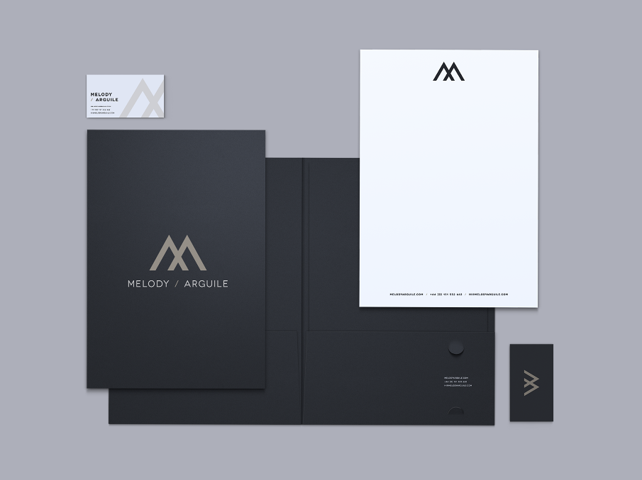

https://dribbble.com/shots/2016184-Craft-Realty

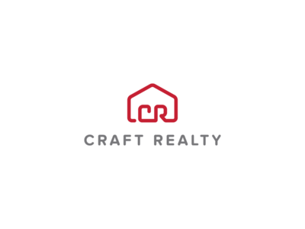

https://dribbble.com/shots/1265940-PEAK-Business-Card?list=179670-PEAK

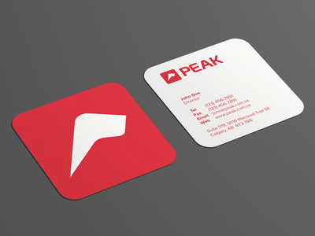

https://dribbble.com/shots/2015671-AIWD-D-Logo/attachments/355888

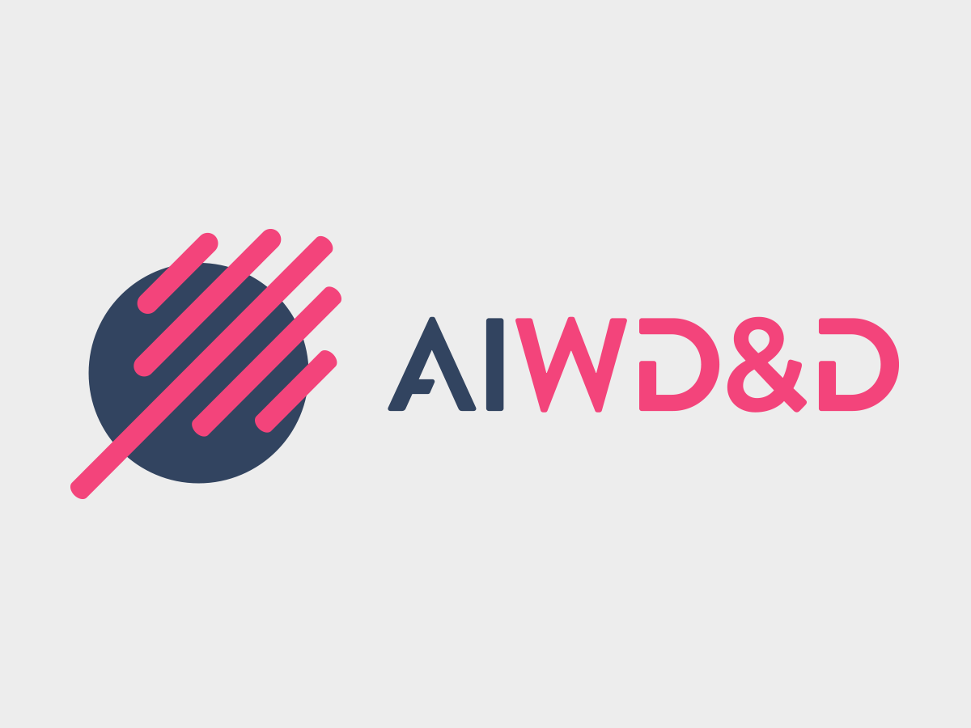

https://dribbble.com/shots/2016480-Albisia/attachments/356104

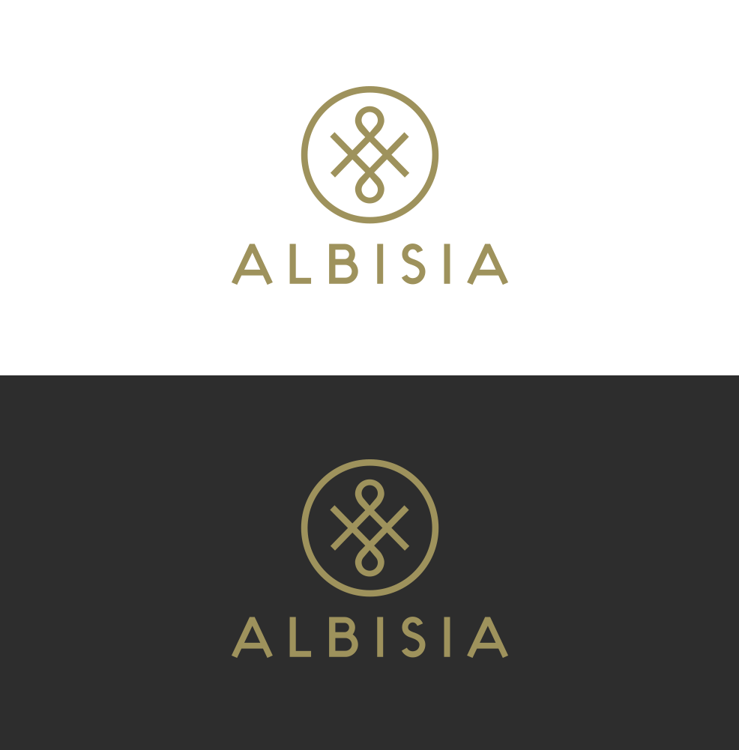

https://www.behance.net/gallery/High-Risk-Giant/10288285

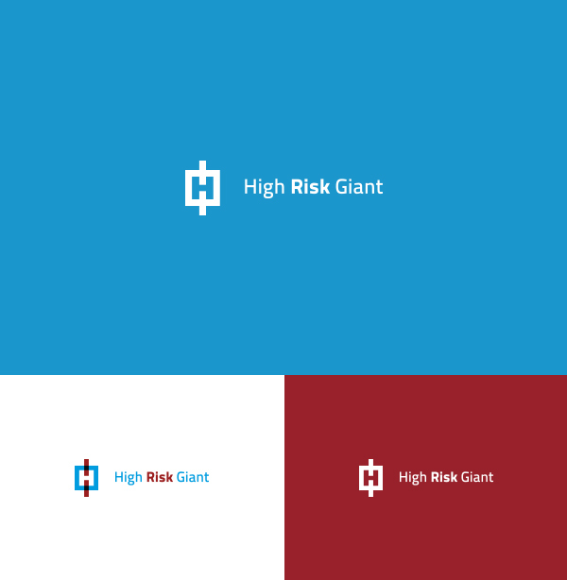

https://dribbble.com/shots/2017958-UpNorth-logo

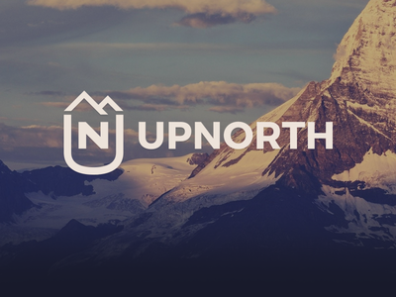

https://dribbble.com/shots/2017851-Ben-Kennedy-Logo-Animation



https://dribbble.com/shots/2015923-Guest-Minded-Mark
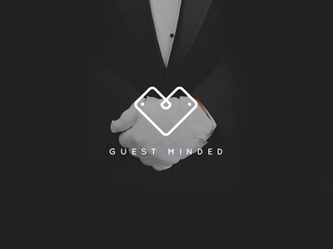

https://dribbble.com/shots/2015573-Exploration



https://dribbble.com/shots/2015295-L2BF

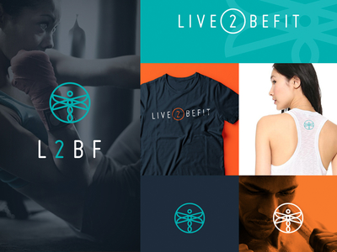

https://dribbble.com/shots/2015282-MinuteMen-Logo



