
Front page
“We design tailor-made solutions to fit your Human Capital and Industrial Cleaning needs, ensuring peace of mind.”
Inside Left
Driven by your success - somewhere on the page as this is our Vision.
Why our clients choose Indgro?
- Extremely efficient
Our front office becomes your back office
- Highly effective
We get results, you can only manage what you measure
- Supremely skilled staff
Matching your hire to retire requirements. No excuses
- Rapid right fit recruiting
Great talent is hard to find – they are already working for us
- Proven business solutions
Testimony of more than 450 satisfied clients since 1982
- Exceptional cleaning with a difference
Cleaning is critical. A clean space is a safe place
- Our Labour and executive talent pool skill sets are vast
We supply your staffing and cleaning needs
- Exceptional Client Satisfaction
98% and above since June 2012
- Flexible
We offer custom cost & compensation structure for your short medium and long term requirements
- Spotless track record
No findings since 1982, and international accreditations
- Timely payments
99.997% accuracy on-time payments
Inside right
“Our deepest fear is not that we are inadequate. Our deepest fear is that we are powerful beyond measure.” - Aristotle
On the flap for the business card:
Website www.indgro.com
General email info@indgro.com
Facebook address /indgro
Twitter @indgro

Back Page
 | VISION  Driven by your success!
MISSION STATEMENT  “I am a proud member of an excellent group, creating exceptional experiences, solving tomorrow’s problems today, by designing tailor-made solutions to fit all your human capital and industrial cleaning needs ensuring peace of mind.” | 
 | OUR VALUES  - Growth to Achieve  Expecting Client, Company and Personal growth.  - Personal Accountability  If it’s to be, it’s up to me.  - Stewardship  Doing right when no one is looking.
INDGRO’S SUCCESS DNA IS COMPOSED OF  - Never take “no” for an answer.  - No excuses.  - Obsession over the detail.  - Innovate.  - Better, better, better.  - Super achievers.  - Mindset of mastery. | 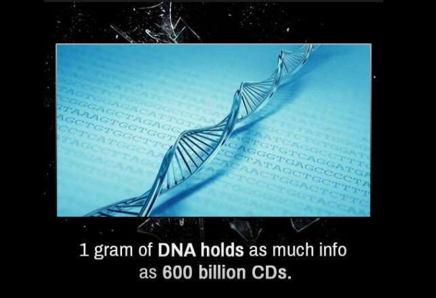

Branch details
