all physiotherapy

active living lifestyle

  - Problem statement
Produce a logo that will be used for the following purposes:
- Business card, letterhead and business logo
- Outdoor signage on a retail strip of shops
- Indoor signage behind the reception desk
- Marketing campaigns on brochures, website, labels, window stickers, posters, business cards

  - All Physiotherapy Profile
All physiotherapy will start as a physiotherapy practice that offers specialist assessment, treatment and rehabilitation in a range of areas:
- Women’s health (pre/post natal exercise rehabilitation)
- Musculoskeletal
- Sports- golf, cycling, running, dance
- Neurological conditions
- Vestibular rehabilitation
- Pediatrics care
- Geriatrics
- Clinical Pilates

We are a contemporary and boutique service that aims to provide patients with the highest quality of care by clinicians who are exceptionally knowledgeable and passionate about their clinical care. We have a focus on providing outstanding customer service, clinical care as well as educating our patients about how to care for their health and well being in the longer term.
The future of the business would to expand to include a multidisciplinary service with the possibility of podiatry, dieticians, occupational therapists, psychologists.

active living lifestyle
all
physiotherapy
podiatry
occupational therapy

  - Aims and objectives
The purpose of the logo is to convey a message of all:
- We provide a service for all people- paediatrics, womens health, sports and geriatrics etc.
- We provide a service that incorporates all types of health professionals
- We are an inclusive service that is all encompassing

The logo would ideally be used in the following format:
all
physiotherapy
active living lifestyle

The logo will look professional, contemporary and boutique, yet simple. It will convey confidence and increase trust in the target population so that they feel confident to call or contact us.
We are flexible with the corporate colours, as long as it conveys the above message and would appeal to males and females. The logo should also look appealing in colour and as a black and white image.
Words to describe the business are:
- Contemporary
- Boutique
- Healthcare
- Rehabilitation
- Mind body
- Active living
- Improving sports performance
- Enhancing lifestyle

Examples of logos and uses:

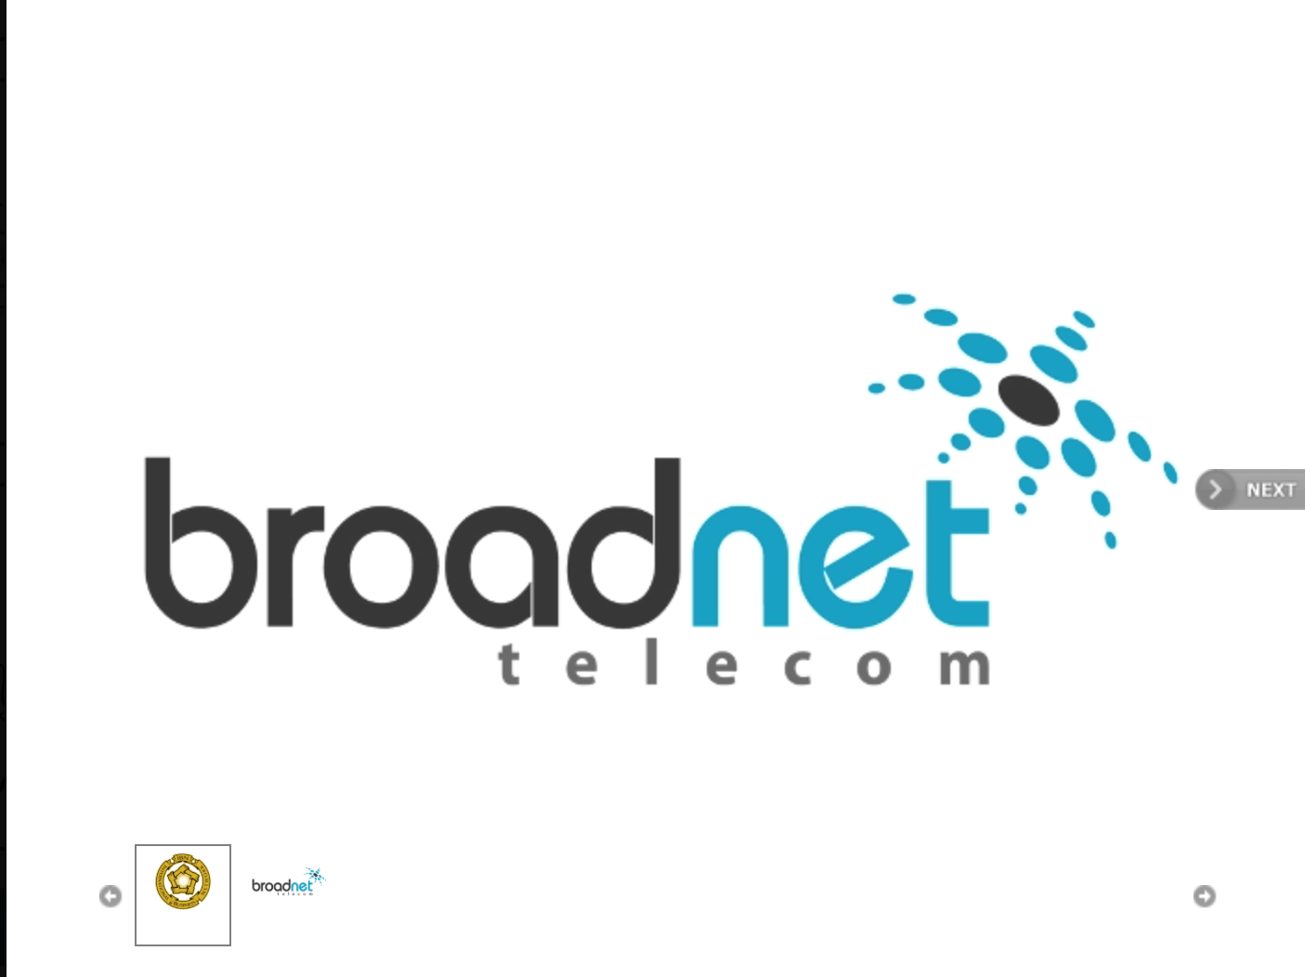

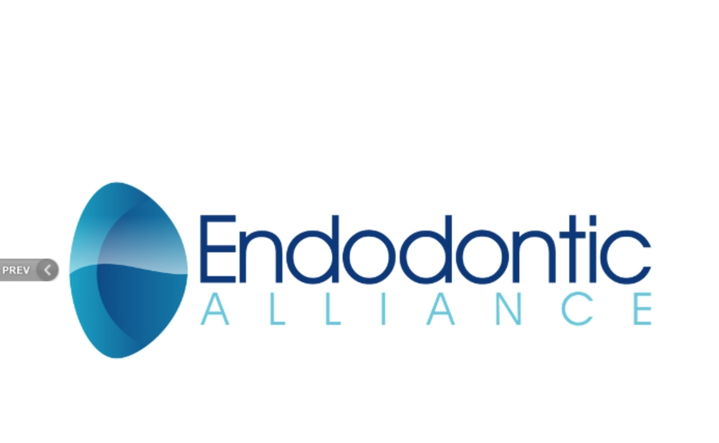

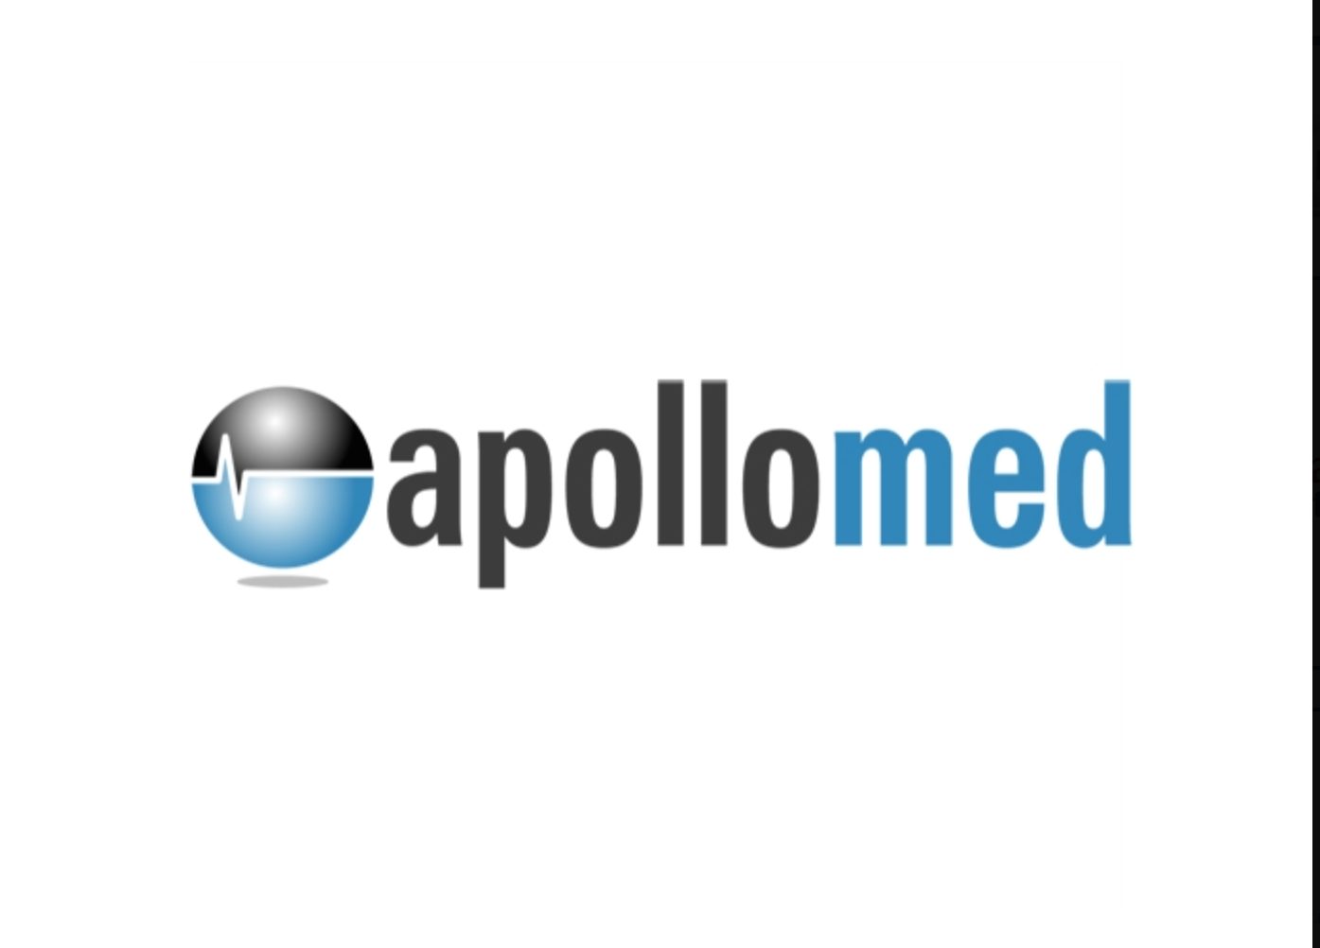

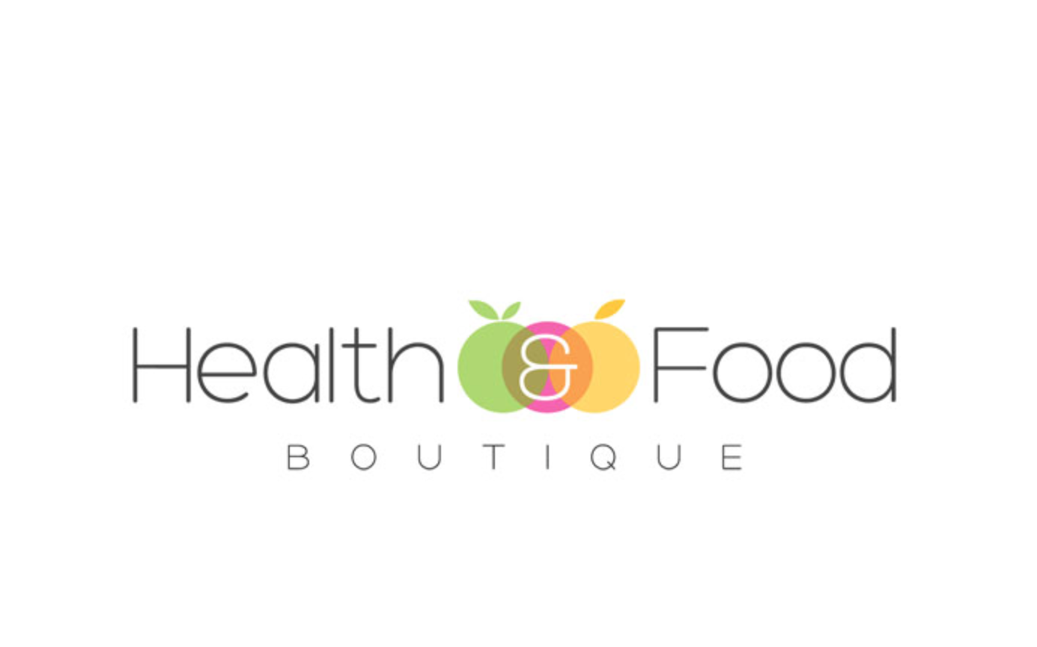

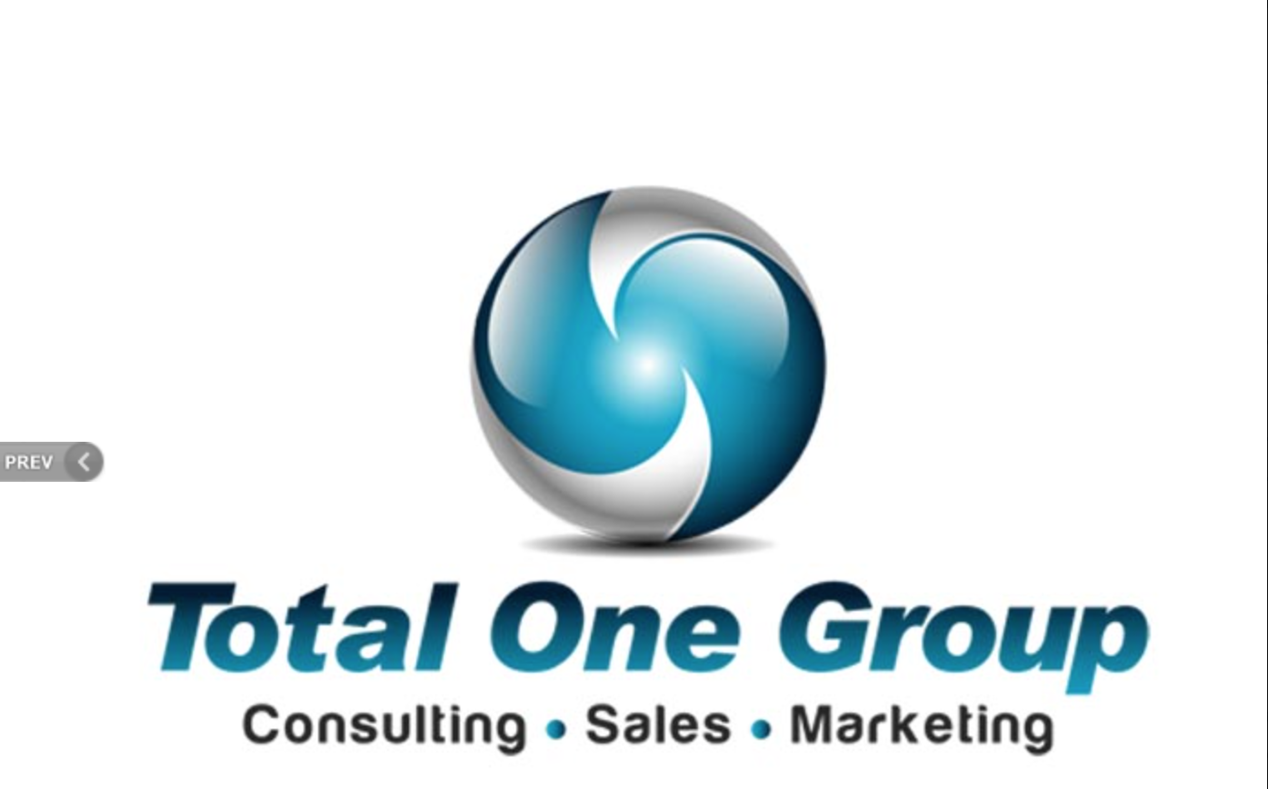

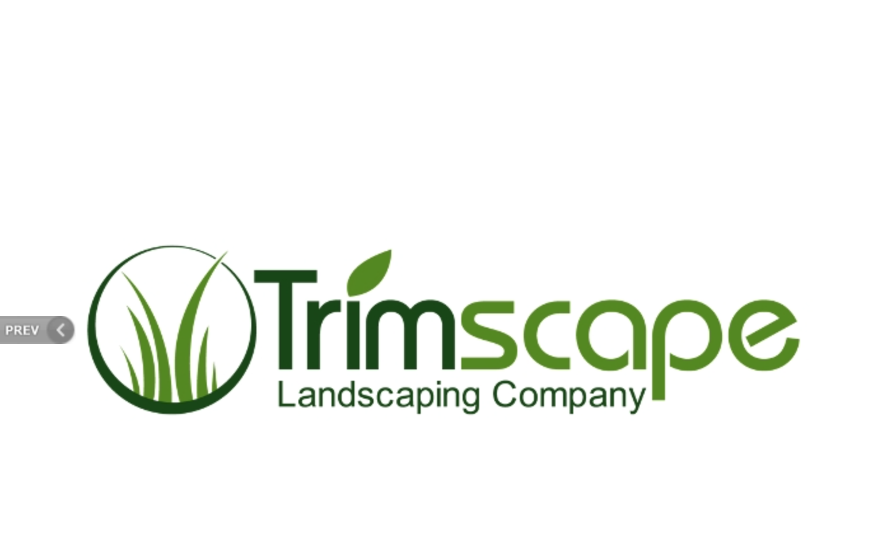

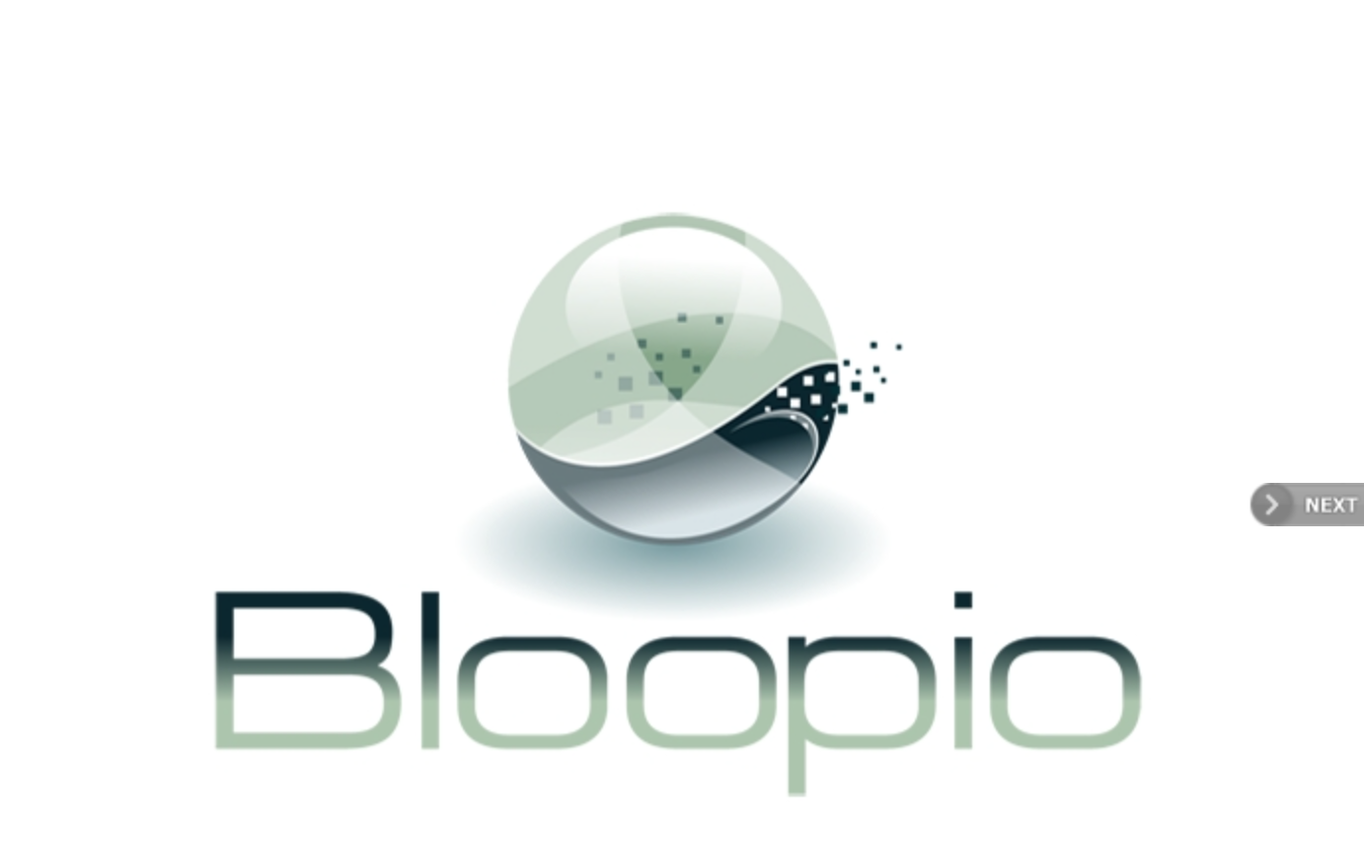

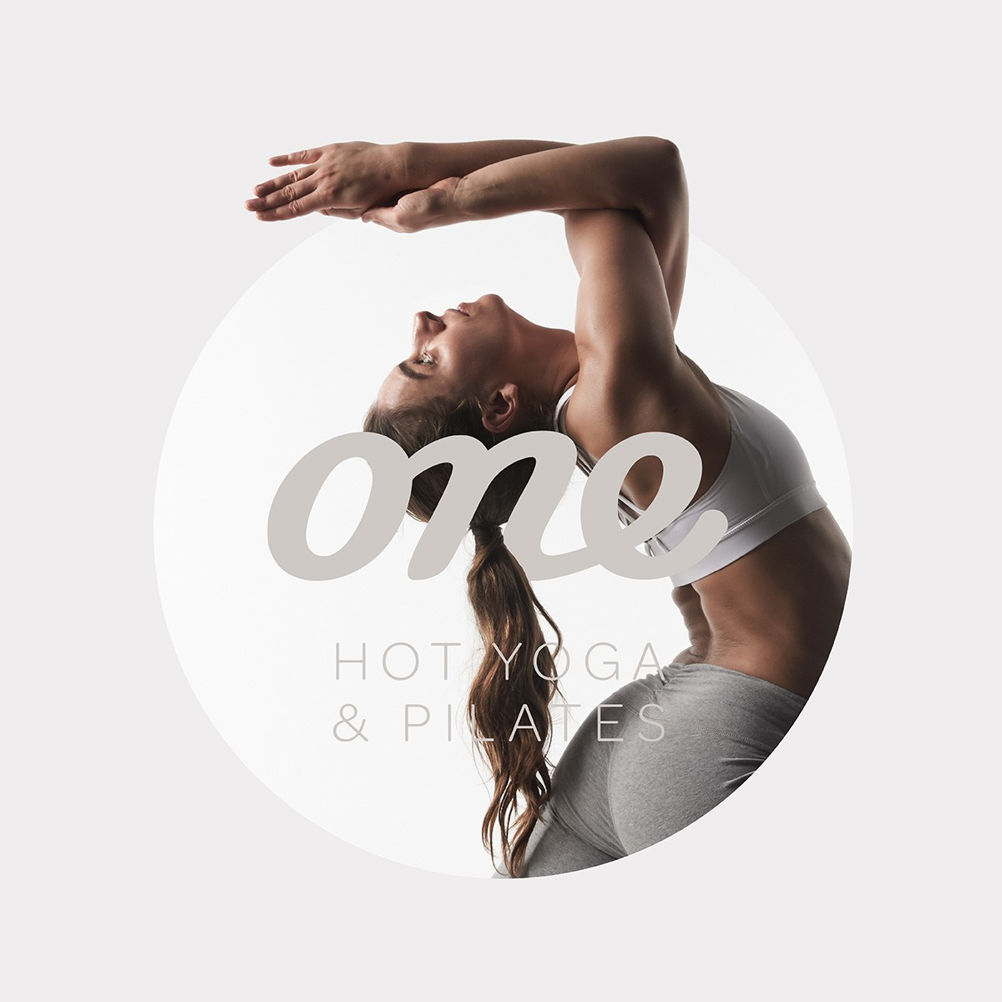

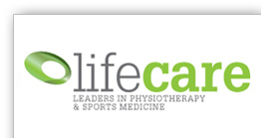

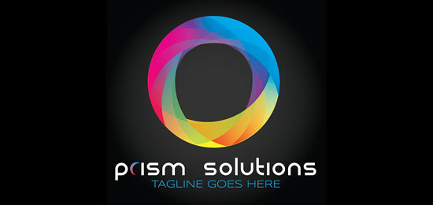
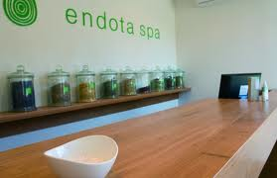

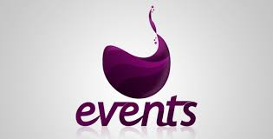

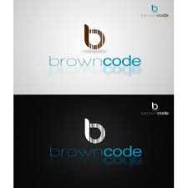

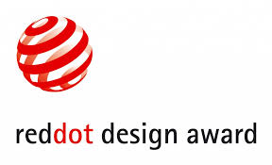

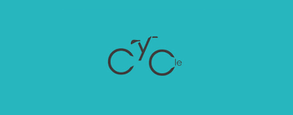

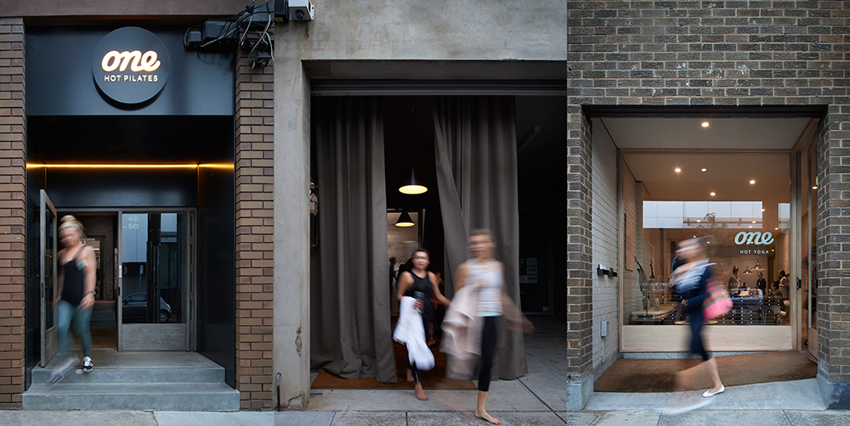

  - Target audience
- Males and females
- 20-59 year olds for injury management and rehabilitation services
- females 20-49 years of age for womens health/ clinical pilates
- 65+ year olds for health promotion
- middle to high income earners >$1400 weekly household income
- Living in urban suburbs
- Sports and dance populations
- Neurological rehabilitation
- Paediatrics or parents of childrens following sports injury

  - Deliverables
- Print-ready logo artwork files: EPS and AI
- Screen-optimized logo artwork files: JPEG, GIF, PNG, and PD
- Logo usage guidelines: PDF and hard copy
- Business-card design (double-sided) print-ready file: PDF
- Any font licenses and font files that may be used to complete the project
- Files that allow for logo use on large vinyl posters
- Files for window sticks
- Digital copy for websites
- Logos for print on business card, appointment cards, envelops, letterhead, brochures
- For use on large outdoor signage on various weather proof surfaces

