THE COMMON GOOD FORUM
Venture Politics: Investing in Our Nation’s Future
May 14th, 8am-3pm
Waldorf Astoria Hotel, New York

The Common Good proudly presents its first annual forum, “Venture Politics: Investing in Our Nation’s Future,” on Thursday, May 14, 2015, 8am-3pm. at the Waldorf Astoria in New York City.
The Common Good Forum will provide a high resolution overview of today’s complex global economic, political, national security, and business landscape so critical for investment and policy concerns.

We will be looking at workable approaches to creating a vigorous and healthy economy, growing jobs and businesses, greater shared prosperity and suggestions of where our public dollars and private investment need to go.

We will bring together thought leaders on the issues facing the U.S., including business innovators helping to revitalize our economy, key economists and experts with a forward-thinking approach to jobs and economic growth, tech experts revolutionizing how we live, influential journalists who are analyzing and evaluating fast-moving developments that are changing our world, and top officials investing the people’s money, including state treasurers and comptrollers.

The TCG Forum will provide an opportunity for top leaders to meet for enlightening and thought-provoking presentations and opportunities for audience participants to network with gamechangers who are making their mark on today’s dynamic and global world. We will draw a blue-chip national and international audience who, while they are in New York, also will be able to take advantage of concurrent cultural events like the Frieze Art Fair, NYCxDesign, the ICFF Global Design Fair and the NYLA International Film Festival as well as the city’s rich tapestry of galleries, museums, theater and music.

The Common Good Forum will be held at the centrally located Waldorf Astoria, in the heart of Manhattan.

THE COMMON GOOD
115 East 57th Street, Suite 1010
New York, NY 10022
212-599-7040
www.thecommongoodusa.org

THE COMMON GOOD FORUM
May 14th, 8am-3pm
Waldorf Astoria Hotel, New York

Among our expected participants:

ECONOMY/BUSINESS/SECTOR LANDSCAPE
  - Steven Brill, founder of Court TV and The American Lawyer founder and best-selling author
  - Willem Hendrik Buiter, Chief Economist at Citigroup
  - Eric Spiegel, President and CEO of Siemens USA
  - James Harmon, Emerging Markets investor, Founder and Chairman of Caravel Management LLC; former Chairman of US Export Import Bank
  - Chris Hughes, co-founder Facebook; Obama campaign social media advisor and owner of the New Republic
  - Zachary Karabell, Economist and President of River Twice Research
  - Robert Lanza: prominent biochemist and Chief Scientific Officer of Ocata Therapeutics
  - Alan Patricof: Managing Director of Greycoft Partners
  - Peter Peterson, former Secretary of Commerce
  - Steve Rattner, Lead adviser to the Presidential Task Force on the Auto Industry, Chairman of Willett Advisors LLC
  - Uwe Reinhardt, prominent expert in health care economics, Princeton University
  - Kenneth Rogoff, former Chief Economist at the IMF; renowned Harvard economist

INVESTING THE PEOPLE’S MONEY
  - Janet Cowell, North Carolina State Treasurer
  - Thomas DiNapoli, New York State Comptroller
·
NATIONAL SECURITY/FOREIGN AFFAIRS LANDSCAPE:
o Michael Chertoff, former Secretary of Homeland Security
o Michael F. Oppenheimer: expert in international relations and political economy, NYU Center for Global Affairs
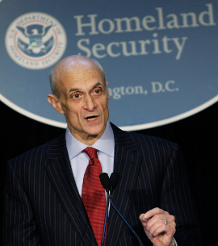
o James Woolsey: former Director of the CIAStephen F. Cohen, Russian studies
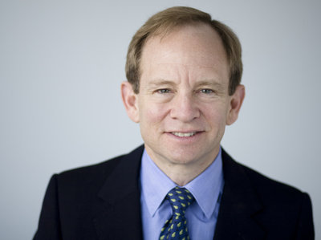scholar; Professor Emeritus at New YorkUniversity and Princeton University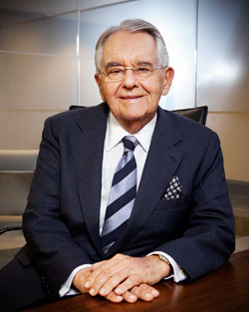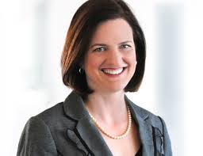
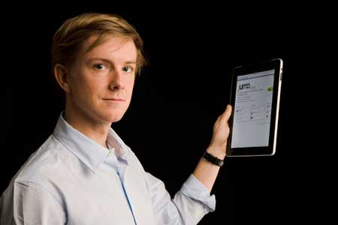

THE COMMON GOOD

The Common Good presents public policy conversations, forums, and meetings around the calendar year with many of the nation’s top thought leaders, innovators and trendsetters in politics, business and culture.

The Common Good is a nonpartisan, not-for-profit organization dedicated to recreating the public square through reasonable discourse and a free exchange of ideas. This open dialog helps to create the environment for good policy and the common ground to implement it.
TCG strives to bridge the growing divisions that threaten our nation and to help promote the informed participation of every citizen so essential for a thriving democracy.

Past speakers at The Common Good

We have hosted some of the most authoritative, most interesting luminaries from many disciplines and from across the political spectrum, including,

President Bill Clinton; Vice Presidents Al Gore and Dick Cheney; House Minority Leader Nancy Pelosi; Economist Paul Krugman; former Vice Chair of the Federal Reserve Alan Blinder; Grover Norquist; strategist David Gergen; former National Security Advisor Zbigniew Brzezinski; Senate Majority Leader Mitch McConnell and former Senator Alan Simpson, former Secretary of Commerce Peter Peterson and former Secretary of State Henry Kissinger; and John Kerry, Claire McCaskill, Chuck Hagel, and Cory Booker.

For 2014 these incredible men and women included:

Google Executive Chairman Eric Schmidt
New York Police Commissioner Bill Bratton
Economist Jeffrey Sachs
New Regency Film CEO and Academy Award-winning producer Arnon Milchan
Five-time Academy Award-nominated director Darren Aronofsky
Political expert Jim McLaughlin
Former New York Times executive editor Jill Abramson
Ambassador Ron Prosor of Israel
Economist Executive Editor and author John Micklethwait
MSNBC star host, Steve Kornacki
Pollster/campaign advisor Jefrey Pollack
Pollster/campaign strategist Anna Greenberg
former Presidential advisor & Fox News commentator Patrick Caddell
Wall Street Journal White House Correspondent Carol E. Lee
Immigration activist Jose Antonio Vargas
Author/expert Gary Sick on Iran and Iraq
Candidates Michelle Nunn, Jason Carter, Representatives Gary Peters & Jim Himes, Senator John Walsh
Journalist/author Todd Purdum
Rolling Stone author/journalist Matt Taibbi
Author Scott Reich on the legacy of John F. Kennedy
Journalist/Author Evan Osnos on China
Women's pay equality leader Lily Ledbetter
President of J Street Jeremy Ben-Ami
Best-selling author and documentary filmmaker Sebastian Junger and a screening of Korengal
Senior Fellow at the Council on Foreign Relations Max Boot
CNBC’s Steve Liesman and John Harwood
Prize-winning host and journalist Soledad O’Brien
Best-selling author Gail Sheehy
MSNBC’s Ari Melber and Jason Capehart
Publisher and businessman, Mortimer Zuckerman

THE COMMON GOOD FORUM 2015
“VENTURE POLITICS: Investing in America’s Future”
May 14, 2015, 8am-3pm
Waldorf Astoria, New York City
SPONSORSHIP OPPORTUNITIES

We are looking forward to having you partner with us in presenting this exciting event. We encourage our corporate sponsors and partners to hold their own networking events in conjunction with the TCG Forum.
$100,000

Premier Platinum Sponsor
- Recognition as the major event sponsor in all Conference materials and press releases
- First option on future sponsorships
- Recognition as the major event sponsor in all Conference materials and promotion
- Acknowledgement in introductory comments
- Prominent event signage
- Premium seating ten (10) attendees at the breakfast, all presentations and the luncheon
- A private reception with conference speakers and panelists
- Executive Membership in The Common Good for one year for five people
- Premium seating for a table of ten (10) at the American Spirit Awards the same evening, cocktails and gala, May 14, 2015.
One Premier Platinum Sponsorship available at $100,000

$50,000

Gold Sponsor
- Recognition as the major event sponsor in all Conference materials and promotion
- Acknowledgement in introductory comments
- Prominent event signage
- Premium seating for five (5) attendees at the breakfast, all presentations and the luncheon
- A private reception with conference speakers and panelists
- Executive Membership in The Common Good for one year for five people
Two Gold Sponsorship available at $50,000

$25,000

Bronze Sponsor
- Recognition as an event sponsor in all Conference materials, signage and promotion
- Acknowledgement in introductory comments
- Premium seating for one table for three (3) attendees at the breakfast, all presentations and the luncheon
- Executive Membership in The Common Good for one year for two people
Bronze Sponsorships available at $25,000

$10,000

Supporting Sponsor
- Recognition as an event sponsor in all Conference materials, signage and promotion
- Acknowledgement in introductory comments
- Premium seating for one table for three (3) attendees at the breakfast, all presentations and the luncheon
- Executive Membership in The Common Good for one year for two people

Individual Tickets
$1500

- Non TCG-Members
Includes seating at the breakfast, all presentations and the luncheon

$500

- TCG Members
Includes seating at the breakfast, all presentations and the luncheon

