HOTEL INFORMATION
LOCATION
The resort offers guests one of the best and most desired accommodations in Coron, Palawan. Located about 25 minutes drive from the airport and just 5 minutes outside downtown Coron, this resort provides peace and exclusivity while surrounded by natural wooded and mountain areas that allow for the perfect relaxation and holiday.

AMENITIES & SERVICES

Swimming Pools and Jacuzzi- Surrounded by a beautifully sculpted tropical landscape, the three swimming pools at Coron Westown Resort are a heaven of serenity and tranquility. For families, the children’s pool with a water fountain is the ideal venue for fun in the sun. Be pampered by water jets in the large poolside Jacuzzi and experience the only dive pool in Coron. All these are surrounded by comfortable lounge chairs and umbrellas for guest’s comfort. Pool service is available from the Restaurant café and Bar, which offer a delightful selection of thirst-quenchers and light refreshments ranging from fruit juices, soft drinks and mineral water to delightful cocktails. A good selection of wines, beers and snacks are also available for your dining pleasure.

Kayangan and Malcapuya Hall- Coron westown resort is not just a place for recreation and family bonding activities. The function rooms located at the second floor of the hotel is ideal for corporate events, business meetings/seminars, annual dinner, wedding reception and other indoor activities for a large group of people. Equipped with extensive meeting and banquet facilities, each function rooms can accommodate from 250 up to 300 pax. Our versatile function/meeting rooms are always ready. For reservations, kindly dial “0” for assistance.

Restaurant Café- The restaurant caters to a wide range of needs from early morning breakfast to leisurely lunch and evening sumptuous dinner. We strive to provide individual services for each guest. Private dinners or cocktail parties can be arranged in a variety of locations throughout the resort to celebrate birthdays, anniversaries and other special occasions. Kindly dial “120” for assistance.

Bar & KTV Lounge- A cozy bar and lounge with an outdoor terrace overlooking the pool. Featuring live sports feeds on the big screen, light pub snacks menu, exciting cocktails and other blends. Sit down and relax to resident band’s music, dance the night away or have a private get together at the KTV lounge. Kindly dial “122” for assistance.

Spa- No vacation is complete without a little pampering. Take time for yourself, replenish your soul and revive your tired body in our Spa. Indulge in our spa and massage services that will leave you and your muscles feeling completely rejuvenated. For additional information and to make a reservation, please dial “0”

Fitness Center- Keep active and stay fit at Coron Westown Resort with exclusive fitness center access, complimentary with room reservations. Energize your body with a full array of Life Fitness exercise equipment including: treadmills, cross trainer, cycling bikes, exercise ball and stretching mat.
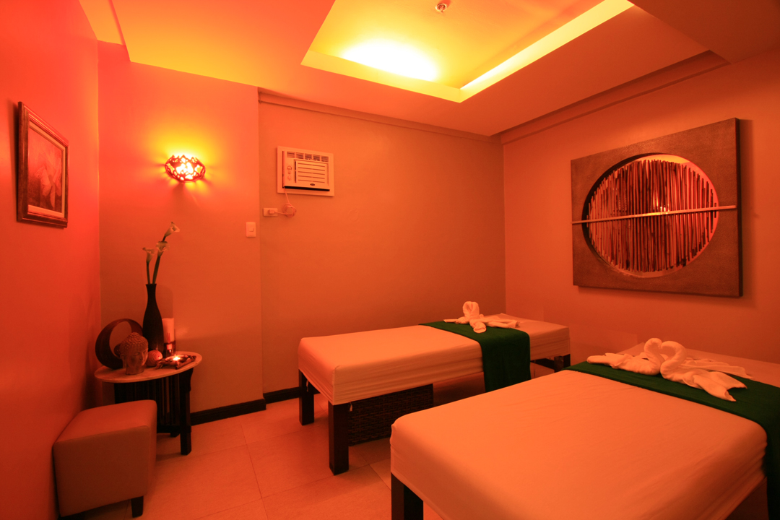
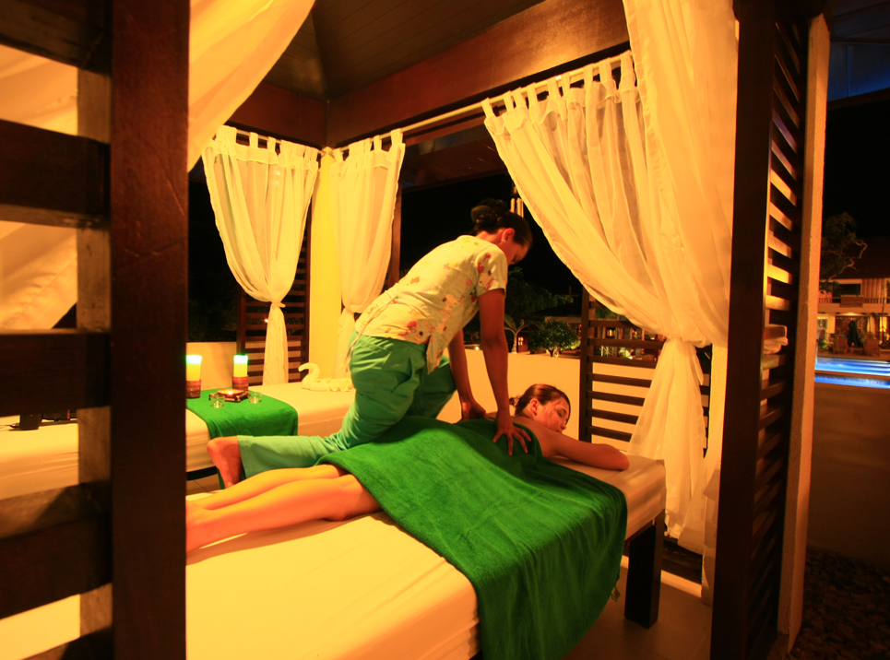

Business Center- A well-equipped business center is located near the lobby to facilitate processing of business plans and correspondences. The business center is equipped with state-of-the-art information technology and communication facilities that include printing, photocopying & fax services and a computer system with internet access. Kindly dial “123” for assistance.

Kids Playground- Our new, secure, outdoor playground is a great place for the kids to let off some steam. Located near the spa villas, the playground is the ideal place for the children to play in a safe environment with lots of fun to be had. Parental supervision is required.

Convenience Store- Food, beverage, personal items and souvenirs are all available at the lobby for your convenience. Kindly dial “0” for assistance.

Elevator- For comfort and convenience, the resort has two modern elevators available for guests

Telephone and Satellite Internet- The resort is equipped with cellular telecommunications facilities and satellite-based wireless internet for all rooms. Wi-Fi is free in the lobby and Restaurant Café only. Computers are provided with free internet access at the lobby. Kindly dial “0” for assistance.

Transportation- Shuttle services to and from Busuanga Airport are available upon request. These services are extended to any point in Coron and other destinations with a minimal fee. Shuttle service to Coron Town is also available upon request. Kindly dial “0” for assistance.

Safety Deposit Box- An electronic safety deposit box is provided in each room for the convenience of registered guests. However, Coron Westown Resort shall not be liable for any loss of valuables and belongings left therein.

Airline Reservations and Ticketing- Assistance will be provided to guests who wish to reconfirm or book their flights. Guests may also check for departure time or make further travel arrangements at the reception.

Housekeeping- room cleaning service is offered to all guest rooms daily. Hang the “room cleaning” sign on your door knob should you require make-up room service between 8:30am to 5:30pm. Kindly dial “129” for assistance.

Laundry and Pressing- Professional laundry, dry cleaning and clothes- pressing services are available for all guests of the resort. All laundry services are handled with the utmost care and attention. Laundry services are available daily and express service is also available. Kindly dial “129” for assistance.
Medical- The resort has key staff members who are certified to provide first aid should an emergency arise. A medical doctor and nurse are also available on call. Kindly dial “0” for assistance.

24-Hour Standby Generator- The hotel is equipped with fully automatic standby power generators that will guarantee round the clock electricity to the resort.

ACCOMMODATION
Coron Westown Resort offers the best and biggest accommodation in the island of Coron. Each room type caters to guests’ specific needs and is equipped in the latest amenities such as premium spring beds, duvet blankets, individually controlled air- conditioning unit, 40” flat screen TV with 32 satellite channels, Wi-Fi internet access and a safety deposit box. Bedside telephone, mini-bar and refrigerator as well as coffee and tea making facility are standard in all rooms. Bathrooms are spacious and include a glass- partitioned walk-in shower and bathroom amenities. Bathtubs and bidet are features in some room categories. All rooms offer complimentary bottled water.

Deluxe Room- This charmingly room offers guests a spacious and modern resort experience with expansive views of the mountain behind the resort. This room type is configured with one Queen-size bed or two single beds and furnished with a work space and comfortable seating area.

Superior Room- This room features two single beds in a modern, tastefully designed interior offering view of tropical paradise. The intricate wood furnishings complete the room ambiance with private balcony overlooking the surrounding islands of Coron.

Premium Room- Pleasantly fitted in earth tones and features a balcony, the Premium Room is more spacious with a breathtaking view of the surrounding islands of Coron. Available bedding options are either a King-size bed or one Queen-size bed and one single bed subject to availability upon guest’s arrival. Each of these stylish rooms provides a haven for those keen to explore Coron’s exotic natural land and seascapes.

Premium Deluxe Room- The relaxing lighting and warm feel of the Premium Deluxe Room makes an elegant and serene ambiance. Featuring a deluxe King-size bed, these carpeted rooms are tastefully decorated to ensuring the best comfort and luxury among all our offerings. Guests can unwind in their private balcony while enjoying awe- inspiring views of the surrounding islands. This spacious hotel room has everything- oversize bathrooms equipped with bidet, a bath tub, a separate glass- partitioned walk-in shower and complimentary bathroom amenities.

Family Room- A classic suite for the entire family, the Family Room is in a league of its own featuring a master bedroom furnished with a King-size bed and an elegant anteroom furnished with two Queen-size beds. Designed with an emphasis on convenience and comfort for the family, these rooms are well- appointed with a 4-seater dining table, two flat screen TV, two refrigerators, two individually controlled air-conditioning units and two spacious bathrooms.

CHECK IN/ CHECK OUT TIME
Check-in time is at 2:00pm. Check-out time is strictly at 12:00pm.

GUEST STAY EXTENSION
Guests who wish to extend their stay must advise the Front Desk at least 24 hours prior to the expected check-out date and is subject to room availability.

VISITORS
Visitors may stay in registered guest’s room only until 9:00pm.

SMOKING
All rooms are non-smoking. Smoking in rooms will be charged accordingly.

DAMAGE AND LOSS
Stained or missing towels, linens and other fixtures in the room shall be charge to the registered guests. Guests who wish to bring home any item found in the room as souvenirs should inform the Front Desk so that they can be billed accordingly.

PROHIBITED ITEMS
For everyone’s safety and protection, bringing in hazardous items inside the hotel premises such as, but not limited to, explosives, volatile or flammable materials, firearms, and illegal drugs is strictly prohibited.

ENERGY AND WATER CONSERVATION
Guests are encouraged to reduce the use of energy- consuming facilities. To further conserve energy, please remove the key from the energy saving device when leaving the room.
Please be advised that the water from the faucet is not potable. All rooms offer complimentary bottled water.

TOURIST RECOMMENDATION

CORON DAY TOURS

CORON TOWN TOUR

Tour Itinerary

04:00PM Pick- up time
Running tour to TOWN LANDMARKS
Public market
Town Plaza
San Agustin church
Coron baywalk
Harbour center
Souvenir shop visit
Cashew harvest factory
Length of tour: 1 hour 30minutes
Activities: shopping, visit to Coron landmarks, photo-shooting
Highlight: Coron landmarks

MT TAPYAS trek
Length of stay: 1 hour
Activities: easy trekking to the mountain top/view-deck, photo-shooting
Highlight: scenic view of Coron and Coron bay

MAQUINIT HOTSPRING dip
Length of stay: 1 hour
Activities: hot spring dip for therapeutic benefit
Highlight: hot spring

07:30PM End of the tour, back to Hotel

Tour Inclusions:
- air-conditioned van for town tour
- all permits & entrance fees
- Services of tour guide
- Cottage rentals
- Government taxes

CORON ISLAND TOUR

Tour Itinerary

08:00AM Pick-up time
15 minutes van transfer from the hotel to boat docking area

08:30AM Departure from boat docking area, 15 minutes boat transfer
15 minutes boat ride to: SIETE PECADOS
Length of stay: 1 hour
Activities: swimming & snorkeling to the marine park to view colorful & diverse corals and fishes under water
Highlight: famous lagoons

15 minutes boat ride to: KAYANGAN LAKE
Activities: swimming, snorkeling and fish-feeding of fishes thriving at skeleton wreck

11:00AM 15 minutes boat ride to: BEACH 91/ ATUWAYAN BEACH
Length of stay: 2 hours 30 minutes
Activities: lunch, swimming, kayaking, photo-shooting, relaxing, siesta
Highlight: white sand beach

01:00PM 15 minutes boat ride to: CORAL GARDEN
Length of stay: 1 hour
Activities: kayaking, swimming & snorkeling to the marine park to view colorful & diverse corals and fishes under water

02:00PM 15 minutes boat ride to: CYC BEACH
Length of stay: 1 hour
Activities: swimming, photo-shooting and snorkeling,
Highlight: white sand beach, coral garden

03:00PM 15 minutes boat ride to: TWIN LAGOON
Length of stay: 1 hour
Activities: easy trekking, photo-shooting, swimming & snorkeling at the lake

05:00PM End of the tour, back to hotel

Tour Inclusions:
- air-conditioned van for all land tour transfers
- Tourist boat
- Kayak
- Life vests
- Buffet picnic lunch and snacks
- all permits & entrance fees
- Services of tour guide
- Cottage rentals
- Government taxes
REEFS & WRECKS TOUR

Tour Itinerary

07:30AM Pick- up time
15 minutes van transfer from the hotel to boat docking area

08:00AM Departure from boat docking area, 45 minutes boat transfer

09:30AM Arrival at: PASS ISLAND
Length of Stay: 1hour stay
Activities: Beach and Snorkeling Activities
kayaking, lunch, siesta, swimming

1:30PM 45minutes boat transfer to LUSONG CORAL GARDEN
Length of Stay: 1hour stay
Activities: snorkeling at one of the excellent coral reefs of Coron
Highlight: excellent coral garden

03:10PM Arrival at: LUSONG GUNBOAT
Length of Stay: 1hour stay
Activities: snorkeling around East Tangat gunboat, a world war 2 Japanese shipwreck & photo shooting
Highlight: Shipwreck

05:00PM End of Tour, back to the Hotel

Tour Inclusions:
- air-conditioned van for all land tour transfers
- Tourist boat
- Kayak
- Life vests
- Buffet picnic lunch and snacks
- all permits & entrance fees
- Services of tour guide
- Cottage rentals
- Government taxes

ISLANDS ESCAPADE TOUR

Tour Itinerary

07:30AM Pick- up time
15 minutes van transfer from the hotel to boat docking area

08:00AM Departure from boat docking area, 1 hour boat transfer

09:00AM Arrival at: MALCAPUYA ISLAND
Length of Stay: 3 hours stay
Activities: kayaking, swimming and snorkeling on the clear water and white sand beach of Malcapuya, snorkel and visit the cultured giant clams
Lunch on the island
Highlight: white sand beach

12:30PM 15minutes boat transfer to BANANA ISLAND
Length of Stay: 2 hours stay
Activities: kayaking, swimming and snorkeling on the clear water and white sand beach of Banana Island
Highlight: excellent coral garden, beach

02:30PM 15minutes boat transfer to BULOG DOS ISLAND
Length of Stay: 1 hour and 30 minutes stay
Activities: swimming and snorkeling on the white sand beach of Bulog Dos Island, explore the island
Highlight: white sand beach and coral garden

05:00PM End of Tour, back to the Hotel

Tour Inclusions:
- air-conditioned van land tour transfers
- Tourist boat
- Kayak
- Life vests
- Buffet picnic lunch and snacks
- all permits & entrance fees
- Services of tour guide
- Cottage rentals
- Government taxes

CALAUIT SAFARI WITH REEFS & WRECK TOUR

Tour Itinerary

03:45AM Pick- up time
15 minutes van transfer from the hotel to boat docking area

04:00AM Departure from boat docking area, 2 hours and 30 minutes boat transfer

07:00AM Arrival at: CALAUIT SANCTUARY
Length of Stay: 3hour stay
Activities: wildlife feeding & interaction, photo-shooting
Highlight: African Animals and Endemic animals of Palawan

10:00AM 30minutes boat transfer to DIBUTUNAY ISLAND
Length of Stay: 2 hours and 30minutes stay
Activities: lunch, siesta, visit mini-caves and swimming on the clear water
Highlight: mini-caves, white sand beach

02:00PM Arrival at: LUSONG GUNBOAT
Length of Stay: 1hour stay
Activities: snorkeling around Lusong gunboat, a world war 2 Japanese shipwreck; photo shooting
Highlight: Shipwreck

03:00AM 10minutes boat transfer to LUSONG CORAL GARDEN
Length of Stay: 1hour stay
Activities: snorkeling at one of the excellent coral reefs of Coron
Highlight: excellent coral garden

05:00PM End of Tour, back to the Hotel

Tour Inclusions:
- air-conditioned van for land tour transfers
- Calauit tour truck
- Tourist boat
- Life vests
- Buffet picnic lunch and snacks
- all permits & entrance fees
- Services of tour guide
- Cottage rentals
- Government taxes

GROUP PACKAGES

3D2N GROUP PACKAGE

Inclusions:
- Two (2) Nights A/C Accommodation
- Welcome Drinks
- Two (2) Breakfast
- Roundtrip Airport Transfers
- Entrance Fees /Van Transfers
- One (1) full Day Coron Island Tour-Joiners

4D3N GROUP PACKAGE

Inclusions:
- Three (3) Nights A/C Accommodation
- Welcome Drinks
- Three (3) Breakfast
- Roundtrip Airport Transfers
- Entrance Fees / Van Transfers
- One (1) full Day Coron Island Tour-Joiners

EXCLUSIVE PACKAGES

3D2N-A DISCOVER CORON PACKAGE

Inclusions:
- Two (2) Nights A/C Rooms with Private Toilet -Hot & Cold Shower
- Welcome Drinks/ Cable TV / Use of Swimming Pool & Resort Facilities
- Two (2) Breakfast / Two (2) Lunch (1 Set Lunch and 1 Picnic Lunch in the Island)
- Roundtrip Airport Transfers / Town Tour on A/C Van with Entrance Fees ( 5 Places to Visit)
- One (1) Full Day Coron Island Ultimate Tour (5 Destinations) / Daily Van Transfers
- Entrance Fees / Services of Tour Guide / Gov't Taxes

3D2N-B EXPLORE CORON PACKAGE

Inclusions:
- Two (2) Nights A/C Rooms with Private Toilet -Hot & Cold Shower
- Welcome Drinks/ Cable TV / Use of Swimming Pool & Resort Facilities Two (2) Breakfast
- Two (2) Picnic Lunch in the Island /Two (2) Snacks
- Roundtrip Airport Transfers / One Day Coron Island Tour (5 Places to Visit)
- One (1) Full Day Banana/Malcapuya /Bulog Islands ( 3 Private Islands )
- Entrance Fees / Services of Tour Guide / Gov't Taxes

4D3N-C DISCOVER & EXPLORE CORON PACKAGE

Inclusions:
- Three (3) Nights A/C Rooms with Private Toilet -Hot & Cold Shower
- Welcome Drinks/ Cable TV / Use of Swimming Pool & Resort Facilities
- Three (3) Breakfast / Three (3) Lunch (1 Set Lunch & 2 Picnic Lunch in the Island )
- Roundtrip Airport Transfers / Town Tour on A/C Van with Entrance Fees (5 Places to Visit)
- One (1) Full Day Coron Island Ultimate Tour (5 Destinations)
- One (1) Full Day Banana/Malcapuya /Bulog Islands ( 3 Private Islands )
- Entrance Fees / Services of Tour Guide / Gov't Taxes

4D3N-D DISCOVER CORON WITH CALAUIT

Inclusions:
- Three (3) Nights A/C Rooms with Private Toilet -Hot & Cold Shower
- Welcome Drinks/ Cable TV / Use of Swimming Pool & Resort Facilities
- Three (3) Breakfast / Three (3) Lunch (2 Set Lunch & 1 Picnic Lunch in the Island)
- Roundtrip Airport Transfers / Town Tour on A/C Van ( 5 Places to Visit)
- One (1) Full Day Coron Island Ultimate Tour (5 Destinations)
- One (1) Full Day at Busuanga - Calauit Safari Park, w/ Reefs & Wrecks Tour
- Entrance Fees / Services of Tour Guide / Gov't Taxes

