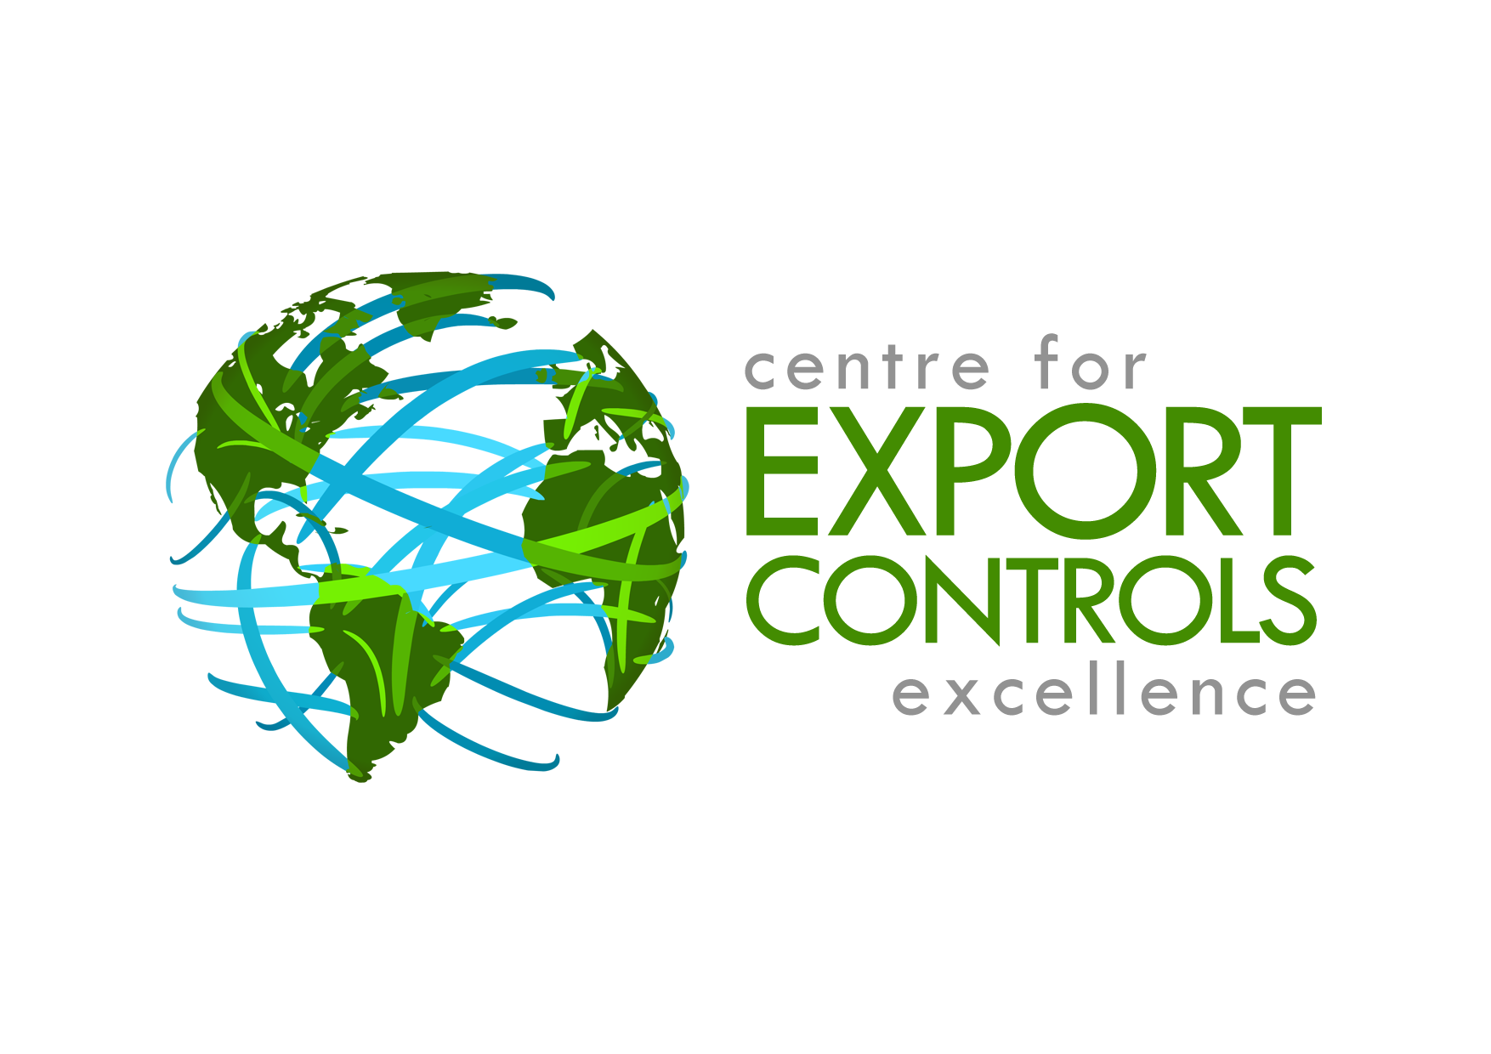
U.S. Export Controls are some of the most complex and stringent in the world. The U.S. Government regulates the transfer of U.S. origin goods and technical data throughout the world, with the intent of preventing unauthorised transfer of technology and know-how.

These controls extend world-wide and can impact anyone dealing in U.S. controlled goods or technology.

This three-day advanced course is designed to give attendees a greater understanding of U.S. Export Controls from a non-U.S. perspective in practical and relevant terms. Though we will cover a lot of material the course is designed for practitioner with an existing knowledge.

$2295.00 AUD per person inc GST
Guest presenters will deliver different aspects of the training program.
Who should attend:
Practitioners that work for dompanies that deal with U.S. based technology or that purchase U.S origin products, components or technology.
The Advanced course assumes a basic understand of U.S. trade controls.
ADVANCED
DEFENCE, EAR & ITAR Training

3-day course
9, 10, 11 September – Melbourne
21, 22, 23 September – Sydney

Program: 0900 to 1630 each day
“Extremely well organized and presented, very informative”
“The Presenter was top rate”
“Excellent overview of a complex topic”
“A ‘must-do’ course for anyone working with defence articles”
“Excellent presentation of a potentially dry subject”
“Excellent course even for previously trained and experienced Practitioners”
“Extremely worthwhile”

DAY 1
EAR
Introduction
- Key concepts
- Export Administration Regulations
- Bureau of Industry & Security

How To Classify Your Item
- How to determine the Export Control Classification Number
Technology Controls
- What technology is subject to EAR;
- License exceptions
- Foreign items incorporating controlled U.S.-origin technology
- Encryption under the EAR

Technical data Considerations
- Controls on physical and intangible data
- Deemed export and re-exports
- Third country national issues
EAR Exceptions
- Terms, provisions, applicability and use of Licence Exceptions
- Changes to Exceptions
- Restrictions governing the use of Exceptions
- Distinction between list based and transaction based Licence Exceptions
Deemed Export
- How to determine when deemed export licenses are necessary

Export Control Reform
- ITAR to EAR
- 600 series
- Specially designed
- Handling licenses and approvals
DAY 2
ITAR
Introduction
- Key concepts
- International Traffic in Arms Regulations

Understanding ITAR classifications

How to classify an item in the ITAR

Re-exports & re-transfers
- Licence free activity
- Returning items to the U.S.

ITAR approvals
- Licences
- Agreements
  - Types of agreements
  - Sub-licensing
  - Dual nationals
  - NDA’s
  - Amendments

Brokering
- Extra-territorial application
- Registration
- Reporting requirements

Destruction and Disposal of ITAR items

Defence services involving ITAR controlled articles and technical data

Recordkeeping for the ITAR

Foreign Military Sales
- Letter of Offer
- Third Party Re-transfer Approvals
- Export Control Reform and FMS

Export Control Reform
- The ITAR definition of Specially Designed
DAY 3

COMPLIANCE & ENFORCEMENT
Trade Control Compliance Framework
- Document development
- Infrastructure
- Risk assessments
- Internal self assessments
Enforcement
- U.S. enforcement
- Fines and penalties
- Case studies
- Preventing violations

NON-US ISSUES
Dual Nationals
- Anti-discrimination
- Privacy

AUSTRALIAN REGULATIONS
- Australia’s System of Export Controls
- Defence and Strategic Goods List?
- Dual-Use List
- Customs Act 1901
- Defence Trade Controls Act 2012
- Catch-All Legislation
- Sanctions Legislation
- Compliance philosophy
- Non-compliance and penalties
- Risk of diversion
- Cyber security
- Red flags
- Self-Assessment Tool
- AU-US Trade Co-operation Treaty
- Managing the transition to intangibles

SEMINAR REGISTRATION
Venue:
Sydney Marriott Hotel
Pitt Street, Sydney

Crown Melbourne
Whiteman St, Melbourne

Attendee 1 Name: ____________________ email:___________________
Attendee 2 Name: ____________________ email:___________________
Attendee 3 Name:_____________________ email:___________________
Attendee 4 Name:_____________________ email:___________________

Company: ___________________________

Address: ____________________________
POLICIES
Cancellation
Cancellations incur a 20% administration fee. No cancellations permitted within 30 days of training commencing.
If a registered attendee is unable to attend, a replacement attendee is allowed.

Workbook
Each attendees will receive a workbook. The workbook is licenced for the use of the training attendee only. If you need other copies , please order them directly.

Multiple attendees
Attendees from the same company booked and paid for at the same time for the same course will received the below discounts:
- 5 attendees
50% discount on the 6th attendee.
- 10 attendees
11th attendee free
- < 10 attendees – contact us
City:_________________ Postcode:_______
Phone: ____________Mobile no: ___________________________

FEE

Defence & ITAR Training ☐ $1395
7 & 8 September – Melbourne
21 & 22 September - Sydney

ADVANCED Defence & ITAR Training ☐ $2295
9, 10, 11 September – Melbourne
23, 24, 25 September - Sydney

Or register for BOTH sessions ☐ $3295

Additional copies of workbook ☐ $ 99

PAYMENT

Payment method: ☐ Invoice ☐ Credit card

Card type: ☐ Mastercard ☐ Visa ☐ AMEX
Card name: _________________________________
Card number: _______________________________
Expiry date: ________________ CVV: ___________

Cardholder email: __________________________

Note: Credit card payments incur a 3% surcharge. AMEX incurs 4%.

.

Email registrations to info@cfece.com
Fax to +61 (0)7 5345 5291

