Task

Design a complete Soccer (football) team player set (T-shirt + shorts).

The design consist of
- T-shirt front
- T-shirt back
- Shorts front

Delivery Requirements

File formats
Design must be delivered in one of the following file formats:
- EPS (PostScript)
- AI (Adobe Illustrator)

Colors
The design can only include a few colors and transparent.
The base color of the T-shirt is green (see pictures) and the shorts is white.
Thickness of lines in design must not be so thin that they fall of when the clothes is cleaned in the washing machine.
The white color is preferred for most of the design, because it looks best on green.

About the team
The 11 ladies plays soccer in Aarhus, Denmark and they are between 18 – 30 years old.
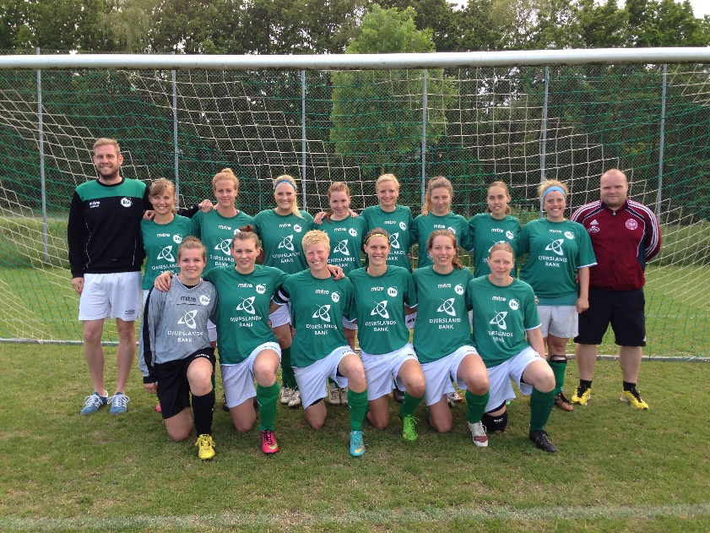

Examples of previous designs can be found here:
https://www.facebook.com/JAIfodbold/photos_stream

Design

History
I want to buy a player set for the ladies and I want it to be personalized with my person included in the design. I got a long history of supporting the team, so they loved the idea and we wrote some ideas down below that can be used for the design.

Design Requirements/ideas
- Back of t-shirt consist of a big number (mandatory) on the top part (as a normal soccer t-shirt)
Below this there is space for some design.
- The twitter hashtag: #JAID2 must appear somewhere.
- The text: “Liderlige Jørgens Damer” (line breaks can be added) (translated: “John Smiths Ladies”) must appear somewhere.
- The logo for the club (“JAI”) must appear somewhere (see picture for an example to the right of the “mitre” logo)

There is one logo (“mitre”) printed on the t-shirt before design is added: (se picture)

Here is two ideas the ladies come up with: (made in MS-Paint, sorry!)
It is just ideas, I expect your proposal to be much nicer.
The two hands holding breast is the design the most like!
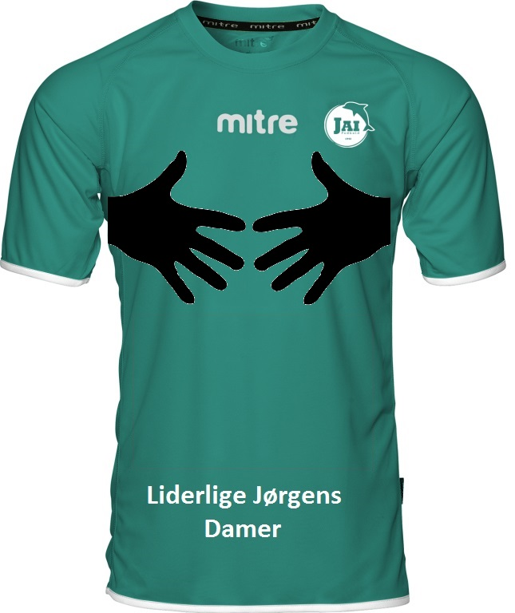
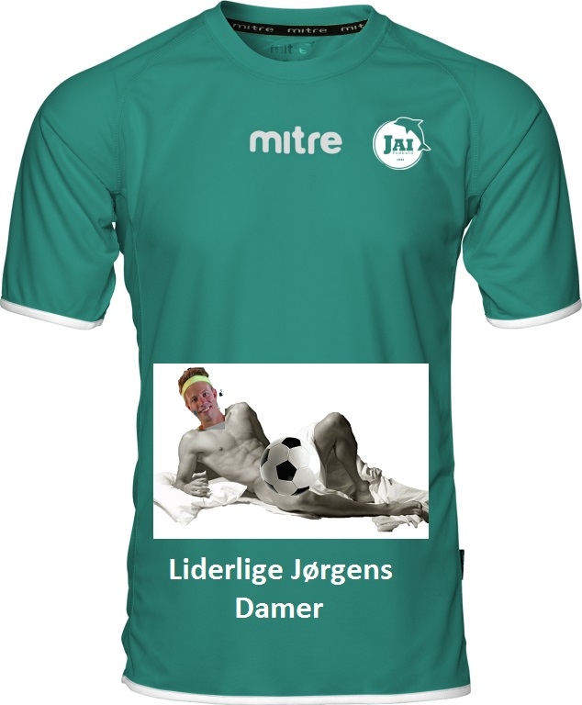

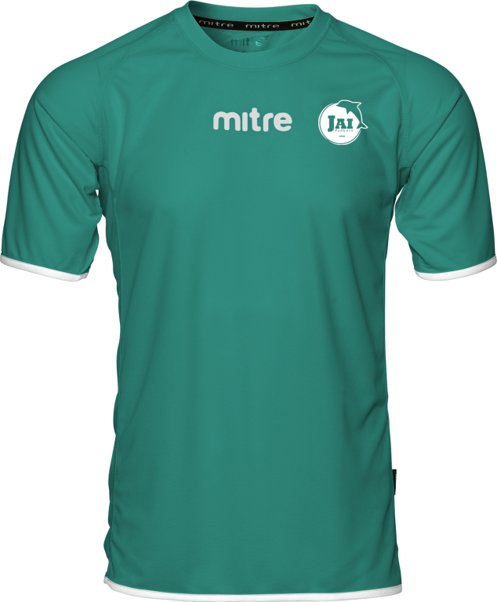

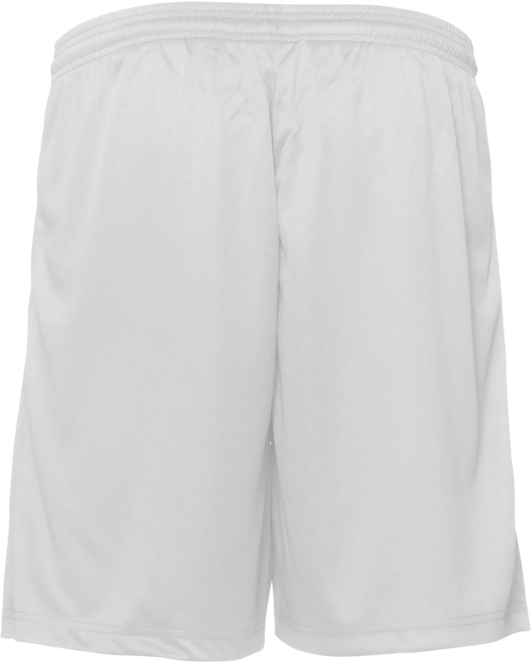
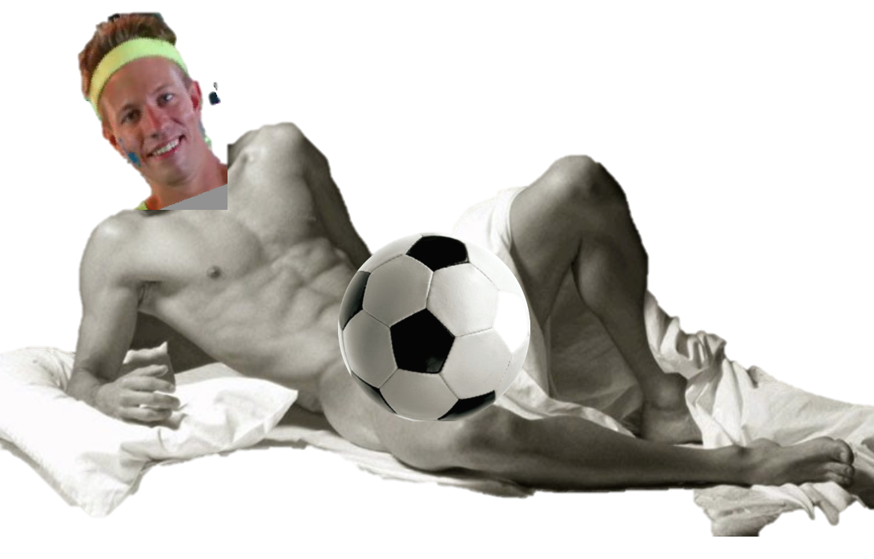
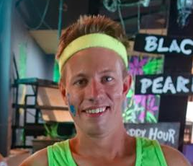


Pictures of me
(Maybe be included in the design as clipart, but is not mandatory)

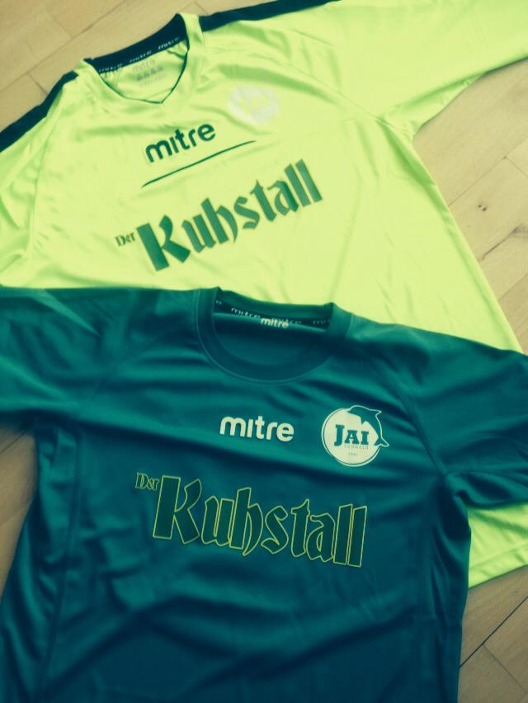
Another example with two colors.

