A font and color scheme we love
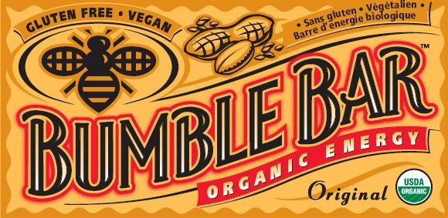
The bag we’ll be using (showcasing a different bakery’s product) Fantastic Vintage Butter Advertisement
