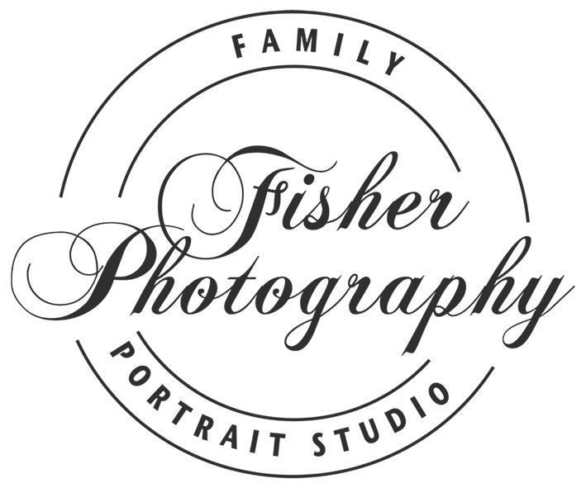
16/01/15
Hi Michelle,
Well, well, well... Who’d have imagined that your recent visit to Bachetta Restaurant in North Cottesloe would win you a free portrait session (valued at $250) with a renowned Western Australian photographer?
Unless you’re one of those charmed people who seem to win everything they enter, this is probably a bolt from the blue... but yes, it’s true. You’re a WINNER!
This is your opportunity to possess the most beautiful photographic art of yourself and your loved ones. We’re looking forward to giving you the experience of a photography session you’ll never forget.
You’ll be asked to imagine your perfect backdrop. Will it be the ocean? A park full of beautiful flowers and greenery? Or perhaps you’d prefer a creative black and white studio session at our North Fremantle studio? The choice is yours.
After your session, we’ll arrange a cinema experience to highlight the many ways of presenting your beautiful images. We guarantee that your images will reflect personality, humour and love. Like so many of our clients, you’ll probably return in future years because our work really does keep on giving.
See yourself in a new light. All you need do now is pick up the phone and call Geoff to book your session. How easy is that?
Heartiest congratulations and best wishes,

Geoff Fisher
Phone 6468 5961

