Front page.

THANK YOU

FROM

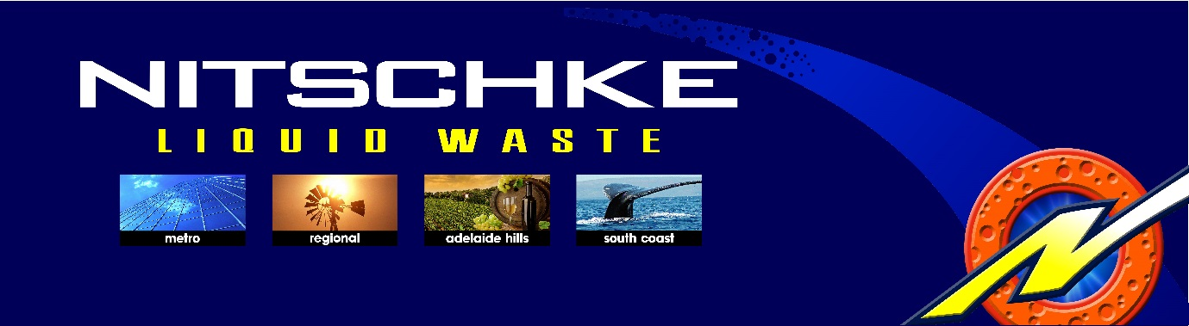

Second page.

A Warm Thank You from all the staff at Nitschke.
Customers like YOU are the foundation of our business.

We appreciate having YOU as a customer and we look forward
to providing you with the best possible service into the future.

PS as an added value if you refer any purchasing grease trap service
clients to Nitschke, YOU will receive your next service fee free of charge
to the value of $99.00. Price includes GST.

Warm regards 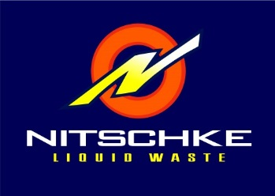

sales@nlw.com.au 08 8260 7660

Micheal Bolderoff
Business owner.

