March 30* 1836
Middle of the Week
*3/27/36 ....one week... 4/3/36*
*August 2, 1833..... sixtynine weeks..... Novenber *30, 1834... Seventy Weeks......(9:24-25)....* * *9/22/32.............A Thousand two hundred and ninety days.(12:11) ..............April 3,* 1836......1335 days (12:12) November 29, 1839* Scattered seven says
*6/4/31.Time, times, dividing of time (7:25) 11/30/34* *4/3/36..... 62 weeks..... 6/11/37*
* 12/16/29.......................................... .........Two Thousand and Three hundred days ..............................................................(8:13-14) 6/3/36* land of salt not inhabited
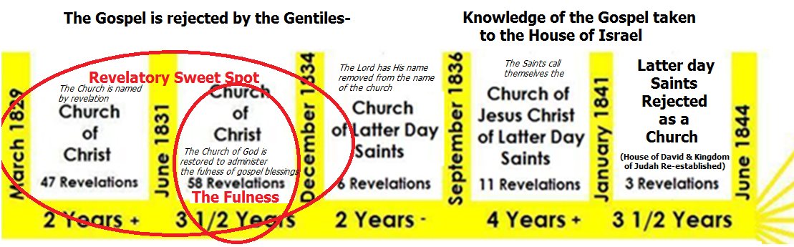

Snippets and scriptural passages that describe each of the five time periods are listed below. They need to go between the pillars
" if the people of this generation harden not their hearts, I will work a reformation among them ( double entendre) ..If this generation do harden their hearts against my word, behold I will deliver them up unto Satan" *The Church of Christ comes out of the wilderness *Aaronic and patriarchal/Evangelical Authority to administer saving ordinances is restored by angels *Saints commanded to go to Ohio to escape the enemy-Law & endowment* The "foundation" is being laid for the Church of God, City of Zion, Stake of Zion, Temple and a great work * "All Flesh is corrupt * "even the few that doeth good have corrupt minds * New York Saints commanded to go to the Ohio to, get the "Law" and "endowment of power" which was necessary to prevent the enemy in secret chambers from bringing to pass their destruction in process of time *Five year strong hold in Kirtland (Jerusalem) promised | "The authority of the Melchizedek Priesthood was manifested and conferred for the first time" * Church of God Restored * Fulness of the Gospel/Priesthood Restored & Rejected *True and Living Church is "nourished" for a 3 1/2 Year Period then flees back into the wilderness * First Laborers Called, Elected and Sanctified *"The covenant.. has been renewed and confirmed upon you ..for the sake of the whole world" *Saints must wait for a little season of chastisement and learning to live laws of Zion*"Verily condemnation resteth upon you who are appointed to lead my Church.. and also upon the Church and there must be a repentance and a reformation.. in all things"*Name of Christ taken out of name of church* Joseph and Oliver enter into "Covenant of Tithing for the Continuation of [gospel] Blessings" enabling the Kirtland Temple to be finished despite the rejection of the fulness by the saints | "Condemnation resteth upon you who are appointed to lead my church.. and also upon the Church and there needs to be a reformation ..in all things" * ".. they have transgressed the laws, changed the ordinance, broken the everlasting covenant." The Name of Christ taken out of name of Church. * The saints petition God to begin to redeem Jerusalem from this very hour, begin to break the yoke of bondage from the house of David, and return the "children of Judah" to their lands of inheritance in America. This is preparatory to the grafting in of the House of Israel per Jacob 5 allegory *  an intervention delays the curse that devours the earth * "..to finish the transgression, and to make an end of sins, and to make reconciliation for iniquity, and to bring in everlasting righteousness, and to seal up the vision and prophecy, and to anoint the most Holy* | " I, the Lord, will to retain a strong hold in the land of Kirtland, for the space of five years, " Zion is not redeemed by September 11 1836 * "What could have been done more to my vineyard..[it] brought forth wild grapes?  I will take away the hedge thereof, and it shall be eaten up; and break down the wall thereof, and it shall be trodden down" * The Temple is Defiled * The failure of the Kirtland Safety Society * mass Kirtland apostasy *Joseph and Sidney flee Kirtland*"All Flesh is corrupt* "this [?] is a year of jubilee to us"* "Something new must be done for the salvation of the church" to preserve the roots *Foreign missions established * Gospel preached in England* Saints flee Kirtland * Missouri Mormon War *Secret establishment of the Danites" Affidavit by Marsh and Hyde | " I am well pleased with your [atonement] offering .." * The fulness of the Priesthood has been lost and taken away. * "ye shall be rejected as a church with your dead" * "He stated that Hyrum held the office of prophet to the church by birth-right & he was going to have a reformation and the saints must regard Hyrum for he had authority"*"Said he would not prophecy any more.--Hyrum should be the prophet"* "The spirit of whoredoms hath caused them to err" * "Throne of David and Kingdom of Judah established * "..we anounce the martyrdom of Joseph Smith the prophet and Hyrum thepatriarch.." * If he commit iniquity, I will chasten him with the rod of men, and with the stripes of the children of men: But my mercy shall not depart away from him," *

Prophetic time sequences during the LDS Restoration from the Book of Daniel (TO BE PLACED DIRECTLY UNDER THE TIMELINE)
Dan 8:13-14 There is 2300 days between the revealing of the daily sacrifice (D&C 20:37 See also D&C 59:8 ) and when it comes to an end in the temple. December 16........ April 3 1836
Dan 7:21-27 The Horn will overcome the Saints until a 3 1/2 year period which begins with restoration of Melchizedek Priesthood and ends with Condemnation of Church. June 5 1834.........December 5 1835
Dan 12:11 From the time that many are made white (Section D&C 84:33, 42-48 ) and are tried, until the daily sacrifice is taken away, April 3 1836 there will be 1290 days. Sept 21 1832...... April 3 1836
Dan 12:12 1335 days after the daily sacrifice is made someone is blessed for waiting See Joseph's petition before congress in behalf of Jackson saints. April 3 1836.........Nov 29 1839
Dan 9:24-25 139 weeks (69 +70) from the commandment to build the city (D&C 94) until the transgression is finished (D&C 110) August 2 1833....... April 3 1836
Dan 9:26 62 weeks after the transgression is finished that Messiah will be cut off. Adding 62 weeks to brings us to the High Council decision to reject the law of God April 3 1836... June 11 1837
Dan 9:27 He shall confirm the covenant with many for one week. (D&C 109 & 110) Sunday March 27th.....April 2 1836
Dan 9:27 In the midst of the week, (middle) the sacrifice and oblation was performed for the last time Wednesday March 30
