Timeline Comments 5
Again- This is looking fantastic.
Here is the final group of adjustment changes.
Adjustment directions #1
I would like to have all text on the graphic using the exact same font type for general consistency. Also, the text in the boxes within each of the five time periods of Joseph's ministry should represent the smallest font on the entire graphic. In other words, there should never be any text with a smaller sized font that that. I will be making the banner large enough so that the text in those boxes is readable and legible. If there are smaller fonts in other places they would not be easily decipherable. Therefore, the text in the box shown below needs to be made larger. It should be at least as large as the font in the five periods. If there is any other text on the large graphic that has smaller font, it needs to be enlarged.
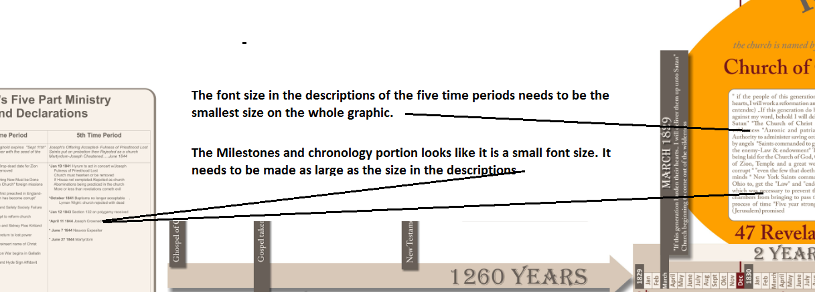
Adjustment directions #2
The eight point summary of 3 Nephi 16 needs to look similar to the other text boxes on the graph. I apologize for not explaining that. I grabbed a graphic that I had previously created instead of retyping it and it did not occur to me to explain that the box in the graphic did not need to be created. (also correct the word "summary")
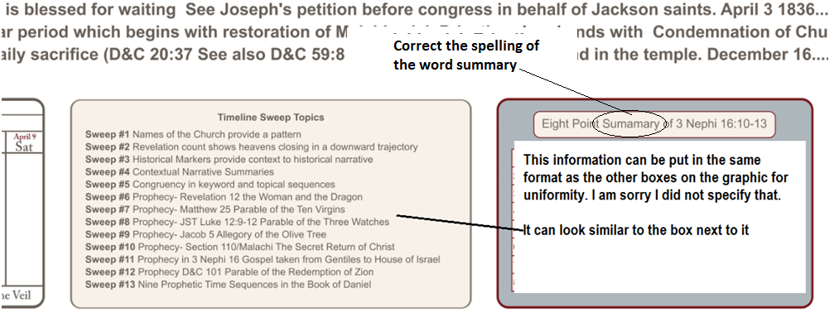
Adjustment directions #3
I would like to visually demonstrate that once the Marvelous Work begins, that the fulness will return to the earth. I would like to accomplish this by putting "the fulness returns" under the Marvelous Work, in a circle with the same color that is used in the five period timeline when the fulness was on the earth for 3 1/2 years.
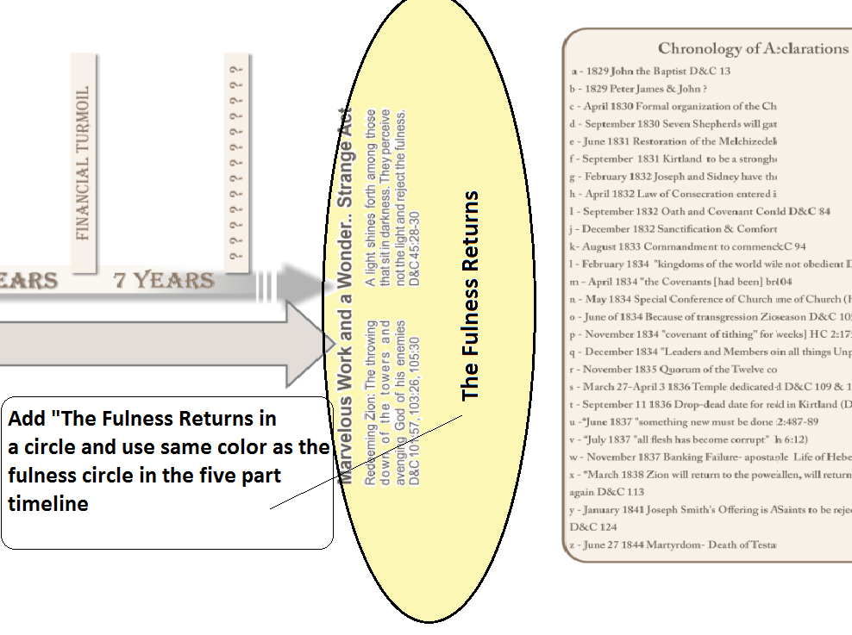

Adjustment directions #4
Add the following header for the Daniel summary "Summary of the Prophetic Narratives from the Book of Daniel"
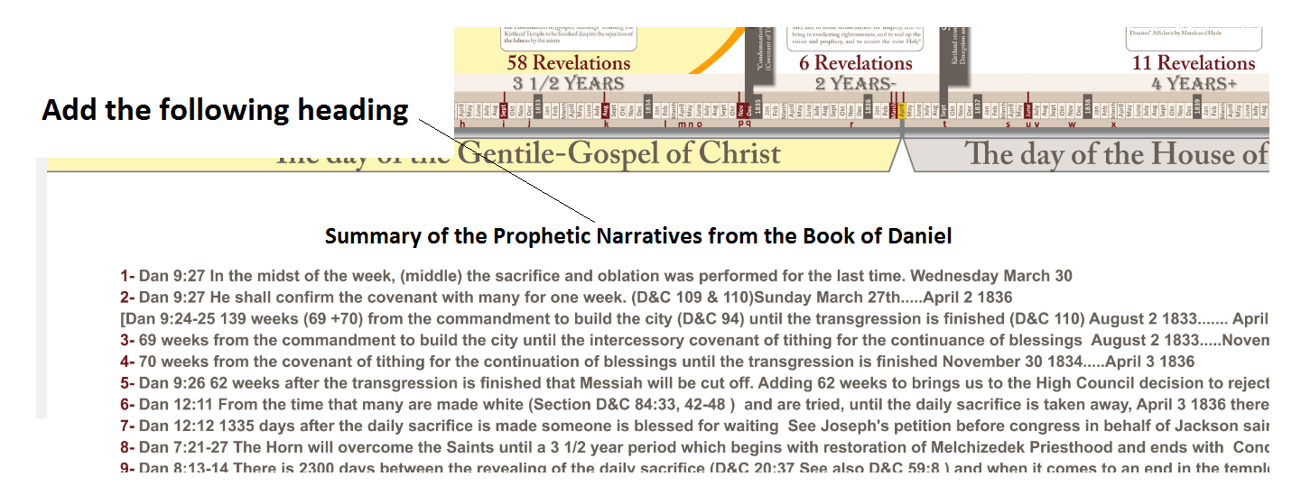
Adjustment directions # 5
Add the spacing in the text box shown below
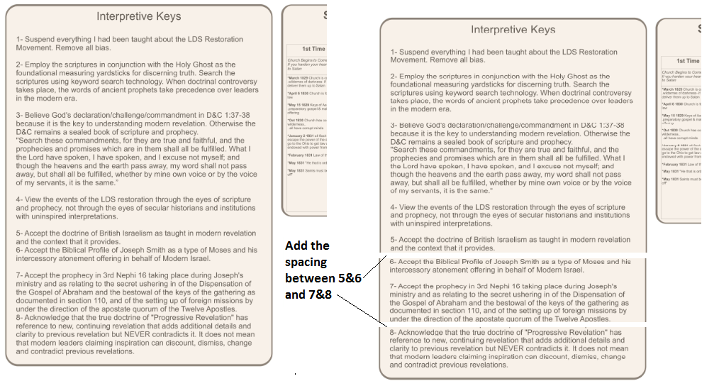
Adjustment directions # 6
In my last request I provided the graph below with three different scripture passages but forgot to provide the text for the first scripture passage. I apologize for that oversight. Here is the text to be included:
"The earth also is defiled under the inhabitants thereof; because they have transgressed the laws changed the ordinance, broken the everlasting covenant." Isaiah 24:5
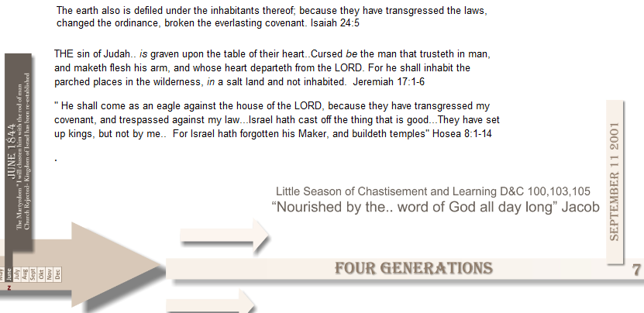

Adjustment #7

Lets put a border around the two weeks and put the header "Eight Day Temple Atonement Protocol"
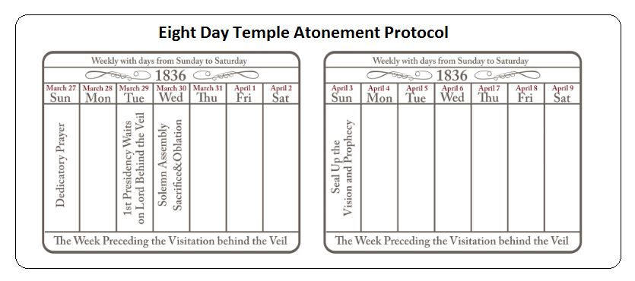
Adjustment #8 General Layout

I would like to adjust where some of the text boxes and graphics are placed and then put a boarder around everything.
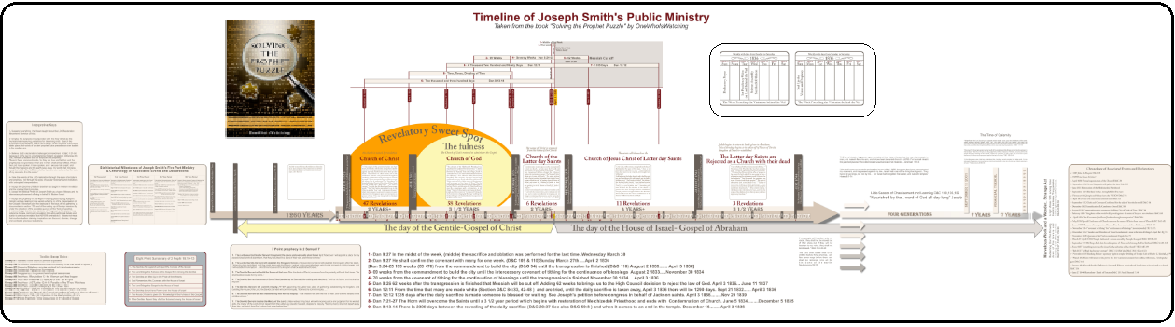
Final Spell Check:
After the above changes are made I will send to the editor to check spelling and grammar. You have been very generous in allowing me to make some alterations from the original specs thank you very much.

