Timeline Comments 4
This is looking fantastic.
I am really pleased with how this has come together. I believe (hope) these will be the last requested changes once we get these changes approved. Once you have made these changes we will need to have my editor provide grammar and spelling repairs.
I had to make a few more changes from the original brief. I would suggest that I increase the agreed upon amount by $100. I also plan on paying a bonus on top of that for the great work you have done. Does that sound fair to you?
Adjustment directions #1
At the end of the timeline we need to put the following vertical text:
"Marvelous Work and a Wonder.. Strange Act"
also the following two sets of text needs to follow:
"Redeeming Zion: The throwing down of the towers and avenging God of his enemies D&C 101:57, 103:26, 105:30"
"A light shines forth among those that sit in darkness. They perceive not the light and reject the fulness. D&C 45:28-30"
(by the way, "turbmoil" should be spelled "turmoil")
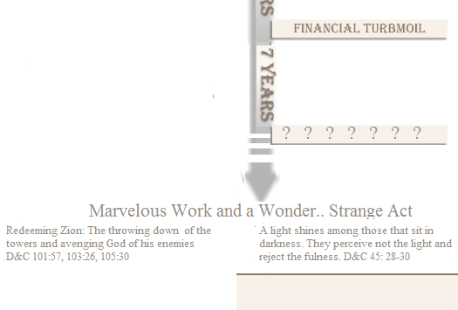

Adjustment directions #2
Above the area with the two seven year periods reading horizontally I need the following text
The Time of Calamity
" Wherefore, I the Lord, knowing the calamity which should come upon the inhabitants of the earth, called upon my servant Joseph Smith, Jun., and spake unto him from heaven, and gave him commandments; And also gave commandments to others, that they should proclaim these things unto the world; and all this that it might be fulfilled, which was written by the prophets—" D&C 1:17-18

"We know that thou hast spoken by the mouth of thy prophets terrible things concerning the wicked, in the last days—that thou wilt pour out thy judgments, without measure; Therefore, O Lord, deliver thy people from the calamity of the wicked; enable thy servants to seal up the law, and bind up the testimony, that they may be prepared against the day of burning." D&C 109:45-46

"O that they were wise, that they understood this, that they would consider their latter end!.. To me belongeth vengeance, and recompence; their foot shall slide in due time: for the day of their calamity is at hand.." Dueteronomy 32:29-36

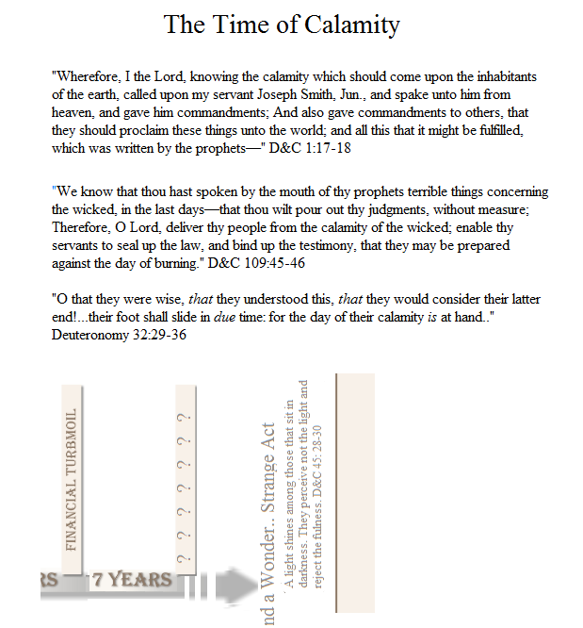

Adjustment directions #3
I would like to illustrate the change over from "The day of the Gentile-Gospel of Christ", to "The day of the House of Israel- Gospel of Abraham" The day of the gentile needs to extend to the left all the way to the "preaching of the gospel to the gentiles" historical marker. "The Day of the House of Israel- Gospel of Abraham" needs to extend all the way to the right until just before "Marvelous Work and a Wonder".
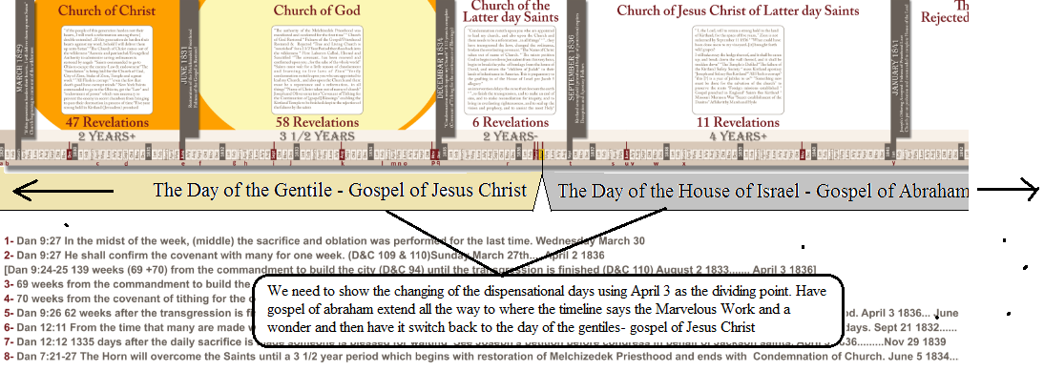
Adjustment directions #4
I want to show the following text at the place indicated on the graphic below (keep in mind that there will be the colored area showing the day of the House of Israel between the text and the arrow
"If my people will hearken unto my voice.. they shall not be moved out of their place..but if they will not hearken to my voice..they shall not be blessed.." D&C 124:45-46
The Lord shall cause thee to be smitten before thine enemies.. and flee seven ways before them: and shall be removed into all the kingdoms of the earth. Deuteronomy 28:25
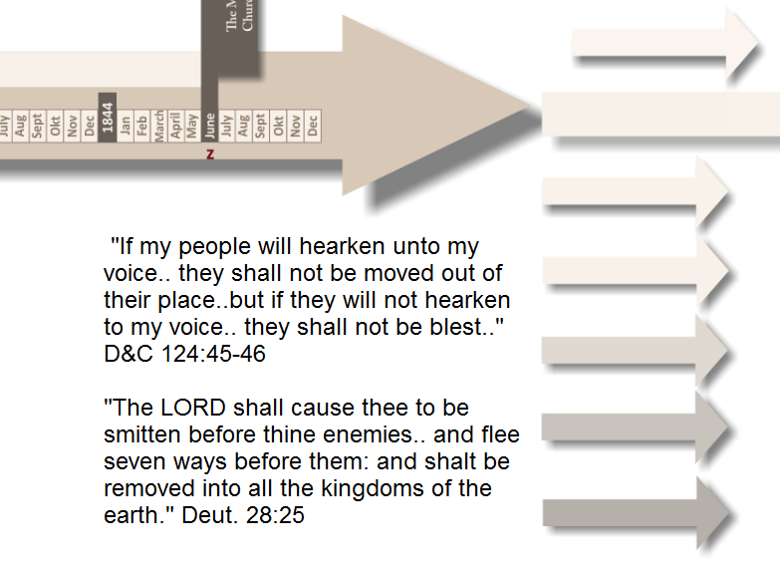
Adjustment directions # 5
Lets get rid of the two unpopulated text boxes to the right of the five part timeline
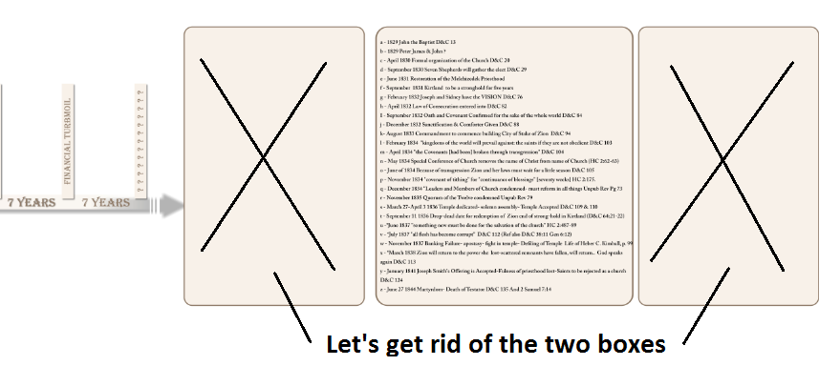

Adjustment directions # 6
We need to put a title above the remaining box that has been filled in with the a, b, c, listing, to the right of the timeline
"Chronology of Associated Events and Declarations"
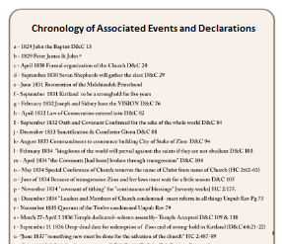
Adjustment directions # 7
Please put the following two passages above the timeline that says "four generations"
THE sin of Judah.. is graven upon the table of their heart..Cursed be the man that trusteth in man, and maketh flesh his arm, and whose heart departeth from the LORD. For he shall inhabit the parched places in the wilderness, in a salt land and not inhabited. Jeremiah 17:1-6
" He shall come as an eagle against the house of the LORD, because they have transgressed my covenant, and trespassed against my law...Israel hath cast off the thing that is good...They have set up kings, but not by me.. For Israel hath forgotten his Maker, and buildeth temples" Hosea 8:1-14

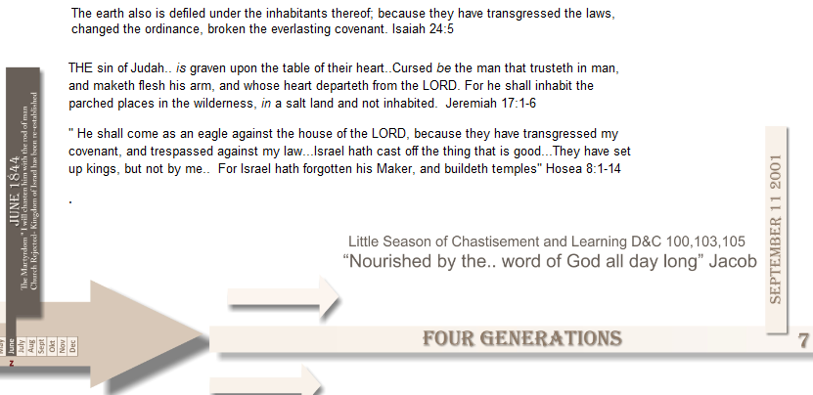
Adjustment directions # 8
We can now add the part of the graphic that is to the left of the five part history of the church. The horizontal timeline leading from Christ's earthly ministry toward the five part timeline can be similar looking to the five part timeline and the horizontal timeline that leads to the Marvelous Work and a Wonder. The three pillars (historical markers) can also be similar looking as the others. The scripture that is between the two pillars is as follows.
"And the woman fled into the wilderness, where she had a place prepared of God, that they should feed her there a thousand two hundred and threescore years." JST Rev 12:5
The text on the pillars from left to right is as follows:
"Gospel of Christ Rejected by Jews-Meridian of Time"
"Gospel taken to the Gentiles by Twelve Apostles"
"New Testament Church flees into Wilderness- 570 AD

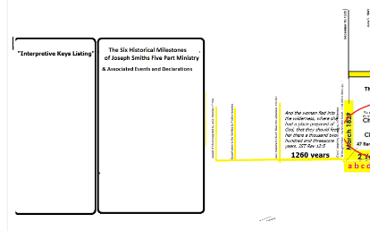
Adjustment directions #9
Populate the box furthest to the left with the following text
Interpretive Keys
1- Suspend everything I had been taught about the LDS Restoration Movement. Remove all bias.
2- Employ the scriptures in conjunction with the Holy Ghost as the foundational measuring yardsticks for discerning truth. Search the scriptures using keyword search technology. When doctrinal controversy takes place, the words of ancient prophets take precedence over leaders in the modern era.
3- Believe God's declaration/challenge/commandment in D&C 1:37-38 because it is the key to understanding modern revelation. Otherwise the D&C remains a sealed book of scripture and prophecy.
"Search these commandments, for they are true and faithful, and the prophecies and promises which are in them shall all be fulfilled. What I the Lord have spoken, I have spoken, and I excuse not myself; and though the heavens and the earth pass away, my word shall not pass away, but shall all be fulfilled, whether by mine own voice or by the voice of my servants, it is the same."
4- View the events of the LDS restoration through the eyes of scripture and prophecy, not through the eyes of secular historians and institutions with uninspired interpretations.
5- Accept the doctrine of British Israelism as taught in modern revelation and the context that it provides.
6- Accept the Biblical Profile of Joseph Smith as a type of Moses and his intercessory atonement offering in behalf of Modern Israel.
7- Accept the prophecy in 3rd Nephi 16 taking place during Joseph's ministry and as relating to the secret ushering in of the Dispensation of the Gospel of Abraham and the bestowal of the keys of the gathering as documented in section 110, and of the setting up of foreign missions by under the direction of the apostate quorum of the Twelve Apostles.
8- Acknowledge that the true doctrine of "Progressive Revelation" has reference to new, continuing revelation that adds additional details and clarity to previous revelation but NEVER contradicts it. It does not mean that modern leaders claiming inspiration can discount, dismiss, change and contradict previous revelations.
Adjustment directions #10
To the left of the two weeks at the bottom of the chart I need the following seven part prophecy
7 Point prophecy in 2 Samuel 7
- The Lord uses his Davidic Servant to appoint the place and eventually plant Israel in it."Moreover I will appoint a place for my people Israel, and will plant them, that they may dwell in a place of their own, and move no more."
- The Lord's Davidic Servant will establish the Kingdom forever. A descendent of David will establish the kingdom after his death. "When thy days be fulfilled, and thou shalt sleep with thy fathers, I will set up thy seed after thee, which shall proceed out of thy bowels, and I will establish his kingdom . . . And thine house and thy kingdom shall be established forever."
- The Davidic Servant will build the House of the Lord. After the death of David, someone from his posterity will build the House. "He shall build an house for my name.."
- The Davidic Servant becomes of Son of God (sealed up to Eternal Life- calling and election). "I will be his father, and he shall be my son.”
- The Davidic Servant will commit iniquity. AFTER appointing the Latter-day place of gathering, establishing the kingdom, and building the House of the Lord, the Davidic Servant will commit iniquity. "If [when] he commit iniquity . . ..”
- The Davidic Servant will be chastened by men for his Iniquity. "I will chasten him with the rod of men, and with the stripes of the children of men."
- The Davidic Servant retains the Mercy of the Lord. Unlike wicked King Saul, who will receive justice and judgment for his wicked acts, the mercy of the Lord will not depart from the Latter-day Davidic Servant, despite his iniquity. "But my mercy shall not depart away from him, as I took it from Saul, whom I put away before thee."

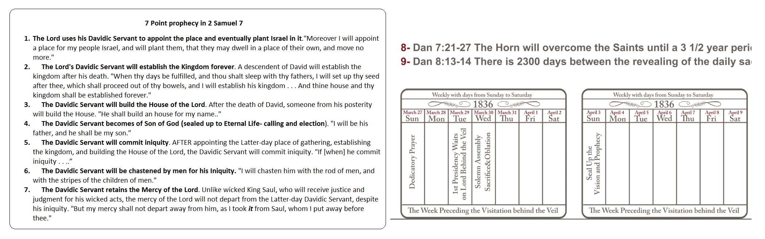

Adjustment directions #11

The next box to the right of the above box needs to have the following text:
Six historical Milestones of Joseph Smith's Five Part Ministry & Chronology of Associated Events and Declarations
Six Historical Milestones  of Joseph Smiths Five Part Ministry  1st Time period begins.....March 1829  Church Begins to Come out of Wilderness  If you harden your heart I will deliver you to Satan  2nd Time Period begins.....June 1831  Restoration of the Melchizedek Priesthood  Revealing of the Man of Sin, the Son of Perdition  3rd Time Period begins..... December 1834  Condemnation resteth upon entire Church  Church must have a Reformation in "all things"  4th Time Period begins.....September 1836  5 Year Kirtland Stronghold expires "Sept 11th"  The Dragon makes war with the seed of the woman  5th Time Period begins.....January 1841  Joseph's Offering Accepted- Fulness of Priesthood Lost  Saints put on probation then Rejected as a church  Martyrdom-Joseph Chastened.....June 1844 | Events and Declarations of the 1st time period  *March 1829 Church is coming out of the  .wildernes of darkness- if harden hearts I will .  deliver them up to Satan  *April 6 1830 Church is formally organized by law  *May 15 1829 Keys of Aaronic Priesthood for  .preparatory gospel & making acceptable offering  *Oct 1830 Church has come out of wilderness..  .all have corrupt minds  *January 2 1831 all flesh is corrupt-  escape the power of the enemy-  go to the Ohio to get law and be  endowed with power from on high  *February 1831 Law of the Gospel is given  *May 1831 "He that is ordained of God.."  *May 1831 Saints must be organized or "cut off" | Events and Declarations of the 2nd time period  *June 4 1831 Melchizedek Priesthood restored  *Sept 11 1831 Kirtland stronghold five years  *Oct 25 1831 fulness gospel= fulness priesthood  *Nov 12 1831 "Church of God" is mentioned  *Jan 4 1833 the fulness of gentiles has come in  . and they are rejecting the gospel  *Dec 1833 "..that call themselves by my name."  *February 24 1834 Conditional Promise- .  A kingdom will prevail from this very hour  *April 23 Covenant broken through transgression  *May 3 1834 Christ taken out of name of church  *June 22 1834 Zion must wait little season  *Jun 23 1834 15 HP to gather strength of house  *Nov 29 1834 Covenant Tithing-Cont of Blessings
Events and Declarations of the 3rd time period  *December 5 1834 leaders & church condemned  *Feb 14 1835 Quorum of 12 called- 3 witnesses  *July 1835 Joseph translates Book of Abraham  *November 3 1835 Quorum of 12 condemned  *Jan 21-Feb 6 1836 Holy anointing-washing feet  *March 27 1836 Dedicatory Prayer- Church to come forth..-  from this place..-let the anointing be sealed..-  Jerusalem redeemed from this very hour..  Yoke broken of house of David  *March 29 1836 1st Pres waited behind veil .  Petition for redemption of Zion- answer is no  *March 30 1836 Solemn Assembly failure M-T-W  *Apriil 6 1836 Christ returns in secret to temple .  Keys of gathering-Disp. of Gospel of Abraham  Anticipated endowment and last commission fail | Events and Declarations of the 4th Time Period  *September 11 1836 Drop-dead date for Zion  . Hedge of protection removed  * June 4 1837 "Something New Must be Done  .for the Salvation of the Church" foreign missions  *July 23 1837 Gospel first preached in England-  . "all flesh has become corrupt"  *November 1837 Kirtland Safety Society Failure .  Mass Apostasy ..attempt to reform church  *January 1838 Joseph and Sidney Flee Kirtland  *March 1838 saints to return to lost power  *April 26 1838 Saints reinsert name of Christ  *August 6 1838 Mormon War begins in Gallatin  *October 1838 Marsh and Hyde Sign Affidavit | Events and Declarations of the 5th Time Period  *Jan 19 1841 Hyrum to act in concert w/Joseph  Fulness of Priesthood Lost  Church must hearken or be removed  If House not completed-Rejected as church  Abominations being practiced in the church  More or less than revelations cometh evil  *October 1841 Baptisms no longer acceptable .  Lyman Wight: church rejected with dead  *Jan 12 1843 Section 132 on polygamy received  *Jan 12 1843 Section 132 on polygamy received  *April 11 1844 Joseph Crowned King of Israel  * June 7 1844 Nauvoo Expositor  * June 27 1844 Martyrdom

Adjustment directions #12
To the right of the two week calendar at the bottom of the chart I need the listing of Timeline Sweep Topics. To the right of that I need the Eight Point Summary of 3 Nephi 16:10:13
Timeline Sweep Topics
Sweep #1 Names of the Church provide a pattern
Sweep #2 Revelation count shows heavens closing in a downward trajectory
Sweep #3 Historical Markers provide context to historical narrative
Sweep #4 Contextual Narrative Summaries
Sweep #5 Congruency in keyword and topical sequences
Sweep #6 Prophecy- Revelation 12 the Woman and the Dragon
Sweep #7 Prophecy- Matthew 25 Parable of the Ten Virgins
Sweep #8 Prophecy- JST Luke 12:9-12 Parable of the Three Watches
Sweep #9 Prophecy- Jacob 5 Allegory of the Olive Tree
Sweep #10 Prophecy- Section 110/Malachi The Secret Return of Christ
Sweep #11 Prophecy in 3 Nephi 16 Gospel taken from Gentiles to House of Israel
Sweep #12 Prophecy D&C 101 Parable of the Redemption of Zion
Sweep #13 Nine Prophetic Time Sequences in the Book of Daniel
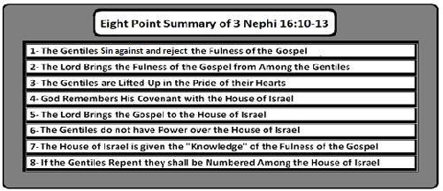

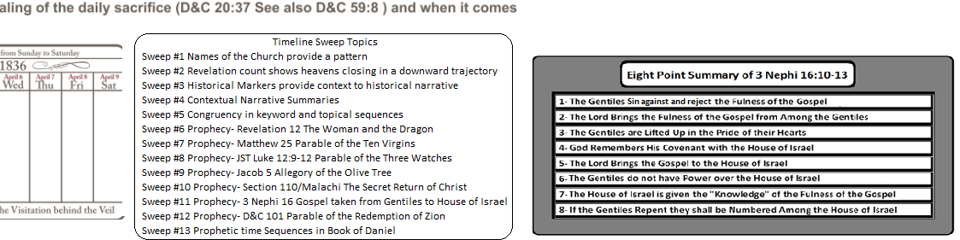
Adjustment directions #13
At the very top of the graphic I need the following title
Timeline of Joseph Smith's Public Ministry
Taken from the book "Solving the Prophet Puzzle" by OneWhoIsWatching
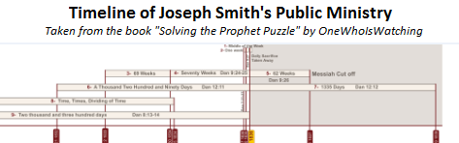

Adjustment directions #14

Once the above changes are made and approved. I would like two formats. One with the cover of my new book embedded into the far left of the graphic and the other without.
This is what the cover looks like:
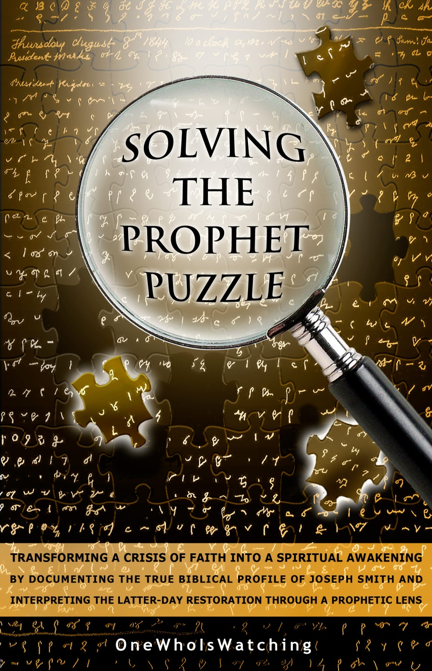
I would like each of these two graphics in the large format and also in the small pdf, like you provided before.
Thanks!!

