Timeline comments 3
This is looking fantastic. The weeks at the bottom look great.
Adjustment directions 1
a- I just realized that I should not have had the vertical time lines on the Daniel timeline at the top going up from the point of origination, only down. It is much cleaner looking and easier to understand that way. Please get rid of upward vertical lines as illustrated below.
b We need to make sure we are consistent looking with how all of the end periods look on the Daniel timeline. Some of the boxes end with black lines while others end with red lines. Lets make them all red lines. Also there is one with a little space between the timeline and the end of the box which will be accentuated when the grapic is blown up to banner size.
c- I had the "Messiah cut off "in the wrong place. Please move it over.
d- I did a poor job showing the three markers and the two weeks at the very top. Please clean it up per the example shown below. The first line to the left marks the beginning of the first week. The second line marks the middle of that week. The third line to the right marks the beginning of the next week.
e when the graphic is put in various programs it alters the colors. As you can see, the color for the fulness looks pale instead of bright yellow and the first circle looks yellow instead of light orange. See if you can make the color of the fulness circle a brighter yellow and the bigger circle more orange looking.
f- The revelatory sweet spot refers to both the first and second time periods, not just the first one. Please move the text "revelatory sweet spot" over a little so that it is in both circles.
-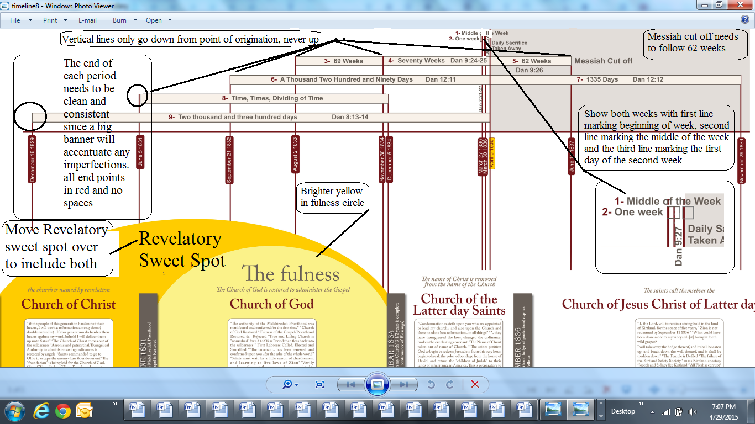
Adjustment directions 2
Lets extend the time line out a little further to show one more period of seven years with question marks at that point in time.
