Timeline Comments 2
I think you did a great job in dealing with the close proximity of March and April. The only other option I see is to scale the entire timeline bigger to provide more room which I don't want to do. So it is fine the way it is.
1941 is wrong. I don't know where it was, but if it had to do with Feb 5, it should be 1834 thank you for catching that!
There are a few spelling and grammar issues in a few places but we can clean those up at the end when my editor proof reads it.
The desired changes are below
Adjustment directions #1
a- Move "messiah cut off" higher to make room of "daily sacrifice taken away" which needs to be moved to the right side of the timeline.
b- Replace the "n" with an "h"
c- Remove the scriptural passage.
d- Add "One Week"
e- Make the vertical Daniel timelines and dates red (or perhaps same color as the names of church and the #of revelations) so they can be followed down to main timeline
f- show line going through middle of week
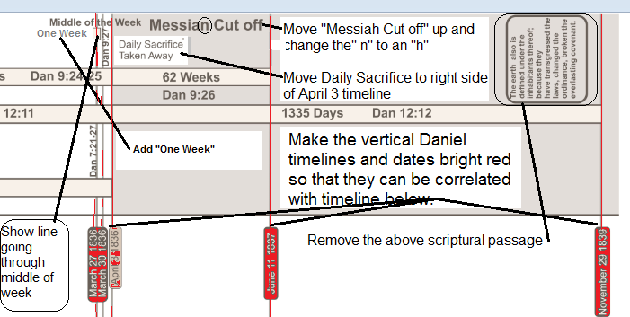
Adjustment directions #2
I just realized that I did not synchronize the Daniel listing of explanations shown below, in the same order as the Daniel timeline at the top of the chart. That would make it difficult for people to make sense out of it at a glance. I have put the summaries in the proper order with numbers so that the readers can easily match them up with the timelines at the top. The timelines at the top also need to be numbered.
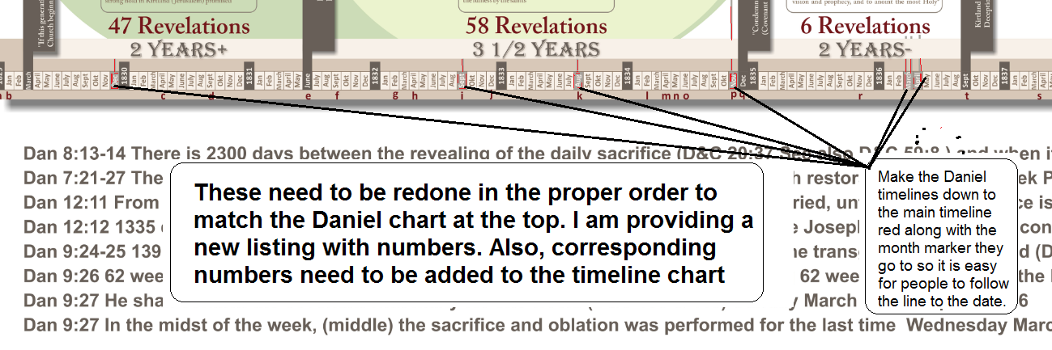
Here is the numbered reformatted Summary to be put under the five part timeline:
Prophetic time sequences during the LDS Restoration from the Book of Daniel
1- Dan 9:27 In the midst of the week, (middle) the sacrifice and oblation was performed for the last time. Wednesday March 30
2- Dan 9:27 He shall confirm the covenant with many for one week. (D&C 109 & 110)Sunday March 27th.....April 2 1836
[Dan 9:24-25 139 weeks (69 +70) from the commandment to build the city (D&C 94) until the transgression is finished (D&C 110) August 2 1833....... April 3 1836]
3- 69 weeks from the commandment to build the city until the intercessory covenant of tithing for the continuance of blessings August 2 1833.....November 30 1834
4- 70 weeks from the covenant of tithing for the continuation of blessings until the transgression is finished November 30 1834.....April 3 1836
5- Dan 9:26 62 weeks after the transgression is finished that Messiah will be cut off. Adding 62 weeks to brings us to the High Council decision to reject the law of God. April 3 1836... June 11 1837
6- Dan 12:11 From the time that many are made white (Section D&C 84:33, 42-48 ) and are tried, until the daily sacrifice is taken away, April 3 1836 there will be 1290 days. Sept 21 1832...... April 3 1836
7- Dan 12:12 1335 days after the daily sacrifice is made someone is blessed for waiting See Joseph's petition before congress in behalf of Jackson saints. April 3 1836.........Nov 29 1839
8- Dan 7:21-27 The Horn will overcome the Saints until a 3 1/2 year period which begins with restoration of Melchizedek Priesthood and ends with Condemnation of Church. June 5 1834.........December 5 1835
9- Dan 8:13-14 There is 2300 days between the revealing of the daily sacrifice (D&C 20:37 See also D&C 59:8 ) and when it comes to an end in the temple. December 16........ April 3 1836
The timelines at the top need to be numbered so that they match with the summaries at the bottom.
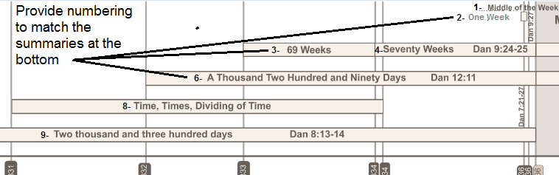
Adjustment directions #3
Lets keep the white background behind the text and also, lets try using the brighter colors to see how they look against the darker colors of the timeline
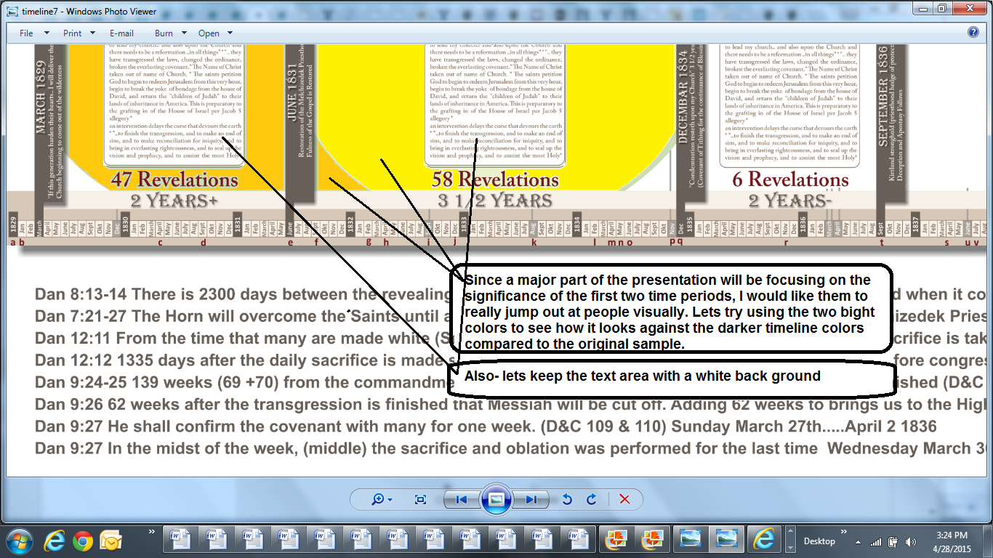

Adjustment #4 The small italic text on these two need to have a little more space between them and the large bold text of the name of the church.

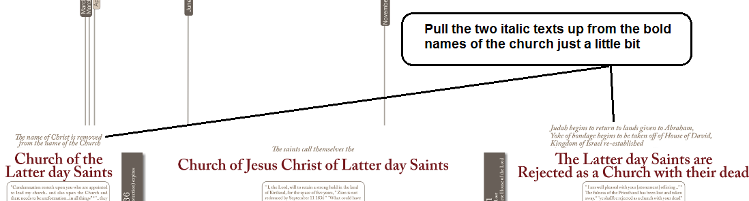
Adjustment directions #5
I need some kind of graphic at the bottom that depicts the seven days of the Temple ritual beginning with the dedication of the temple on March 27 1836 and showing the how the Vision behind the veil took place on the eighth day (first day of the next week) Sunday to Sunday. The week needs to also document the Zion petition behind the veil by the 1st Presidency on Tuesday the 29th and the Solemn Assembly on Wednesday the 30th (the midst of the week) according to Daniel.
I don't need two graphics.. I simply put two of them as ideas and top provide the concepts I want to provide. Please be sure to include exact dates.
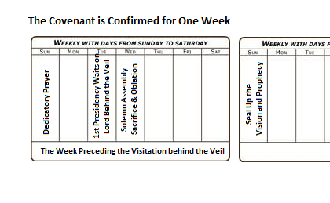
After these changes are made, it seems like we will be 80% done and the rest should move pretty quickly. Pretty much copy and paste text in boxes. You are doing a great job I am very happy with what you are doing.
Thanks!

