Timeline Comments 1
This is looking good. I am concerned about being able to use this graphic as both a large banner for doing presentations and also a fold out in a book. I think the text between the collums will be large enough in a really large banner perhaps four feet vertical and 8 or 10 feet horizontal... but as a fold out in a large book, I am concerned whether the text between the pillars will be legible. Any suggestions? Perhaps we do one version without the text between the pillars? I don't know..
Here are the adjustments for this part of the project
Adjustment directions #1
I want to try to have a general look of consistency throughout the timeline. Each of the five groups of text that I provided to be put between the pillars, are about 150 words long so they are about the same length. I would like to have them each put in a border and kept the same size, then they can be centered between the pillars. Although there will be more white space in the longer time frames, this will provide a more standardized look. (I used the same text in the sample for convenience, in reality they would have different content)
The following graphic illustrates the general concept
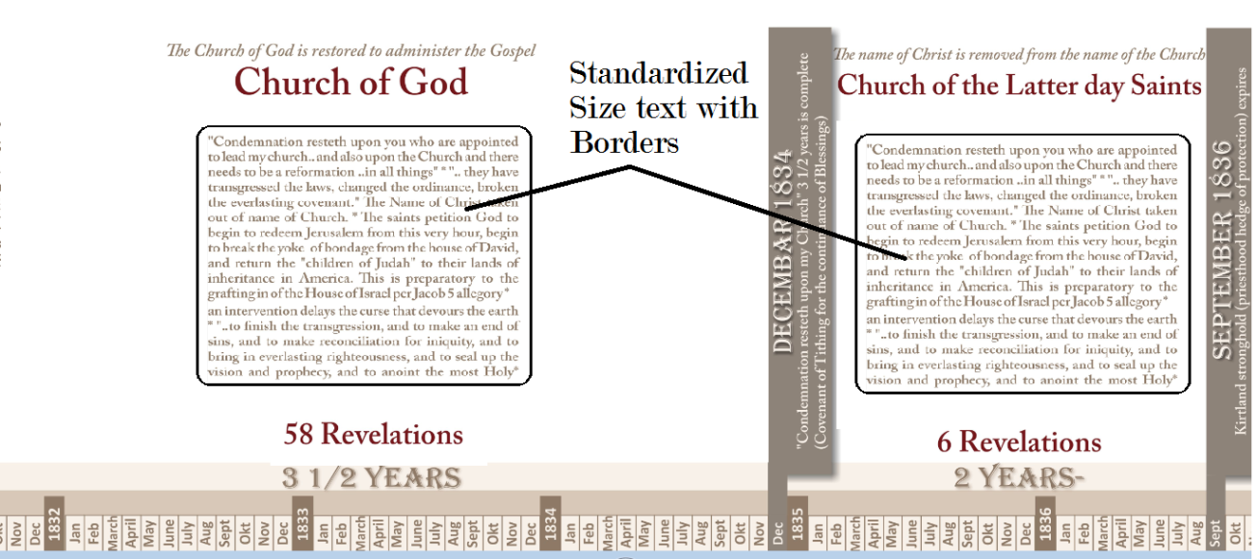
Adjustment directions #2
I need the font bigger on the names of the church and also on the number of revelations and number of years
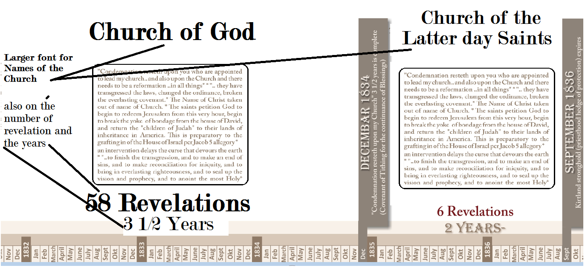
Here is a possibility for the longer church name in the last period:
"Latter day Saints
Rejected as church
With Their Dead"
Adjustment directions #3
Bring the dates for the Daniel timeline to the end of each sentence and pull the one arrow out just a little

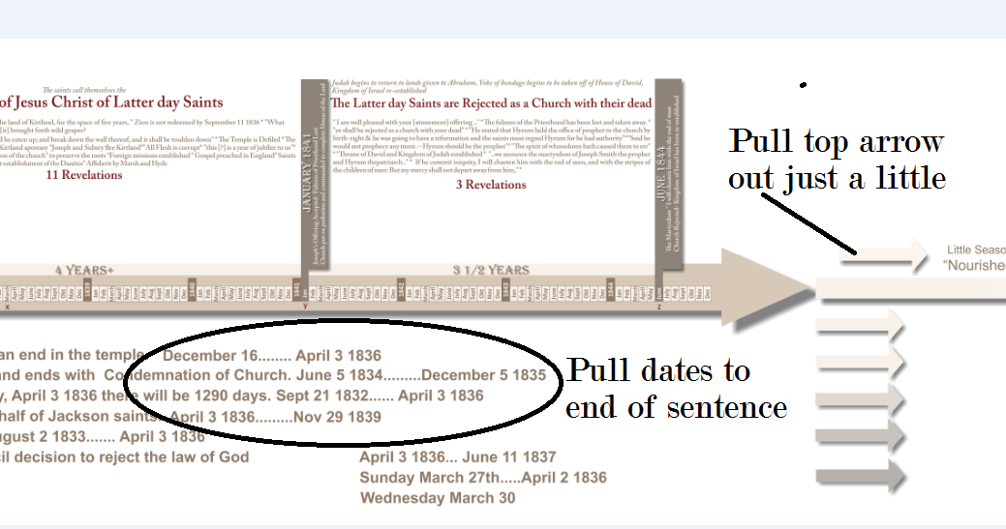
Adjustment directions #4
We need to extend the length of the pillar to avoid cutting off of any letters and we need the date and events on the pillars to stand out.
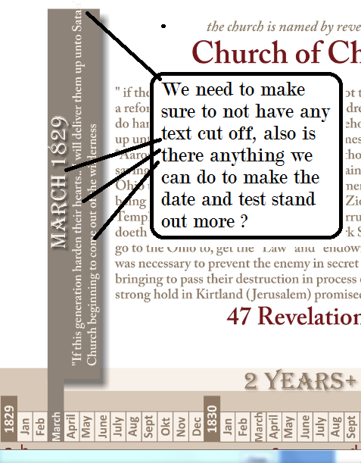

Adjustment Directions #5
Lets pull the text up just a little
Also, I have a few more scriptural snippets I will be providing for the designated area.
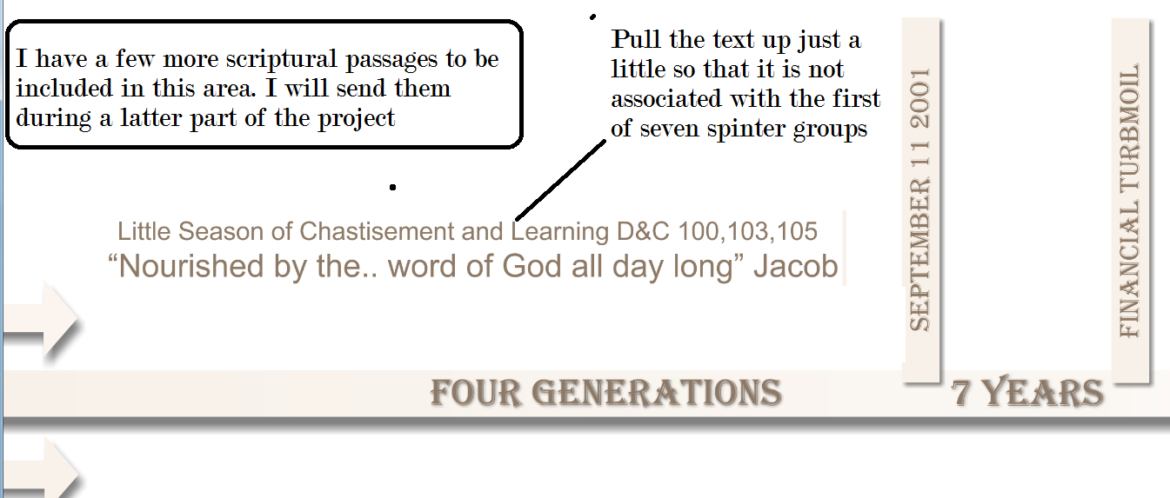
Adjustment Directions #6
Lets have the timeline fade instead of break and also we are missing some of the alphabetic listing of events. They should go all the way to "z"
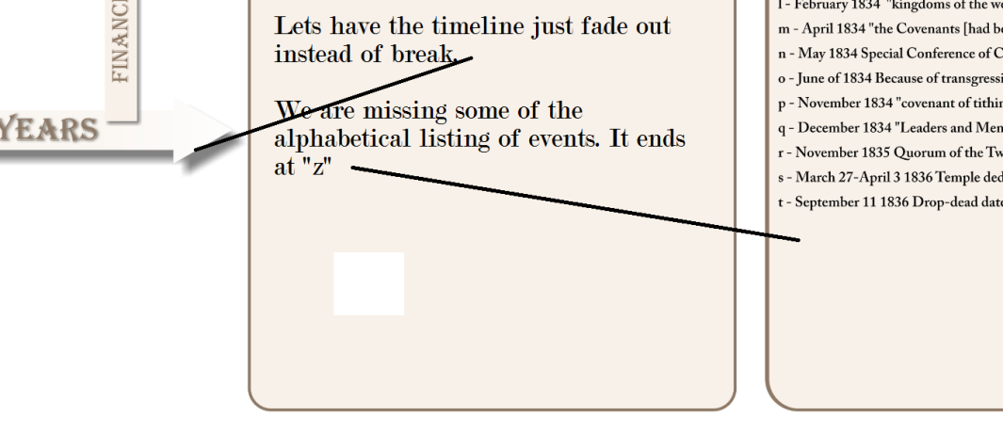

Adjustment Directions #7
Once the above changes have been made and approved, we need to put the colored circles in to designate the two periods of the revelatory sweet spot and the one period when the fulness of the gospel was on the earth. I don't know what colors to use. I like how conservative you have been with the colors so far. I do want these areas to stick out, but I don't want to detract from the professional coloring. I am open to suggestions.

The scriptures spell fulness with one "l" and the common dictionary spells it with two "l"'s "fullness". For now let's spell it with one "l" and I will consult my editor when be do the final spell check.
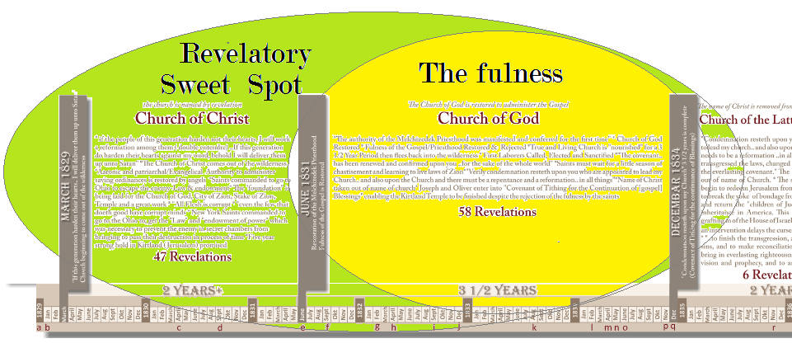

This is really starting to take shape I am really excited about this. You are doing a fabulous job. I really like the general look of the timeline.... and the dates at the bottom and the alphabetical markers really turned out well!
I will be looking forward to reviewing the adjustments and will be getting ready to send the next installment of directions.

