Briefing landing page Pivot Gadget

- http://tablegrideditor.com/ use this as a reference page for in case this document is not clear enough

- The horizontal lines in this document refer to the different sections that should be on the website

- Make sure everything that is clickable on the website of the Table Grid Editor, is clickable on the website of the Pivot Gadget

- Make sure that the different sections have different urls so we can analyse these different sections in Google Analytics as different page views

- Besides that, feel free to experiment and to create something cool in your style, as long as all the given information is on the website

- Completely at the top comes the banner with on the left side the logo of the Pivot Gadget and totally at the right side the logo of iDalko. This logo expands from the complete left till the complete right side. Banner:

 logo
- Under this logo, the buttons ‘home’, ‘use cases’, ‘features’, ‘pricing’ en ‘contact’ must come on the right side

- Then the introduction text should be placed. This introduction text is

“The Pivot Gadget is an advanced reporting tool that helps you visualize key information in a multidimensional table. Customize this add-on by quickly designing cross tabulations across a long list of dimensions and aggregations. The Pivot Gadget helps you with your issuetracking, for example by making it possible to track and compare your time spent on every issue.”

- The title of this introduction text is ‘Turn your JIRA data upside down”

- As on the website of the Table Grid editor, this text should be placed on the left side with under the text two buttons “try it for free” and “buy now”

- For the right side of the text, create a cool image(s) of the Pivot Gadget, feel free to experiment, as long as its clear (see http://tablegrideditor.com/). You can find more relevant pictures in the attachment.

- Under this section, a customer review should be placed in a bar which is formatted in a color that matches the colors of the Pivot Gadget logo.

- The review in this bar should be

“This plugin gives you instant statistics about your project on a very flexible way. I didn't need any documentation to use the gadget. The support of iDalko is also very good. I had an issue/question with the gadget and created a support case and within a day I already iDalko solved/answered my support case.”

- Show the 4 review stars

- Present 3 use cases next to each other with the main title:“This multifunctional advanced reporting tool allows you to”

- Compare estimated time with time spent (title)
Manage workload and draw attention to overtimes (copy)
Picture:

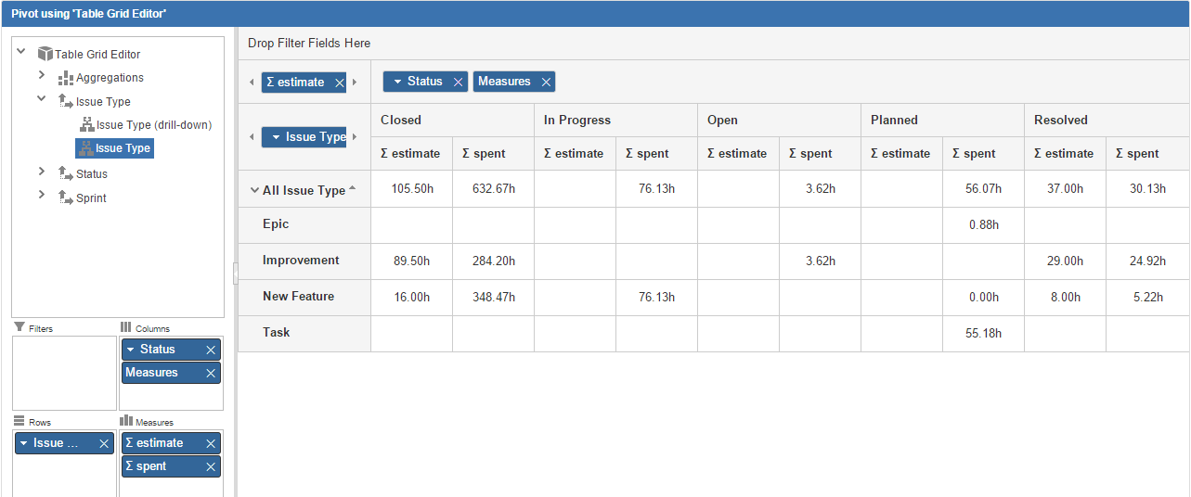

- Create dynamic status reports (title)
Timeframe your amount of work and overview your current sprint status (copy)
Picture:
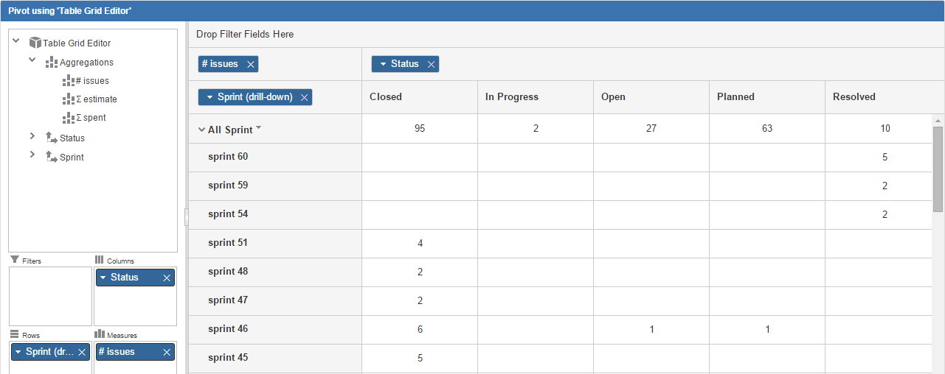

- Overview support requests created by customers (title)
Assess the estimated quality of your team members per issue type and how many tickets with different statusses have been reported by each reporter (copy)
Picture:

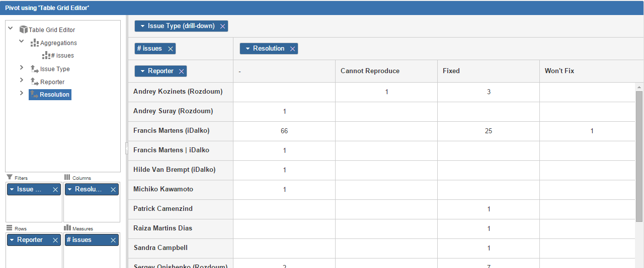

- Below the three use cases, present the features section with the title “Features” (take a look at http://tablegrideditor.com/):
The Pivot Gadget is packed with useful features allowing you to easily manage any information right within your JIRA issues. (copy)
- Multidimensional: create a multidimensional matrix by combining different dimensions and aggregating over different types of values.
Example icon(you may use or create other icons if you wish; this is just a suggestion): 
- Time tracking: besides counting issues, this add-on also allows timetracking aggregations such as sum of original estimate, remaining estimate, time spent. b

example icon:
- Drill down function: get a detailed view of the information behind the issue thanks to the drill down function
Example icon: 
- Quick visualisation: obtain instant statistics by constructing a direct overview of your data

Example icon:

- Pivot your Table Grid Data: Combine the strengths of the Table Grid Editor with the Pivot Gadget
Icon?

- Then comes the pricing and license information section. Use the title “Countless uses in one easy-to-use add-on” (title)
- And add the text:

“Thanks to the Pivot Gadget’s, it is now possible to do much more with your JIRA data. This add-on is incredibly easy to use. Did you know you can even pivot your Table Grid Editor data? There are packages available for every size organization. (copy)
- Make a ‘prices’ and ‘license details’ section (it should be presented just as on the website of the Table Grid Editor)

- Lifetime license: same as Table Grid Editor website
- Table grid editor users: are entitled for a 50% discount. Contact us for more info.
- Discounts for academic users: same as Table Grid Editor website
- Free for non-profits and open source projects: same as Table Grid Editor website
Prices: License details
10 users  25 users  50 users  100 users  250 users  500  2000 users  10 000 users  >10 000 users | 10$  150$  275$  500$  625$  750$  1000$  1200$  1500$

Below this section: button ‘try it for free’ Below this section: button ‘buy now’

- Then comes the service section. Use the title “Professional service by iDalko Atlassian platinum expert”
- Use the next body copy

“The Pivot Gadget is an Atlassian-verified add-on. The company behind the Pivot Gadget is iDalko, an Atlassian Platinum expert partner. We are well known for our excellent customer service. If you have any questions, comments or suggestions, contact us and we will get back to you as soon as possible.”

- Below this text, the next two logos should be presented



- Then the next sentence(s) should be presented; this should be highlighted (see Table Grid Editor) + below the text should be a button that redirects to the download page (“start my free trial now”)

Pivot Gadget: an advanced reporting tool to visualize your data
Why no try it for free today?

Start my free trial now

- The last section is Contact us (title)
- The text for this section is:

“If you have any questions or need additional information, please call us: +32.3.808.05.89, e-mail us at support.tge@idalko.com or use our contact form on the right.”
- Then place these images under the text

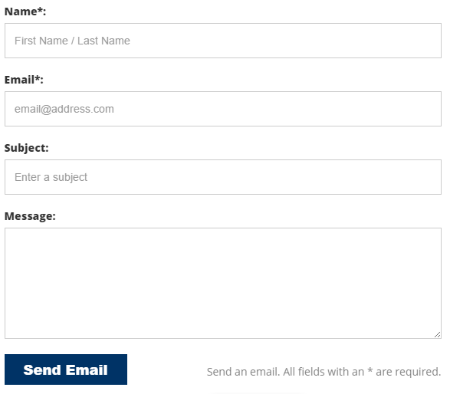
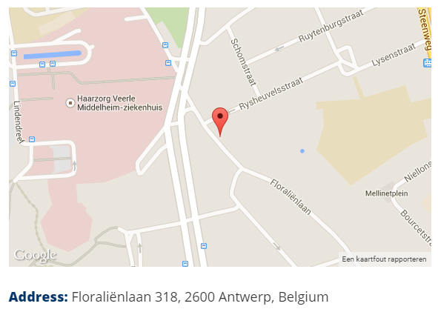

Bovenkant formulier
- T he banner should consist of these items:
Onderkant formulier
- Floraliënlaan 318, 2600 Antwerp, Belgium | Phone: +32.3.808.05.89 | Email: support.tge@idalko.com
- Copyright © 2015 iDalko

Thank you and enjoy

