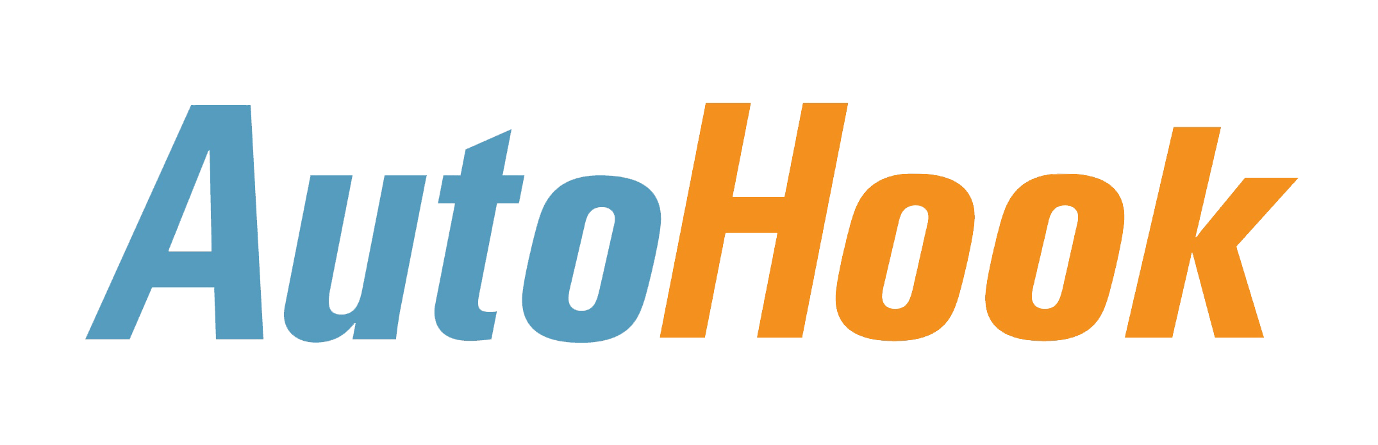 Mobile2Show 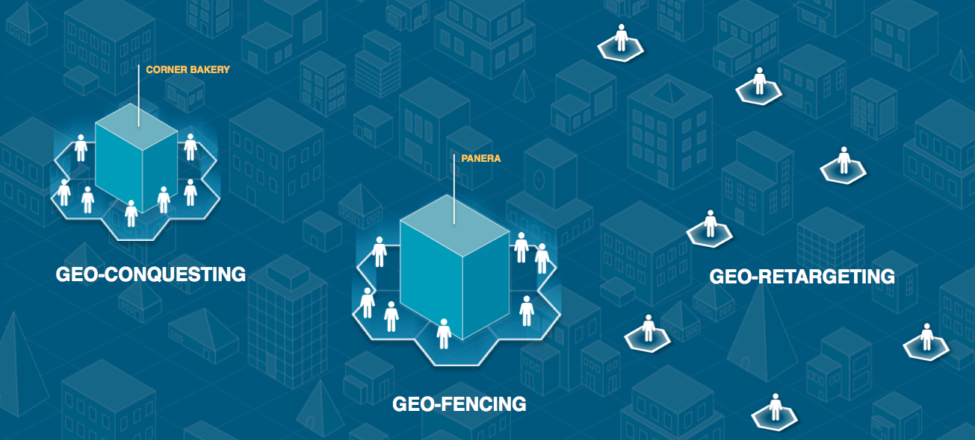
What is Mobile2Show?
Mobile2Show is the best in class mobile showrooming solution. It targets Competitive Dealerships/Brands in the mobile environment, both on your mobile site and 3rd Party mobile sites while driving prospects into your showroom.

How can your dealership compete with Showrooming?
Drive customers out of your competitor’s dealership and into your dealership.

- With Responsive Design, our call to action immediately changes on your mobile site to form a mobile banner
- Customers, who are viewing your mobile site in a competitors dealership, are targeted with an enhanced incentive offer with a test drive via text or email
- Promptly connecting the Customer to your Dealership with mobile texting powered by ContactAtOnce, driving instructions, etc.
- Our integration with Apple Passbook & Google Wallet allows a notification to be sent to the Customer when they are near your dealership

What if the Customer is not on Your Mobile Site?
HookLogic’s dynamic incentives can target customers browsing on hundreds of mobile sites and apps, powered by Verve Mobile. Our Dealers & OEM partners can:

- Protect their own backyard through Geo-Fencing
- Conquest around Competitor’s Dealerships with Geo-Conquesting
- Re-Target those Shoppers who have previously expressed interest in your dealership

Using the same Pain Free Redemption / Fulfillment process that already serves nearly 70% of current KIA dealers

