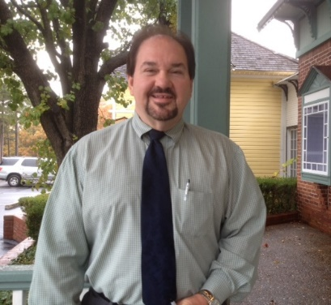 An American Speaks

The richness of Mike Bishop’s experiences have made him a popular entertainer and speaker for more than two decades. As one of 11 children in a tiny Arkansas delta town in ear shot of Memphis TN. he found music his ticket to the world as a successful entertainer. Until recently he served as President/CEO of the Greater Eureka Springs Chamber of Commerce. Mike has woven his observations on the road and business into compelling and inspiring stories for everyone from youth groups, Chambers of Commerce, Veterans and Christian organizations
www.anamericanspeaks.com e-mail info@anamericanspeaks.com
Call 479-244-0362
Mail: 103 E. VanBuren #352 Eureka Springs, AR 72632

Mike offers your group the inspiration, motivation and reinforcement to live, vote and support your traditional American values!

