Logo Design for Holy Trinity Church, Knaphill and St Saviours Church Brookwood
Design Brief
Introduction (Client description)
- Holy Trinity Knaphill (HTK) and St Saviour’s (STS) are two Anglican Churches based in neighbouring ‘villages’ on the outskirts of Woking.
- Churches are managed under one incumbent
- The church seeks to be relevant to the locality
- Much new development happening in the area – new families moving in
- Many residents commute to London
- The social grade of people attending the Churches is typically ABC1 reflecting the demographic of the area.
The parish employs both a Children and Families Worker and a Youth Pastor. As well as the activities they oversee the church runs a number of different groups that seek to connect with people of all ages and circumstances. Most of these happen at HTK but there are significant ones at STS [e.g. Messy Church / Coffee Drop-in]. Our connections with our local primary schools are also key to our engagement with the community. Both churches have halls which are rented to community groups with HTK hall being the more active. Recent changes at STS have made the church building more useful for community activities.
Target Audience
Our Mission Statement is ‘Making Jesus Visible by Word and Power’. We speak of those places where each of us interfaces with the world around us as our ‘frontlines’. Our desire is to live and act in these places in such ways as to demonstrate our love for God in our love for our neighbours. In so doing we hope we may provoke opportunities to talk about Jesus. For example, offering prayer is one way we can introduce people to the power of God’s love and mercy.
While we seek to connect with all age groups we are conscious that the younger generations are less connected with matters of faith than previous generations, so we have a strong focus in reaching out to children, youth and families. We’d like to think that our church is accessible and inviting to all who want to seek God and know more about him. Nevertheless we need to remember that ‘outreach’ means going to where people are not – not expecting them to always come to where we are.
In the immediate terms a new housing development of 300 homes exactly midway between both Churches is a burgeoning front line. In addition to the above we also wish to connect with this demographic. The housing will be split 75% private housing and 25% social. Private housing will typically cost upwards of £450K.
Ideas
- a Church is about people and God; there's not much point in a Church without either of those; and there's not much point in a Church without people worshiping God. So one image could have people represented and God represented. The representation of God depicted in Exodus 19:9 when Moses went up Mt Sinai "See I will come to you in a thick cloud" could be a powerful image.
- The cross in the arch of the wrought iron railings outside HTK is another idea. (See later picture )
- HTK and STS both have thriving pre-schools
- Both STS and HTK have flexible interior layouts but STS is smaller and so lends itself better to exploring new ideas such as Café Church.
- We want to emphasise the way HTK and STS work together and promote the fact that each church does naturally connect with its locality. Perhaps the Logo could come in two forms; one with the HTK aspect prominent for local use in Knaphill and one with the STS aspect prominent for local use in Brookwood? But one unifying logo would be equally regarded.
- We are in particular trying to appeal to families
Feelings/concepts/ideas that could be conveyed:
- Warmth and welcome | - Learning
- Cross of Jesus | - Relevance
- Sense of community and belonging | - Sanctuary
- Worship | - Contemporary
- Journey | - Non-judgemental

Things to avoid:
- We don’t want the logo to be fussy or difficult to see from a distance.
- How important is it to say we are ‘Anglican’? Labels like that are less and less relevant to people or understood!
- We need to be careful to check that the images and language we use are understood by the wider community in the way we mean them! For example – ‘Church Family Unity’ below might be read by some as implying we’re only there for Christians and especially those in families. We favour using fewer words and letting the shape/form convey the impression.

Logos we like: (some for content, others for styling.
- Something more contemporary than this – but the idea is good. 5) & 6) below are more the style that we’re aiming for.

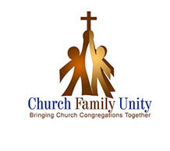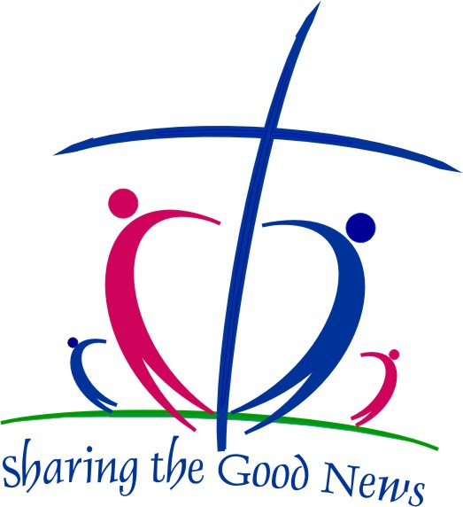
3) Interesting because it’s hinting toward the contemporary
2) Contemporary but the people look drunk – they’re meant to represent a heart we think.
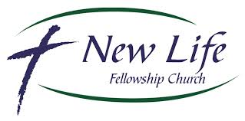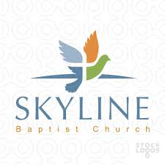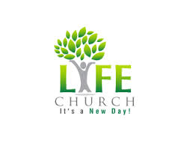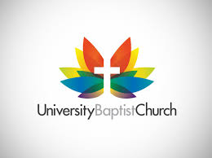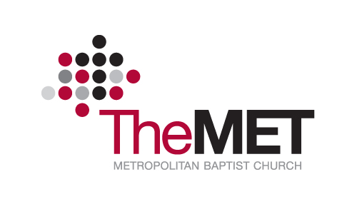
5) and 6)
These both look interesting because they are imaginative, stylish, contemporary.
4) Simple but not arresting enough
7) Strong use of colour – find this attractive. Like the idea of the cross emerging in white out of another background.
8) This looks like a graphical way to represent people – from above. The cross is just visible. Quite clever.

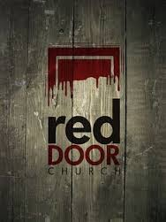
9) Something VERY different. Potentially interesting because it’s highly contemporary – but needs to translate to other areas of the brief. This is really to illustrate that we’re open to ideas that are very different to the norm.

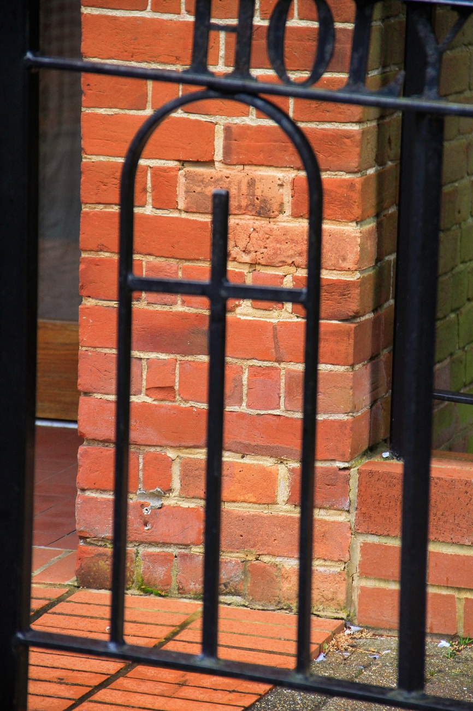 Picture of wrought-iron railings – cross design in an arch.

Further Notes:
Colours: should be appropriate to attracting families and young people. The church is built of a local brick so perhaps that brick colour can be incorporated as one of the colours if appropriate.
Where will the logo be used:
- Overhead projector
- Stationery
- Signboards - visible from a distance
- Leaflets
- Website – please try to visualise how logos might best be used on a website
The following text would be needed as part of the logo design:
“Messy people. Real God. Changed lives”
Format:
.eps plus one transparent GIF 2400 pixel width
Ownership of design:
Ownership of the design will transfer to us after purchase.
Any font(s) should please be identified with an indication of where they may be obtained.

