Support EHR adoption and protect clinician efficiency

PHYSICIAN PRODUCTIVITY
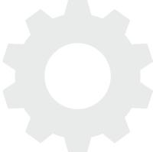
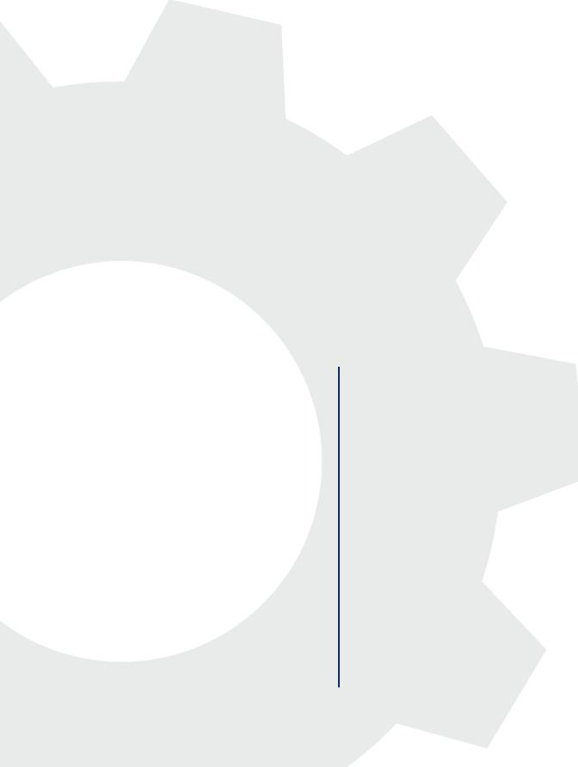
Electronic health records (EHRs) and corresponding meaningful use guidelines aim to ensure optimal patient outcomes through prompt and accurate documentation. However, clinicians oftentimes experience a drop in productivity when entering patient data directly into the computer system and, therefore, elude its use. Providers want to fulfill their documentation responsibilities without compromising attention to their patients, extending their workday or decreasing their patient throughput. Medical facilities aiming to gain provider buy-in understand the key to clinician productivity is establishing a streamlined workflow where it’s easy for the right person to fulfill the right task.
Our solutions provide the flexibility needed to support clinician adoption of an EHR system by allowing them to quickly accomplish their documentation goals while capturing the necessary structured data to support meaningful use. This blended approach ensures clinician productivity is maximized, clinician workflow and revenue capacity is retained, and patient encounters are documented comprehensively.

“GMT has been a game changer for me. I'm able to see 5-10 more patients a day and the quality of the dictations is outstanding. I love the iPhone platform and I love the setup online for editing notes..”
‘‘
’’
Veronica Diaz, MD Jupiter Hand to Shoulder

Dictation: the fastest way to document patient encounters
Streamline
documentation,
maintain
productivity
- Manually entering data into the EHR makes poor use of clinician time and impedes the personal interaction with the patient
- Dictation requires no training, no change in workflow, no physical workstation, while still achieving desired documentation and quality improvement goals
- Skilled transcription editors can create documentation for the EHR up to 69% faster than the point-and-click method
- Exclusive, powerful template capabilities allow an unlimited number of custom print, document and dictation templates that further the efficiency of dictation

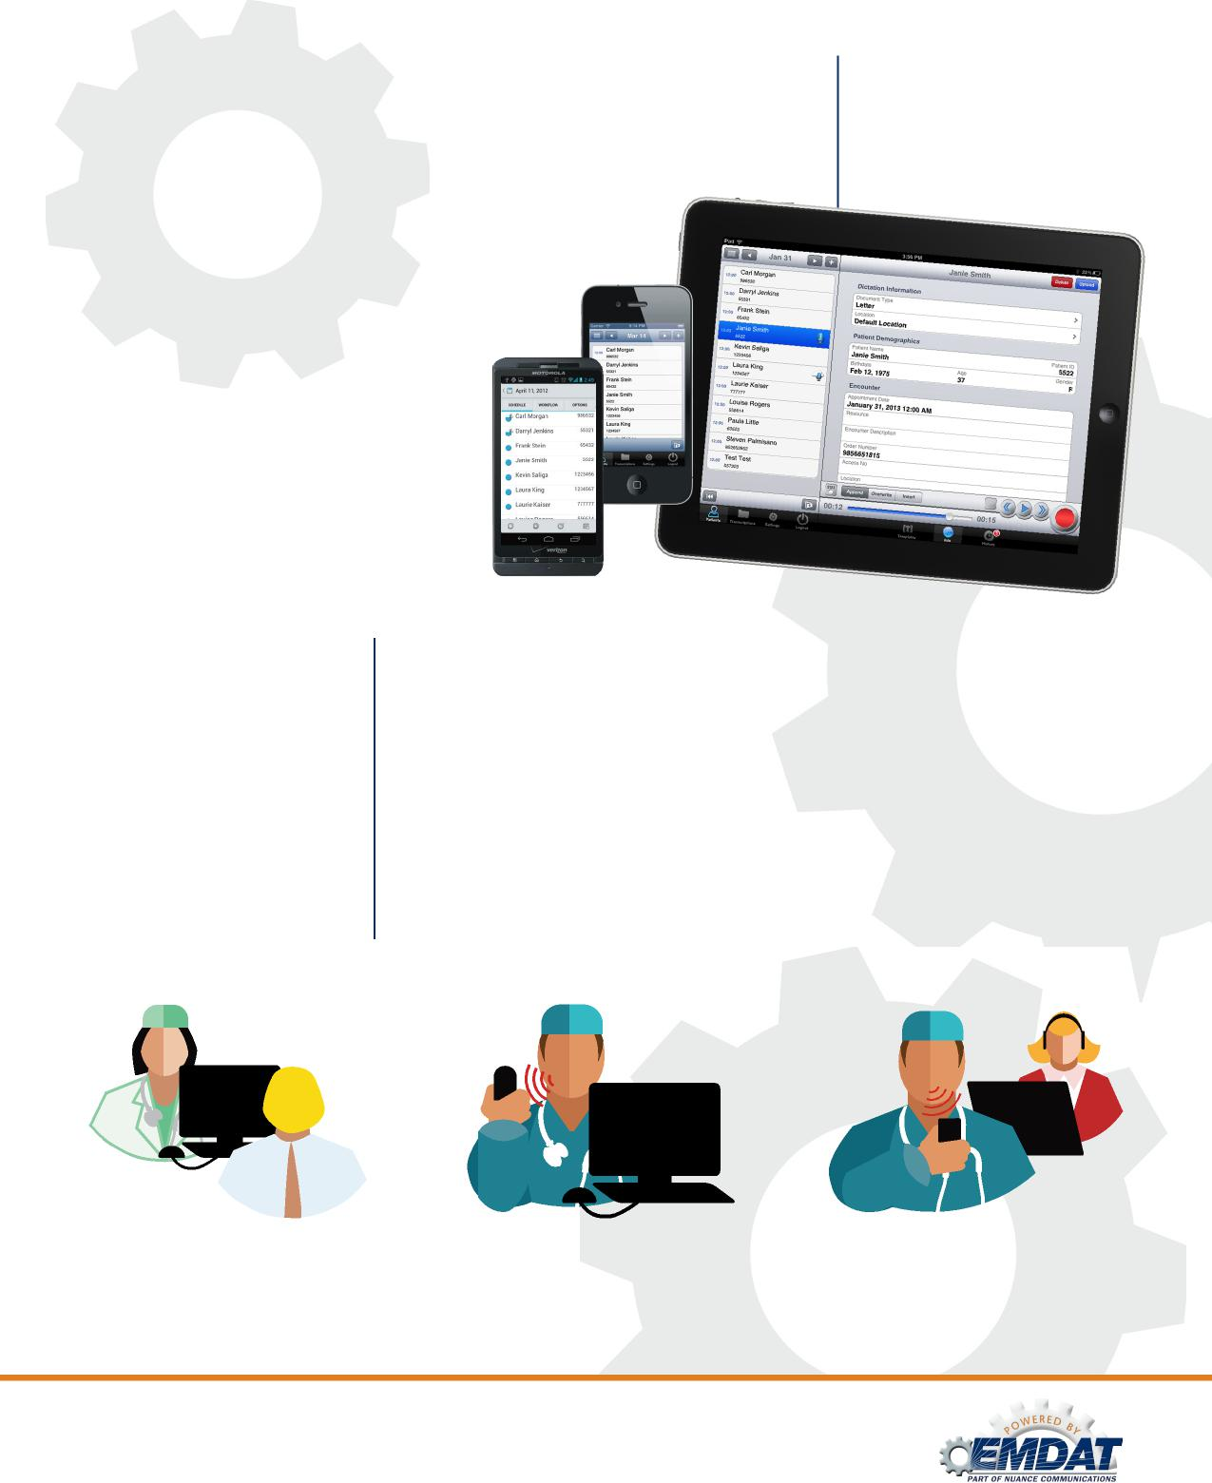
Robust functionality makes documentation convenient
- Easily create and manage documentation from anywhere using a Wi-Fi network or cellular data connection
- Fits any clinician workflow preference including dictation,
templates and speech recognition
- Real-time access to patient worklist and
patient transcription history while dictating —
streamlines workflow and saves time
- Simultaneous access to view, edit and authenticate documentation any time, anywhere decreases turnaround time
Support EHR
adoption,
automate data
collection
EHRs and dictation — a winning combination
- Documentation through dictation is thorough, robust and tells the entire patient story, improving care quality
- The majority of structured content needed for meaningful use is gathered prior to the provider interaction
- Data extracted from the narrative report can auto-populate the EHR, enabling support for quality initiatives while protecting provider time, giving you the best of both worlds
DOCUMENTING IN AN EHR
USING EMDAT WITH
AUTOMATIC INTEGRATION
Enable
flexibility,
Emdat Mobile
4.5 minutes
DOCUMENTING IN AN EHR USING POINT AND CLICK

1.4 minutes
3.9 minutes
DOCUMENTING IN AN EHR USING FRONT-END SPEECH RECOGNITION

