
Pay Less for the Same Documentation
AT 11¢ PER LINE
$2.42
OTHER COMPANIES
WITH OUR SOLUTION
OTHER COMPANIES

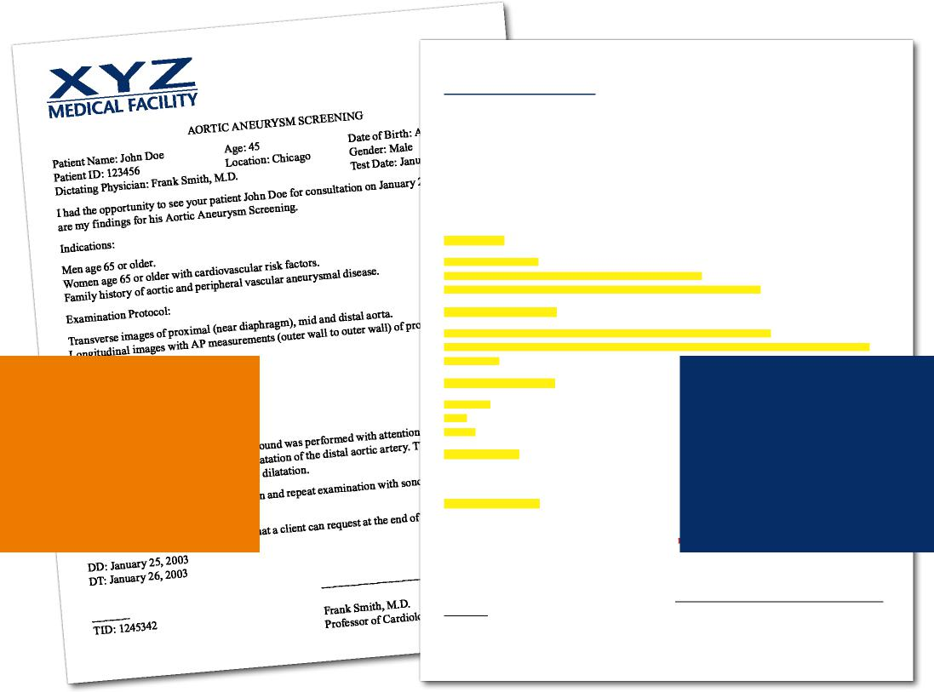
AORTIC ANEURYSM SCREENING
Patient Name: John Doe Age: 45 Date of Birth: August 28, 1958
Patient ID: 123456 Location: Chicago Gender: Male
Dictating Physician: Frank Smith, M.D. Test Date: January 21, 2003
I had the opportunity to see your patient John Doe for consultation on January 25, 2003. Below are my findings for his Aortic Aneurysm Screening.
Indications:
Men age 65 or older.
Women age 65 or older with cardiovascular risk factors.
Family history of aortic and peripheral vascular aneurysmal disease.
Examination Protocol:
Transverse images of proximal (near diaphragm), mid and distal aorta.
Longitudinal images with AP measurements (outer wall to outer wall) of proximal, mid and
distal aorta.
Aorta Measurements:
Proximal: 2.1 cm Mid: 2.7 cm Distal: 2.9 cm
Interpretation: Abdominal aortic ultrasound was mid and distal aorta. There is very small dilatation borderline for a very small aneurysmal dilatation.
Recommendations: Clinical correlation and repea is recommended.
This paragraph is a fixed paragraph that a client ca
DD: January 25, 2003
DT: January 26, 2003
44% SAVINGS
$1.68
USING OUR SOLUTION

TID: 1245342 Frank Smith, M.D.
Professor of Cardiology
Automated content. Templated text. Reduced costs.
Our innovative pricing model can lower costs by as much as 50%. Our exclusive Qualified Text characters are not only billed at a reduced rate, but also decrease the number of transcribed lines by nearly 35%. Couple that with our automated fixed content report sections, and we deliver significant savings over the competition. Healthcare organizations can control costs, minimize transcription and speed documentation.
More automation. Less typing. More profits.


