presents
  - One Day - Meet our Educators, Learn about upcoming Events

What is Equitopia
The ultimate vision for Equitopia is to have a positive impact on the lives of horses and their humans through providing a non-judgemental and supportive learning environment that delivers tangible results for its participants.
Through the careful selection of professionals in the industry and supportive services, who agree in principle on the basic guidelines for the care and welfare of horses, as well as the importance of including the care and welfare of the rider, we will strive to become a groundbreaking leader in promoting a “Whole Horse and Rider” wellness and training program for the general good.

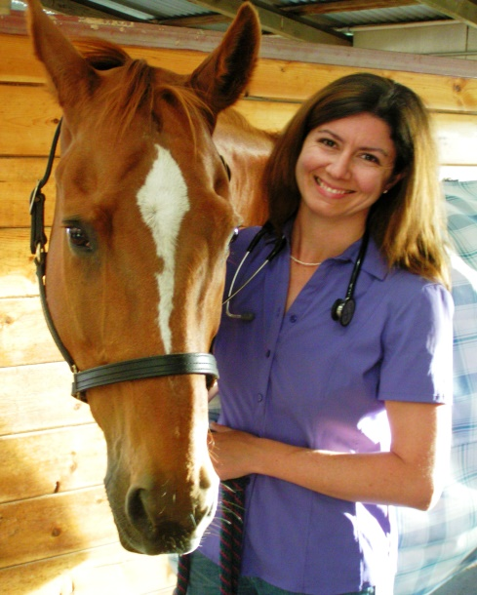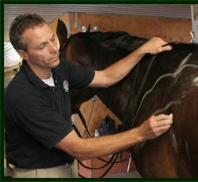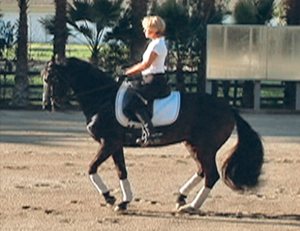

COME MEET US ON SATURDAY 25th APRIL FOR OUR INTRODUCTORY DAY

8:30 am - 9:00 am Registration
9:00 am - 9:15 am Introduction to Equitopia plus speakers
9:15 am - 10:15 am Recognizing the Horse in Pain – Dr. Joanna Robson DVM, CVSMT,CMP, CVA, CSFT, CIT
10:15 am - 10:30am Coffee Break
10:30 am - 11:30am Shoeing or Trimming to Suit your Discipline – Mike DeLeonardo, CJF, APF, RJF
11:30 am - 2:30pm Saddlefitting – Karn Loshbaugh, CSF
12:30 pm - 1:30pm Lunch
1:30 pm - 2:30pm Your Horse’s Digestive Tract; how it impacts Feeding Management – Dr. Clair Thunes, PhD
2:30 pm - 2:45 pm Coffee Break
2:45 pm - 3:45 pm Foundation Training – Recognizing Correct Carriage and Engagement – Karen Loshbaugh
3:45 pm - 4:45 pm Panel Discussion with Q&A

Cost to attend - $49.00

Register at www.equitopia.center or call (707) 704 4904 for more information

