LOCAL ELECTRICIAN IN YOUR AREA

For all your electrical needs

New installations - Renovations – Additions - Upgrades – Repairs – Maintenance

CALL TODAY FOR A FREE NO OBLIGATION QUOTE

- Lighting – LED lighting – Garden lighting - Ceiling fans – Dimmers – Smoke detectors - Power points – Ovens and Cooktops - Telephone – Data – TV/Aerial – Switchboard upgrades – Safety switches (RCDS) and Circuit breakers - Surge protectors – Hot Water Units – Test tagging

JOEL JOHNSON - 0413 719 050 - pivotalpower@outlook.com

ABN 25 604 250 973 Lic 279277C

At Pivotal Power we are fully insured and all work is completed to current Australian Electrical Standards

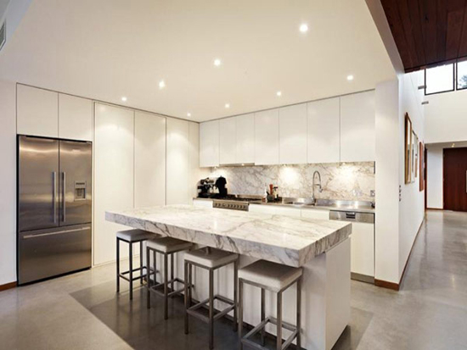

Are you spending too much on your electricity bill?
Are you sick and tired of changing globes?

SAVE UP TO $500 OFF YOUR ELECTRICITY BILL
Based on changing just 22 of your halogen downlights to LED

Why not save yourself some money while adding value to your house!

LEDs use at least 75% less electricity and last up to 50 times longer

YEARLY PRICES BASED ON 6 HOURS USE PER DAY @ $0.26 per kWh

NUMBER OF DOWNLIGHTS | HALOGEN GLOBE (50W) | LED (10W) | SAVINGS
1 | $28.47 per year | $5.69 per year | $22.78 per year
10 | $284.70 | $56.90 | $227.80
20 | $569.40 | $113.80 | $455.60
30 | $854.10 | $170.70 | $683.40

YEARLY REPLACEMENT COSTS BASED ON 6 HOURS USE PER DAY

NUMBER OF DOWNLIGHTS | HALOGEN (AV. 1000 HOURS) | LED (AV. 50000 HOURS)
1 | $8 | $0
10 | $80 | $0
20 | $160 | $0
30 | $240 | $0

Not just downlights, you can change any light to LED
- Oyster lights - Directional lights
- Spot lights - Wall lights
- Pendant lights - External lights

