Website

Home
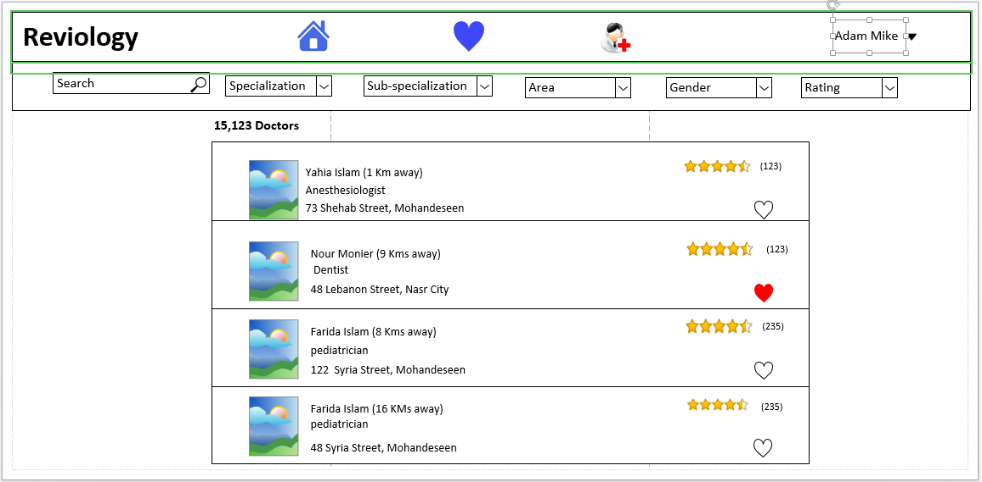

Adding doctor – Basic info
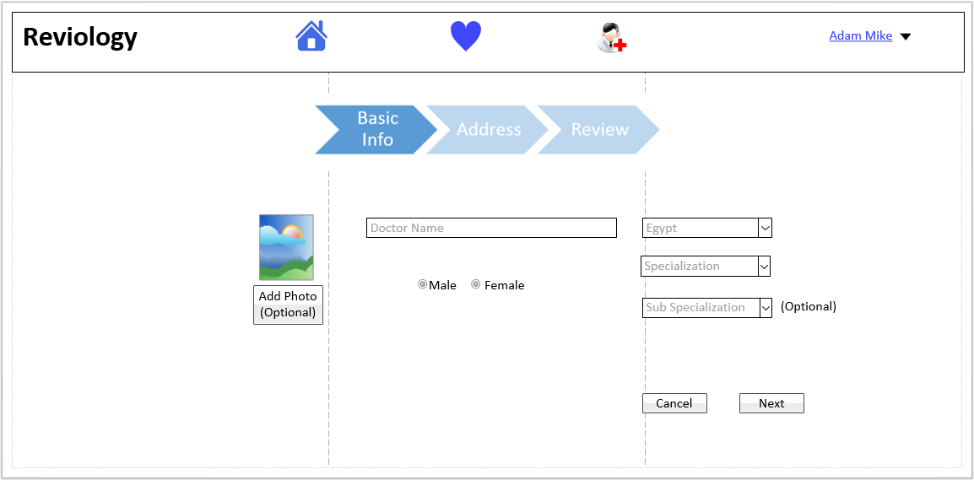

Add Doctor - Address
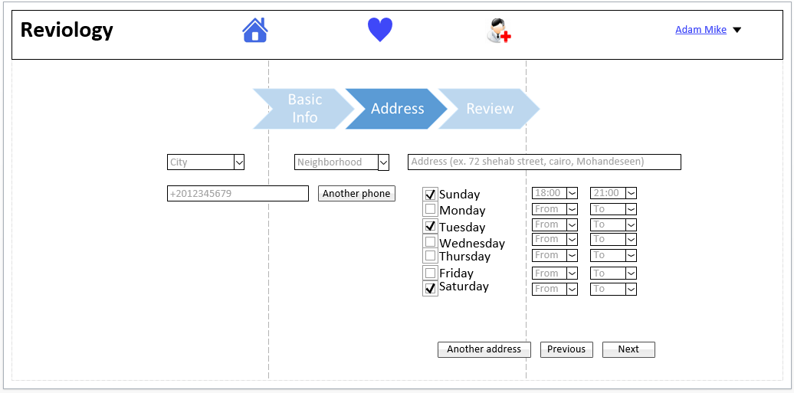

Add Doctor – Review
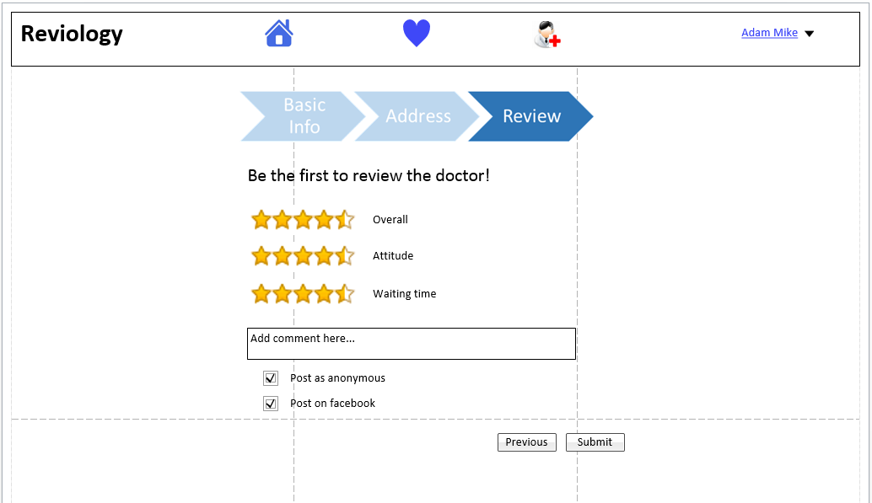

Doctor View
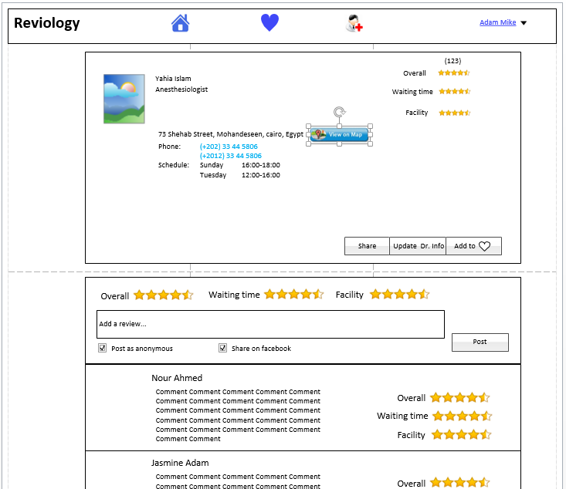

Favorites View
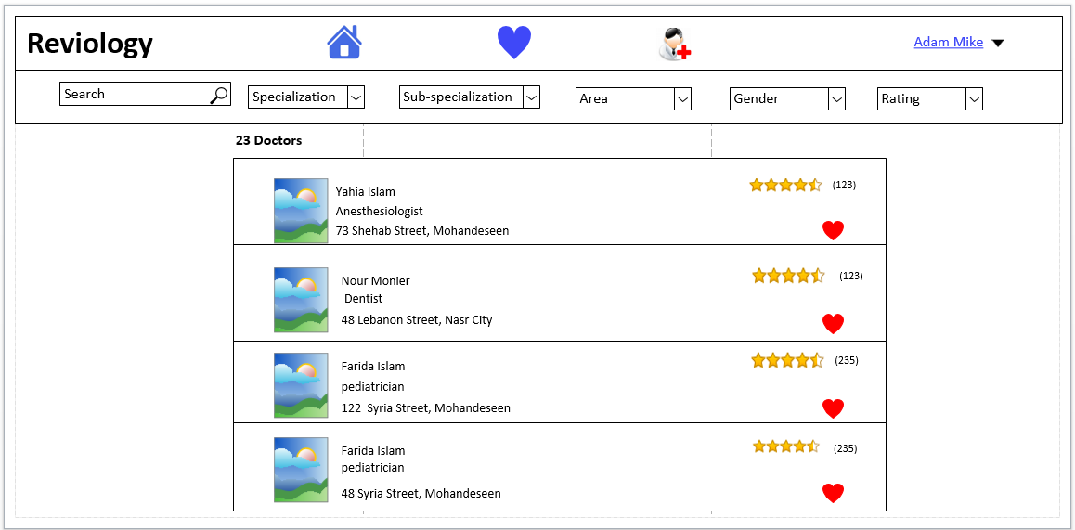

Reviews Popup
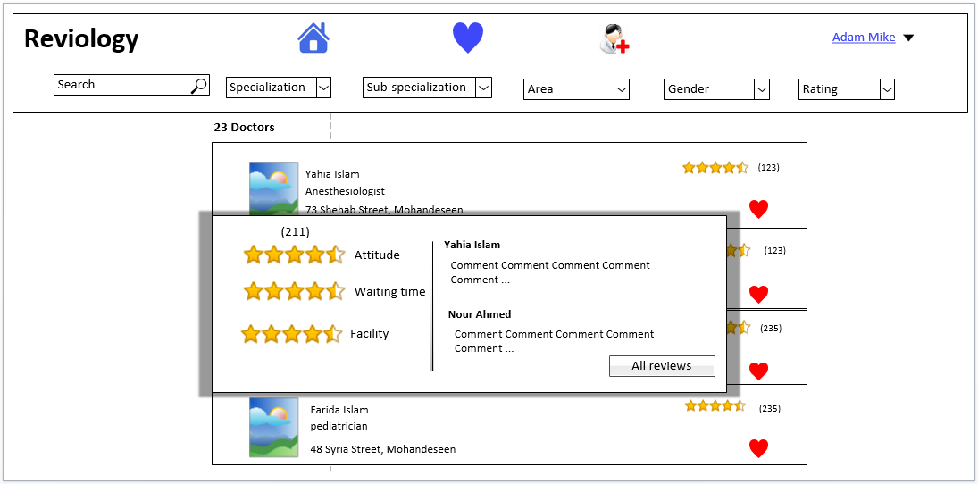

Sign in Page
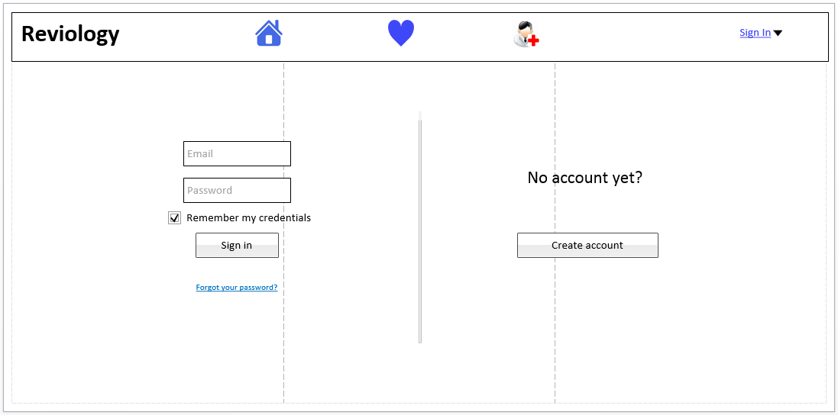

Sign up Page
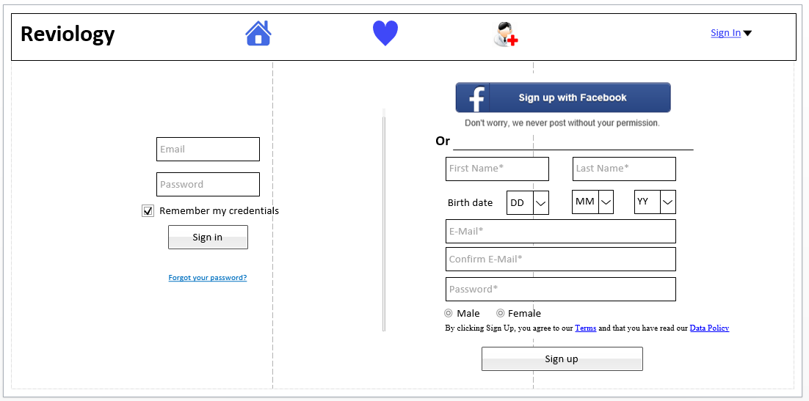

Menu
- If signed in: Name
  - If not signed in : (sign In/sign up)
- Settings
  - Location, give the user the options of:
    - Select from dropdown Country + city
  - Language
    - Drop down choose application language (save language for every time the user opens the application again)
  - Change password takes user to “new password screen”

- Contact us
- Sign out

