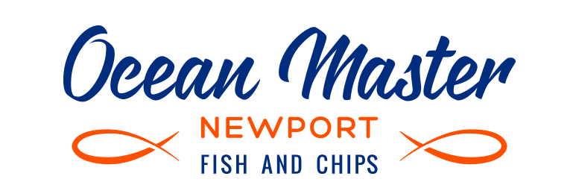
Project Scope:
Brochure design for Ocean Master Newport
Description:
Ocean Master Newport is undergoing a brand refresh that needs to be complemented with updated collateral. This includes a trifold A4 brochure that is distributed to local residents with the store menu, contact details, location, etc.

Key elements:
- Logo
- Full menu including images and prices
- Short description
- Key selling features
- Contact details with map of location
- Social media promotion

Here is a basic layout to follow – if you think the brochure can be presented in a better way please let me know.

Inside Flap  To include imagery and description  Ocean Master Newport, located across from Newport Beach, has been creating delicious, mouth-watering fish and chips since 1993.  Family owned and run, our passion is to not only make our freshly cooked seafood a family favourite, but also as healthy as possible. That’s why we use wild caught sustainable fish, and cook all our flash fried fish and chips in cholesterol free rice bran oil – a rich source of natural antioxidant Vitamin E and Oryzanol.  Ocean Master Newport, as one of the original Ocean Master stores, uses the secret cooking methods conceived over 31 years ago to create the tastiest fish and chips. Our quality seafood is prepared with a special seasoned dip that seals in the incredible flavour, and freshly cooked as you order, ensuring that we provide you with the best seafood every time. The tradition runs deep at Ocean Master Newport.  Don’t forget to ask about our daily fish specials, delivered fresh from the fish markets. Gluten free options available. | Back Page  To include logo, address, location map, contact number, social media and disclaimer.  Logo  385 Barrenjoey Road  Newport Beach 2106  (Corner of Coles Parade)  Map  Phone ahead ready to pick up  9979 9300  Follow us on Facebook  /OceanMasterNewportFishChips  Prices subject to change without notice | Front Page  To include logo, imagery and possibly key selling features including:  Wild caught sustainable fish  Cooked in 100% rice bran oil  Gluten free options available

Panel 1 | Panel 2  To include menu with imagery for packs and burgers, text, and prices as per latest menu supplied  Packs  Burgers  Family meals  Individual items | Panel 3

Content:
- Logo: as created by you
- Address: 385 Barrenjoey Road, Newport Beach 2106 (Corner of Coles Parade)
- Map: do you need me to supply or will you create?
- Phone: 9979 9300
- Facebook: /OceanMasterNewportFishChips
- Key selling features:
  - Wild caught sustainable fish
  - Cooked in 100% rice bran oil
  - Gluten free options available
- Description
Ocean Master Newport, located across from Newport Beach, has been creating delicious, mouth-watering fish and chips since 1993.

Family owned and run, our passion is to not only make our freshly cooked seafood a family favourite, but also as healthy as possible. That’s why we use wild caught sustainable fish, and cook all our flash fried fish and chips in cholesterol free rice bran oil – a rich source of natural antioxidant Vitamin E and Oryzanol.

Ocean Master Newport, as one of the original Ocean Master stores, uses the secret cooking methods conceived over 31 years ago to create the tastiest fish and chips. Our quality seafood is prepared with a special seasoned dip that seals in the incredible flavour, and freshly cooked as you order, ensuring that we provide you with the best seafood every time. The tradition runs deep at Ocean Master Newport.

Don’t forget to ask about our daily fish specials, delivered fresh from the fish markets. Gluten free options available.

- Menu: as per PDF menu supplied and images

