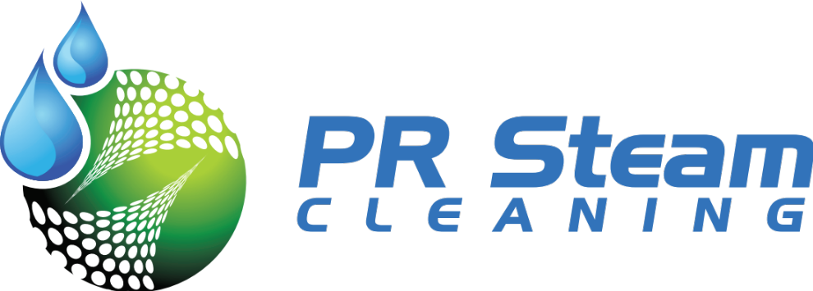

A Cami Construction Division

PR Steam Cleaning is a business that provides commercial cleaning services utilizing steam vapor, which offers the most effective and ecologically friendly method of cleaning today.

The name and address of the business is:

PR Steam Cleaning

35 Calle Juan C. Borbon Ste. 67-105
Guaynabo, PR 00969

Website: prsteamcleaning.com

Market

The potential market for this business are hotels, motels, restaurants, hospitals, fast food facilities, nursing homes, day care centers, schools, country clubs, churches, office and apartment buildings, malls, movie theaters, super markets, airports, parks, and any other facility.

Nature of the Business and Services
PR Steam Cleaning is an insured, commercial cleaning service utilizing the Optima Steamer™ DMF as its main cleaning equipment. It offers cleaning service tailored to its customers’ needs.
Cleaning with steam:
1. No chemicals or soaps involved
2. Safe and eco-friendly green cleaning
3. Cleans, sanitizes, deodorizes and disinfects all at the same time
4. Causes no allergies

This is an eco-friendly process that employs hot steam vapor to effectively clean and sterilize. Steam can penetrate pores and clean more thoroughly without commercial chemical cleaners, whereas hot steam destroys mold as well as spores, germs, viruses, dust mites, and bacteria leaving the surface clean and sanitized.

Steam Vapor cleaning cuts grease, sanitizes, kills mold, mildew, bacteria and other allergy causing pathogens. Vapor cleaning uses no chemicals which eliminates one of the largest costs of cleaning services, the chemicals.

The Optima Steamer™ DMF is a revolutionary, environmentally-friendly vapor steam-cleaning machine. Using the latest in equipment technology–coupled with the unrivalled strength and purity of steam–the Optima Steamer™ DMF Vapor Steam Cleaning Machine can quickly and effectively remove dirt, stains, grease, odors and other contaminants from a variety of surfaces without chemicals and without creating waste water run-off.

The Optima Steamer™ DMF is ideal for mobile cleaning operations such as mobile auto detailing and commercial cleaning.

Opportunities

The Optima Steamer™ DMF is ideal for mobile cleaning operations such as mobile auto detailing and commercial cleaning.

- Fast food restaurant restrooms and food prep areas that are less than spotless. How many fast food restrooms have you been in where the floor is sticky or has build up dirt?

- Auto Steam Cleaning

- Carpet Steam Cleaning

- Industrial Steam Cleaning

- Furniture

- Boats of all sizes

- Awnings, blinds and shutters

- Cleaning after renovation of buildings

- Remove bacteria, yeast, molds & fungi

- Sanitize equipment used for food & beverage

- Safe & effective for cleaning park & recreational equipment

- Great for property management services, military equipment, graffiti removal, weed removal and so much more!

Benefits

- Quickly, easily removes dirt, stains & grease

- Reduce water & chemical consumption

- Clean hard to reach nooks & crannies

- Eliminate waste-water & overspray

- Two operators can clean at once

- Deodorize & sterilize surfaces

- Easy to maintain & operate

- Continuous, on-demand steam

- Quiet & low exhaust output
We strive to serve every customer with the highest

