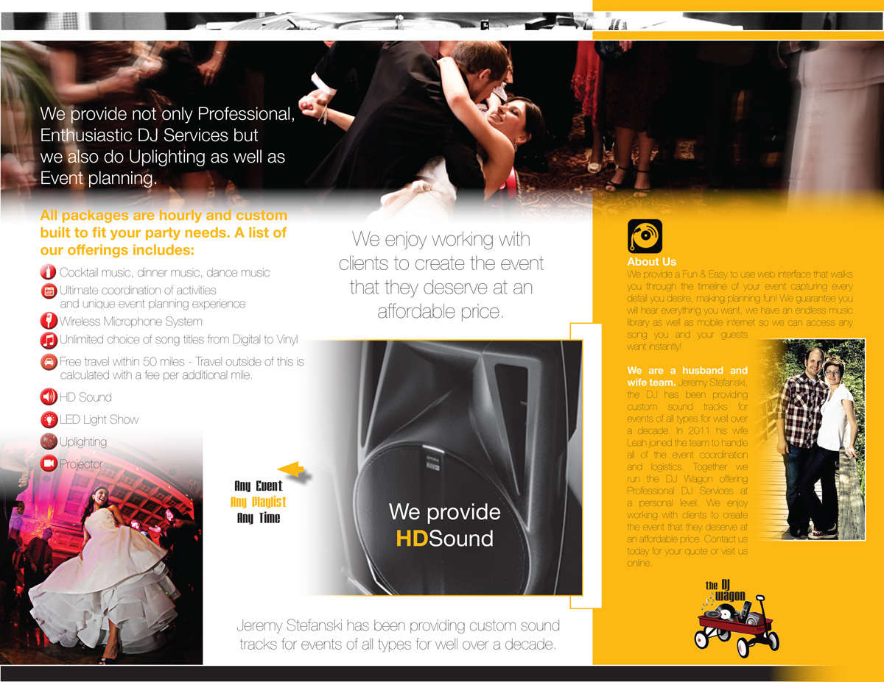
All Packages are hourly and custom built to fit your party needs. A list of our offerings includes:
Cocktail, Dinner & Dance Music
HD Sound
LED Light Show
Wireless Microphone System
Unlimited Choice of Song Titles
Uplighting
Projector & Screen
Unique Event Planning Experience
Free Travel* within 50 miles of 48192
*Travel outside of this area is calculated with a fee per additional mile.
Change the background from Yellow to Red like on the reverse side.
Can you also put a circle of white or a circle gradient behind the logo to make it “pop” out of the red background?
Change text and arrow to Red
We provide Professional and Enthusiastic DJ Services along with Uplighting and complimentary Event Planning.
About Us
We make planning fun and easy with a web interface that walks you through the timeline of your event, capturing every detail. With our endless music library and mobile internet access, you are guaranteed to hear everything you want.
The DJ Wagon is a Husband and Wife team! Jeremy & Leah Stefanski handle and coordinate everything from planning to execution of each event. Together they provide a personal level of service to create the event you deserve at an affordable price. Contact us today or visit us online to get your event started.

