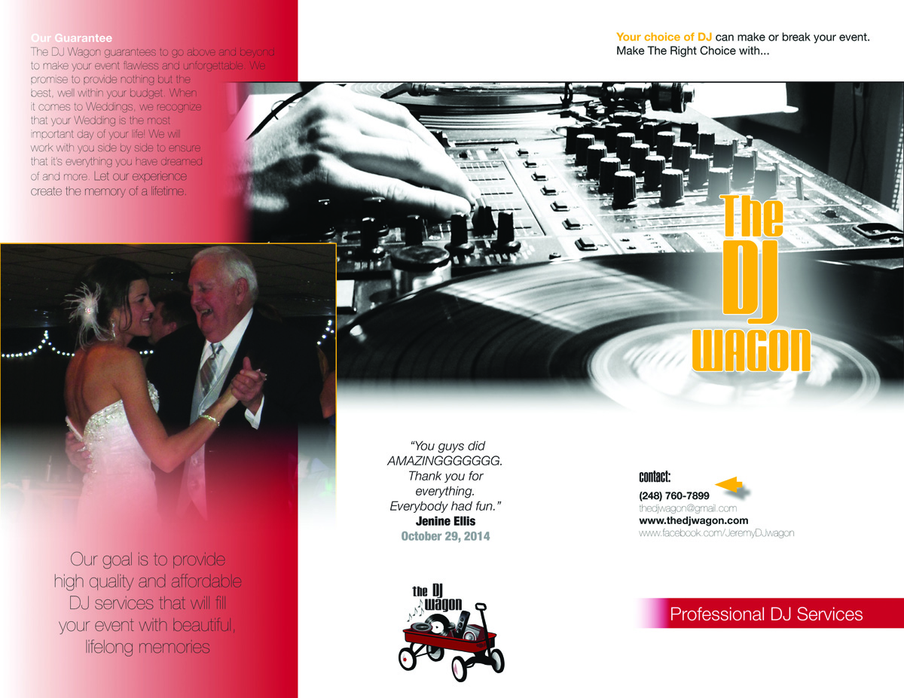
Our goal is to provide high quality and affordable DJ Services that will fill your event with beautiful moments and lifelong memories.
Change arrow to red and make the font here a few sizes larger
Change Text to Red
Change picture outline to a Dark Red
Our Guarantee
The DJ Wagon guarantees to go above and beyond to make your event flawless and unforgettable. We promise to provide nothing but the best, well within your budget.
We recognize that your Wedding Day is the most important day of your life! We offer unlimited pre-event consultations to ensure that your big day is everything you dreamed of and more.
Let our experience provide you with the best sounding and most memorable night of your life.

