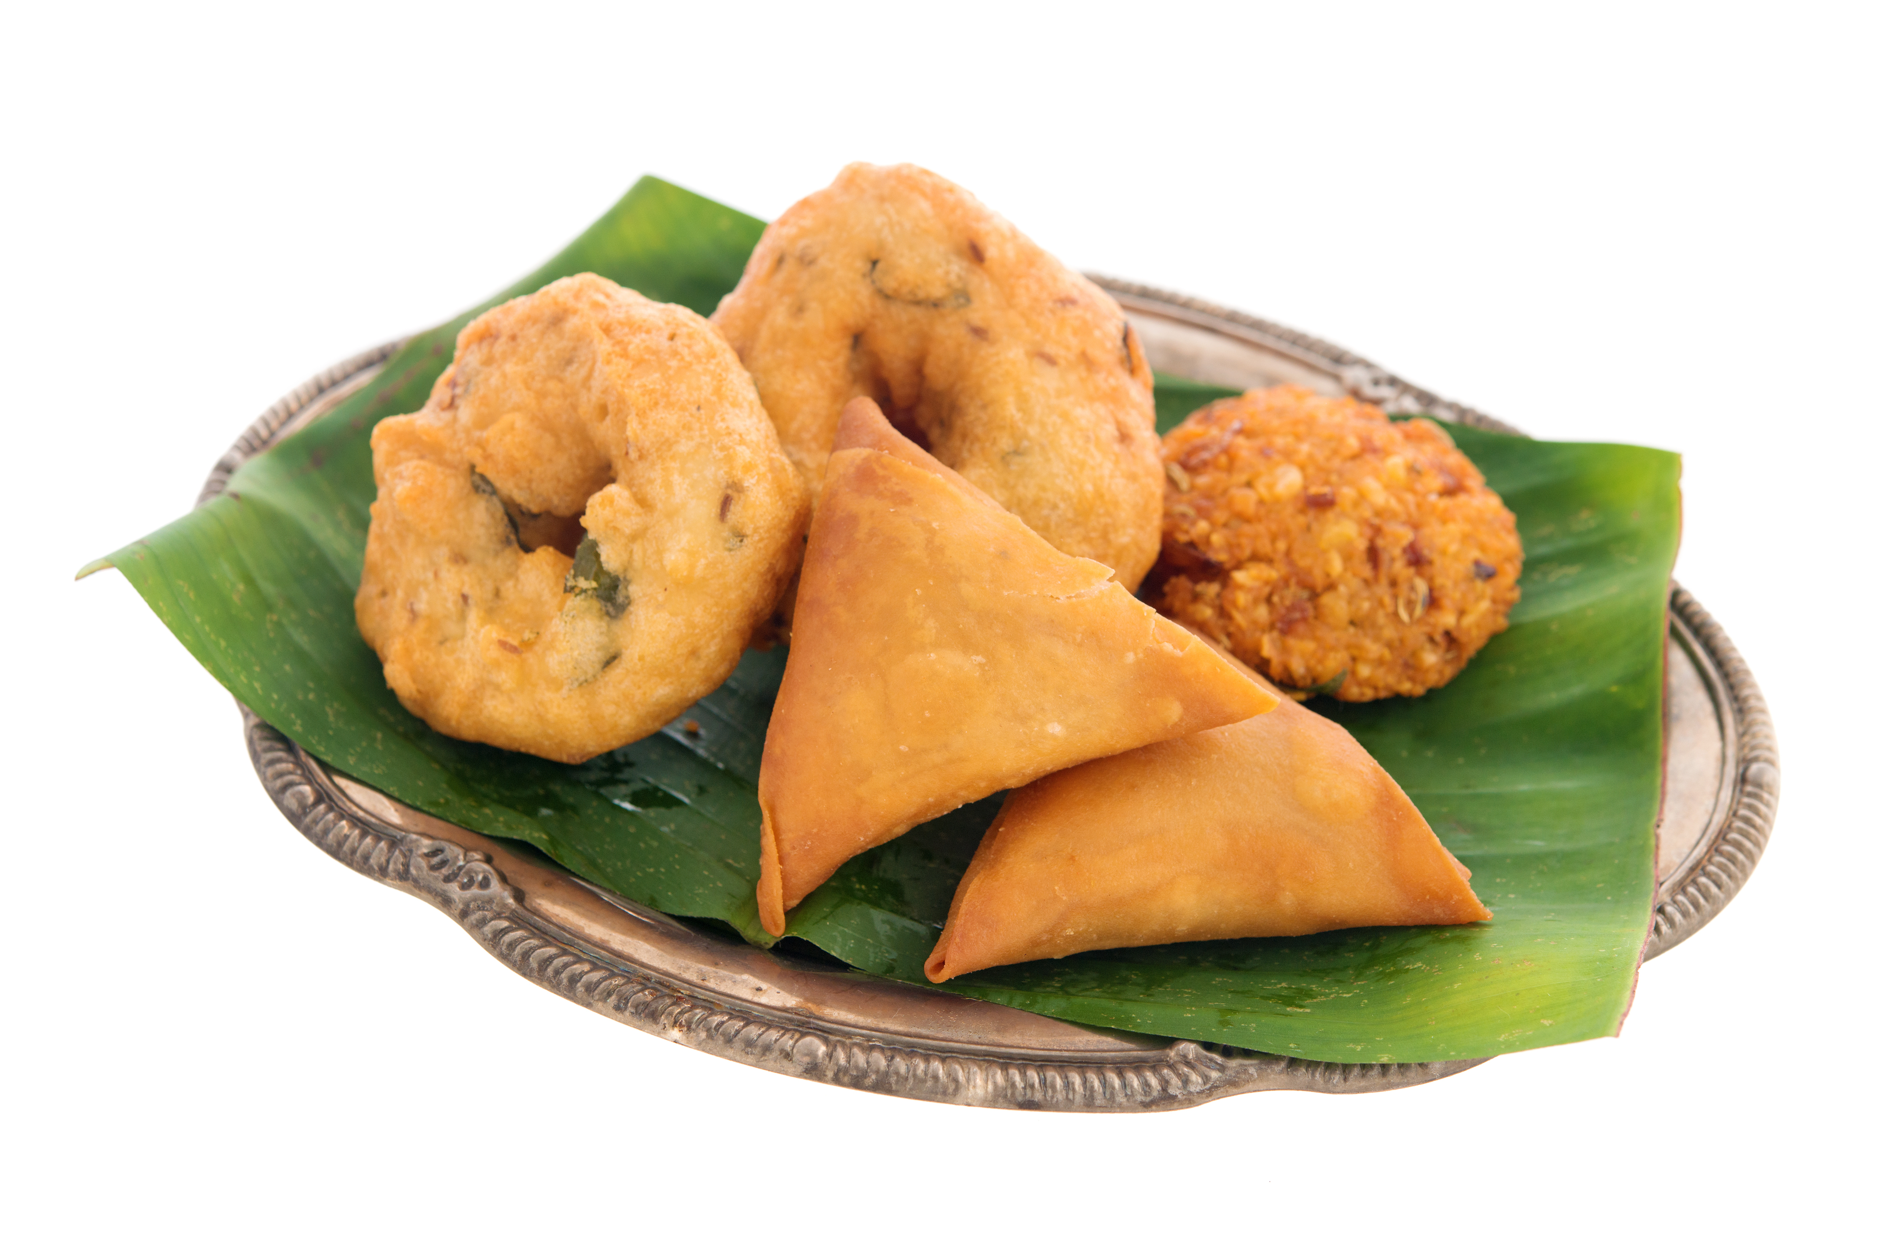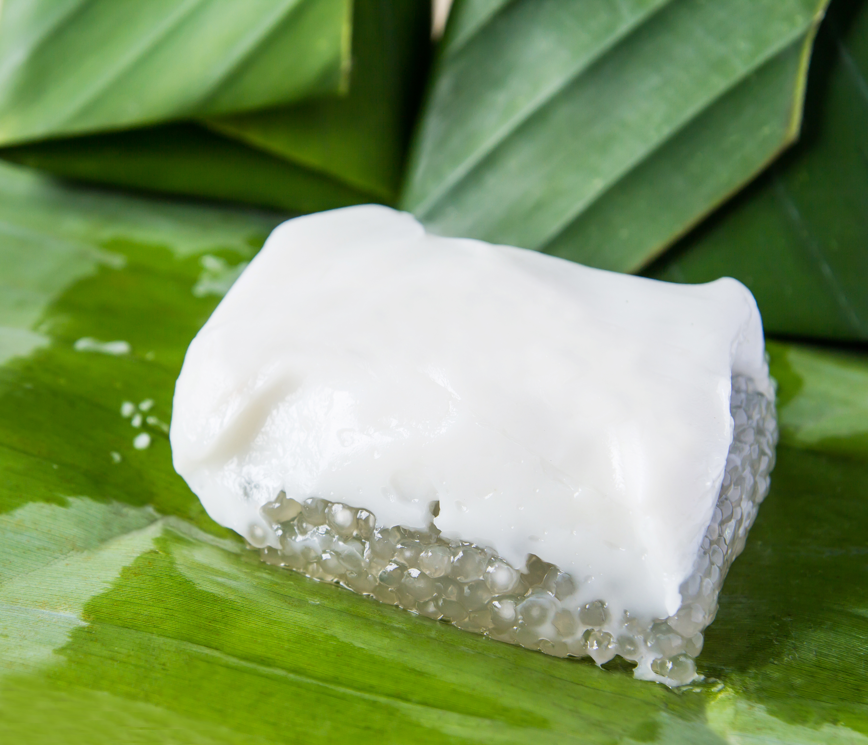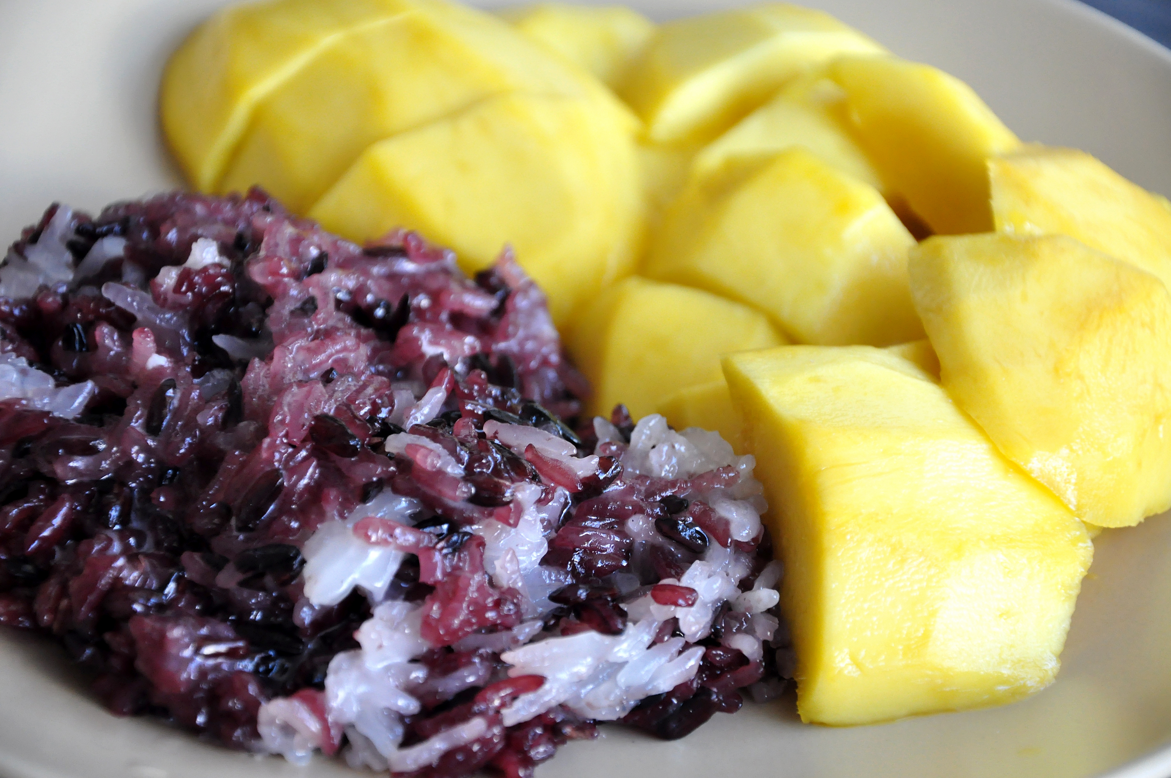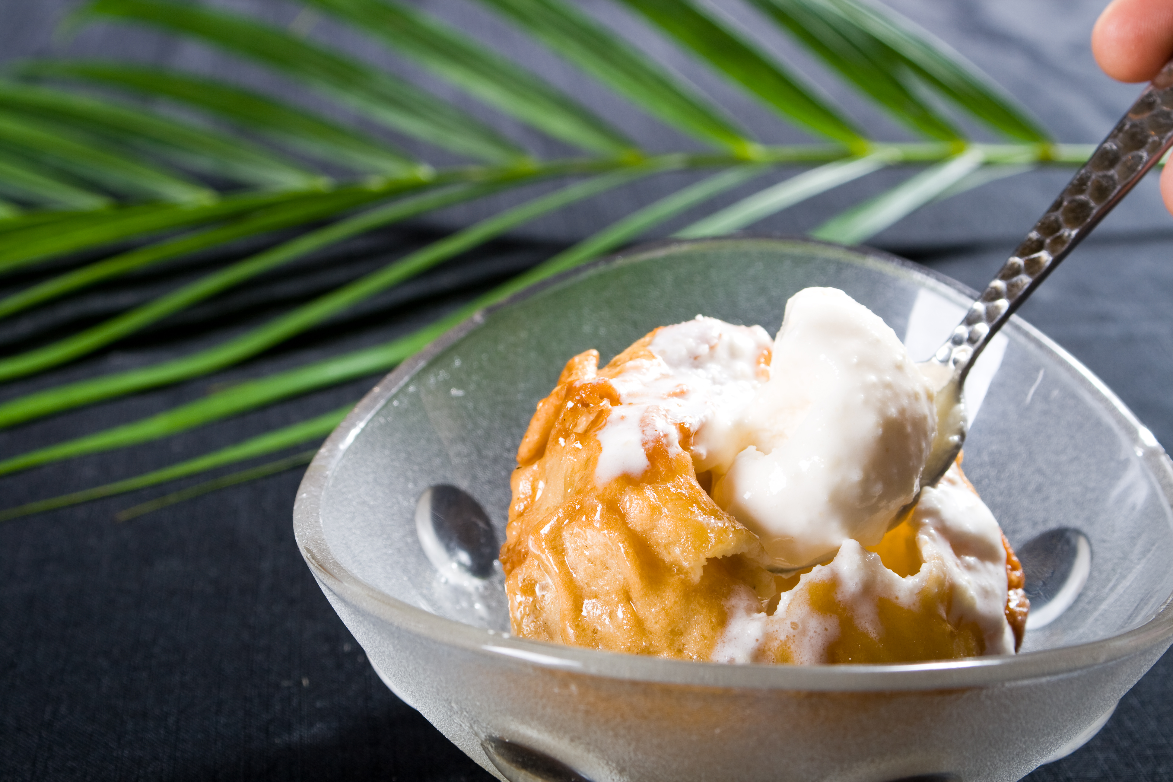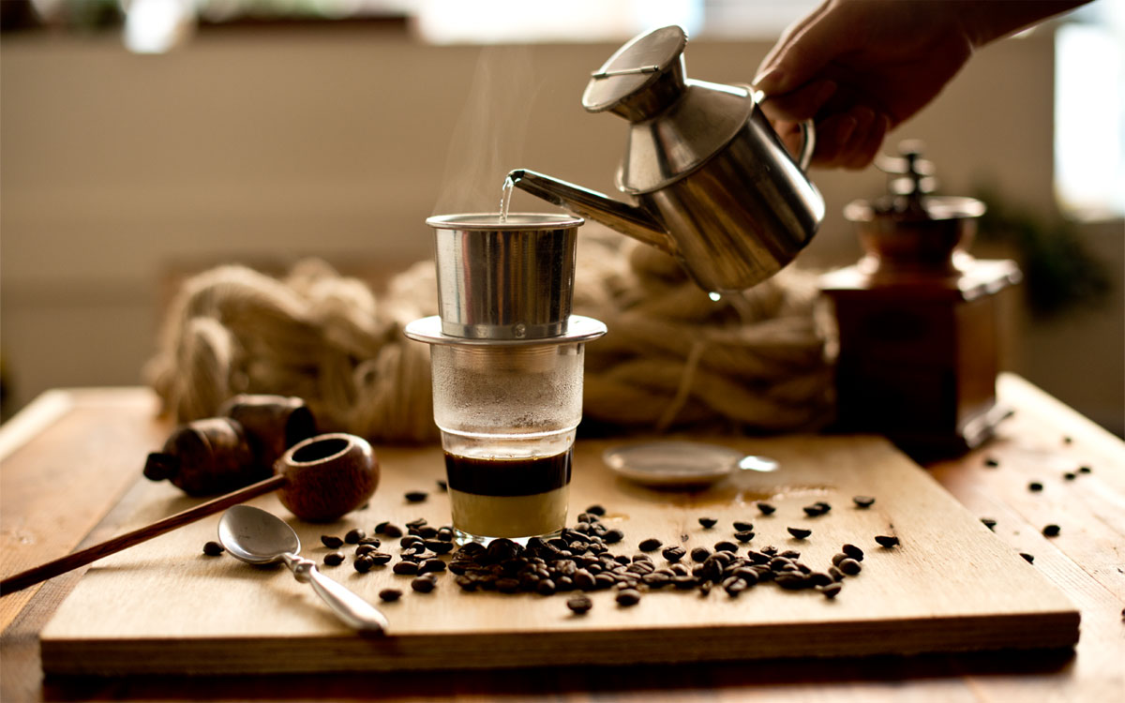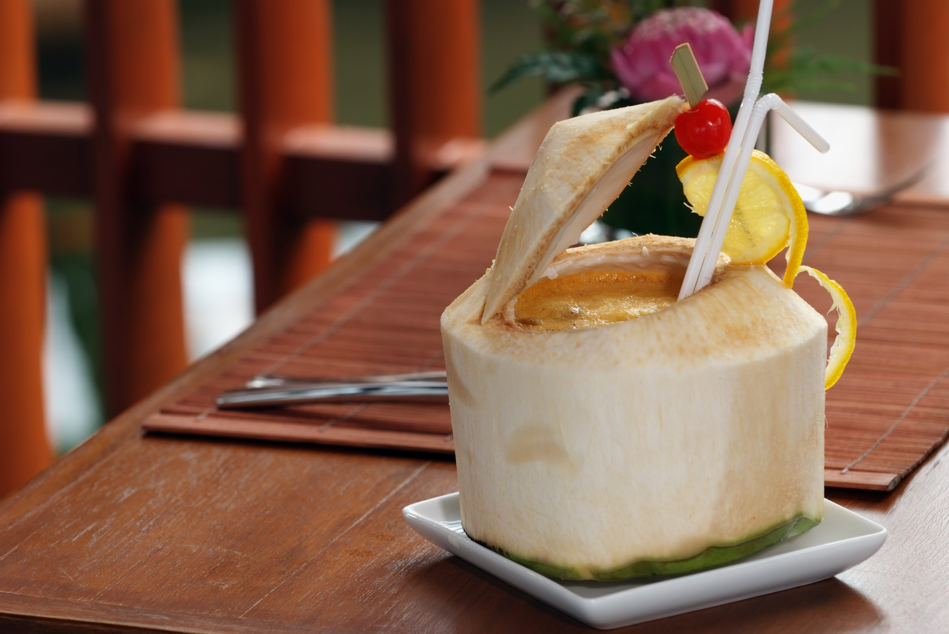
Vietnamese Coffee
$6.90
Fried Ice-Cream with Caramel/Chocolate/Strawberry Topping
$6.90
Black Sticky Rice with Mango
$6.90
Banana Sago Pudding with Peanut Topping
$6.90

Banana Fritter with Vanilla Ice-cream
$6.90

FRESH YOUNG COCONUT JUICE
$5.50

