Graphics Design worksheet

Design #1.

Objective

Design a logotype for the company.

Specs.

256 x 256 png. You can use any color(s) of your choice. It can even be one single color. Transparent background. We are open to any ideas.

Example to look like

Basically it is a pyramid of rocks stacked one on top of another.



Design #2.

Objective

Design graphics for what the UI screen may look like. Setup screen.

Specs.

800 x 600 png. You can use any color(s), gradients and fonts of your choice. White background. We are open to any ideas.

Example to look like

This is a jigsaw puzzle. Inside each piece there is one label, there may also be an icon (upper left corner) and a numeric counter (upper right corner). A couple of the jigsaw pieces should also contain 1 – 3 photos (just like shown below).

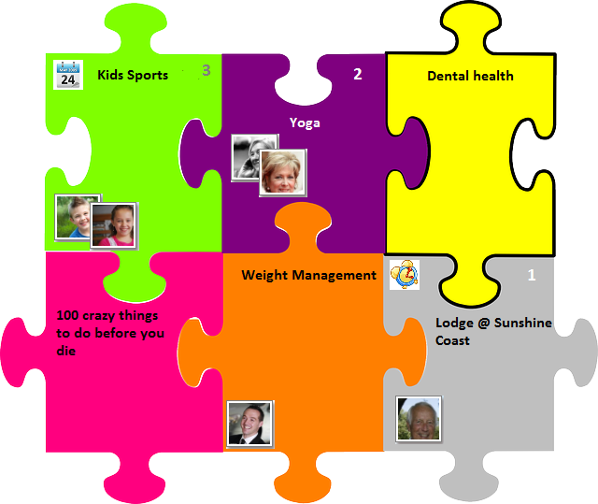

Design #3.

Objective

Redesign graphics for what the UI screen may look like to make it consistent with all other screens, colors, fonts. Feed screen.

Specs.

800 x 600 png. You can use any color(s), gradients and fonts of your choice. We are open to any ideas.

Example to look like

This is what the screen looks like now. It consists of two panes. Left pane contains a list of messages with their type icon, title and the source/connection. Right pane contains the content of the message. There is also a pager on the bottom of the screen.

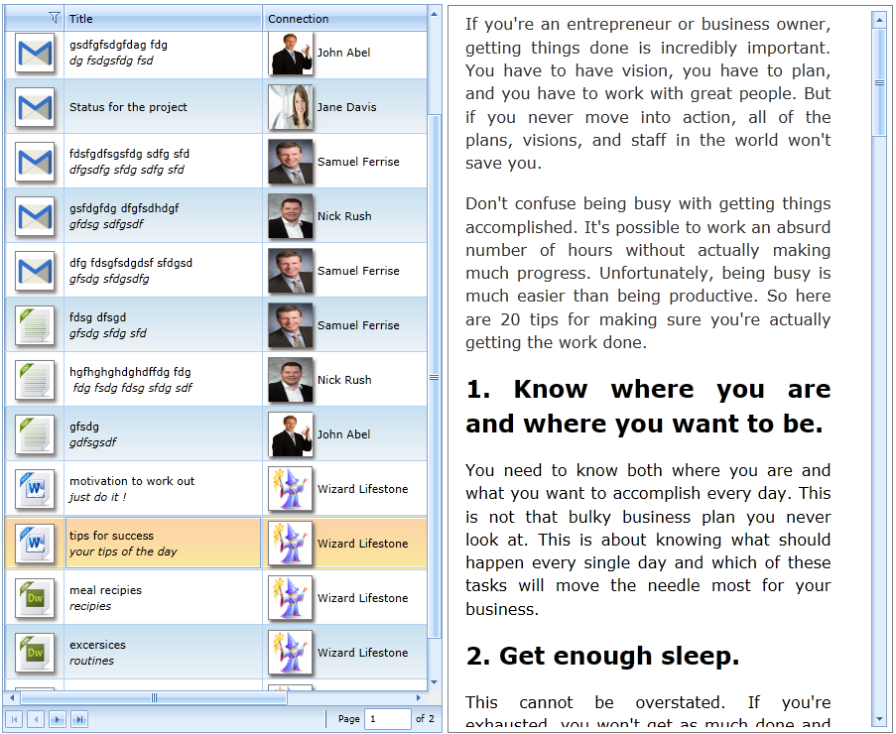

Design #4.

Objective

Redesign graphics for what the UI screen may look like. Calendar screen.

Specs.

800 x 600 png. You can use any color(s), gradients and fonts of your choice. We are open to any ideas.

Example to look like

This is what the screen looks like now. It is a calendar with a filter on top. Each day of the calendar contains a few items (as in to-do items). The main idea is to optimize the screen space to allow as many to-do items in each day to be visible as possible. You can reposition any labels, make them vertical and so forth.

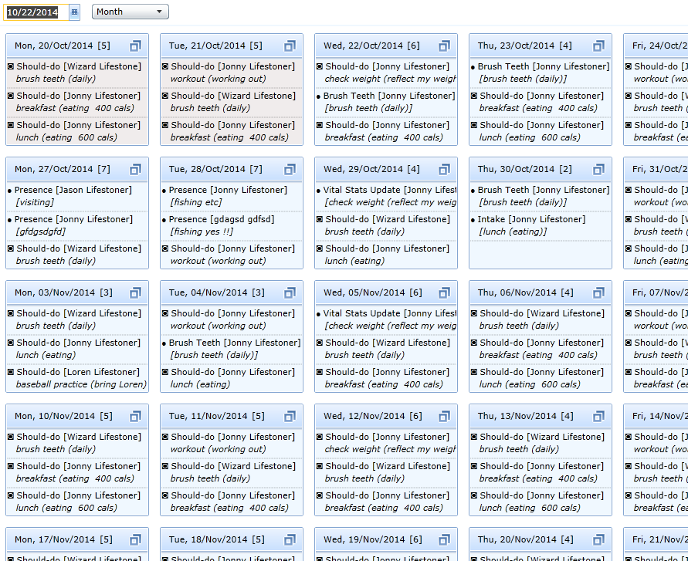

Design #5.

Objective

Design an account diagram.

Specs.

800 x 600 png. Single color for diagram elements and icons, black color for the labels. White background.

Example to look like

This is what the screen should look like. You can rearrange positions of any diagram item to fit to screen better. An item with a label “Book of life”, please use label “Book of Life, Chroniclz” instead. In the diagram items where you see a blank square in the upper right corner there should be an icon that represents it. For example “Calendar / Guidance” diagram item should have an icon that represents a calendar. “Life Style Templates” item should have an icon that represents a template (you choose what it may be) etc.

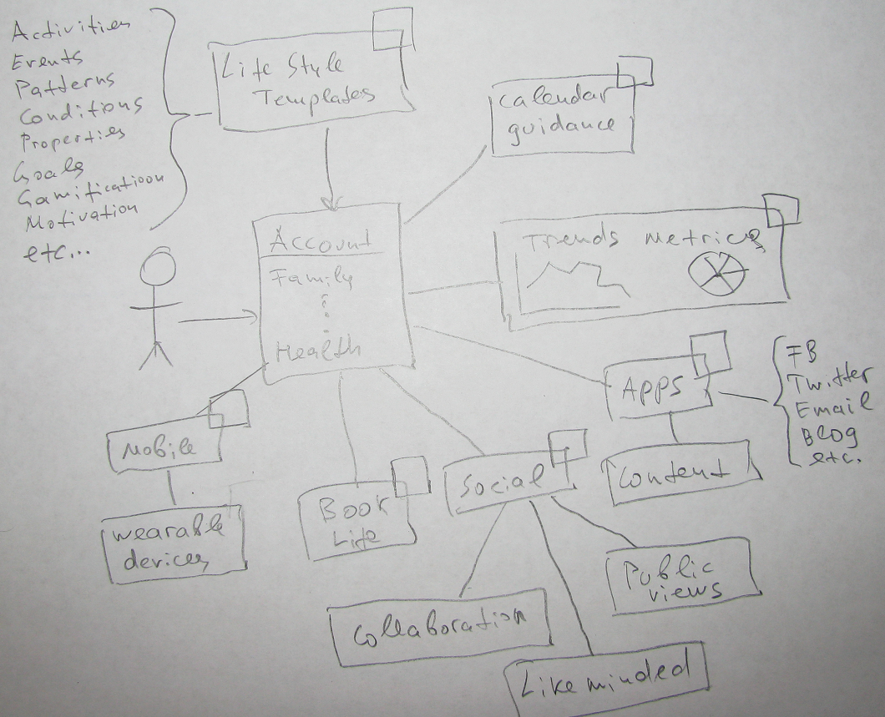
Design #6.

Objective

Design graphics for what the UI screen may look like. Account filter screen.

Specs.

800 x 600 png. You can use any color(s), gradients and fonts of your choice. We are open to any ideas. White background.

Example to look like

This is what the screen should look like. Inside each rectangular item there should be a colorful drawing/icon that represents it. For example inside “Health & Fitness” item, apart from the label itself there should be an icon representing health & fitness (you choose what it may be). You can position these icons at any place relative to the labels (above, below, to the left etc)

