Project Name: New Icons!

Target Audience -

Moms and families, middle to high income. Not necessarily health fanatics, but interested in eating healthy.

Existing Website (being revamped now) -

www.mealgarden.com

Existing Concepts/Icons

The text presented below is very close (or exactly) what will be used in the infograph/landing page.

We are looking to create more compelling and descriptive images/icons for each step.

3 Steps To Easier, Healthier
Family Meals



1) COLLECT YOUR RECIPES

What? Take recipes from any source or location and add them to your Meal Garden cookbook.

Note to Designers: We can take pictures, emails, emailed links and automatically upload them into the Meal Garden cookbook associated with the persons email address (s)

Why? Get all your recipes health rated and stored in one convenient place.

2) SCHEDULE MEALS

What? Easily schedule your family’s meals for the week.

Why? Stay on top of healthy family meals! Based on what you’ve scheduled, Meal Garden will tell you how healthy your family is eating.

Note to Designer: This is built to be very flexible, we’ve benchmarked against existing systems to ensure it’s very flexible and easy to use.


3) GROCERY LIST

What? Get an automatically generated grocery list!

Note to Designer: It’s more a shopping tool. Create lists, share with family members, organize by store and have the system remind you based on time and location.

Why? Save time! With an organized grocery list in hand, grocery shopping will be that much easier.
OR easily send your grocery list to someone who will help you shop.

4) KNOW WHAT YOUR FAMILY IS EATING


Meal Garden’s health meter is baked into every step of the way. Every recipe that is entered into Meal Garden is run through our patented algorithms and matched against your family profile to provide a concise picture of how healthy a meal is for your family.

ADDITIONAL IMAGE (S)

The image below is a good example of an image for the Health Algorithms:

- Recipes go in the top and are run through the system
- They are compared to your family profile
- The algorithms spit out a rating

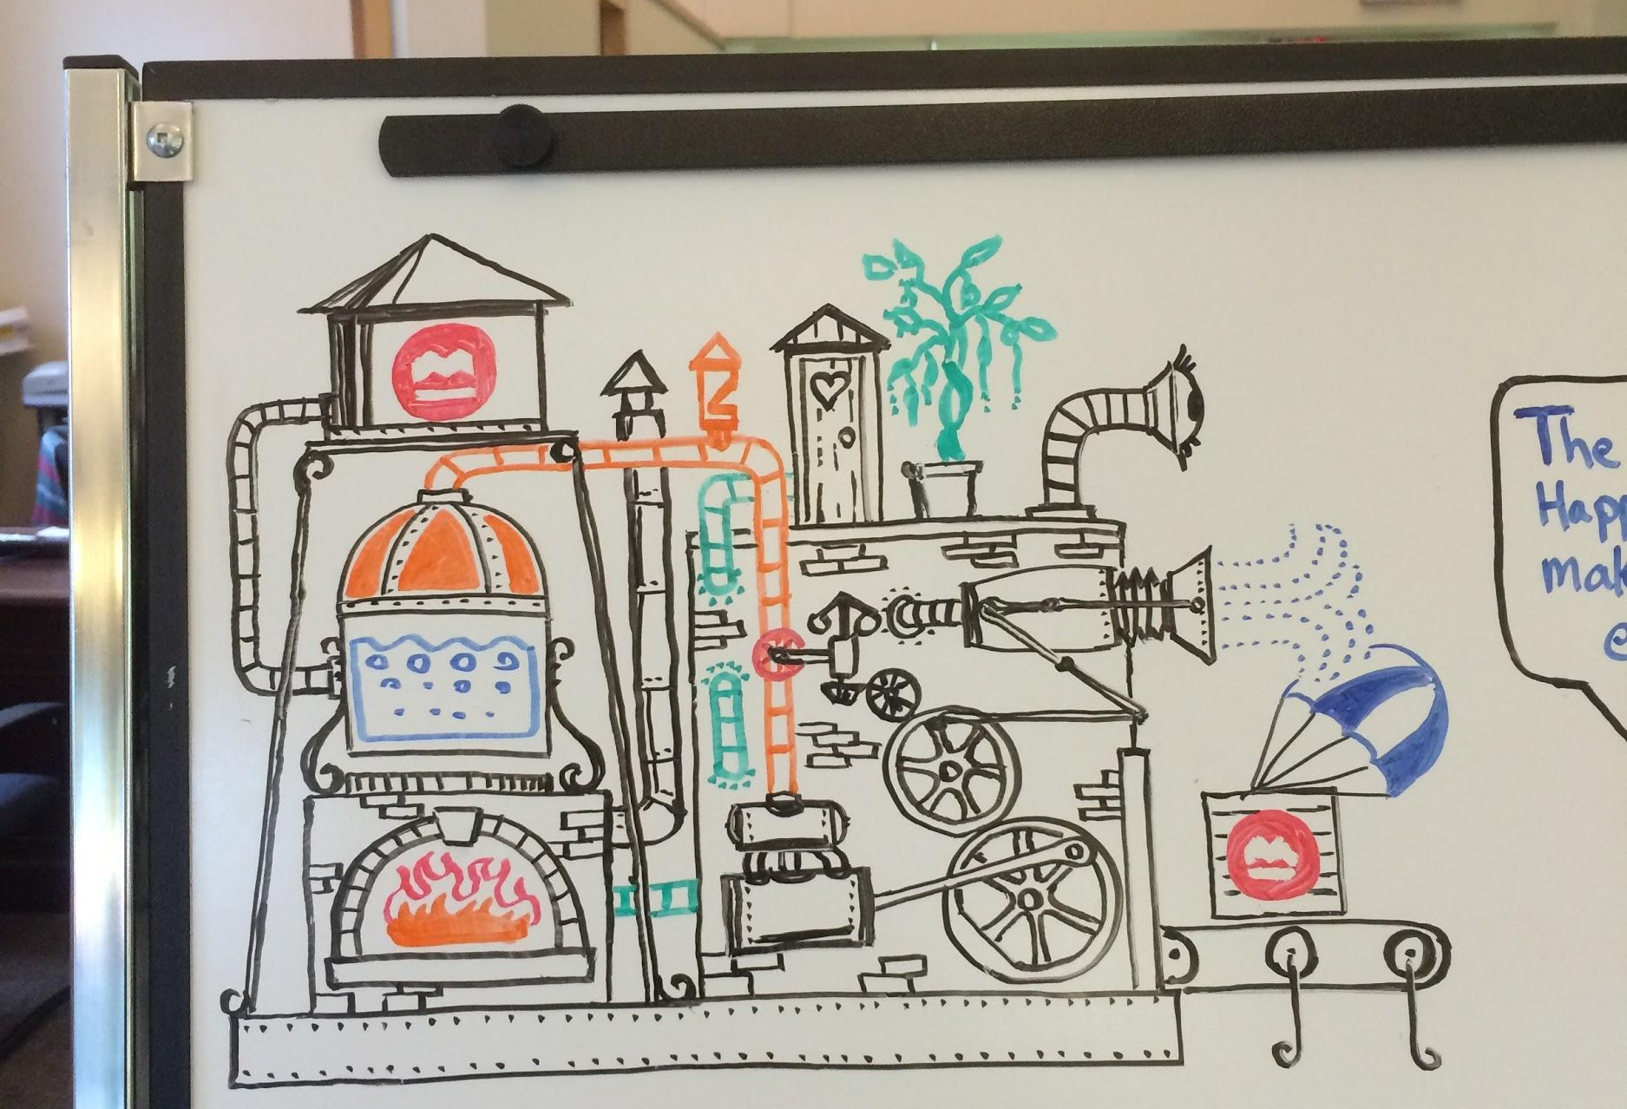

Something along these lines….be creative!

